Rotary Club of Castro Valley
Meeting Highlights – January 31, 2016
Special Fundraising Challenge
Breathing for Life Project

On Monday, Dwight Perry had a meeting with Jim Knuppe, the owner of AAAAA Rent-A-Space. Dwight shared with Jim that the Club needs to raise an additional $50,000 to complete our Breathing for Life Project. He agreed to do a matching contribution over the next four weeks. Jim will contribute dollar-for-dollar until we reach a total of $50,000. In other words, if we raise $25,000, he will match it.

This is very generous donation and the Club can do it. Please take a minute to think of anyone you can ask to make this fundraising match a reality. If we can get five individuals to donate $5,000 each, we will reach our goal.

If you have not donated to the BFL Project, now is the time to do so. If you have already donated, thank you very much and please consider an additional donation.

Thank you to Obse Lubo for spearheading this project and the committee (Bill Nott, Kern Lewis, Cliff Sherwood, Dwight Perry, Jim Negri and Carol Wikle) as well as everyone who has contributed the time, effort, support and heart to this life-saving project. We are so close.

Mo Ghaffarzadeh - AgroTech
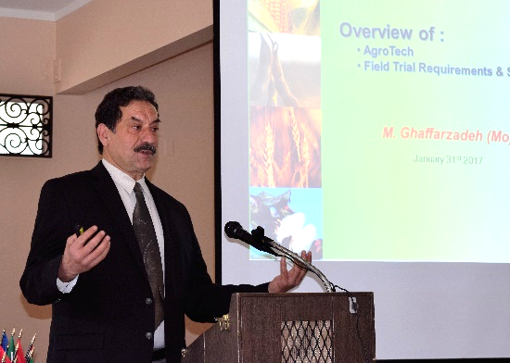
Mo Ghaffazadeh, owner of AgroTech in Davis, spoke on how technology is being used to more and more improve plants to deal with drought, soil conditions, insects and other factors that threaten agricultural. He described his work as

- Provide Superb and Quality Ideas
- Explore New Technologies
- Develop Partnership
- Learn and Exchange Ideas
- Utilize Best Practices
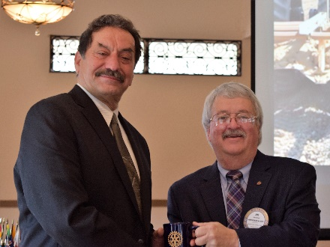
He decribed the process that he uses to test seeds in orer to find the best ones to support the agricultural industry. He presented a series of slides that showed how drought effected the production of a crop based on when and how long the drought occurred during the growing cycle. The same number of drought days could have significantly different impacts depending if the drought was at the start, in the middle or at the end of the growth cycle. Mo concluded his presentation with a video displaying testing process that he uses in his work.

Jake Stewart – Update on Redwood Canyon Golf Course
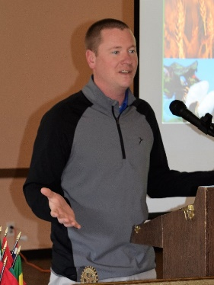
Jake Stewart, General Manager of Redwood Canyon Golf Course provided an update on the recent flooding at the golf course. In responding to questions, he indicated that Redwood Canyon has been working with EBMUD regarding the release of water from Upper San Leandro Reservior that caused the flooding. Jake indicated that there has minimal damage to the course and currently holes 2-8 are open. As soon as the water recedes and the course dries out, it will be fully reopened. The Castro Valley Forum had two stories on the flooding in its February 1st edition and more information is availabe from EDMUD at www.ebmud.com.

Announcements
- President-Elect Jim Negri, who was presiding today since President Carol had jury duty, announced that he has mailed a letter to all member describing the planning that he is doing for next year and requesting members to volunteer for the many positions that need to be filled to ensure the Club continues to be vibrant and successful. Please take the time to review the opportunities and return the form to Jim by February 27th.
- Presient-Elect Jim distributed a signup sheet to serve dinner at the Youth to Youth Conference at Castro Valley High School on March 4th. The Danville and San Ramon Rotary Clubs are providing the financial support for the conference. Our Club is being asked to provide the volunteers to serve dinner. You can up at a future lunch meeting or look for an email with information about Youth to Youth.
- Ken O’Donnell, Poker Tournament Chair, distributed fliers to recruit players and sponsors. Mark Poniatowski announced that Dawn Ortiz and he are collecting prizes. Contact Mark or Dawn for more information.
- Mathilde Schmidt made a contribution in recognition of her 64 years of marriage to Leo. Congratulations to Mathilde and Leo!
- Randy Vanderbilt and Bill Nott shared planning information regarding the Chili Cook-off and Rodeo Parade respectively. Randy said to watch for an announcement regarding the next meeting, which will be held at a local brewery to taste beers to serve at the Chili Cook-off.

Next Meeting
On February 6th, the Club will be sponsoring the Club Level Richard D. King Youth Speech Contest for students from Castro Valley and Redwood Christian High Schools. This event always showcases the talented students in our schools. It is a great opportunity to invite a guest. With the speakers and their guests, there will be a larger than normal audience. Please RSVP via the email invitation so that we have sufficient seating and food.

