Rotary Club of Castro Valley
Meeting Highlights – January 9, 2018

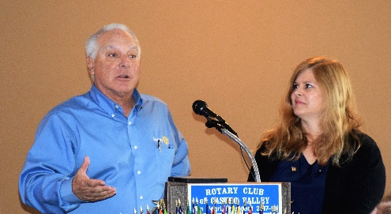
The Empowerment Project – Sal Sbranti and Milanka Schneiderman
Rotarians Sal Sbranti (President – Elect) and Milanka Schneiderman (Immediate Past President) presented The Empowerment Project, which developed by the Rotary Club of Antioch and is presented to all 8th-12th grade females in the Antioch Unified School District as well as others. Since October 2015, the program has been presented to over 5,000 people.

The Film
The Empowerment Project is the incredible journey of a crew of female filmmakers driving across America to encourage, empower, and inspire the next generation of strong women to go after their career ambitions.
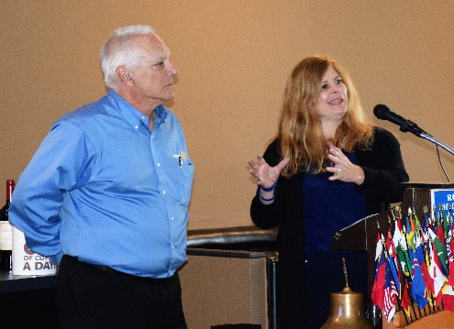
Driving over 7,000 miles from Los Angeles to New York over the course of 30 days, the documentary spotlights 17 positive and powerful women leaders across a variety of lifestyles and industries.

In celebration of the all-female focus in front of and behind the camera, the filmmakers turned the cameras on themselves, capturing their transformational journey. The film challenges the audience to ask themselves, "What would you do if you weren't afraid to fail?"

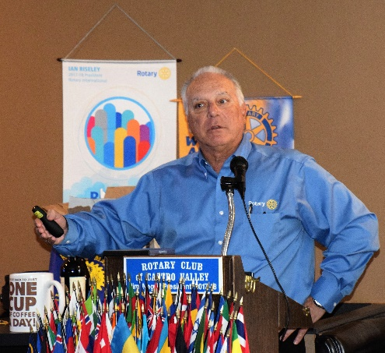
The Program
The Basic Program is about 75 minutes long with the typical format of
- A school administrator or well-known staff gives a 5-minute introduction (e.g., thanks Rotary, sets ground rules);
- The 50-minute movie is shown;
- A Facilitator introduces a panel of 4 to 5 members followed by
- Q & A between the students and panelists, which has turned out to be the most powerful part of the program.
The Empowerment Project has been endorsed by the State Superintendent of Public Instruction Tom Torlakson and Stephanie Anello.

Criteria for the Panel
- Local – Wanted the students to recognize that there are successful women locally
- Diversity in Careers – Lawyers, Engineers, Doctors, Politicians, Police Captains, Environmental Specialist, Bankers, Hospital Administrator, Journalist, etc.
- Successful
- Diversity in Culture – try to match cultural diversity of the students
- Different panelists for different event
- Not all panelists were Rotarians
All the panelists were highly motivated to participated and wanted to participate in future events.
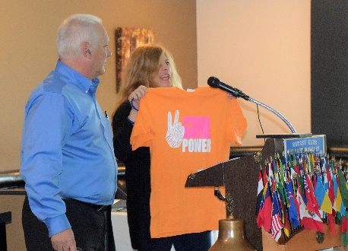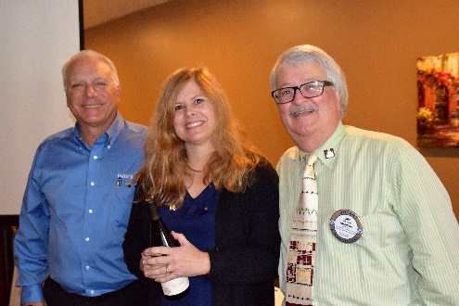
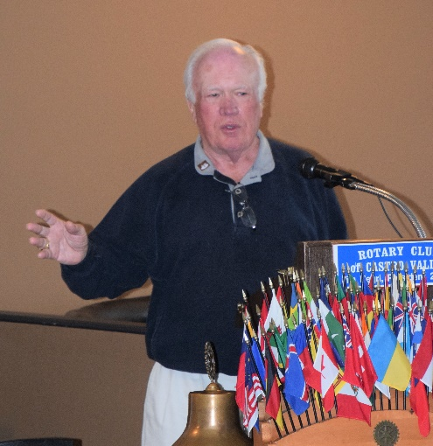
Dwight Perry – 50 Years in Five Minutes

Dwight Perry presented traced his 50-year career from Los Angeles to San Luis Obispo to Castro Valley in the Club’s next Craft Talk. Dwight described his student days that interested him in the printing business, his work for various companies, which finally led him to purchase his first printing business in Castro Valley. Over the years, Dwight purchased various printing businesses before retiring and founding Perry’s Creative Promotions, which is an authorized Rotary International vendor. Thanks to Dwight, every Castro Valley Rotary President has his/her own presidential pin. Over the years, Dwight has been a valuable member of the Rotary Club of Castro Valley and has served as District Governor as well as on many District and Club Committees. We thank Dwight for exemplifying Service Above Self.

Upcoming Speakers and Events
- January 16 – Lunch Speaker – Susie Passeggi, Director of Castro Valley Adult and Career Education, speaking on New Careers in Medical Technology
- January 17 – Castro Valley Eden Area Chamber Mixer for AgDay at the HARD Offices (1099 E Street Hayward) at 5:30-7:30 pm
- January 23 – Lunch Speaker – Parvin Ahmadi, Superintendent of Castro Valley Unified School District, speaking on New Bills Impacting Education
- January 30 – Lunch Speaker TBD
- January 31 – Board of Directors Meeting at 6:00 p.m. at the Castro Valley Unified School District Board Room (4400 Alma Avenue) – All members are invited to attend
- February 6 – Lunch Speaker – Susan Ewing Haley, Curator of the Golden Gate National Recreation Area, speaking on the history of the GGNRA
- February 8 – Planning Meeting for Texas Hold ‘em Tournament and Rodeo Parade at Direct Sales Floors at 5:00-6:30 pm
- February 13 – Lunch Speaker - Craig Semmelmeyer, Developer - Main Street Property Services, speaking on the development of the Daughtrey's Building
- February 20 – Lunch Program – Richard King Speech Contest with students from Castro Valley and Redwood Christian High Schools

Service Above Self

