Rotary Club of Castro Valley
Meeting Highlights for July 10, 2018

President Charles Takes the Reigns
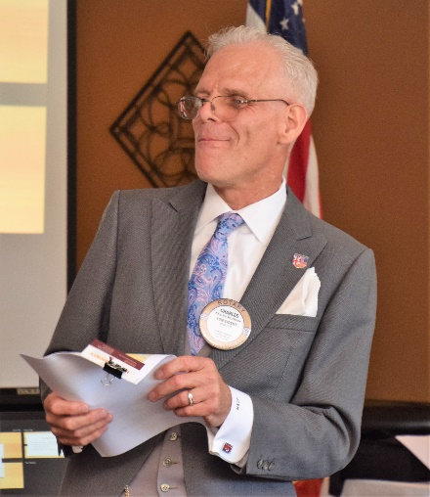
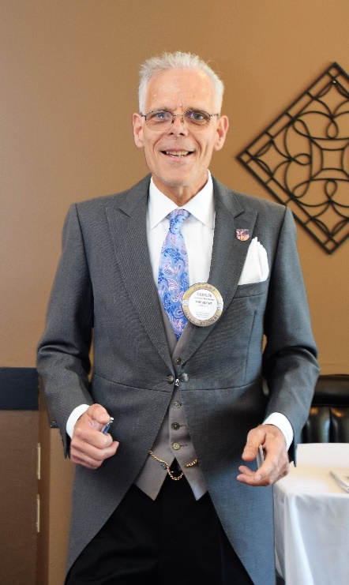
Charles Mortimer presided over his first meeting as the 2018-2019 President of the Rotary Club of Castro Valley. Using the 2018-2019 Rotary International Theme of Be The Inspiration, Charles asked each Club member to Be The Inspiration this year by being engaged in the Club and stepping up to the plate in the service of the Club, our community, and Rotary. Service Above Self.

President Charles briefly shared his experiences at the Rotary International Convention in Toronto including the emotional presentations by Princess Anne and former first lady Laura Bush.

Charles stressed that he wants to keep in place the things that Past President Jim Negri started and build upon and enhance those practices. He noted that he is in the process of filling the Committee and Event Chairs and encouraged members to serve as a Chair. Charles stressed the desire to start working on events, projects, and programs months in advance to ensure the greatest success.
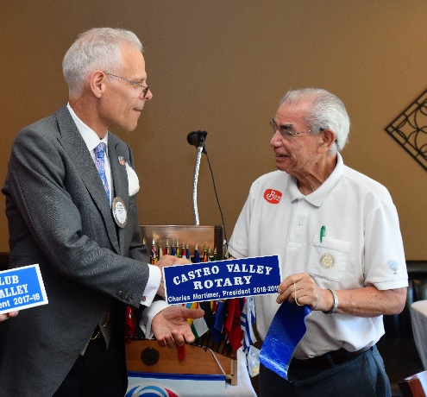
President Charles noted two important upcoming dates and mark you calendars:
- August 14 – The visit of 2018-2019 District Governor Tim Lundell at lunch, which will be presided by a Board of Directors meeting at 10:30 a.m.
- August 21 – The Club will hold its Annual Picnic at Lake Chabot Park at 5:00 p.m. There will be no lunch meeting on this day.

Left: Ben Gurule presents President Charles Mortimer with his 2018-2019 Presidential nameplate for the podium.

Kellie Hayes – The Role of California Private Fiduciaries
Rotarian Jim Phillips introduced Kellie Hayes from Lucky Fiduciary Services who described her career path to becoming a fiduciary. She had handled event planning and was a Development Director for a non-profit organization. Kellie shared a story where a donor to the non-profit organization changed his mind on his deathbed and how that experience led Kathie to explore the world of a private fiduciary. In 2006, the State of California created a very regulated license for private fiduciaries and Kellie received hers in 2010.

Kellie’s presentation focused on (1) The Role of Private Fiduciaries; (2) Why Someone Would Use a Private Fiduciary; (3) How A Private Fiduciary Works; and (4) How to Find a Private Fiduciary.

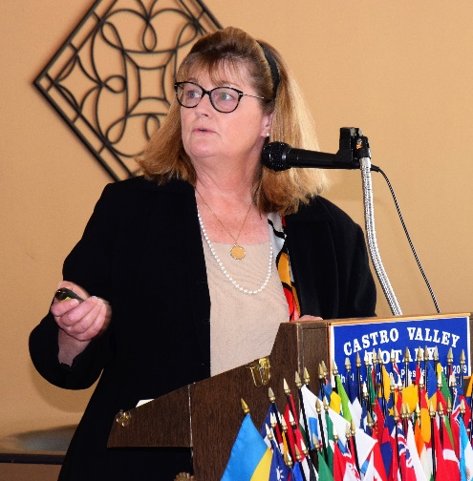
The Role of Private Fiduciaries
- Trustee
- Consultant
- Guardian
- Power of Attorney (but not an attorney)
- Money Manager (bills, general care)
- Case Manager (3rd party)
- Others as defined by the client or courts

Kellie described in the past how family and the churches would handle the role of a fiduciary, but that has changed.

Why Someone Would Use a Private Fiduciary
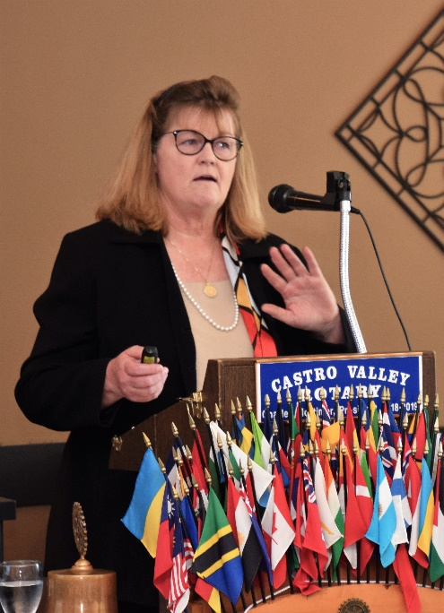
- They don’t want to and can’t handle their legal, financial or other affairs.
- There are no family members available to handle the affairs.
- The individual needs a neutral, third-party to handle affairs.
- The individual has an opportunity to choose someone he/she trusts to handle their affairs in the present or in the future.
- The court orders a private fiduciary in some cases.
→Kellie stressed that a private fiduciary works with attorneys but is not an attorney.

How A Private Fiduciary Works
- Within California law under the Department of Consumer Affairs
- Under a Code of Ethics
- Follows the terms of the trust or other legal documents
- With the individual, family, friends, and if necessary, the courts
- With attorneys and financial advisors

How to Find a Private Fiduciary
- Through an estate planning attorney
- Through the Professional Fiduciary Association of California (PFAC) at www.pfac-pro.org
- Through the State of California Department of Consumer Affairs Professional Fiduciaries Bureau at http://www.fiduciary.ca.gov/ where the public can file a complaint and all actions taken by the Bureau are listed.

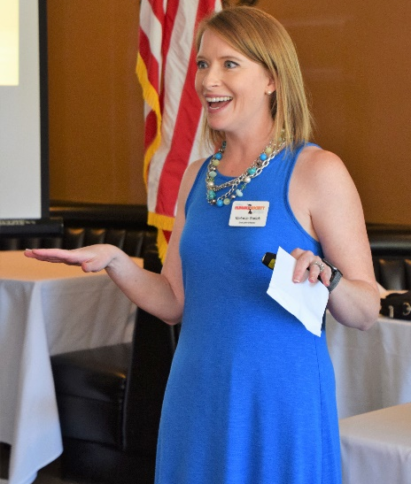
What’s New in Castro Valley? – Melanie Sadek, Valley Humane Society
Melanie Sadek from the Valley Humane Society (VHS) in Pleasanton kicked off the year with the first What’s New in Castro Valley? presentation. The Valley Humane Society has served the community for over 30 years and now operation out of 5000ft² serving supporters of dogs and cats.

In her brief presentation, Melanie focused on
- VHS focuses on animal welfare and bonding.
- VHS works on pulling animals from the pounds in the area.
- VHS has over 500 volunteers working in its facilities and over 50 foster homes.
- VHS handles around 600 adoptions/year – dogs at $150 and cats at $100.
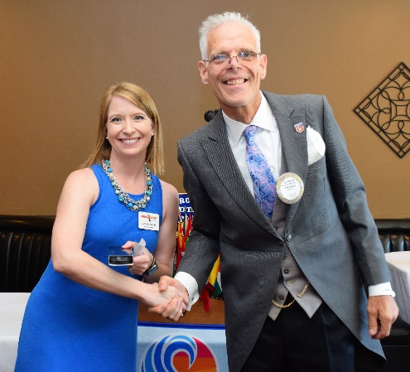
- VHS provides educational programs for children that teach the children about compassion and VHS support many other educational programs in the schools and community.
- VHS handles 120,000 animal meals/year but can’t use all the meals, so it donates some to low income families so that they can feed their pets and not use valuable financial resources and Meals on Wheels in the Tri-Valley so that seniors can keep their pets who are true companions.
- The Canine Comfort Pet Therapy program brings animals where other pets can’t go. VHS provided three dogs to the victims and first responders during the Ghost Ship Fire in Oakland.
- VHS works with individuals and families when they need to give up a pet so that the pet is place in an appropriate sending.

More detailed information regarding the Valley Human Society is available at https://valleyhumane.org/

Will You Be The Inspiration?
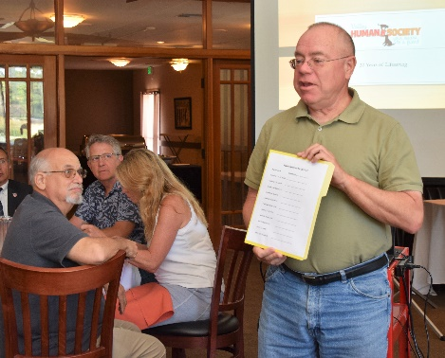
Gary Howard provided the first opportunity to respond to the challenge from President Charles to be the inspiration and step up to the plate. Gary Howard will be the 2018-2019 Speaker Chair, but for the program to maintain its excellence, Monthly Speaker Chairs are necessary. Gary circulated a sign-up sheet for 2018-2019. Former Speaker Chair Gary Bosley has developed a step-by-step, easy-to-follow template. If you did not sign up at the meeting, please contact Gary and volunteer for a month this year.

Upcoming Speakers – Details on the website/Don’t forget to RSVP by 9:00 am on Monday
- July 17 – Tom Guarino and Laura Wetmore, PG&E – An Update on PG&E Locally
- July 24 – Kern Lewis, KO Websites – Current Trends in Social Media
- July 31 – Tim Smith, LogoBoss - Getting and Keeping a High Profile for a Business or Organization

Upcoming Events – Details on the website (www.castrovalleyrotary.org)
- July 18 - Chamber Mixer at Meek Estate Park at 5:30-7:30 PM
- July 25 – Board of Directors Meeting at Don Jose’s at 5:45-7:15
- August 14 – District Governor Visit at Lunch
- August 21 – Club Picnic at 5:00 pm at Lake Chabot Park

Photos from July 10th Meeting
