Rotary Club of Castro Valley
Meeting Highlights - July 17, 2018

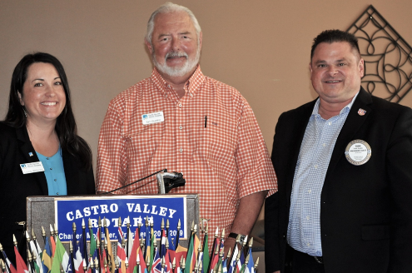
Tom Guarino and Laura Wetmore of PG&E – Local Update on PG&E

Tom, Senior Government Relations Representative at PG&E, and Laura, Senior Manager, Mission Division at PG&E share the work that PG&E is doing locally.

As part of the lessons learned from the unprecedented wild fires last year PG&E has embarked on a program of protecting our communities by timely response and a defensive action plan. This program consists of the following elements:
- Ability to predict the changes in weather:
  - Since January 2018 PG&E has added 50 new weather stations with around 200 more planned to be built and installed by the end of the year.
  - Data collected from these stations will be streamed live in real time to the state and local agencies and the public through on line sources such as NOAA and Meso West to improve response time to changing weather conditions.
- PG&E’s Community Safety Program includes working with customers, community leaders and first responders and precautionary measure intended to reduce wild fire threats and strengthen the communities for the future.
  - These measures include turning off power for safety, updating data base of customers so that customers can be provided early warning through automatic calls, in addition to updates through social media, local news, radio, and the pge.com website.
  - Customer preparedness:
  - PG&E wants customers to have a fire prevention plan which should include updating information with PG&E, preparing and practicing an emergency plan, trimming back bushes, knowing how to use one’s fire extinguishers and replace batteries in smoke alarms.
  - Having emergency supply kits stored in an easily accessible, waterproof location with at least a one-week supply of the following items:

  - Drinking water; 1 gallon of water per person per day
  - Non-electric can opener and forks, knives, and spoons
  - Flashlights and a battery powered radio
  - Basic First Aid Kit
  - Blankets and clothing
  - Activities for children

  - Important documents such as ID’s, medical records, and photos
  - Food and pet food
  - Mobile phone including a portable charger
  - Extra batteries
  - Medication and eyeglasses
  - Toiletries
  - Cash ($100) and credit cards
  - Paper towels, trash bags, and a multi-purpose tool that includes a knife

- The need for a power shutoff will be determined by PG&E based on the condition (e.g., high winds, low humidity, probability of fire).
  - The Power shut off is generally expected to be a day long but may last one week.
  - PG&E will try to provide at least a 24hour notice.
With these preparations and cooperation of customers, PG&E is hoping to be better prepared for all emergencies and avoid last year’s devastating fires.

Left to Right: Official Club Shopper Heidi Hausauer announced that she finished shopping for the Backpack project last weekend. Watch for details on stuffing the backpacks. Remember, the more helping hands, the easier the work. Kern Lewis intently listens to the speakers while his son looks on. Kern will be the lunch speaker on July 24. His topic will be Current Trends in Social Media. Dawn Ortiz and new member Sherry Yarnal pose for a photo. Photos by Murline Monet.

Learn About 2018-2019 Rotary International President Barry Rassin

Rotary’s new president, Barry Rassin, strikes a perfect balance between Bahamian bonhomie and decisive leadership. Read more in the Rotarian at https://www.rotary.org/en/barry-rassin-strikes-balance-between-bahamian-bonhomie-and-decisive-leadership. Plan on joining President Barry at the District 5170 Presidential Dinner on January 3, 2109.

Upcoming Speakers and Events
- July 24 – Lunch with Kern Lewis speaking on Current Trends in Social Media
- July 25 – Board Meeting at Don Jose’s at 5:45-7:15 pm. All members invited.
- July 31 – Lunch with Tim Smith speaking on Getting and Keeping a High Profile for a Business or Organization
- August 7 – Lunch with Dennis Waespi, Director – East Bay Regional Park District
- August 14 – Lunch with District Governor Tim Lundell
- August 21 – Club Picnic at Lake Chabot Park at 5:00 pm – Dark at Lunch
- August 22 - Board Meeting at Don Jose’s at 5:45-7:15 pm. All members invited.
- August 28 – Lunch with Keith and Teddie Siebert, owners of TwiningVine Estate Winery in Castro Valley
Thank you to President-Elect Todd Anglin for presiding over the meeting
in the absence of President Charles Mortimer.

