Rotary Club of Castro Valley
Meeting Highlights – July 18, 2017

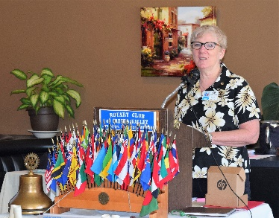
District Governor Visits
District Governor (DG) Orrin Mahoney was the honored guest and featured speaker. Prior to lunch, DG Mahoney met with the 2017-2018 Club officers, board members and committee chairs for 75 minutes to learn about the Club, and how the DG and District 5170 can support the Club. Milly Seibel, Assistant Governor (AG) for District 5170 Area 4 (Castro Valley, Dublin, Hayward, Livermore, and Pleasanton Clubs) introduced DG Orrin Mahoney. AG Seibel is a member of the Rotary Club of Livermore.
Assistant Governor Milly Seibel

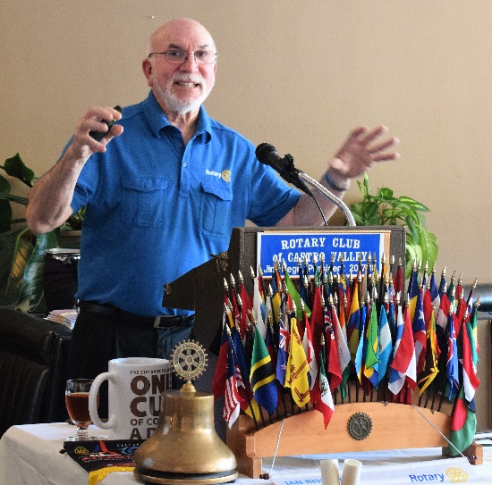
After a distinguished 35-year career at HP, DG Mahoney retired and devoted his time to community activities. Orrin is a long-time resident of Cupertino who served on the Cupertino City Council including two terms as Mayor. He joined the Rotary Club of Cupertino in 2000 and has served that Club and District 5170 in many different roles as well as participating in a number international trips as part of Club and District International Projects. Orrin’s theme for his year as District Governor is

Rotary: Building Lifelong Friendships and Making a Difference.

DG Mahoney focused his presentation around the First Object of Rotary, which is to encourage and foster the ideal of service as a basis of worthy enterprise and, in particular, to encourage and foster the development of acquaintance as an opportunity for service.
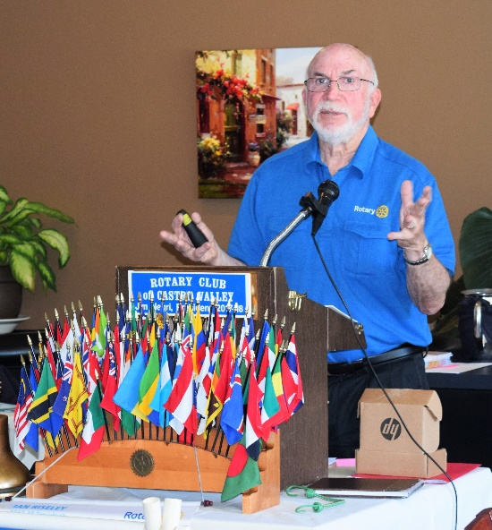
During his presentation, DG Mahoney emphasized that Rotary International (RI) recognizes the changing demographics and life styles in many communities, and has created greater flexibility for local clubs in terms of membership and organization. DG Mahoney encouraged the Club to consider these options to build membership. For example:
- Membership - Opening membership to community workers and part-time volunteers and not limit membership to only business professionals and community as well as developing other types of membership (e.g., corporate, honorary, Rotaract, family).
- Meeting Requirements – RI has changed meeting requirement 4 per month to 2 per month as well as establishing Internet Clubs (e.g., Passport Club).
- Membership Criteria – Includes "Persons of good character, integrity, good reputation and leadership quality engaged in business, professions and community work and willing to serve in local or international projects. The purpose should be To develop acquaintances as an opportunity for service and making friends while doing good.
- True Power of Rotary - District 5170 consists of 54 unique Clubs that together form one of Rotary's strongest Districts. The Clubs in District 5170 share ideas and experiences - Community leaders joining together to exchange ideas, promote peace, empower youth, and enrich our communities and the world. This is Rotary District 5170.
- Inspire and support youth through
- Interact (over 4000 Interactors in District 5170, the largest in RI)
- Camp RYLA
- Youth Exchange Program
- Rotaract
- Manages and supports the Annual Rotary Fundraising campaigns, including End Polio Now
- Manages the allocation of District Designated Funds (DDF) and operation of the Rotary District 5170 Foundation

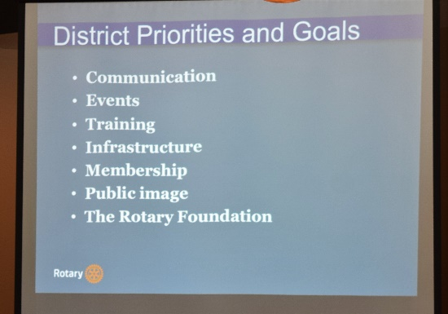
DG Mahoney emphasized that District 5170 is there to assist and promote the goals and work of the individual clubs. He stressed that important, valuable community work happens at the local level. Making a Difference Starts in Castro Valley.

The DG review upcoming District events (e.g., fund giving workshop, membership workshop, Avenues of Service, District Conference, RI Convention). President Jim thanked DG Mahoney for an inspiring and informative presentation.

The Rotary Foundation (TRF)
Each year, the Rotary Club of Castro Valley establishes an annual giving goal to The Rotary Foundation. Since the Club was founded in 1953, it has donated over $823,000 to TRF. The goals for 2017-2018 is $10,000. To meet this goal, the Club with Dwight Perry as the coordinator, requests each member to become a Double Sustainer, which means donating or pledging to donate $200 to TRF during the year. Dwight collected donations and pledge cards.
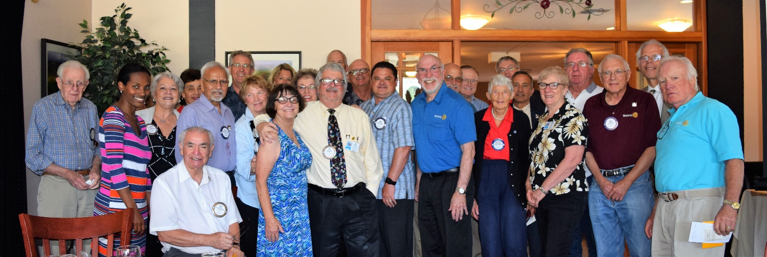
All donations to TRF count towards a member’s Paul Harris Fellow (a donation of $1000 over time). The Club has 29 members who have received a Paul Harris Fellow and 20 of the 29 are multiple Paul Harris Fellow recipients. District Governor Orrin Mahoney acknowledged contributions and pledges by awarding Foundation pins to the members.

There is a way to donate online (monthly, quarterly, or annually). President Jim will send a separate email with instructions. Donations in any amount are welcomed.

Invite a Guest Program
President Negri distributed invitation cards to each member and asked each member to invite at least one guest during the next month. Increasing membership is one of President Jim’s goals and members make a commitment to it during Péllo Walker’s presentation on July 11th. When you bring a guest in the next month, turn the card into Jim to be entered a drawing. President Jim asked all members to actively participate in this effort to invite guests to our meetings and experience Rotary,

Poker Tournament
President Jim Negri recognized Mathilda Schmidt, Mark Poniatowski, Dawn Ortiz, and Randy Vanderbilt with a Peet’s coffee card and coupon for stepping up to be the Coordinating Committee for the Poker Tournament. Information regarding planning meeting will be out soon. The Poker Tournament is the Club’s most significant fundraiser and is the least labor intensive of all the Club’s fundraisers. Please be involved in the Poker Tournament this year – the easiest way is to recruit poker players.

Upcoming Events
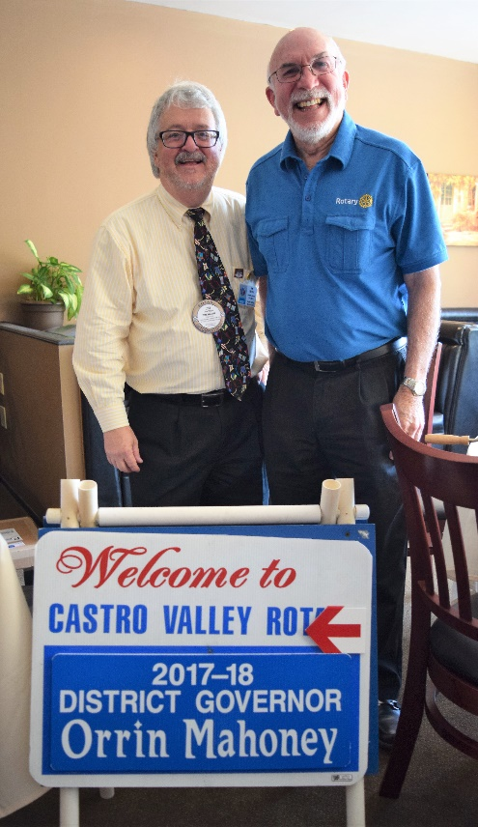
July 25: Lunch meeting at 12:00 pm with Jeff Kircher, Founder of Litterrati
July 26: Board meeting at 6:00 pm at the Chamber of Commerce – All members are invited
July 27: Chamber Mixer at 5:30 pm at Meeks Estate Park
August 1: Lunch meeting at 12:00 pm with Parvin Ahmadi, Superintendent of CVUSD
August 8: Lunch meeting at 12:00 pm with Christoph Nauer on “Success Breeds Success”
August 15: Dark at lunch
August 15: Club Picnic at 5:30 pm at Lake Chabot Park – details will be emailed
August 19: District 5170 Membership Seminar at 9:00 am -12:30 pm at Castlewood CC, Pleasanton

Details for all events and the 2017-2018 Calendar are posted on the Club website, www.castrovalleyrotary.org

.

