Rotary Club of Castro Valley
Meeting Highlights – July 2, 2019
Todd Anglin, President

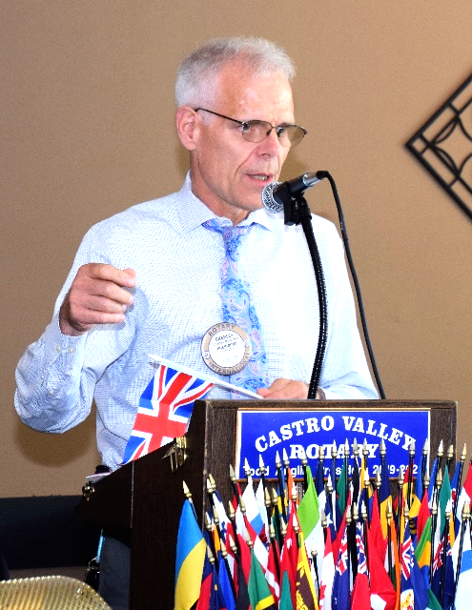
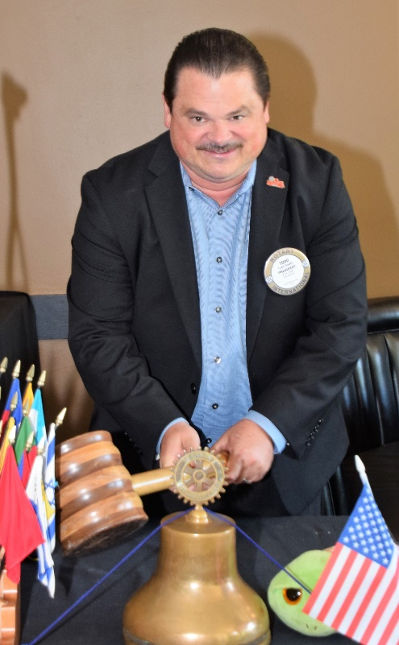
President Todd Anglin Rings in the New Year – Rotary Connects the World
Todd Anglin, 2019-2020 President of the Rotary Club of Castro Valley, rang in the new year with one of the softest bell ringing in recent memory despite an oversized gavel. Before recapping his trip to the Rotary International Conference in Hamburg, Germany and presenting his goals for the year, President Todd had Immediate Past President Charles Mortimer review his year as president (2018-19) as the Club witnessed the continued leadership of the Club.
After thanking the Club for an out-standing Demotion last week at Rowell Ranch Rodeo Park (Charles is very thankful that he still has his head), Past President Charles Mortimer reported on the past year and
- Thanked everyone for their positive response to any request that he made throughout the year, which made his work as President much easier;
- Recounted the many successes of the year;
- Reported that the Board was able to resolve issues related to the Endowment and contributed $19,000 to the Endowment from the profits of the Texas Hold’em Tournament; and
Past President Charles Mortimer reflects on a successful 2018-2019 Rotary year.
- The Club ended the year with $62,000 “in the bank.”

President Todd started the his presidential year with a thought from Anne Frank that he saw while attending the RI Conference, I hope I will be able to confide everything to you, as I have never been able to confide in anyone, and I hope you will be a great source of comfort and support.
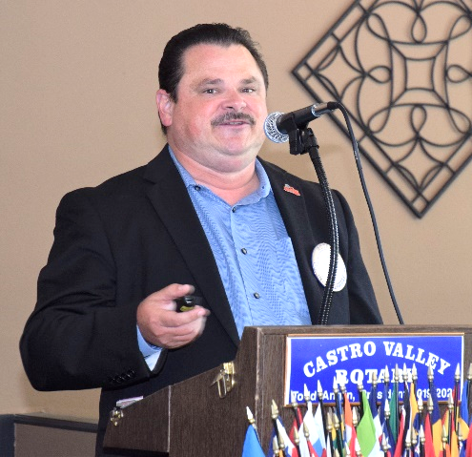
In addition to the “Typical Rotary Goals” of Membership, Service, and Re-Engaging past active members, President Todd cast his Vision for 2019-2020 as follows:
- That every Castro Valley resident understands what Rotary is and does by using active and effective communication and events including the Castro Forum, social events, a strong partnership with the Castro Valley/Eden Area Chamber of Commerce and just plain fun, which will drive the growth of the Club. All members have a role in sharing the Rotary story with family, friends, and colleagues.
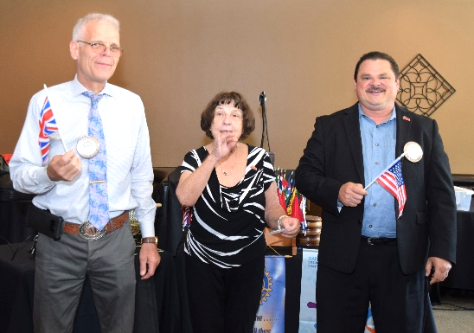
- Initiating a Club Mixer in lieu of the Tuesday lunch meeting at 5:30-7:30 p.m., which will allow others to attend and members to bring guests in a more informal environment to learn about Rotary and the Rotary Club of Castro Valley. More and more Clubs are moving to this format as well as other non-weekly lunch formats to build membership. Mark your calendars that the Club will be DARK on the following dates for the Mixer: July 30 at Don Jose’s Mexican Restaurant, September 24 at JP’s Family Restaurant & Sports Lounge, and October 29 at a site to be determined. The Adobe Center may be an option for a Mixer. The Board will evaluate the success of the Mixers after the October Mixer and decided on whether to continue them. (Please note that the 2019-2020 Calendar with almost event for the year is now posted on ClubRunner under the masthead. Please be sure to check the calendar on a regular basis.)
Songs of the Day: “My Country Tis of Thee” (by Americans) and “God Save the Queen” (by Brit - singular) by Ceta Dochterman, President Todd and Past President Charles.
- That a Speakers Committee has been formed to coordinate speakers for the entire year rather than assigning a single month to one member. Gary Howard and Gary Bosley are heading up the Committee. If you have ideas for speakers, please share your thoughts with Gary and Gary, otherwise known as Gary². Gary Howard will continue to mail a postcard with the speakers for the month as well as posting the speakers in the Castro Valley Forum. You have plenty of advance notice to invite guests to hear outstanding speakers throughout the year. (Editorial comment: Since Gary will be President next year, someone should learn the process in order to take on the role next year.)
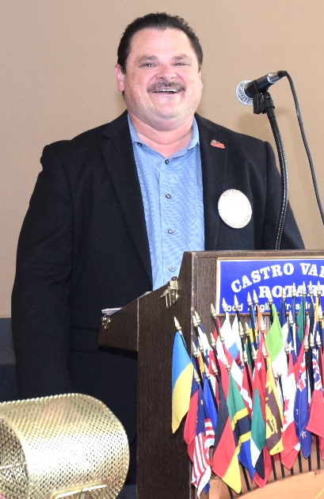
- The process to award grants has been totally revamped. A committee of Todd Anglin, Gary Howard, Charles Mortimer, and Dwight Perry will review grants and make recommendations to the Board for funding. There will be two grant cycles per year.
- Currently, all the Club’s major fundraising occurs in March and May, the Club needs a Fall Fundraiser. Todd is open to any idea, but especially ones at are not labor intensive, but generate good revenue. If you have an idea, please share it will Todd ASAP. The Club needs a Fall Fundraiser Chair immediately. See Todd for more info.
- Todd plans to use an updated website, technology, and social media to get the message out. Charles Mortimer and Ashley Strasburg will be chairing this committee. The list of all Committee Chairs is posted on ClubRunner and will be updated as additional Chairs are added.
- Event Chairs, which are also posted on ClubRunner, include Gary Howard – Rodeo Parade; Randy Vanderbilt – Chili Cook-off; Dawn Ortiz - Texas Hold’em Tournament; Bernie Kempen – Richard D. King Student Speech Contest; Ashley Strasburg and CVEACC staff - Club Mixers. More listings will follow in the coming weeks. Each chair will need assistance, so step up and volunteer. Service Above Self.
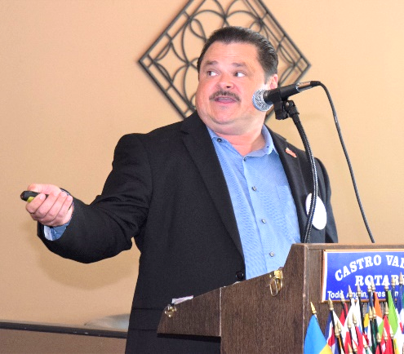
- The Club will have a booth at the Fall Festival.
- The Club is purchasing shirts for Rotarians to wear when working Club events. If you have given Todd your shirt size, please do so ASAP.
- ClubRunner technology is being updated and will be able to handle all events, make payments, track attendance and allow the Club to have five (5) email addresses with automatic redirects to one address. Be sure to download the ClubRunner mobile app.
- The Board will continue to revisit 501(c)3 status for the Club.
- Gary Bosley is finalizing the Club Directory. Please make sure that you have provided Gary with all the necessary information.
- Board meetings are scheduled for the 4th Wednesday of the month unless otherwise noticed. The meeting will be held at JP’s Family Restaurant & Sports Lounge at 6:00-7:30 p.m., a half hour later than this year. Food will be available for purchase. All members are invited to attend the Board meetings. Red Badge members must attend at least one Board meeting on the path to earning their Blue Badge.
President Todd’s Rotary International Hamburg Convention Takeaways – Rotary Connects the World
- Rotary International Goals are (1) Membership Growth; (2) Increased engagement including families; and (3) United Nations ambassadors
- The Opening Ceremony with the Parade of Flags was impressive. There 1.2 million Rotarians in 35,000 Rotary Clubs in over 160 countries.
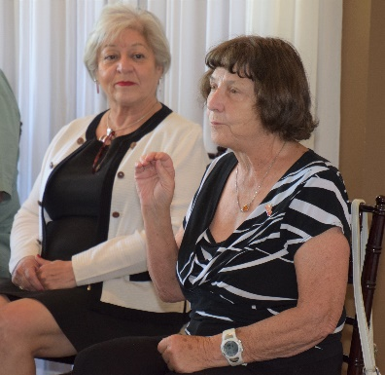
- There were 25,000+ members in at the Convention in Hamburg. The General Sessions were repeated twice to accommodate everyone.
- There was fantastic entertainment, powerful stories, incredible friendship, and sharing of successes throughout the Rotary world.
- The Convention featured multiple breakout sessions for Rotarians to share and learn including Castro Valley High School Interact student Elena Lottich who serves at the District 5170 Interact Outreach Coordinator. Elena and other Interactors presented to over 500 Rotarians in one breakout session. The Club helped sponsor Elena trip to the RI Convention.
Elena Lottich describing her RI Convention experience.
Ceta Dochterman sharing the House of Friendship experience at the RI Convention.
- The House of Friendship was massive and illustrated the great work that Rotary is doing throughout the world.
- Rotary International President Mark Maloney focused on families and countless opportunities for Rotarians to serve their communities.

Plan Ahead for the 2020 Rotary International Convention
The 2020 RI Convention will be held in Honolulu on June 6-10. Rooms are going fast. It is critical to reserve rooms now since RI expects over 25,000 conference attendees and there are only 17,000 rooms. Book early. Registration information is available at http://www.riconvention.org/en.

Scenes from the Meeting
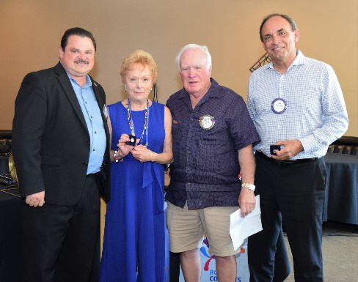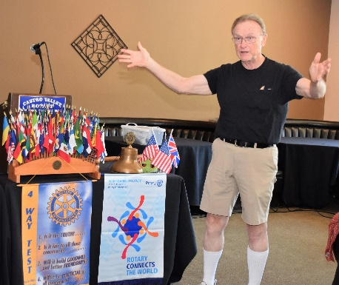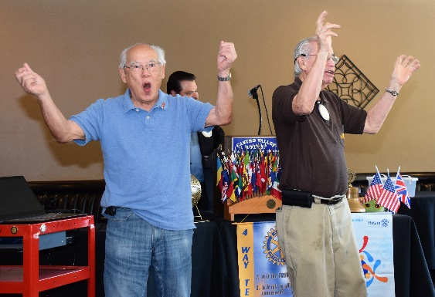
(L-R): President Todd Anglin and Rotary Foundation Chair Dwight Perry present Carol Bigelow (PH +2) and Jim Phillips (PH +4) with their Paul Harris pins. Bruce Johnson enthusiastically leads the Four Way Test. Tommy Gee and Ben Gurule lead the Hello Song.
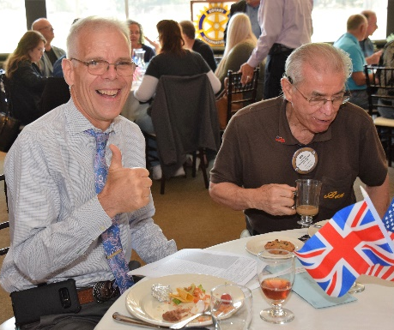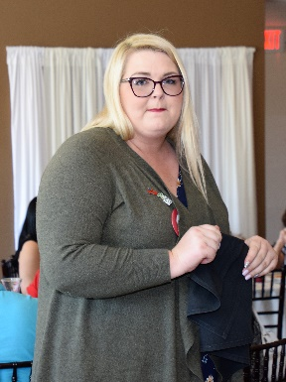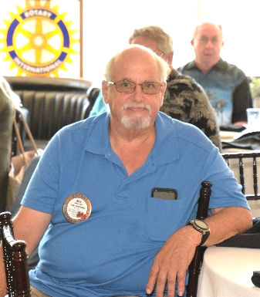
(L-R): Past President Charles Mortimer gets to enjoy lunch for the first time in a year. Ashley Strasburg introducing the staff of the Castro Valley/Eden Area Chamber of Commerce. Bill Nott contemplating something.

Upcoming Speakers
July 9 - David Scharff of Silver Transitions - “Long-term Care Options for Seniors”
July 16 - Paul Keim - “What's up at SmallTown?”
July 23 - Wendy Sinsted - “Sulphur Creek Nature Center”
July 30 - DARK at lunch – Rotary Club of Castro Valley Rotary Mixer at Don Jose’s Mexican Restaurant at 5:30-7:30 p.m.

Upcoming Community Events
July 9 – Castro Valley/Eden Area Chamber of Commerce (CVEACC) Networking Mixer at the San Lorenzo Library at 5:00-7:00 p.m.
July 11 – The Windchaser Wine Tasting and Food Pairing Event at The Meadows Bistro at Redwood Canyon at6:00 p.m. Details here.
July 16 – CVEACC presents Castro Valley Street Eats at Adobe Park at 5:00-8:00 p.m.
July 23 – CVEACC Networking Mixer at Meek Estates at 5:30-7:30 p.m.

Notes by Bruce Johnson
Photos by Jim Negri
Jim Negri, Editor

