Rotary Club of Castro Valley
Meeting Highlights – July 24, 2018
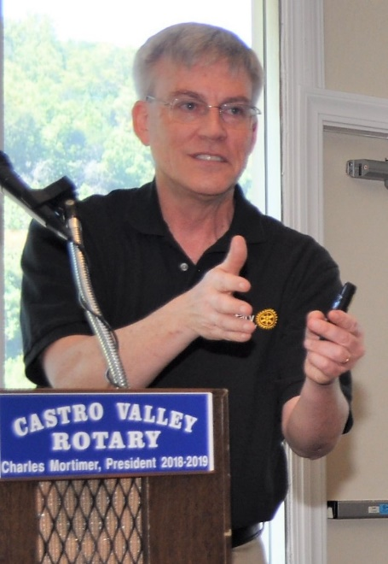
Rotarian Kern Lewis from KO Websites in Castro Valley on Current Trends in Social Media.
To illustrate and highlight the current trends, Kern walked members through actual monthly analytical data from a client and explained how the data addresses a current trend in social media.
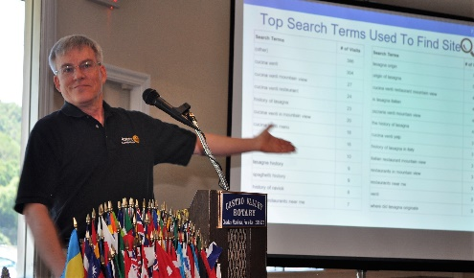
As a starting point, Kern pointed out that the most important steps in setting up of a website are:

- Search Engine Optimization
- Social Media Channels
- Search Engine Marketing

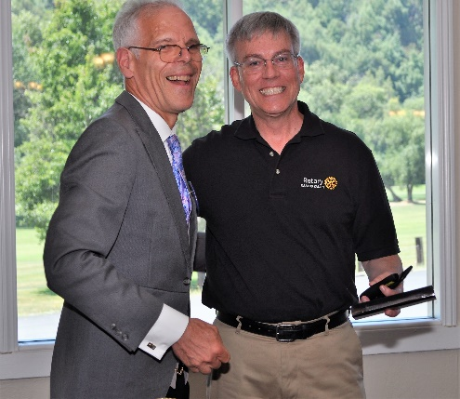
In the past two years, cell phones have become the most commonly used device to search the Internet. Due to this current trend, all website design is influenced by the size of a cell phone screen. starts with making certain that the website displays appropriate on a cell phone screen, which obviously is smaller than a tablet, laptop, or desktop computer. Therefore, it is natural that the design of the website is influenced by the dimensions of the cell phone screen. The designers of the website try to include all important and attractive features of the product on this page. All the other information about sharing or referral features is being included around the main screen. The web site should also have cross referral feature on various social media sites and due to its characteristics or commonalities due to location, function or services. For example, a restaurant site may have referral features from articles on food recipe sites or entertainment sites etc.
In addition, the direct hits to the site and from referrals should be able to be quantified so that the effectiveness of the site can be evaluated.

Rowell Ranch National Day of the Cowboy
Rotarian Brian Morrison invited everyone to attend the Day of the Cowboy at Rowell Ranch on Saturday and Sunday, July 28-29.

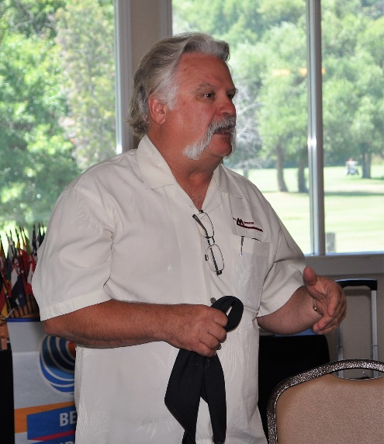
On June 7, 2012, the California Senate voted to make the third Saturday in July as National Day of the Cowboy. California became the second state in history, Wyoming was the first to establish the Cowboy Day in perpetuity, which is a day to recognize and celebrate the cowboy culture and pioneer heritage.

To celebrate and honor the American Cowboy, on Saturday, July 28, National Day of the Cowboy, Rowell Ranch Rodeo, hosted a free Cowboy Education Day. Participants learned about cowboy culture and western heritage. Participants saw displays from saddle makers, horse shoeing, Chuck Wagon cooking, and Dutch oven cooking. The arena featured dog and horse demonstrations. The celebration continued Sunday with the Second Annual Western States Ranch Rodeo Association sanctioned Rowell Ranch Day of the Cowboy Ranch Rodeo, which included every day ranch tasks like calf branding, team roping, yearling doctoring, line sorting, and trailer loading. Contestants included local ranchers, as well as cowboys and cowgirls from throughout California and Oregon,
Welcome Our Newest Rotarians
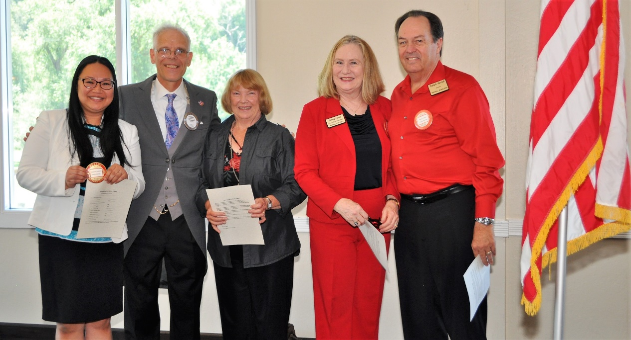

President Charles Mortimer (2nd from left) and Member Chair Virginia Degner (3rd from left) introduced and inducted, the Club’s newest Rotarians Rosalyn Antonio (1st from left who works at Edward Jones in Castro Valley Village) and Corporate Members Sherry and Ralph Yarnal (4th & 5th from the left in red who own Yarnal Jewelers in the 580 Marketplace) Rosalyn, Sherry and Ralph were presented with their Certificates of Membership and Red Badges.

Announcements
- Cliff Sherwood announced that the Club Picnic will be on August 21st at 5:30 p.m. at Lake Chabot Park. Watch for further details and the sign-up list. The Club Picnic is always a great time for Rotarians and their families to build strong bonds while having a good time.
- The Castro Valley Sports Foundation will hold a Golf Tournament on Saturday, September 15th, to support athletic program in local schools and community organizations. Details available here.

Upcoming Speakers - Check the Club website, www.castrovalleyrotary.org, for details on the speakers.
- July 31 – Lunch speaker will be Tim Smith from LogoBoss
- August 7 – Lunch speaker will Dennis Waespi, a Director of the East Bay Regional Park District
- August 14 – Lunch speaker will be Rotary District 5170 Governor Tim Lundell
- August 21 – Dark at Lunch for Club Picnic at 5:30 p.m.

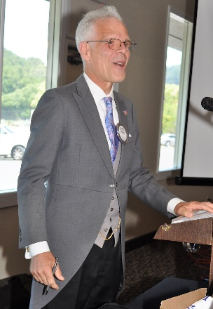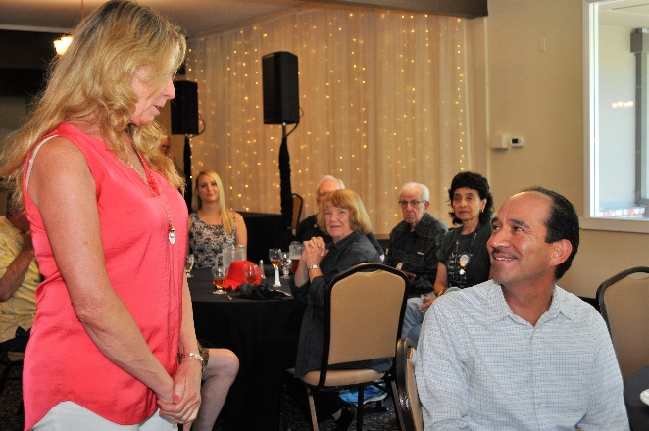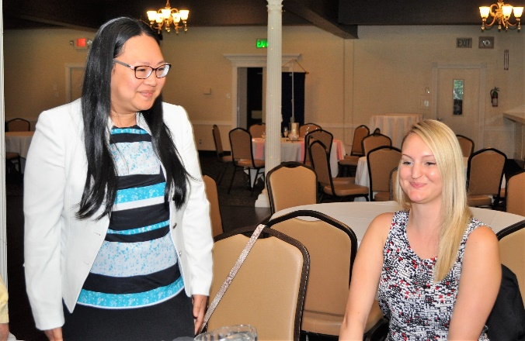

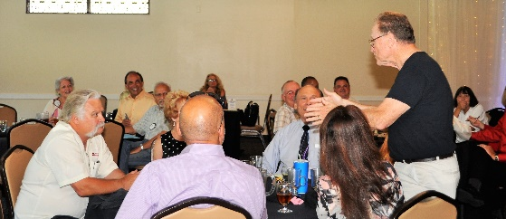
Thank you to Murline Monet for the for the photos.

