Rotary Club of Castro Valley
Meeting Highlight – July 31, 2019

Getting and Keeping a High Profile for a Business or Organization
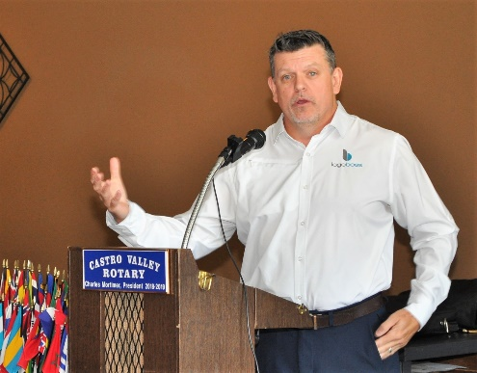
Tim Smith from LOGOBOSS discussed the importance of branding in a business. He stressed that every business or organization represents a brand. The successful ones build a brand, while others are branded by their performance and/or perception by their customers. Some quotes that illustrate the point:

Branding is not what you say you are, but what they say you are.

Brand. It is not what you say it is. It’s what they say it is.
mStoner Staff
Branding is what people say about you when you are not in the room.
Jeff Bezos, CEO & founder of Amazon
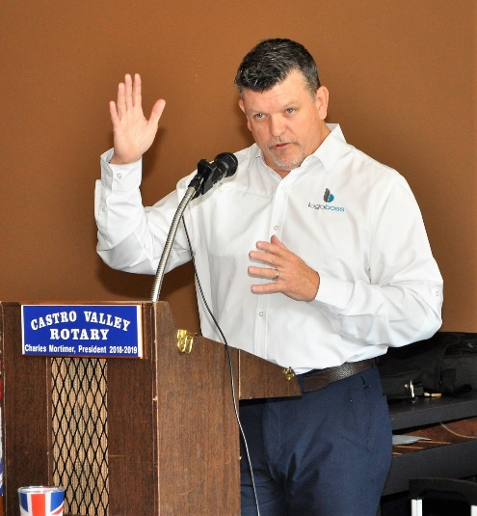
All successful businesses and organizations spend considerable resources in defining their brand. The three most important factors in branding or rebranding are:

- Focus differentiation: What makes your brand unique, better, different, cheaper and how your customers feel?
  - Brainstorm each step of your business and narrow down your most valuable benefit.
- Voice and Message: Think over the message conveyed and how does it make the customers feel.
- Consistency: Make the message Simple, Clear, Compelling, and Consistent.

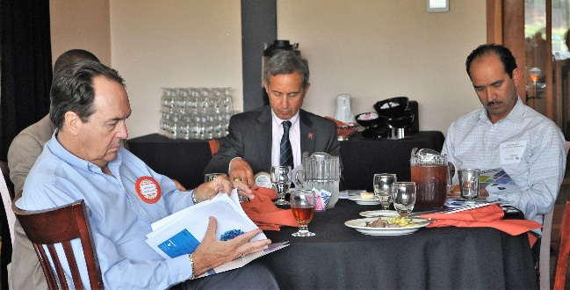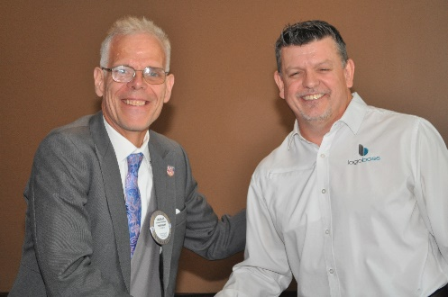
Members and guests review the materials that Tim Smith provided in his presentation.
President Charles Mortimer thanks Tim Smith an outstanding and informative presentation.

Announcements
- President Charles Mortimer announced that the District Governor (DG) Tim Lundell will be visiting the Club on August 14th. The DG visits all 53 Clubs in District 5170 during the year. The DG will meet with the Board of Directors at 10:30 a.m. to 12:00 p.m. Officers and Directors are expected to attend, but any member may attend the meeting. Attendance at a board meeting is a requirement to earn one’s Blue Badge. DG Lundell will to the lunch speaker that day. More information about District 5170 is available at https://rotarydistrict5170.org/.
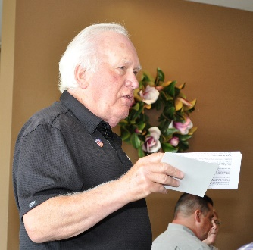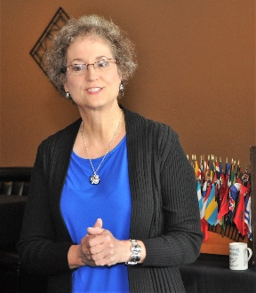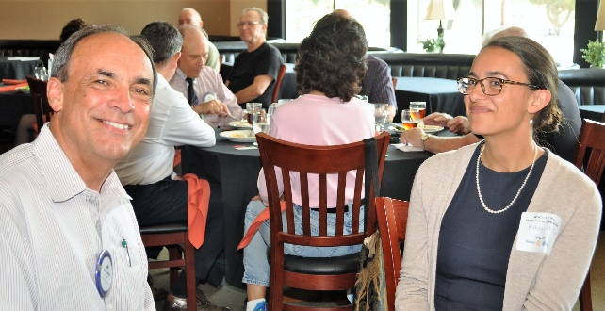
- Dwight Perry requested for donations to The Rotary Foundation (TRF). The Club’s TRF fundraising goal in 2018-2019 is $10,000. Dwight has mailed all members a pledge/donation card and requested that your pledge/donation be returned prior to the DG’s visit on August 14th. Traditionally, the DG presents all Double Sustainers (a $200 pledge/donation to TRF) a special pin to recognize a member’s contribution to TRF.
- Cliff Sherwood announced that the Club Picnic will be held on August 21st at the home of Randy Vanderbilt. The cost of the picnic is $35 per person (children are free). Details will be emailed to members the week of August 6th.
- Heidi Hausauer announced that the Club will be stuffing the student backpacks on August 7th at 5:45 p.m. at her office. All members are encouraged to lend a hand, so the process goes quickly. Plus, you don’t want to miss out on being in the PR photo.
- On August 7th, President Charles Mortimer will represent the Club at the CVSan board meeting to receive a donation from CVSan from its Earth Day & Recycle Day Event in April. The Rotary Club of Castro Valley was one of three community organization designated to receive funds. The next Recycle Day is August 4th. Details here.

Upcoming Speakers and Events
- August 7: Lunch Speaker – Dennis Waespi, Director – East Bay Regional Park District
- August 14: Board Meeting with District Governor Tim Lundell at 10:30 a.m. All members are invited.
- August 14: Lunch Speaker – District Governor Tim Lundell
- Remember to donate or pledge to The Rotary Foundation (TRF) at the meeting. See the letter that Dwight Perry mailed you. Become a Double Sustainer.
- August 21: Club Picnic – No Lunch Meeting
- August 28: Lunch Speakers – Teddie & Keith Seibert, Owners – TwiningVine Estate Winery
- August 29: Board meeting re-scheduled to September 5th
For details and to RSVP for lunch, check your email and the Club website, www.castrovalleyrotary.org.

