Rotary Club of Castro Valley
Meeting Highlights for June 13, 2017

Speaker of the Day
Carolyn Darcy, President of the Castro Valley Women's Club, was the lunch speaker at the meetings. The Castro Valley Women's Club, was founded by Barbara Russell and Helen Fowler in 1948. The primary purpose of the club was and is to work towards the betterment of the community while building better friendships. The club has about 50 members and hold monthly meetings.

For 69 years, the club has sponsored a yearly scholarship program for college bound Castro Valley High School seniors. In addition, the club has made donations and provided support for local organizations including the following: Chanticleers; Castro Valley Little Theatre; Castro Valley Art Foundation; Spectrum Community Services; FESCO; Castro Valley Outreach annual holiday food and toy drive; George Mark Children's House; Sulphur Creek Nature Center; Walpert Center; local and school libraries; Building Futures with Women and Children Shelter; funding to purchase bullet proof vests for the Alameda County Sherriff's K-9 Unit; and Bronze Donor, Castro Valley Veterans Memorial.
Luc Dochterman & Eagle Scout Project
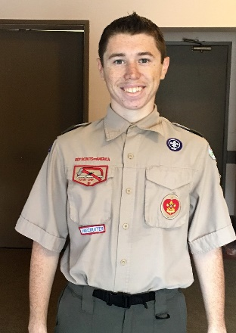

Luc has recovered sufficiently from his illness and was able to personally thank Rotarians John Aufdermauer, Gerard De Miguel, Kern Lewis, and Randy Vanderbilt for their assistance in build the storage unit for Castro Valley Elementary School. He will be completing the project on June 17 and the Club will be looking forward to photos and a future report.

President Carol Wikle
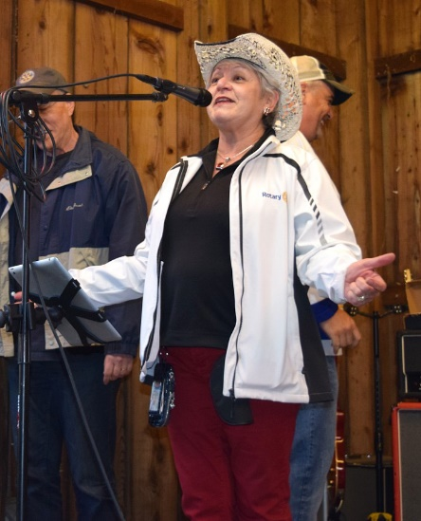
This was the last lunch meeting with President Carol presiding. She thanked all members for their co-operation and help throughout the year. Specifically, she thanked Margie Ramos for all of her behind the scenes work such at the weekly meeting setup and birthday cards; and, Bill Nott for his computer and technical assistance throughout the year.

President Carol listed the following significant accomplishments for the year:
- Inception of Amazon Smile for the Endowment;
- Reorganizing the Club accounting systems with a permanent, outside bookkeeper;
- Finalizing the 2015-16 tax returns;
- Completing the funding for the "Breathing for Life" Project;
- Inducting 8 new members, half who have assumed significant leadership roles; and,
- Transitioning the oversight of the Endowment from Alan West to Dan Willits.

Demotion of President Carol Wikle
Date: June 20, 2017
Time: 6:00 – 8:30 p.m.
Location: Rowell Ranch Picnic Area
For further information, please contact Kern Lewis.

Looking Ahead
June 20 - Dark at Lunch for the President Carol’s Demotion at 6:00 p.m.
June 27 – Lunch meeting with Ken Sommers from the George Marks Children’s House
July 4 - DARK – No lunch meeting
July 11 - First meeting with President Jim Negri
