Rotary Club of Castro Valley
Meeting Highlights – June 18, 2019

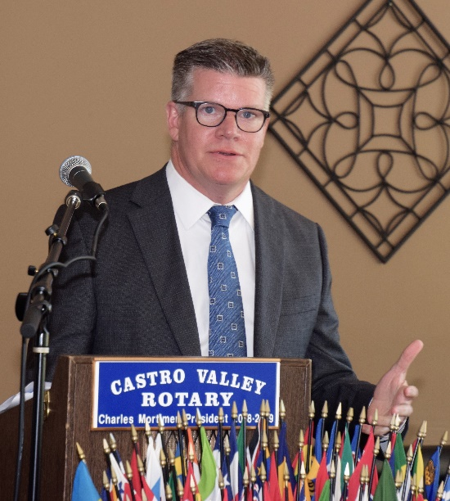
Rob Warren – Alameda County Assistant District Attorney – Grand Jury Advisor
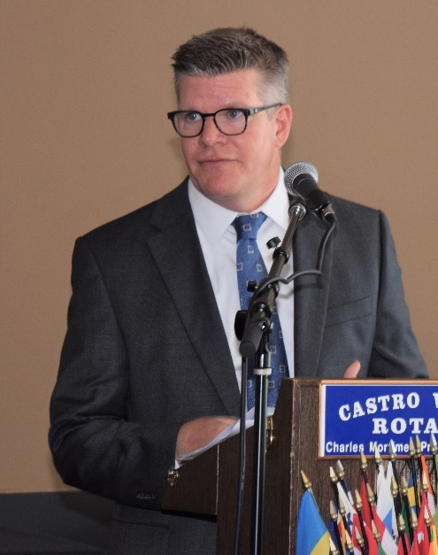
President-Elect Nominee Gary Howard introduced the day’s speaker, Rob Warren, a Castro Valley resident, to talk about the Alameda County Civil Grand Jury. Working as an arm of the Superior Court, the Civil Grand Jury is comprised of 19 citizens authorized to investigate local government to ensure that public agencies are working in the best interests of the public. Its independence gives the Grand Jury a unique role in securing local government accountability and in examining allegations of misconduct.

Rob serves as the legal advisor to both the Civil Grand Jury and Criminal Grand Jury in Alameda County. He reviewed the role of the Civil Grand Jury which includes the broad legal authority and investigative powers allow it to:
- Determine whether public monies are being spent wisely and for appropriate purposes;
- Ensure local government agencies conduct their business in an open, transparent manner;
- Inquire into the conditions of the jails, detention centers, and hospitals; and
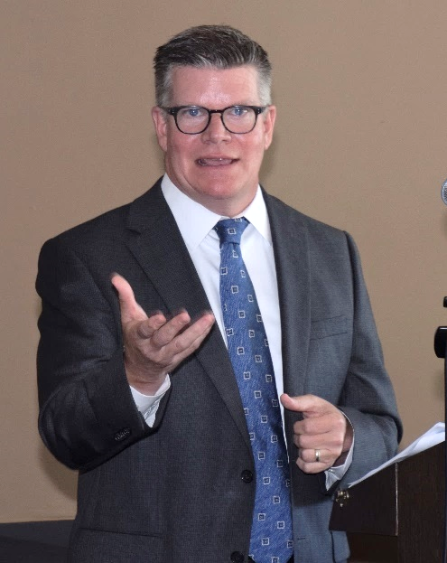
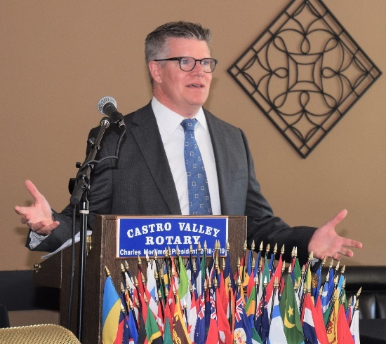
- Inquire into charges that a public official or employee engaged in willful misconduct while in office.

During his presentation, Rob shared several examples of the Grand Jury’s that has made a difference in Alameda County. One outstanding example was the investigation last year the City of Oakland's unfunded retiree health care costs which resulted in the Oakland Police Department union renegotiating their agreement and reducing the $860 unfunded liability by half. Another example resulted in Alameda County receiving funding for cell phone emergency warnings for which the County had not applied. The Civil Grand Jury serves as a reminded to elected leaders that they must follow the law and rules. The Grand Jury can not change public policy or question the votes of public officials. Due to the nature of each Grand Jury, the Grand Juries in various county do not often coordinate their efforts. The State of California does not have a Grand Jury. The closest body is the Little Hoover Commission.
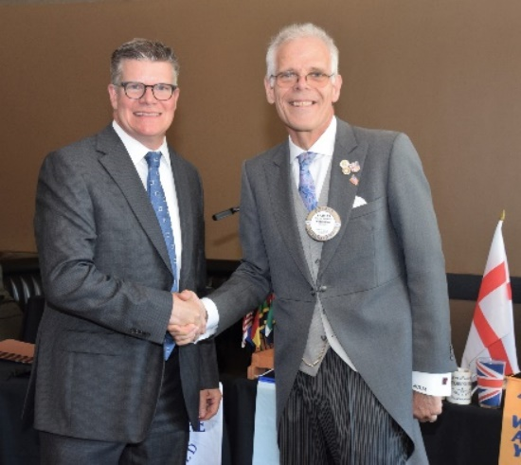
Topics of investigation can reach the Civil Grand Jury from individuals, news articles, and the interest of a grand juror. The Grand Jury is always looking for individuals to serve. Individuals can apply online or through Rob as the Assistant District Attorney. Jurors are paid $15/hour. More information on the Alameda County Grand Jury is available at http://grandjury.acgov.org/index.page

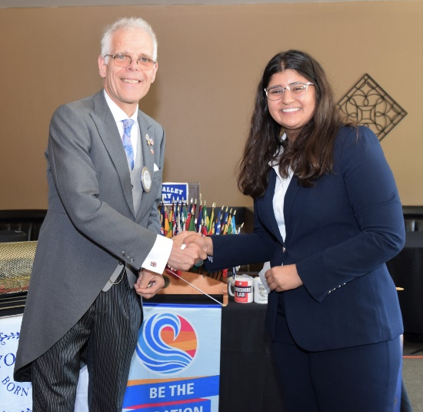
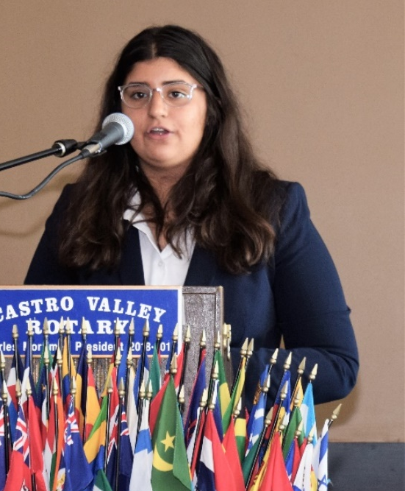
Anmol Gil is the Outreach Coordinator for the Interact Club at Castro Valley High School. Next year, she will a junior and it will be her third year in Interact. Anmol has been active with the starting and supporting the Junior Interact Club at Canyon Middle School and next year she will be working to start a Junior Interact Club at Creekside Middle School.

Anmol spoke about the Vietnam Project on which she and the Interact Club is working. There are currently 80 million slaves, mostly women and children. CVHS Club is sponsoring the Vietnam Project to fight this terrible situation. Anmol hopes to make a trip to Vietnam as part of this Project.

Scenes from the Meeting
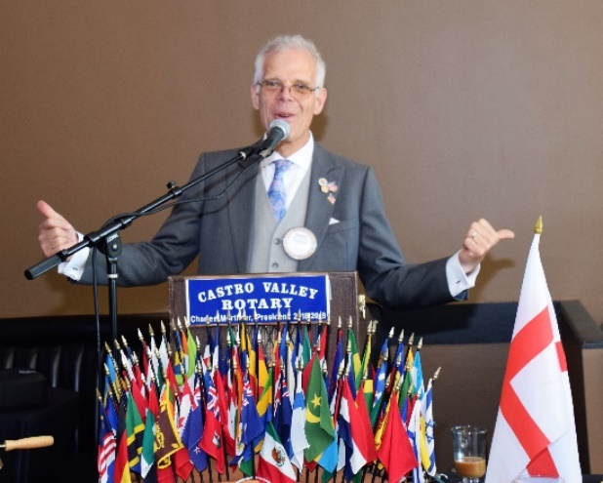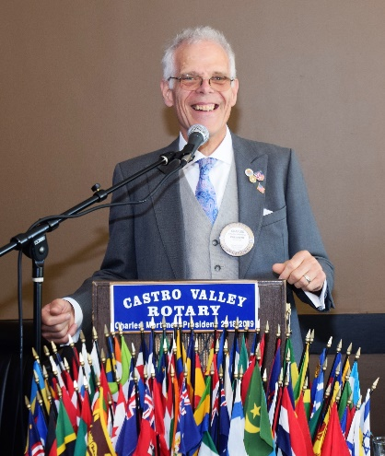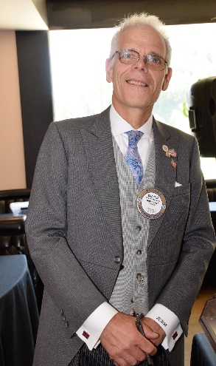
President Charles Mortimer enjoying his last lunch meeting of his term. Thank you, Charles!

More Scenes from the Meeting
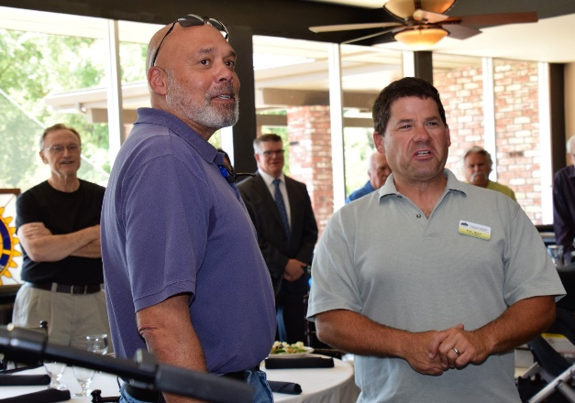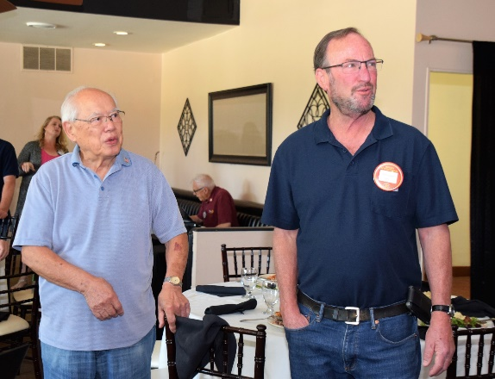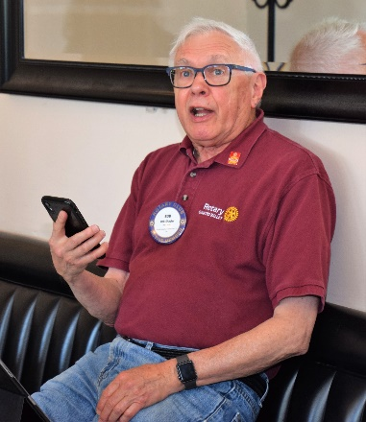
(L-R): Aaron Lewis, Visiting Rotarian from San Leandro, Peter Rosen, representing the Castro Valley Eden Area Chamber of Commerce, Tommy Gee, Visiting Rotarian from Honolulu, and Red Badger Dave Sadoff are roped in by Bill Nott (not pictured) to lead the Song of the Day, In the Good Old Summertime. Not best example of the Club’s ability to carry a tune. Bob Shayler shares the Thought of the Day from Paul McCartney (it was his 76th birthday), “I don't work at being ordinary."

More Scenes from the Meeting
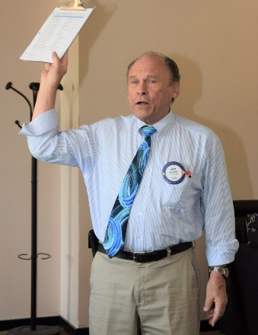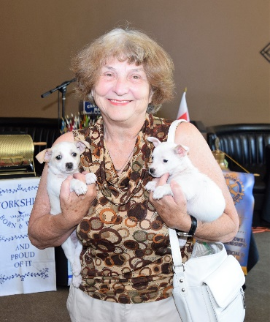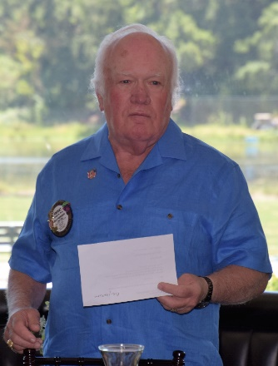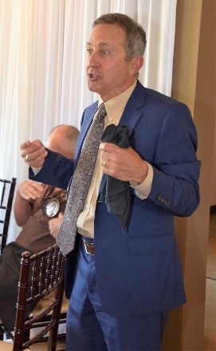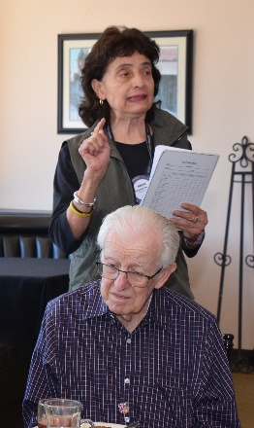
(L-R): Gary Bosley reminding members that he still needs biographies and photos from some members to complete the Club Directory. If you are interested in sponsoring the Directory with an ad, please see Gary ASAP. Ceta Dochterman with two chihuahua dogs that need to be adopted ASAP. Contact Ceta. Dwight Perry providing a history of the Four Way Test with the Cliff Dochterman Collarary. If you don’t know what it is, please see Dwight. Mark Poniatowski explaining why he brought his staff to lunch today – the birthday person treats and Mark treated everyone to a Rotary lunch. Margie Ramos offering a list of things about the Club for which see is thankful.

Demotion of President Charles Mortimer
Tuesday, June 25, 2019
5:30-8:30 p.m.
Rowell Ranch Rodeo Park

If you know the pun embedded in the above announcement, let me know and I will have a prize for you.

