Rotary Club of Castro Valley
Meeting Highlights – March 19, 2019

Route 238 Property Development - Jennifer Ott, Deputy City Manager – City of Hayward
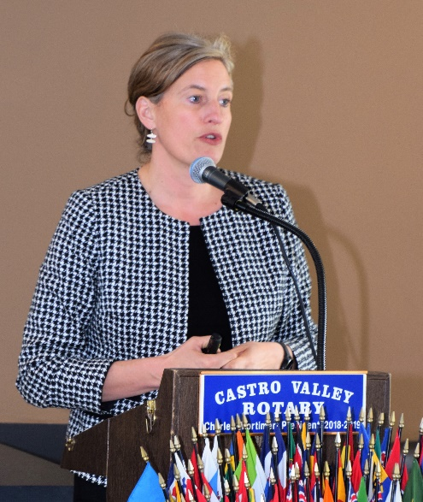
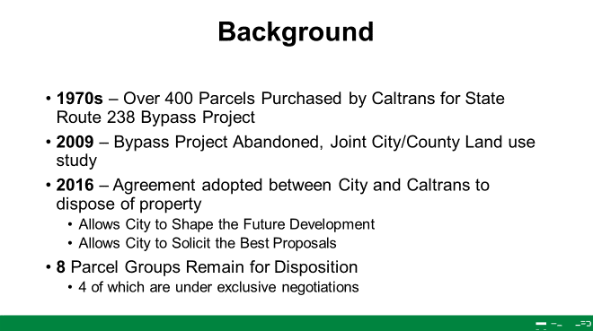
Jennifer Ott, Deputy City Manager – City of Hayward provided an outstanding overview of the Route 238 Property Development. Jennifer previous was with the City of Alameda and oversaw the development of the former Alameda Naval Air Station. She started her presentation with a background on the project, which started in the 1970’s with the purchase of over 400 properties by CalTrans for the State Route 238 Bypass Project, which never was built. All of the slides presented in the Meeting Highlights are available here.

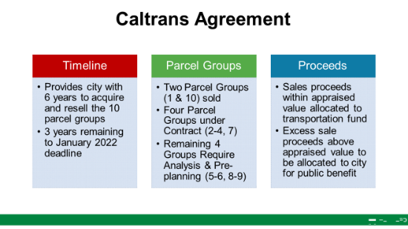
Jennifer described the 2016 agreement adopted between the City of Hayward and CalTrans to dispose of the 400+ properties. The City has until January 2022 to complete the process. Currently, 8 of the 10 parcels remain for disposition. Another feature of the agreement includes that sales proceeds above the appraised value be allocated to the City of public. The agreement provides the City of Hayward with local control over the disposition of the properties and the use of sale funds.

The City of Hayward has four goals/objective for these projects:

- Eliminate blight in neighborhoods
- Provide for the cohesive, productive use of land
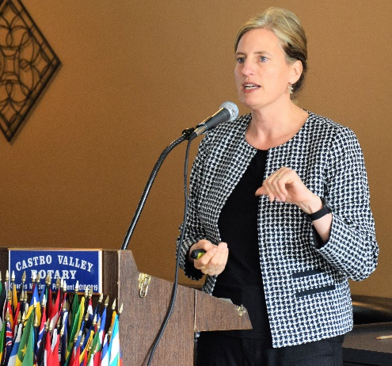
- Sell property groups in excess of Caltrans purchase price
- Use value of the land to fund key public benefits within and nearby the parcel groups (e.g. upgraded infrastructure, park/trail amenities)

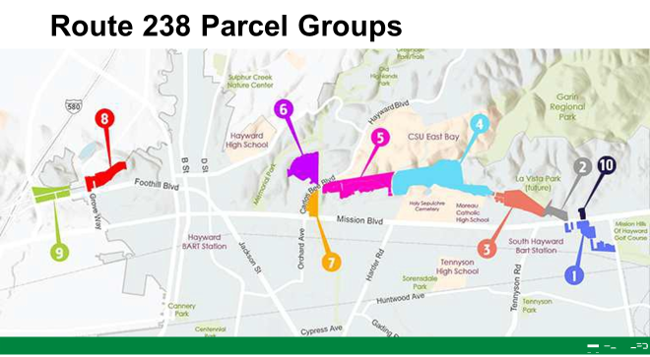
There were 10 parcels in the agreement with CalTrans. Since the disposition of Parcels #1 & #10 are complete, Jennifer focused on the status of Parcels #2-#9 as detailed in the following slides from her presentation. Interesting points from the presentation (see slides below) included:

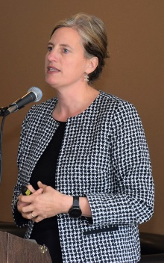
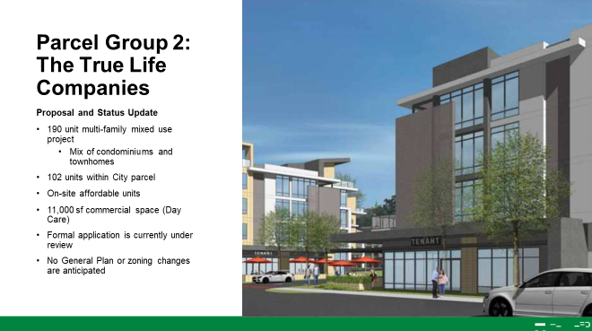
Parcel 2: Currently in progress. Includes 190 multi-family mixed use housing with affordable housing.

- Parcels 3 & 4: A partnership with Eden Housing, who has spoken at Rotary in the past, and The Pacific Companies. Includes 150 affordable housing units and 49,000sf charter school site.

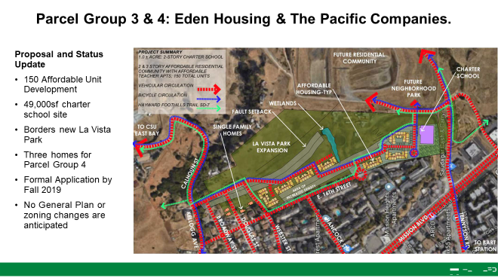
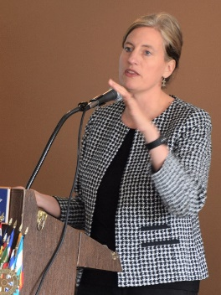
- Parcel 5: Currently in the master planning stage. Designed for 70-80 low density homes.

- Parcel 6: Currently in the master planning stage. Designed for mixed used zoning with 1000+ residential units including student housing for CSUEB.
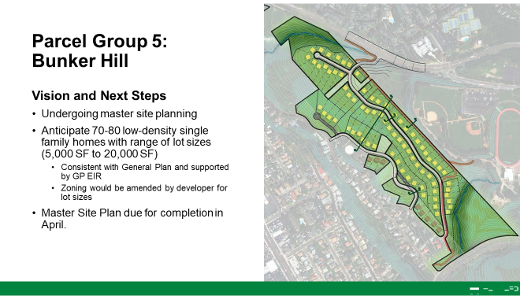
- Parcel 7: With the change in the purchase of cars (i.e., online shopping), auto dealers no longer need to be located along the freeway. The parcel is being planned for a two-story Subaru dealership at Mission Blvd. and Carol Bee Blvd.
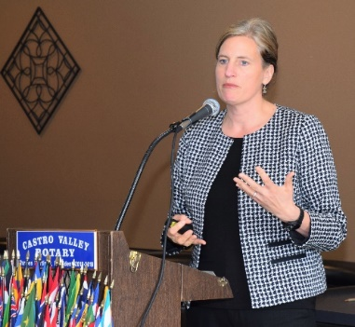
Parcel 8: Currently under planning. This parcel impacts Castro Valley and includes mixed housing including Senior/Assisted Living Facilities and affordable housing.

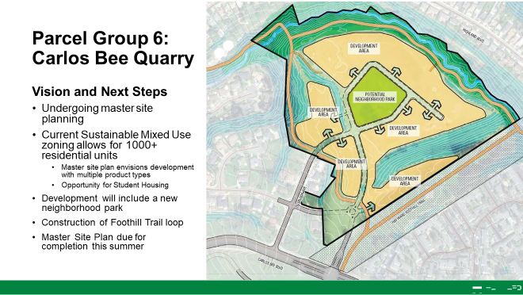
- Parcel 9: The development of a business concept hotel is in the current planning.

Jennifer stress that the City may sell the land for less money in order to provide a public benefit (e.g., parks, trails, affordable housing, senior housing) for the community. The City of Hayward is also looking a 45-unit navigation center for the homeless.

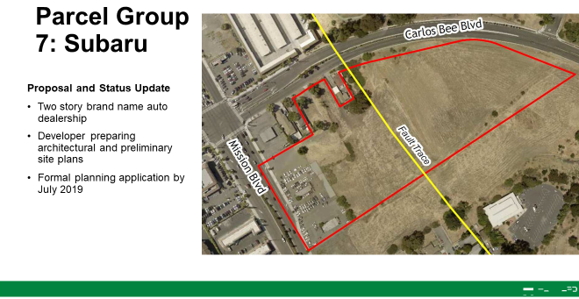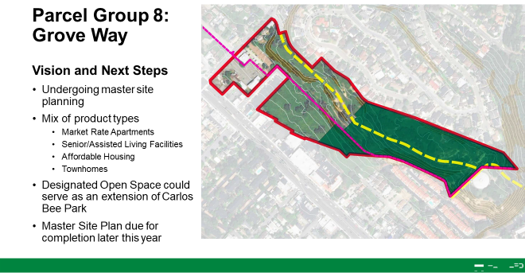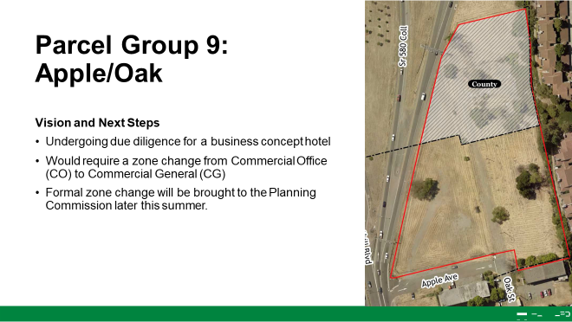

Check ClubRunner for upcoming speakers and events.

Scenes from the Meeting
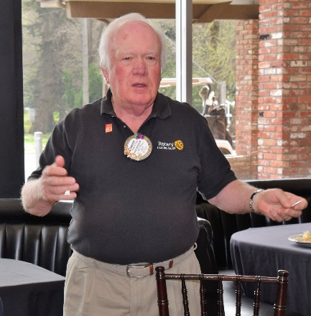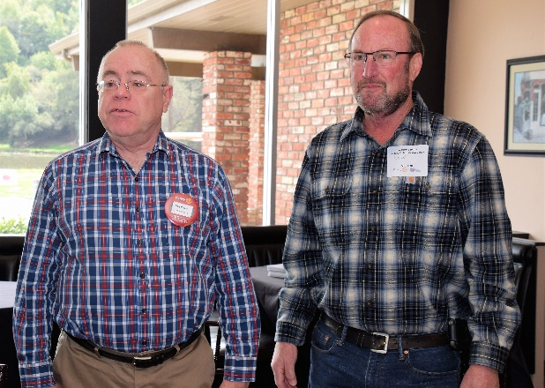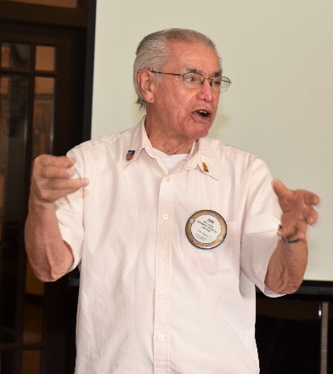
(L-R): Dwight Perry leads the Club in the Four Way Test using President Charles’ new Four Way Test coin. If you haven’t received your coin, please see President Charles asap. Later in the meeting, President Charles announced, he actually had Dwight announce it, that Dwight recently received the Rotary District 5170 The Carl G. Orne Award, which is named for the 1986–87 District Governor and is awarded to the individual who makes the greatest personal commitment to world peace and understanding. Congratulations to Dwight Perry!!! Dwight also announced that all members of the Club are invited to a meeting of the Rotary Foundation (Areas 1-4) on March 20 at Pete’s Hardware at 5:30-7:00 pm. If you wish to learn more about The Rotary Foundation (TRF), this is the meeting to attend. If also meets requirements for Red Badge members. Gary Howard introducing his guest and potential Rotarian, Dave Sadoff, President Pro Tem of the CVSan Board of Directors. Ben Gurule leading the Hello Song.

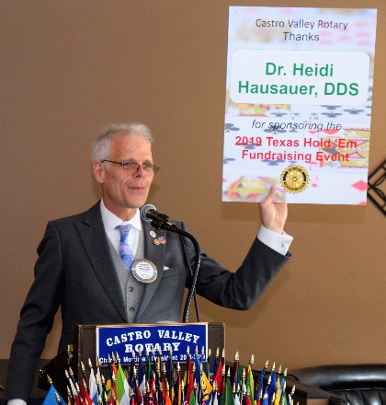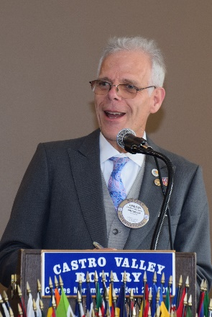
(L-R): Jeff Moore reporting that at the recent meeting of the Planning Commission, the Commission reached agreement to eliminate 18 billboards in the county including two in Castro Valley. Carol Bigelow continued her collection of canned and non-perishable food for Ruby’s Place. Michaela Thompson reported on the financial success of the Texas Hold’em Fundraiser. President Charles displayed a sponsor sign from Texas Hold’em. One of the many faces of President Charles during the meeting.

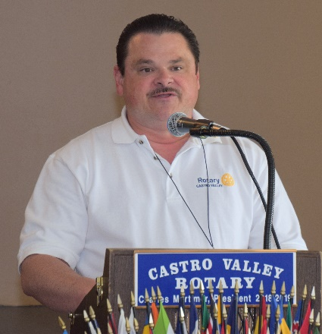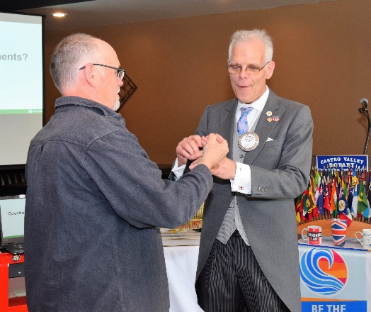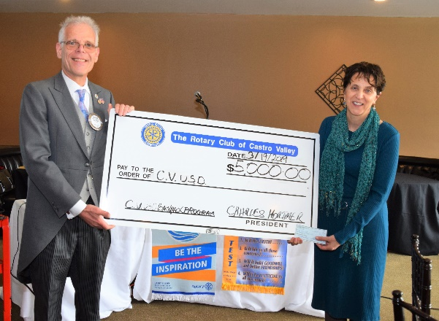
(L-R) President-Elect/Parade Chair announcing the upcoming Planning Meeting of the Chili Cook-off and Rodeo Parade Committees. Chili Cook-off Chair Vanderbilt picking the marble. President Charles presenting Superintendent Parvin Ahmadi with $5000 check to support the Literacy Project for pre-school students, which is one small example of the hard work of Rotarians making a difference in the community.

