Rotary Club of Castro Valley
Meeting Highlights for March 20 & 27, 2018

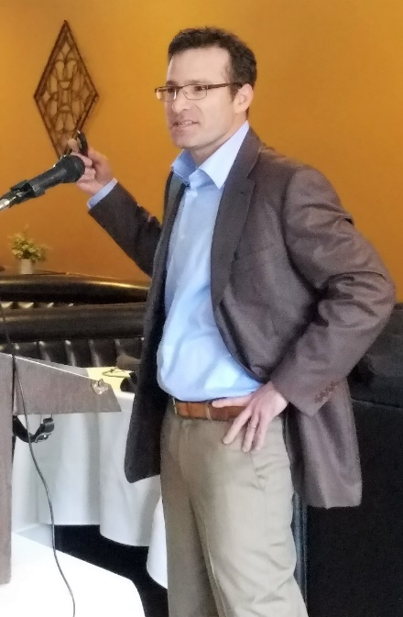
Noah Rubin – Wealth Management Perspectives (3/20/18)
Noah Rubin, a Financial Advisor with Morgan Stanley, presented an overview of the financial markets in 2018 including a review of the markets in 2017 as well as a preview of the potential impact of the recently passed tax laws. Noah started with an overview of the S&P 500, which he termed “one for the books” as the S&P climbed over 400 points with the potential for more growth due to the tax cuts. During 2017, the International Markets significantly outperformed the U.S. Market. A third factor driving the growth was low volatility (i.e., the marker seldom went down/all-time lows in terms of volatility), which has changed in the opening months of 2018.

During this period, the Fed raised interest rates three times, but the market took the increases in stride with no effects. Looking ahead to 2018, Noah reviewed the Morgan Stanley recommendations, which included:
- Don’t expect another 20% increase in the market.
- Consider equities over fixed income.
- Consider a barbell approach to investments focusing on dividend growth over dividend yield.
- Consider financials and energy rather than technology.
- Consider international investments.
- Interest rates are likely to rise due to inflation and growth expectations during the first half of the year but drop during the second half.
- The S&P 500 is still trading below fair value
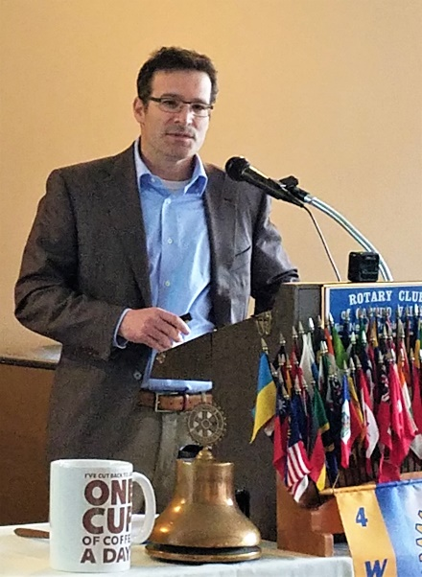
Please note that the above summary was a general overview of the financial markets
and not intended as advice for individual investing.

The second part of the Noah’s presentation focused on the recent changes to the tax code and included the following key points:
- The corporate tax rate was cut from 35% to 21% with provisions for companies to bring back overseas funds to the U.S., which could stimulate the economy through increased capital investment or dividends.
- Individual tax brackets were reduced, and standardized deductions increased. Several deductions have been capped or eliminated (e.g., Alternative Minimum Tax has been repealed), which will impact high tax states like California.
- The tax changes will benefit those in the upper tax brackets and could the middle class in the long run.
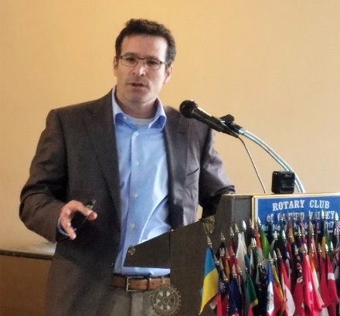
- The changes to the tax code adds to the deficit, but hopefully, economy growth will make up the difference.
- The changes to the tax code could add 7% to the S&P 500.
- Given life expectancies, it is no longer uncommon for individuals to live 30 years in retirement; therefore, planning for retirement is critical.

Mr. Rubin provided members with a folder of handouts that included articles on Taking Charge of Your Wealth, Ten Things You Should Know About 529 College Saving Plans, and An Introduction to Morgan Stanley GIFT’s Donor Advised Fund Program as well as answering numerous questions during the Q&A session and after the meeting. As a Financial Advisor, Mr. Rubin can provide a wide range of services.

Presentation to the Castro Valley Endowment
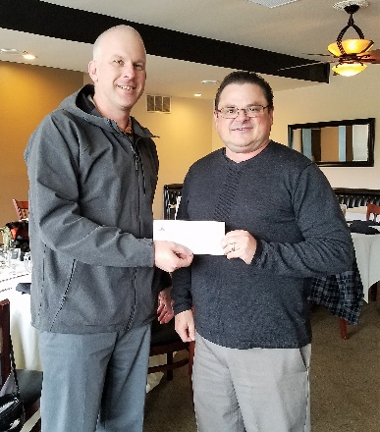

Todd Anglin presents Dan Willits with a $500 check to the endowment as part of a State Farm grant that Todd applied for as a State Farm agent. Thank you to Todd and State Farm for supporting the philanthropic efforts of the Castro Valley Rotary Endowment, which supports scholarships for graduating high school seniors.

Many companies have matching grant program. Please check with your company to see if it has a match grant program, which is an easy way to support the Endowment.

CVSan Update
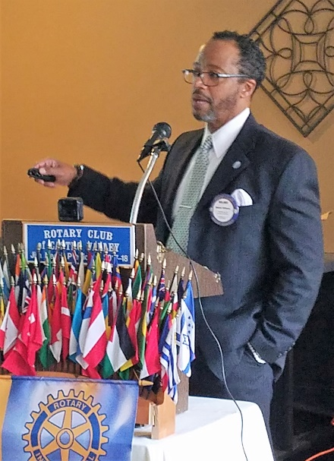
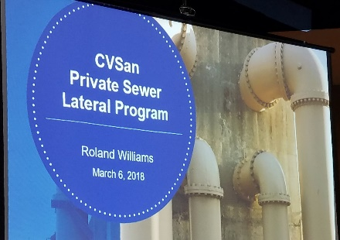
CVSan General Manager and Castro Valley Rotarian Roland Williams provided an overview of the proposed Private Sewer Lateral Program that generated a great deal of discussion at the recent MAC meeting. The Private Sewer Lateral Program would require all properties within CVSan’s boundaries, built more than 20 years ago, to have their sewer laterals inspected and repaired/replaced, if necessary, when the property is transferred. If a sewer lateral was replaced less than 20 years prior, it would not have to be inspected. CVSan will be holding a Town Hall Meeting on April 24th from 6:00-8:00 p.m. at the Castro Valley Library. More information regarding the proposal and the meeting is available here.

Redwood Road Update
Roland also provided an update on the opening of Redwood Road. Based on reports from the Alameda County Department of Public Works, the road should open in two weeks (i.e., the end of March) pending the weather.

Announcements for both March 20th and March 27th

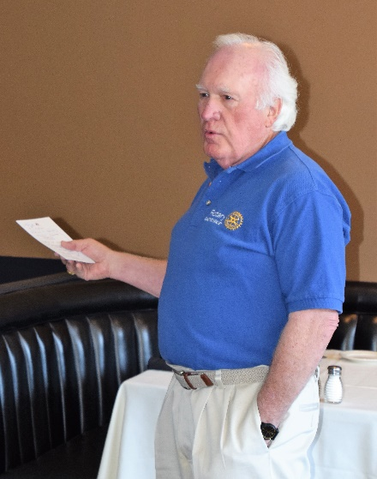
End Polio Now
District 5170 End Polio Now Chair and Castro Valley Rotarian Dwight Perry explained the District 5170 End Polio Now Flash Campaign. The District is asking every Rotarian to donate $50 to the campaign, but donations in any amount are gladly accepted. The Flash Campaign runs until April 30th. Make checks to TRF (The Rotary Foundation) and give to Dwight at our next meeting or mail it to P.O. Box 2117, Castro Valley, CA 94546. All donations are credited to the member’s Paul Harris account.

District 5170 Training Assembly
The District Training Assembly takes place on April 14 from 8:00 a.m. to 2:00 p.m. Any member serving in a leadership role (Officer, Director, Chair) in 2018-2019 should attend as well as anyone seeking to learn more about the operation of Rotary. Attendance at a District Assembly or Conference is requirement to earn a Blue Badge. The cost including breakfast and lunch is $49, but the Club pays the cost. If you plan on attending, please contact President Jim by April 4th to sign-up and selection sessions. See the choice of sessions here.

Support the Castro Valley Forum
President Jim Negri encouraged all members to sign-up for a one-time, $10 subscription to the Castro Valley Forum. The Forum is a great community resource that directly benefits the Rotary Club of Castro Valley. Jim will present all checks for subscriptions to Publisher Fred Zehnder. The Club raised $210, but subscriptions are still being accepted. Make checks to the Castro Valley Forum and give them Jim.
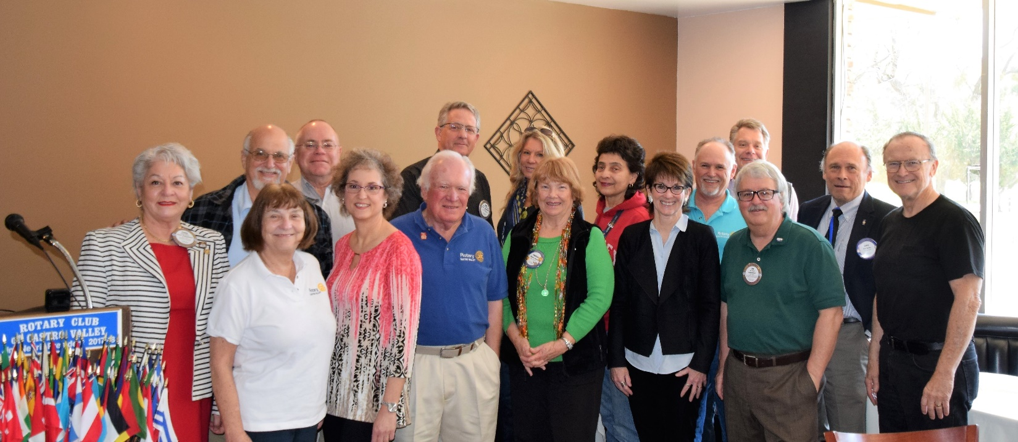
Pictured above left to right (front row): Carol Wikle, Ceta Dochterman, Dr. Heidi Hausauer, Dwight Perry, Virginia Degner, Murline Monat and President Jim Negri; (back row): Bill Nott, Gary Howard, John Aufdermauer, Dawn Ortiz, Marjorie Ramos, Randy Vanderbilt, Jeff Moore, Gary Bosley and Bruce D. Johnson. Supporters not pictured are Todd Anglin, Jim Phillips and Cliff Sherwood.

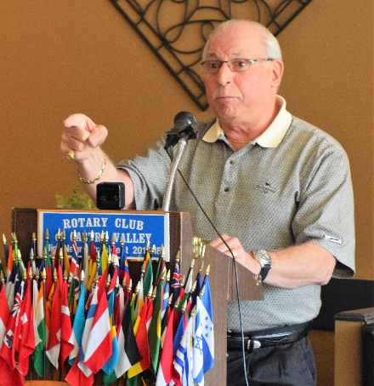
Al Pardo – Post-Polio Syndrome Start-to-Finish (3/27/18)
In one of the most compelling, personalized presentation, Al Pardo, who works as a Marshall at Redwood Canyon Golf Course and is a good friend of our Dwight Perry, addressed the issue of Post-Polio Syndrome Start-to-Finish. He suffered his first polio attack of Polio when he was two years and ten months old. Until then, Al was a normal healthy child before he fell, which appeared to be a normal fall for a child of his age, but he could not get up. Al had polio.

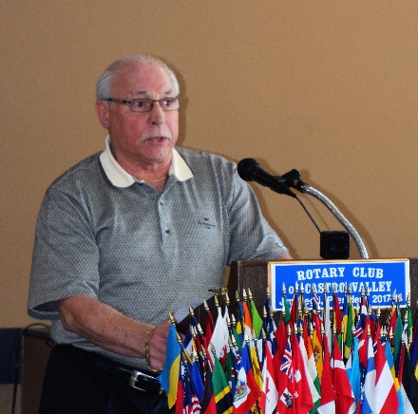
Al was in-and-out of hospitals until he was finally diagnosed with polio, which is also known as poliomyelitis, a crippling and potentially deadly disease caused by the poliovirus. The virus spreads from person-to-person and can invade a person's brain and spinal cord causing paralysis (inability to move). After he recovered from his first attack of polio, Al had to wear leg braces and could not participate in any sports like football or baseball. Al shared heart-wrenching stories of how he was treated by others, especially classmates, due to his polio. He was a strong-willed youth and decided to participate in gymnastics, which developed his upper body muscles and could participate in routines involving upper body strength. Due to polio his left leg is about 1 ½ inches shorter and he had to wear leg braces and shoe lifts. Al shared the experience of being able to buy his first pair of store-bought shoes at 16.

After graduating from high school, Al learned to live with his conditions and had a successful career in the trucking industry; however, he later was afflicted with post-polio syndrome, which affects approximately 25-40% of the people who have survived an acute attack of polio. Typically, the symptoms appear 15-30 years after recovery from the original attack at an age of 30-60. Symptoms include acute or increased muscular weakness, pain in the muscles, and fatigue. After this attack, Al said that developed a mindset of How I can be the best as I can be given my limitations of health? With this attitude, he was once again started enjoying and participating in life. He got remarried and with support of his wife and family has lived a very productive and useful life. He is an avid golfer and worked as a Marshall at Redwood Canyon.
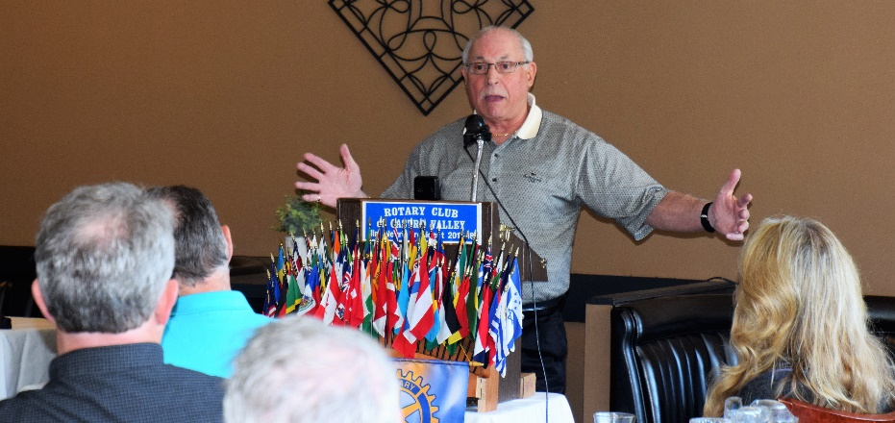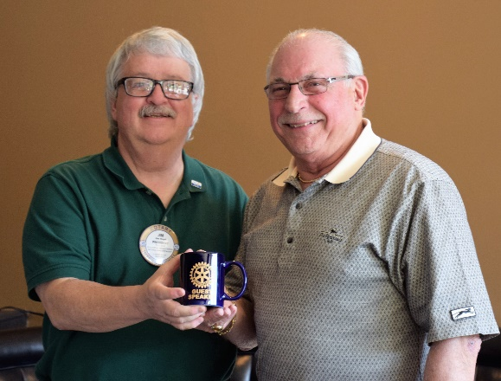

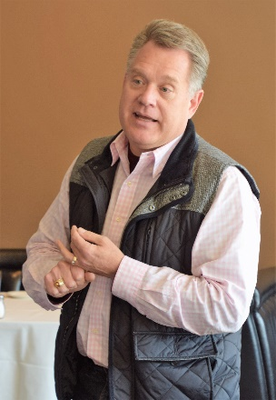
Planning Commission Update
Commissioner and Castro Valley Rotarian Jeff Moore provided an update on recent legislation that would allow for development of property and bypass normal approval processes to provide more afford housing. The legislation removes local control/approval under certain conditions. See Jeff more details

Upcoming Speakers
- April 3: Graham Lustig is the Artistic Director of the Oakland Ballet Company. He recently brought his program Jangala (The Jungle Book) to the Castro Valley Center for the Arts. It was very enthusiastically received. Come and hear more about his innovative programs.

- April 10: Katie Annand and Katherine Krassilnikoff provide pro bono representation to unaccompanied immigrants minors who are facing deportation hearings. Hear more about the organization Kids In Need of Defense (KIDS) and the challenges that the kids face.

- April 17: Carolina Salazar (District Director to Assemblyman Bill Quirk) and Michael Kusiak (Castro Valley Matters) will report on legislative initiatives and how these may affect Castro Valley

- April 24: David Judson is the Managing Director of the Castro Valley Center for the Arts since it was built 13 years ago. It has become a bustling hub of the Arts. David will highlight the successes and the sustainability of the Center.

