Rotary Club of Castro Valley
Meeting Highlights – March 26, 2019

“Do You Speak Insurance?” – Todd Anglin, State Farm Insurance
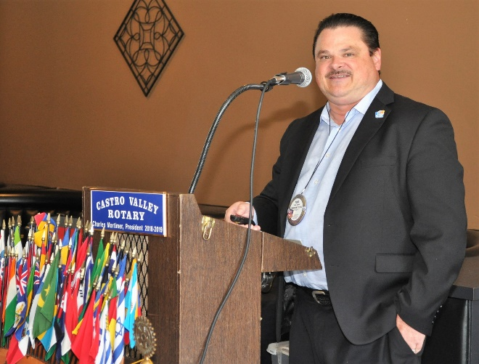
President-Elect Todd Anglin was the lunch speaker and focused on role as a State Farm Insurance agent. Todd started by stating that many people do not understand what insurance they have or don’t have, what their liability exposure is, and that they can be sued; hence the Sprichst Du Versicherung title. Todd is probably getting ready to do some business Rotary International Convention in Hamburg, Germany this June.

Throughout the presentation, Todd continued to explain that his role is to help people understand their insurance coverage, the options, the discounts, and what is/is not covered by their insurance policies. Todd explained what liability exposure means (i.e., the insurance pays the $100,000 and then sues the individual who would be liable for his/her net worth plus 50% of income for 20 years), which seemed to be very good reason to fully understand your liability exposure.

Continuing the discussion on auto insurance, Todd touched on the following points:
- Umbrella policies are critical to have when you have any worth.
- You can add $1M in coverage incrementally for very little cost.
- Comprehensive (anything other than collision) claims do not count against your rates.
- Under uninsured motorist coverage, the first injury is the maximum that would be paid if the other party was not properly insured to cover your medical damages.
- Medical payments are simple payouts for each passenger in your car to cover things (e.g., hospital deductibles, loss of work, ambulances). It is very inexpensive to increase this coverage.
- Emergency Roadside is often very inexpensive rather than AAA at $185+/year.
- Consumer often miss some discounts (e.g., multi-car is a huge discount, good student, multi-line such as home/car/umbrella, good student).
- Auto rates went way up in 2016 & 2017 as insurers were losing billions due to skyrocketing costs (medical, labor & parts - many windshields today have cameras, sensors, and must be calibrated to replace, cars lost in the recent fires). The good news is the rates seem to have peaked and may likely come back down a bit in the next couple of years.

Moving on to home insurance, Todd stressed that it was important to tailor a home insurance policy to one’s needs and focused on
- What goes into Coverage A/Dwelling and the importance of looking at the cost per square foot, which has increased significantly due to the recent fires and construction in general. The key takeaway is to check to see that you have enough coverage.
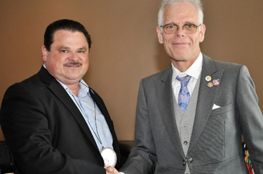
- What goes into Personal Property Coverage, which is everything you could move out if you bought a new home, but it is important to notice the sub-limits under Policy Options (e.g. $2,500 maximum on jewelry, $1,500 on business property); however, you can purchase a separate Personal Articles Policy to protect high worth items.
- The Building Ordinance/Law (e.g., issues related to codes, permits, rebuilding requirements) section is important to evaluate since the costs have increased due to the recent fires.
- Loss of Use Coverage is another important aspect of home insurance. It pays additional expenses if you had to move out of your home for a covered loss (e.g., evacuation, fire). I heard many in Santa Rosa were getting a check for $1,500 total to live off for 6-24 months here. Check what you currently have and sometimes very inexpensive to increase the amount of coverage.
- If your earthquake coverage is older than three years, it is a good idea to check your light of recent changes.
- Know the difference between “Replacement Cost” (i.e., insurer will pay to replace with a like unit) and “Actual Cash Value or Depreciated” (i.e., insurer will pay you pennies on the dollar for each item based on age and/or usage.
- Choosing the right Deductible can reduce the cost of insurance.

Todd conclude with a discussion on life insurance that included the following key points:
- The key question to ask is “What would happen tomorrow if your income stopped coming in and how would that impact everything (e.g., the family, kids, spouse, parents, paying off loans, paying for education, needing childcare to be able to work). It is important to consider life insurance for one’s family.
- Term is inexpensive when young, but only pays out 1-2% of policies, and it becomes very expensive when one is older or renewing a policy. In addition, one needs to qualify for it.
  - It can be a great way to protect for a short-term debt (e.g., a mortgage, raising a child). There are different versions to consider.
- Permanent life insurance is more expensive, but never expires; builds cash value which can be used tax free; can be a great supplement to retirement income; and can be left as a tax-free estate plan for loved ones.

Scenes from the Meeting
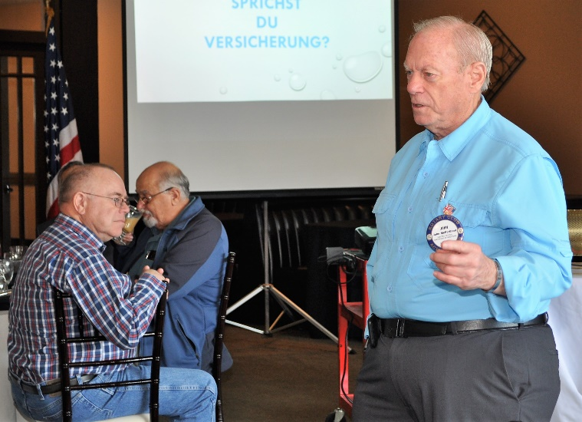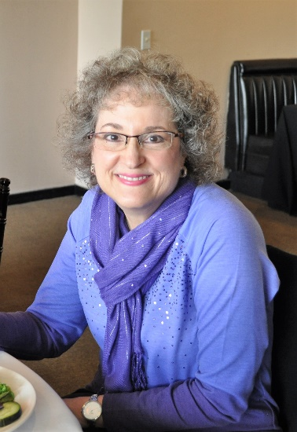
(L-R): Dwight Perry reporting on the Flash Campaign to End Polio. Before showing a Polio Plus Campaign video, Dwight noted that as of March 20th, there were only 6 cases of polio worldwide. Watch the video here. BART Director and Castro Valley Rotarian John McPartland discussed BART extension to Santa Clara County (i.e., to downtown San Jose by 2026), expanding BART parking at Bayfair, and two stations in Tracy with diesel trains. Dr. Heidi being her ever cheerful self.

Upcoming Events – Check ClubRunner for more details and more events
April 2 | Lunch meeting with Robert Maddow, former Chief Counsel for EBMUD
April 2 | Castro Valley Eats start. Details here.
April 3 | Planning Meeting for Chili Cook-off and Rodeo Parade at 5:30 p.m. at Direct Sales Floors
April 6 | District 5170 Training Assembly at Biltmore Hotel in Santa Clara – Contact President Charles to attend
April 6 | Eden Awards at Our Lady of Grace. Details here.
April 9 | Lunch meeting with Kevin McCormack from the California Institute of Regenerative Medicine
April 16 | Lunch meeting with Patty Goodman, a survivor of childhood polio
April 23 | Lunch meeting with Assistant District Attorney Robert Warren on the Alameda County Grand Jury
April 30 | Lunch meeting ABC7 weatherman Spencer Christian

