Rotary Club of Castro Valley
Meeting Highlights - March 28, 2017

Lunch Speaker: Rebecca Passche, Director of Woodroe Woods School
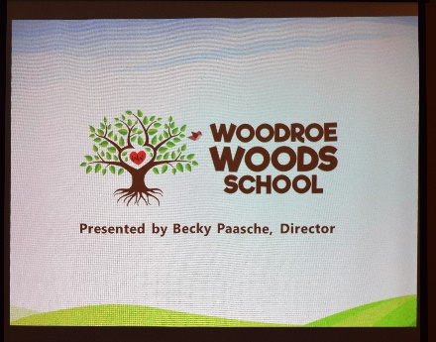
Rebecca provides history of Woodroe Wood School from its founding in 1971 to the closing of the Hayward site in 2016 to the reopening if its new site in San Leandro this year. Woodroe Wood School was founded in 1971 by Nira Dean, a Bay Area native, who began her career as an Early Childhood Educator teaching in Head Start in Union City during the late 1960’s. She went on to open her own preschool in 1971, renting space from local churches before buying and moving to what was known as Woodroe Woods School in Hayward Hills. In 1974, Nira passed the school on to her daughter Kerry Kennie Rice and her spouse Greg Rice, who ran the program until the closure of the Hayward site in June 2016. Under their leadership, the school grew and flourished and became a staple of the Castro Valley/ Hayward community. In 2016-16 school year, the school reopened in San Leandro with Rebecca Paaasche as the Director. Woodroe Woods School was a 501© corporation.
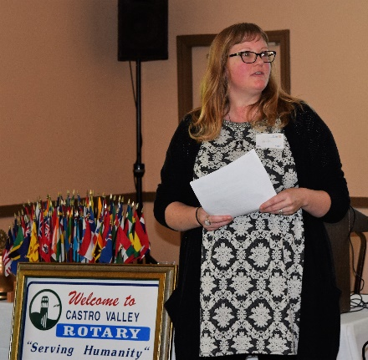
In 2016, the school served about 160 children during the school year, and about 200 during the summer season. More than 5,000 children have made their way through the program over the 40+ years of the school’s existence. Wait Lists regularly ran up to 100+ children. The program includes 2 preschool classes, 1 kindergarten, and1 1st/2nd grade combo. The staff consisted of 20 teachers and 3 administrative personnel. The pupil to teacher ratio is 8:1 in preschool and pre-K, and 15:1 in KG and elementary.

In 2015, the Directors communicated their intent to retire, sell the property, and ultimately close the school in June 2016. Parents, teachers, community members, and volunteers came together to form a movement called Woodroe’s New Beginning to develop options for continuing the school.

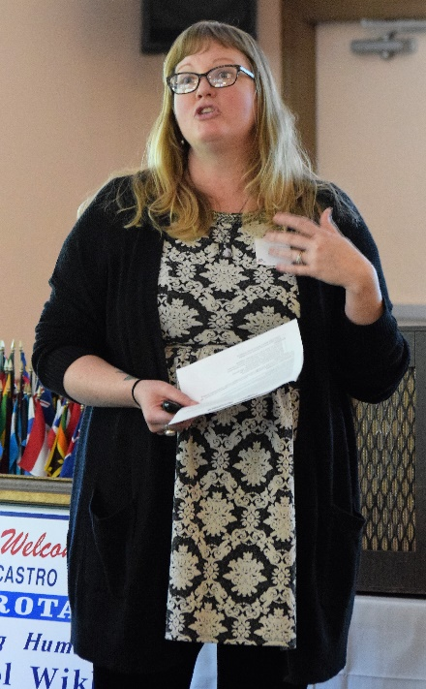
In July 2015, the only major preschool in the area, Camelot, with an enrollment of approximately 130 children announced its closure with one week notice for the families. It had been in operation for 33 years on the property owned by San Lorenzo Unified School District (SLZUSD). The Woodroe Woods and Camelot parents and teachers tried to buy the property, but were outbid by Mission Hills Schools.
In April 2016, the volunteers formed a new entity (Woodroe, Inc, DBA Woodroe Woods School) and started the long process of certifying it as a non-profit.

The SLZUSD offered to rent a portion of a large school that had been left vacant by the Chinese Christian School at 750 Fargo Ave. in San Leandro. The property was bare. With the help of a swarm of volunteers and teachers the Woodroe Woods relocated to this site in less than 2 months. Woodroe Woods School reopened at the new location in June 2016. It started with 80 children and now has 112. The school has reopened 4 pre-school classes as well as K, 1st and 2nd grade classes. The school is planning to add a 3rd grade class next year and a grade per year after that up to 5th grade. They have just advertised a 9 weeks of a wonderful summer camp program. Approximately 80% of the students still come from the Castro Valley/ Hayward area.

Woodroe Woods School is a lay Based School. The pre-school and K program is focused on providing, nurturing, simulating, and creative environment, child centered exploration, support for social/emotional growth, tools for conflict management and problem solving, ample opportunities for outdoor play, seamlessly integrated academics (especially early literacy and math concepts) and a low tech approach up to K. They strive to instill self-confidence and self-worth, respect for on-self and others, and an appreciation of nature (gardening, nature themes) and all living creatures (class room pets).

The elementary school program, while keeping true to the overall philosophy, also introduces more rigorous academics, hands on learning through experiments, field trips guest experts, and in depth research, a focus on STEAM (science, technology, engineering, art, math), while still allowing for outdoor play and exploration. The program is in compliance with the California Common Core State Standards.
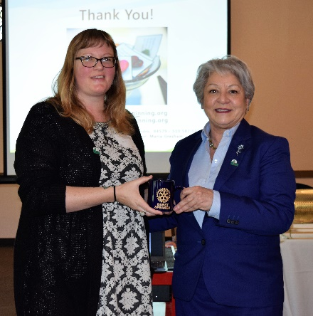
Woodroe Woods School is an all- inclusive program that accepts children of all levels, national and ethnic origins, and family backgrounds. Based on the financial ability, the school offers a limited amount of tuition- breaks to underprivileged families.

Rebecca pointed out that there is a tremendous need for early childhood education in our area. The Castro Valley/ Hayward area is underserved and there is a lack of traditional preschool programs that are not religiously affiliated. Family childcare and small daycare centers are saturated and children typically outgrow daycare around age 3. There is a strong need for similar programs which have proven to be extremely effective at producing successful individuals in schools and beyond.

Woodroe Woods School does not have a permanent home and is looking for individuals and organizations like the Rotary Club of Castro Valley to help it secure a permanent location in Castro Valley/Hayward area. Rotarian Todd Anglin and his family are active members of the Woodroe Woods School community.

Additional information regarding Woodroe Wood School is available at www.WoodroesNewBegining.org.

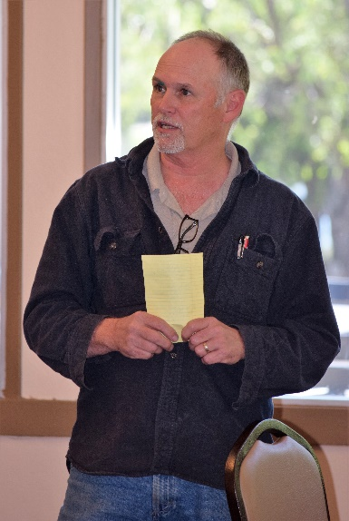
Announcements
- President Carol Wikle reminded members to provide any comments on the proposed membership application of Tim Sbranti, Deputy Chief of Staff for Congressman Eric Swalwell.
- Randy Vanderbilt, Chair of the Chili Cook-off on May 12, asked for volunteers to attend meetings at other Rotary Clubs and distribute fliers for the Chili Cook-off. We are still looking for cookers, who can advertise their business or organization in their booth
- President-Elect Jim Negri asked those members who are interested in attending the District Assembly on April 13 in Milpitas to RSVP to him by April 4. The Assembly is scheduled 5:00-9:00 p.m. with two training sessions and dinner with a keynote speaker. The Club pays the cost of registration.
- President Carol shared a letter (see the next page) and cards from FESSCO thanking the Club for the Children’s Christmas party. Thank you to everyone who made the party a success.

Upcoming Events

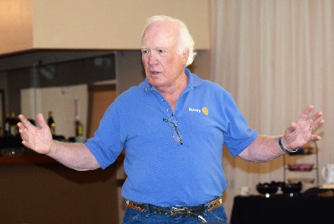
April 4: Lunch Meeting – Dr. David Berke
April 10: Board of Directors Meeting – Chamber of Commerce
April 11: Lunch Meeting – Mary Ann DeGrazia, CV Arts Foundation
April 13: District Assembly in Milpitas at 5:00-9:00 pm
April 18: Lunch Meeting – Dr. Bruce Roberts, Medical Director – Lighthearted Medicine
April 25: Michael Kusiak, Castro Valley Matters

This is a great example of Service Above Self.

