Rotary Club of Castro Valley
Meeting Highlights - March 5, 2019

Linda Foster - Protecting, Mitigating, Recovery & Retrofit Programs for Californians after a Major Quake
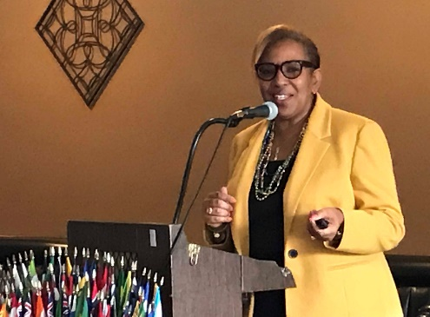
Linda works with the California Earthquake Authority and she talked about 5 things to know about Earthquake Risk in California:
- Risk is Real in California. Most people in California live within 30 miles of an active fault. The last major earthquake in our area was the 6.8 earthquake of October 21, 1868 on the Hayward Fault which was the most destructive in California's history. There is a 76% probability that a 6.8-7.0 level earthquake will hit the Hayward Fault within the next 30 years.
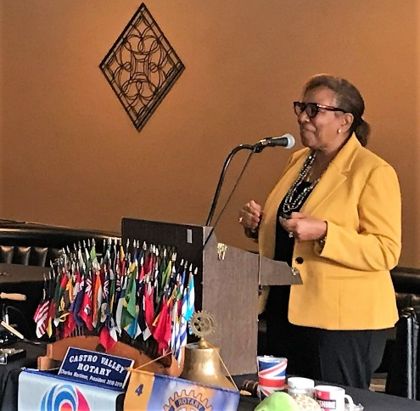
- California Earthquake Authority (CEA) is a not for profit, privately-funded, publicly managed organization that provides residential earthquake coverage for the California homeowners. After the Northridge Earthquake in 1994, home insurance policies do not cover Earthquake damage in California. CEA works with most Insurance companies. CEA can pay claims of up to $7.5 billion in any single disaster. The next major earthquake could result in damages of up to $35 billion. Every CEA policy holder will be eligible for $1,500 emergency repairs. Loss of use coverage will have no deductible.
- Benefit of Insurance is Real. Most home owners in California do not have earthquake coverage. Less than 10% of the houses are covered by earthquake insurance. Government and disaster relief agencies assistance will be limited to health and safety needs. Government loans, if available, must be paid back. Use the CEA premium calculator to determine your need for earthquake insurance. The link is https://www.earthquakeauthority.com/California-Earthquake-Insurance-Policies/Earthquake-Insurance-Premium-Calculator.
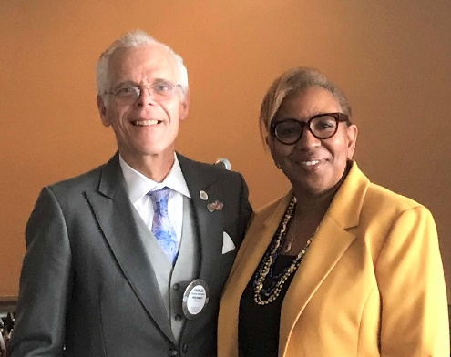
- Choice. CEA provides various policy options to cover home owners risk and to suit their budget. The CEA premium calculator provides real options for risk coverage and affordability. Policies from CEA cover a range of deductibles of 5-25% deductibles for coverage to suit the budget of all homeowners.
- Retrofit. CEA is assisting home owners of older homes in upgrading their home foundations to better survive a large earthquake. CEA is offering $3,000 to every homeowner for the required foundation upgrades. Homeowners should take the risk of earthquake seriously and take all necessary actions to protect their homes and Lives. The risk is real, and it can happen today.
Scenes from the Meeting
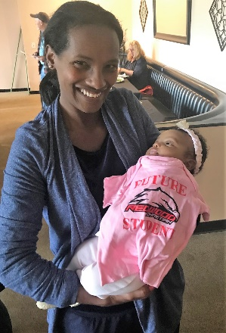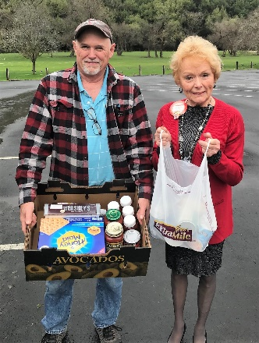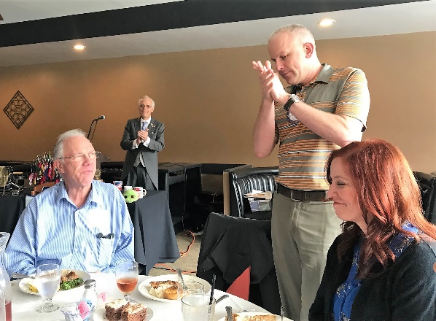
(L-R): Obse Lubo and her daughter, Tokkonee. Randy Vanderbilt and Carol Bigelow with food for the ongoing food drive. Carol is collecting food every week until “hunger is gone.” Dan Willits welcoming his dad, Jim Willits, and Gwen Schlatter.

Richard D. King Student Speech Contest
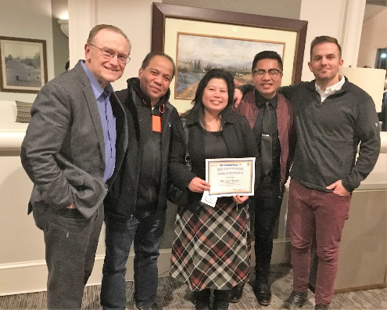
After winning the Rotary Club of Castro Valley Speech Contest, JD Ducusin, a Senior at Redwood Christian High School, moved on to compete in the Rotary District 5170 Area 4 Speech Contest (Castro Valley, Dublin, Hayward, Livermore and Pleasanton Clubs) at Castlewood Country Club on February 28th where he finished second. While JD is not moving forward to the District 5170 Finals, he represented the Rotary Club of Castro Valley with distinction. JD is pictured with Castro Valley Rotarian Bruce Johnson (right) his parents, and RCHS Assistant Principal Evan Barnhart.
Photo by Linda Johnson.

Upcoming Meetings and Events (check ClubRunner for details)
- March 19 - Lunch Meeting with Jennifer Ott, Deputy City Manager of Hayward
- March 19 - Texas Hold’em Debrief Meeting at Offices of Mark Poniatowski – 5:30 pm
- March 20 - Rodeo Parade & Chili Cook-off Planning Meetings at Direct Sales Floors – 5:30 pm
- March 21 – Castro Valley/Eden Area Chamber of Commerce Taste of Castro Valley & Business Expo at Castro Valley Moose Lodge (free) – 5:30-7:30 pm
- March 26 – Lunch Meeting with Todd Anglin, State Farm Insurance
- March 27 – Rotary Club of Castro Valley Board Meeting (open to all members) at Don Jose’s Restaurant – 5:30 pm
- May 10 – Chili Cook-off at Rowell Ranch Rodeo Park - 5:00-8:00 pm.
- May 11 – Rowell Ranch Rodeo Paraded Sponsored by the Rotary Club of Castro Valley on Castro Valley Blvd. starting at 10:00 pm
- June 25 – Demotion of President Charles Mortimer at Rowell Ranch Rodeo Park – 5:00-8:00 pm

