Rotary Club of Castro Valley
Meeting Highlights – March 6 & 13, 2018

Jessica Nusse, Solid Waste Specialist from the Castro Valley Sanitary District (CV San)
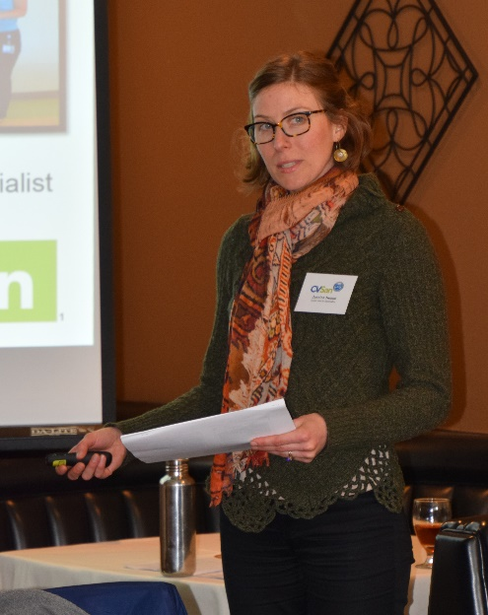
Jessica Nusse spoke about Zero Waste Initiatives in Commercial Business. She shared the 4 R's for handling waste: Reduce, Reuse, Recycle and Rot and went into detail with slides for each "R" providing great examples of what to do and what not to do as well as answering questions from the audience.

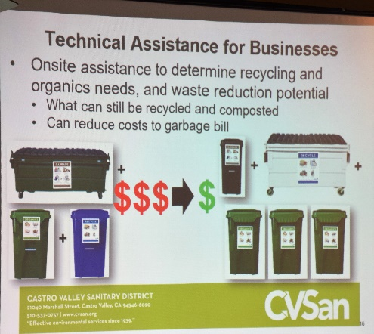
For instance, used pizza boxes cannot be recycled due to the food contamination. The boxes must go into the Rot (garbage) bin and empty aerosol cans CAN be recycled as a metal product in the Recycle container along with all glass bottles -- just be sure to keep the caps on since the caps will be reclaimed after the bottle is broken by huge magnets and be sure to leave caps on all water bottles being recycled! An important fact was that the #1 item in all landfills is, unfortunately, uneaten foods and spoiled foods, approximately 30%!

Jessica also shared what she can do for individuals businesses and encouraged business owners to contact her to schedule a review of their businesses. Jessica graciously agreed to share her PowerPoint presentation with the Club. It will be posted on the Club’s website.

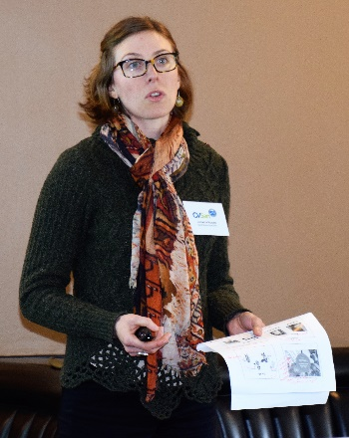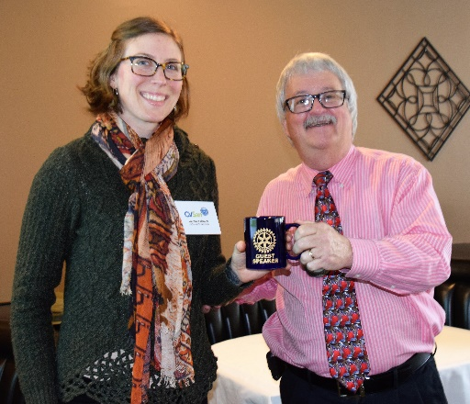
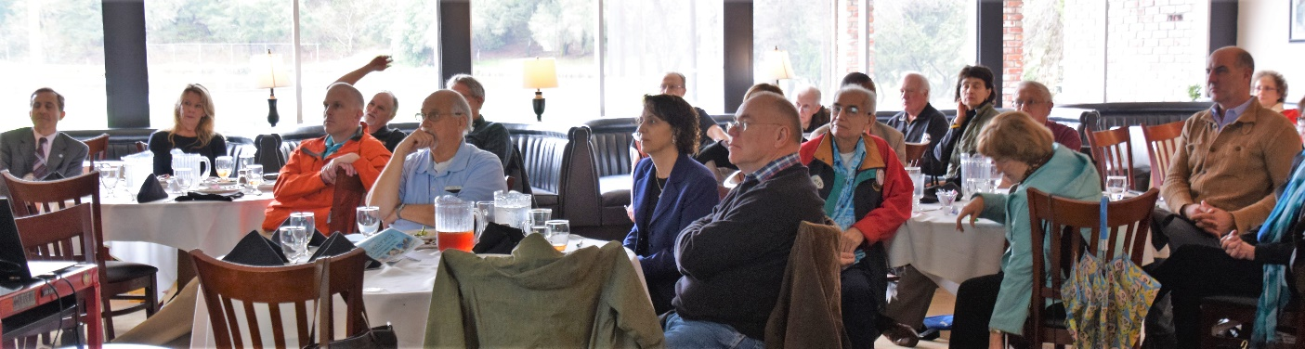

Support the Castro Valley Forum
President Jim encouraged everyone to support the Castro Valley Forum by taking one-time subscription of $10. Please bring a check to the next meeting or mail it to the Post Office Box. Checks may be made to Castro Valley Forum or the Rotary Club of Castro Valley. Jim combine the check and present them to Publisher Fred Zehnder with a list of donors from the Club. If you have already subscribed directly to the CV Forum be sure to notify Jim so that your name can be added to the list. Jim has asked the other service clubs/organizations in Castro Valley to do the same. The CV Forum is the key communication piece for Rotary as well as a great community resources. Show your support.
New Member – Fremont Bank – Castro Valley Branch
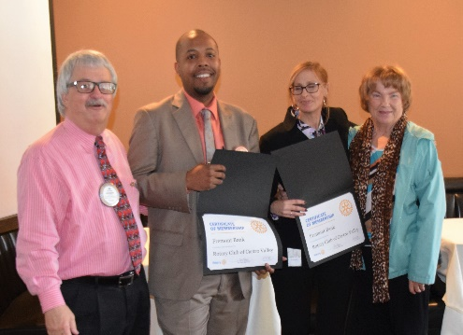
President Jim Negri and Membership Chair Virginia Degner were pleased to induct Fremont Bank - Castro Valley Branch as the Club’s newest Corporate Member. Branch Manager Lytrel Carter will be the official member of the Club and Saundra Gregory will be the associate member. Fremont Bank was a sponsor of the Texas Hold ‘em Fundraiser. If you have not had the chance to introduce yourself to Lytrel and Saundra, please take the opportunity to welcome them to the Club at the next meeting.

End Polio Now Flash Campaign
District 5170 End Polio Now Chair Dwight Perry reminded everyone of Rotary International’s Flash Campaign that is running through the end of April. Every Rotarian is asked to donate $50 towards the effort to finally eliminate polio. This year, there are only two known cases in the world! Please bring a check (make the check to TRF) or cash to the next meeting or mail it to the PO Box. Red Badger Gary Howard was the first to donate on March 6th. Several members donated at the meeting. Let’s follow their lead.

Texas Hold ‘em Fundraiser
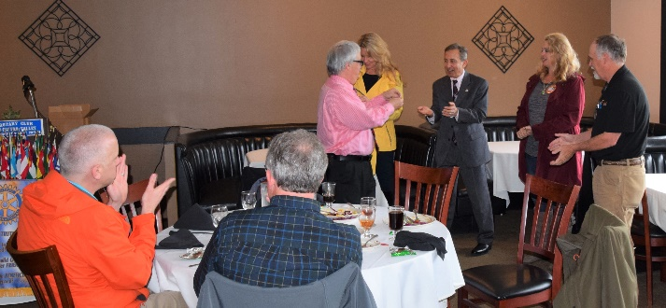
Saturday, May 10th, was a special night for the Rotary Club of Castro Valley! Under the leadership of Mark Poniatowski, Dawn Ortiz, Michaela Thompson, and Randy Vanderbilt, the Club held its Texas Hold ‘em Fundraiser. While the event included a change of venue and format (poker, dinner, and music), it was a rousing success. The number of players and dinner guests exceeded the committee’s best hope. Revenue should easily meet the projected target. Attendance was near 100 people. Financial details and photos will be posted in the coming weeks. President Jim thanked Mark, Dawn, Michaela, and Randy for their outstanding work and the courage to make changes to the event. Jim presented each of them with a Rotarian of the Month pin.

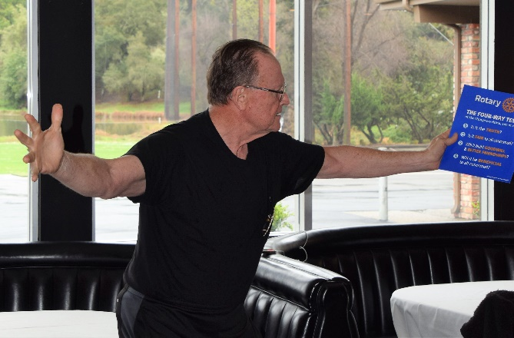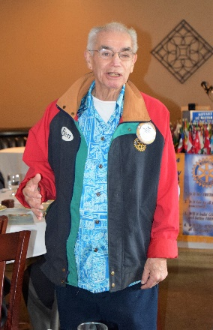
Bruce Johnson led the in a very animated and rousing Four Way Test. The Club welcomed back Ben Gurule who reported that he is on the road to recovery from his illness. Members attentively listening to the presentation.

Announcements
- President Jim stressed the need for volunteers on March 24th to support the Youth to Youth Conference for middle school students to be held at Castro Valley High School. The conference is a joint program of the Castro Valley and San Ramon Valley Unified School Districts and supported by the Rotary Clubs of Castro Valley, Danville, and San Ramon. Volunteers are especially needed to serve lunch and dinner. Please use this link to learn more about the conference and to sign-up as a volunteer: http://www.signupgenius.com/go/20f0849afa628a3f49-youth. Information has been sent to all members via email and a postcard.
- Castro Valley USD Superintendent Parvin Ahmadi invited everyone to attend the District’s Education Day on March 27 at the Castro Valley Center for the Arts (CFA). The day starts with breakfast (7:30-8:00 am) followed by presentations on Career Technical Education, the Arts, and the new Wellness Center (8:00-9:00 am). The day will conclude with a short tour (9:00-9:30 am), which leaves you plenty of time to make it to Rotary at lunch. Register for the event at https://cvusd-educationday2018.eventbrite.com Deadline to register is March 21.
- Chili Cook-off (May 11) and Rodeo Parade (May 12) Chairs Randy Vanderbilt and Michaela Thompson, fresh from the Texas Hold ‘em Fundraiser, told everyone to relax for a week before planning for the events kick into high gear.

Meeting Highlights – March 6
In the absence of President Jim, President-Elect Charles Mortimer fresh from PETS training ran the meeting during he presented Castro Valley/Eden Area Chamber of Commerce CEO Ashley Strasburg with her official Red Badge.
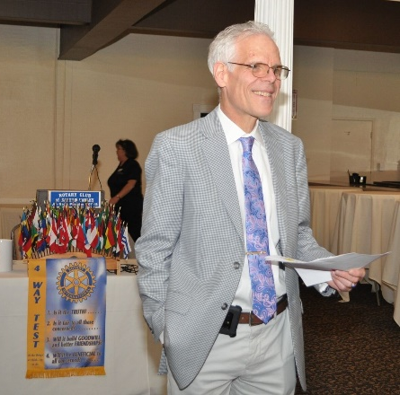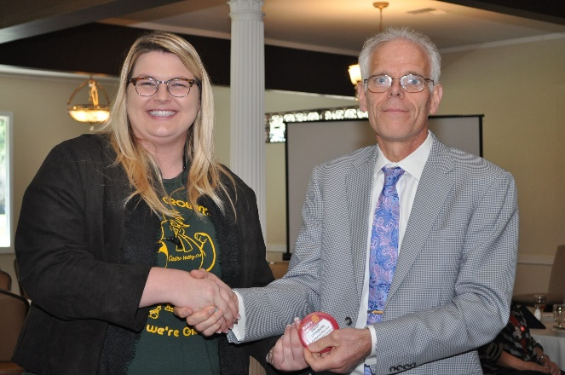
The program featured Annie McBride, a long-time Irish dance teacher speaking on the History of Irish Dance in the Bay Area with performances by her students.
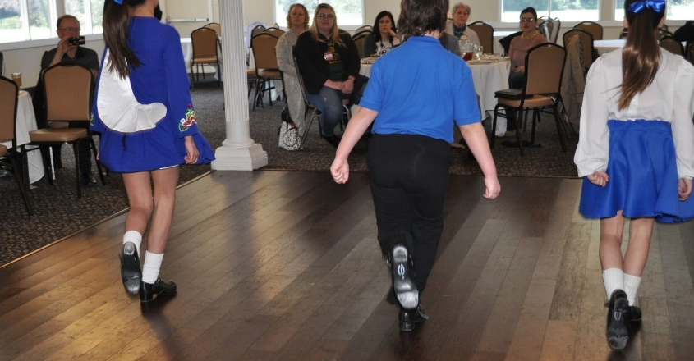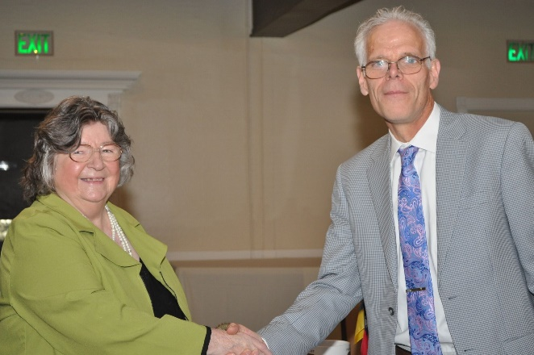
Here are a couple of YouTube links to the performances:
- https://www.youtube.com/watch?v=lo9yATEI8S4 and https://www.youtube.com/watch?v=dV38rLlJdqI

Upcoming Speakers and Events
- March 20 - Financial Markets in 2018 & Tax Reform
Noah Rubin will be speaking on Financial Markets and the firm’s 2018 recommendations on global equities, interest rates and bonds as well as Tax Reform: Key Themes & Issues.
- March 15 - 2018 Taste of Castro Valley and Business Expo – Moose Lodge at 4:30-7:30 pm – Details here
- March 27 - CVUSD Education Day at the CFA at 7:30 -9:30 am - Details here
- March 27 - Post Polio Syndrome Start to Finish - Al Padro will speak on "Post-Polio Syndrome Start to Finish." He suffered from polio and now has been hit with post-polio syndrome. Al will share his experience. Al works as a Marshal at Redwood Canyon and is a good friend of Dwight Perry.

