Rotary Club of Castro Valley
Meeting Highlights – March 7, 2017

Lunch Program: Castro Valley Eden Area Chamber of Commerce
Mike Tacconi, Board President, and Caryl Mahar, Business Development & Marketing Director

Mike Tacconi and Caryl Mahar, who is a Castro Valley Rotarian, shared the history, purpose and current work of the Chamber of Commerce. The Chamber is celebrating its 80th anniversary on March 17. There are four staff members. See the Chamber website, http://www.edenareachamber.com/, for more information.

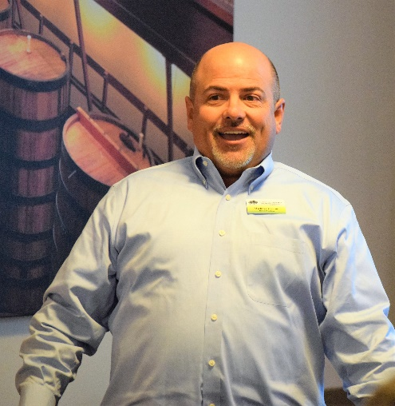
The Chamber serves the communities of Castro Valley and, Ashland, Cherryland and San Lorenzo, which comprise Eden Area. These communities offer rich and diverse opportunities to shop, play, learn, and live. Each community has a unique history and flair offering residents and visitors experiences to remember. For example, Castro Valley's sylvan Lake Chabot and world-class Eden Medical Center are just a few minutes apart.

For local businesses, the Chamber provides visibility, growth and networking opportunities, and a unified voice with local government regarding business and development issues. The Chamber sponsors monthly mixers throughout the community on the third Thursday of the month (check the Chamber calendar for details). Among the annual events are the Fall Festival, Business Expo/Taste of Castro Valley, the Light Parade, Barks & Brews, Eden Awards, Food Trucks, ribbon-cutting for new businesses and new Chamber members. Each event offer local businesses, including the Rotary Club of Castro Valley, opportunities to be involved and promote their business and/or organization.

The Chamber produces both a printed and online directory businesses and services as well as a wealth of local information. The Chamber also provides help for new businesses and navigating through various regulatory requirements and agencies. During 2016, the Chamber arranged 74 days of Eden Nights with an estimated attendance of 10,000. The Chamber published 130 newsletters with 29,731 Event pages and 15,700 people reached per month. It also helped 59 New Businesses, with 48 business connection hours, 13 community deals, and 8 community events.
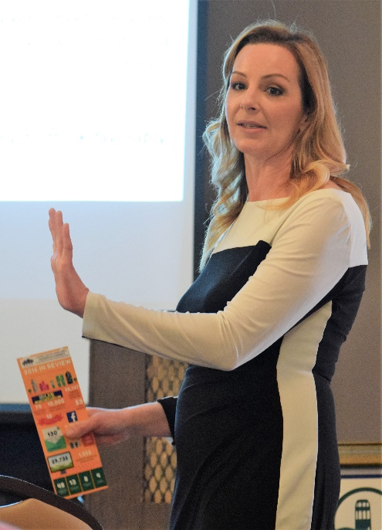
Additionally, the Chamber is working with the Eden Area Career Pathways Consortium to link education and employment in high demand industry sectors through the development of a career pathway and high quality work-based learning partnerships with the Castro Valley and San Lorenzo School Districts. If you are interested in speaking to classes or having an intern in your business, contact the Chamber.

A Career Pathway is a sequence of classes organized around an Industry Sector. The industry theme is woven into work-based learning activities by teachers with input from working professionals. Work-based learning activities involve direct interactions with industry and community professionals that provide high school students with hands on experiences which is accomplished through classroom visits, field trips/business tours, career fairs/days, mock job interviews, service learning projects, job shadowing, internships, and participation on advisory boards. Being involve in this effort supports Rotary’s Vocational Avenue of Service

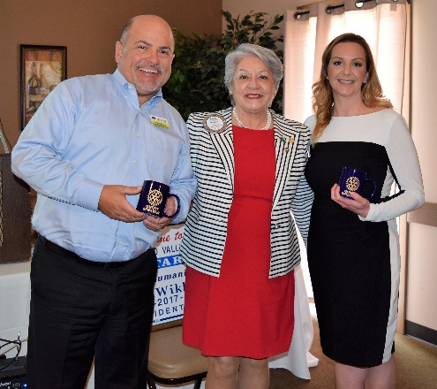

The Castro Valley Eden Area Chamber of Commerce and the Rotary Club of Castro Valley have a long history of supporting each organization’s activities and programs, and anticipate even more collaboration in the coming year. Please refer to the sign-up sheet that President-Elect Jim Negri sent out.

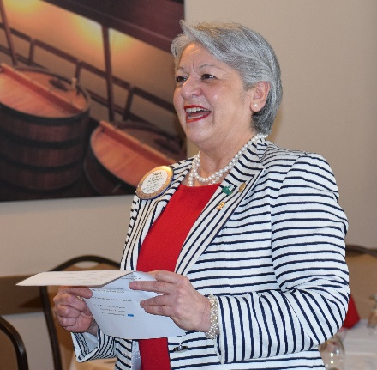
Youth to Youth Dinner
President Carol offered a big Thank You to Kern, Bill N, Bob, Ceta & son Luc, Mathilda, Christine, John A, Todd and Margie for serving dinner at the all-day Youth to Youth Conference for middle school students in the Castro Valley and San Ramon Valley School Districts. It is a great event and the Club was pleased to assist and looks forward to providing greater assistance next year.

Breathing for Life Project
President Carol announced that $359,855 has been collected for Breathing for Life Project. The final grant submission is being finalized. The Club will hear about its approval and funding from Rotary International in June.

Upcoming Lunch Speakers
March 14th - CHP Officer Daniel Jacowitz
March 21st - Glen Pomeray, CA Earthquake Authority
March 28th – Becky Paasche & Antonia Mambelli, Woodroe Woods School

Don’t forget to RSVP for the lunch meetings.

Upcoming Events/Meetings
March 13th – Board of Directors Meeting – 6:00 p.m. at the Chamber of Commerce
March 18th – Poker Tournament – Still time to sign-up and/or sponsor
March 23rd – Chili Cookoff & Rodeo Parade Planning meeting

.

