Rotary Club of Castro Valley
Meeting Highlights - May 1, 2018

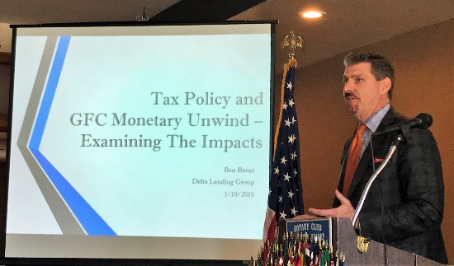
Ben Bauer, Senior Mortgage Consultant - Tax Policy and Great Financial Crisis Monetary Unwind- Examining the Impacts
Ben a Senior Mortgage Consultant/Branch Manager for Delta Lending Group spoke on Tax Policy and Great Financial Crisis Monetary Unwind. Ben started with the idea that global Central Banks took unprecedented monetary policy actions during the past decade to stem the collapsing global economy. These policies ranged from $20 trillion in total assets purchased to negative interest rates.

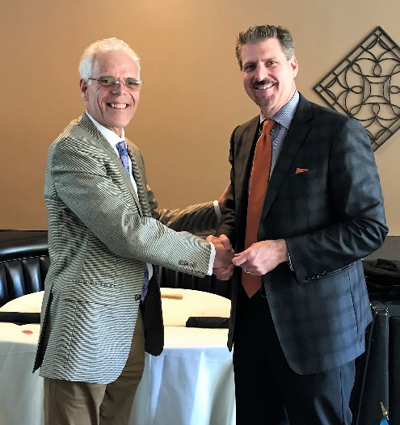
Ben then examined the effects of the current tax policies on interest rates. His analysis seems to indicate that interest rates will rise in near future (2018-2020), and that home prices and wages will increase. Home prices will continue to increase and become increasing difficult to afford for the first-time home buyer. Speakers throughout the year have been delivering the same message. Ben believes that inflation will likely increase but will be restrained by government action. Due to the current tax policy, businesses will benefit, but the desired result of expanding opportunities and the economy may not happen. Ben stated that businesses are likely to buy back their own shares, thus reducing demand for more credit, which may stabilize the markets in the short-run and is likely to offer opportunity for moderate growth.

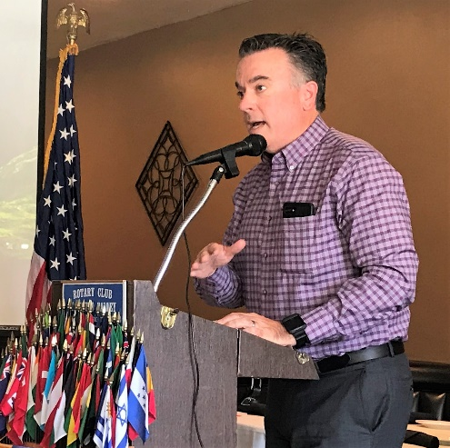
What’s New Castro Valley?
Bill Jarvis, a Broker Associate with United Lending Partners in Pleasanton and a former member of the Club, provided an update on the Castro Valley market prior to Ben Bauer’s presentation. Bill started by noting that the house prices in California are increasing at an alarming rate, making it very difficult for the first - time buyer to buy a home in Castro Valley or anywhere else in California – something that has been described over and over at Club meetings this year. He calculated that low-priced home in Castro Valley will cost $659,000 and with a 20% down payment will result in a monthly payment of $3,860. An average home in Castro Valley now costs $1,000,000 and with a down payment of $200,000 will result in a monthly payment of over $6,000.

Announcements
- Carol Wikle reported on the Breathing for Life Project. Rotary International has made its visit to Ethiopia and the project is scheduled for review and approval by Rotary International in June.
- Heidi Hausauer reported that Mathilda is slowly recovering. This week was her birthday. She has good and bad days. Send her best wishes.

