Rotary Club of Castro Valley
Meeting Highlights - May 14, 2019

Dr. Marty Nemko – National Expert on Career Advice
Dr. Marty Nemko is among the nation’s most sought-after experts on both career and education issues. Marty has been interviewed by hundreds of major media (e.g., The Today Show, NPR's Talk of the Nation, New York Times, Los Angeles Times, TIME, and even Cosmos Girl). He has written many books including Cool Careers for Dummies, which was the #1 rated career guide in a reader's choice poll and #2 on the Wall Street Journal National Best Seller list. He has written numerous articles for TIME, Washington Post, Atlantic, U.S. News & World Report, Los Angeles Times, and San Francisco Chronicle. Marty is a regular contributor (i.e., 1380 articles and counting)) for Psychology Today.
Marty has worked as the host of “Work with Marty Nemko " for over 30 years on a San Francisco NPR affiliate (KALW, 91.7 FM) and has appeared Has appeared on CNN, ABC, PBS, NPR, BBC, The Daily Show, Today Show, CBS's Early Show, Oprah and Friends, and NPR's Talk of the Nation, ABC-TV's 20-20, and in the New York Times and Wall Street Journal. Dr. Nemko earned his Ph.D. from University of California and subsequently taught at California State University State East Bay, Golden Gate University, UC Davis, and UC Berkeley in the Graduate School of Education.
During his presentation, Marty described working with various individuals and the career advice that he provided. In describing these experiences, he discussed the 16 career advice tips he offers during his seminars.
Choosing a Career and Job:
  - Focus on what really matters: You are likely to be happy with your career and job if you focus less on its prestige and coolness and more on utilizing your natural strengths and is challenging with a good boss and co-workers, reasonable pay, commute and job security.
  - Career passion comes after you have chosen it: Most people come to love their jobs only after they choose it and it took time to become a go-to guy/gal at it.

Landing a Job:
  - One Job-search method does not fit all: Based on your past performance and current preferences, decide the proportion of job search time you should spend on in-person networking, online networking, cold contact of employers, answering ads, and headhunters.
  - Use a point-by-point cover letter: The best cover letter explains how you meet the main job requirements.

Negotiation:
  - Get a second offer: Having two or more employers competing for you boosts your negotiating position.

Succeeding on the Job
  - Find out the Truth. Most people think they are above average: Get feedback from your boss and respected co-workers. It will help you to identify your strengths and areas needing improvement.
  - You must stop procrastinating: Only 10-20% of the successful executives are procrastinators; whereas more than 80% of the unemployed are procrastinators. Get comfortable being uncomfortable.
  - Think time effectiveness: Ongoing, ask yourself,” Is it worth doing?" and if so, with how much perfection. Your effort should be based on your answer.
  - If you are smart, avoid teams: Try to work solo if you are brighter and more motivated than most of the coworkers. If you are not, get on the teams.
  - Tell quest stories: Everyone knows telling about your personal quest stories describing your personal experience of travails to a problem are more motivating for the people who work for or with you.
  - Hire Slow; Fire fast: For managers it is always better to hire people slowly after due diligence. Prefer people with reliable references. You should evaluate candidates mainly by having them do simulations of tough tasks they will encounter on the job. If an employee is doing poorly, after brief attempt at remediation, it is usually wiser to cut your losses and try someone else. Extra time is usually wasted and stressful for the employee and increases employee's resentment and enmity, resulting in likelihood of filing a wrongful termination claim.

Self-Employment:
  - Do not innovate, Replicate: Lower your risk in starting a business by taking a proven business idea and cloning it in a new location or giving it a minor tweak. You are most likely to succeed by incorporating the best features of five busy Laundromats than by trying to invent some new product.
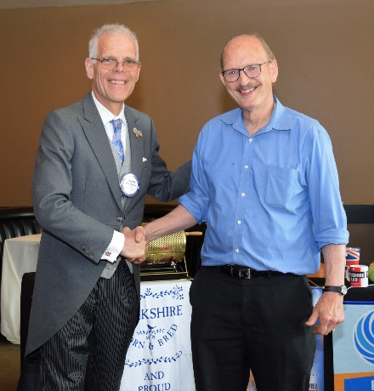
  - Keep it Simple: The more complicated the business the bigger the risk. Do one thing well and the when that succeeds try experimenting new ideas or products, without compromising your money-making initial idea.
  - Be Cheap: Money is a business's lifeblood. Spend too much and it will die. Expand and/or try new ideas or products without taking undue risk to your established cash flow. Try buying at the cheapest price available so that you can maximize profits. Also control your expenses.

General Advice:
  - Work Long Hours: That does not sound like fun, but when you are doing work you are good at and realize that the life-well-led really is mainly about productivity, you will be glad to work long hours.
  - Follow my father's advice: When I asked him, a Holocaust survivor, why he so rarely talked about that, he said," The Nazis took five years from my life. I will not give one more minute. Never look back. Always take the next step forward." I can offer no better advice.

Scenes from the Meeting
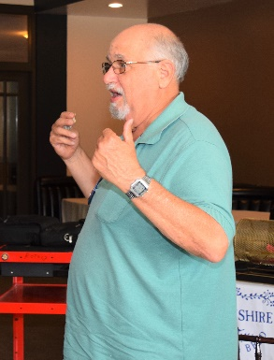
(L-R): Ben Gurule leads the Hello Song. Bruce Johnson reads a thank you letter from Ruby’s Place while babysitting Obse’s new baby. Red Badger Dave Sadoff not only leads the Four Way Test but Pays It Forward for missing the Chili Cook-off and Rodeo Parade Bill Nott and Cliff Sherwood making announcements.

Chili Cook-off and Rodeo Parade
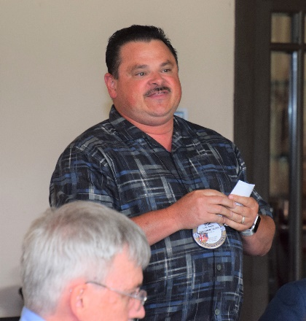
(Left to Right): Rodeo Parade Chair Todd Anglin reports on the success of the Parade and thanks everyone who volunteered and supported the Parade, especially Dwight Perry who generated a record amount in sponsorships. Judge Heidi, not Doctor Heidi, thanks everything who judged at the Chili Cook-off (tasting the chili) and the Rodeo Parade (all the categories to select the winners). Stephen Gray of Eden Medical Center/Sutter Health reports on the in-house Chili Cook-out competition that Eden held to select its entry for the Chili Cook-off – the entry won a prize. Chili Cook-off Chair Randy Vanderbilt once again did a tremendous job on the Chili Cook-off and thanks everyone who participated. Randy was also actively involved in the set-up and take-down for the Parade. These Rotarians definitely exhibited

Service Above Self!
President Charles Mortimer presents Elena Lottich, Castro Valley High School Interact Vice-President and District 5170 Outreach Coordinator, with a check for $2,700 to support her trip to the Rotary International Convention in Hamburg, Germany to be part of the District 5170 Interact presentation at the Convention. District 5170 Interact is the largest Interact District in Rotary International and raises over $100,000 annually.

Did you know that Interact stands for INTERnational ACTion? More information on District 5170 Interact at https://www.interact5170.org/. Information about the Castro Valley High School Interact Club available at http://castrovalleyinteract.weebly.com/. Information about the Interact Club at Redwood Christian High School that the Club also sponsors is available at https://www.rcs.edu/christian-academy-interact-club/

