Rotary Club of Castro Valley
Meeting Highlights – May 15, 2018

Rowell Ranch Pro Rodeo
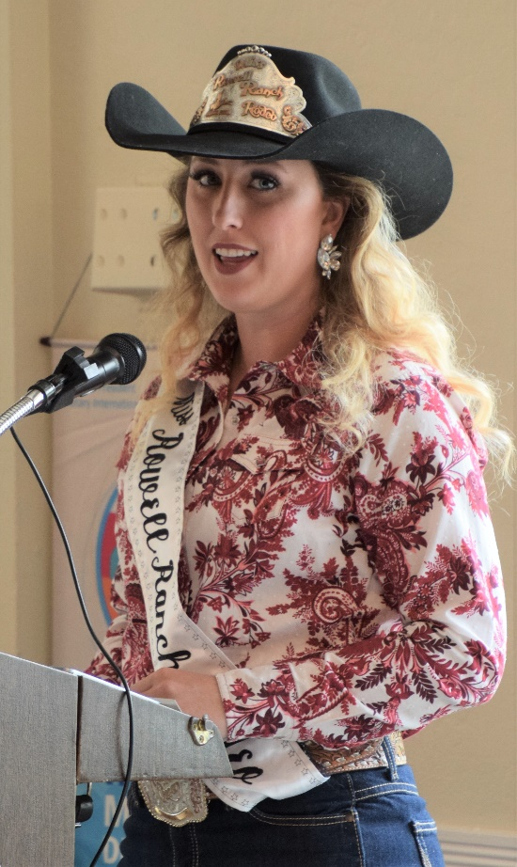
The program this week was devoted to the Rowell Ranch Pro Rodeo and was a joint meeting of the Rotary Clubs of Hayward and Castro Valley. Becca Savery, the 2018 Rowell Ranch Rodeo Queen, opened the program with a brief welcome and thanked the Rotary Clubs for their support. First hosted by Harry Rowell "The

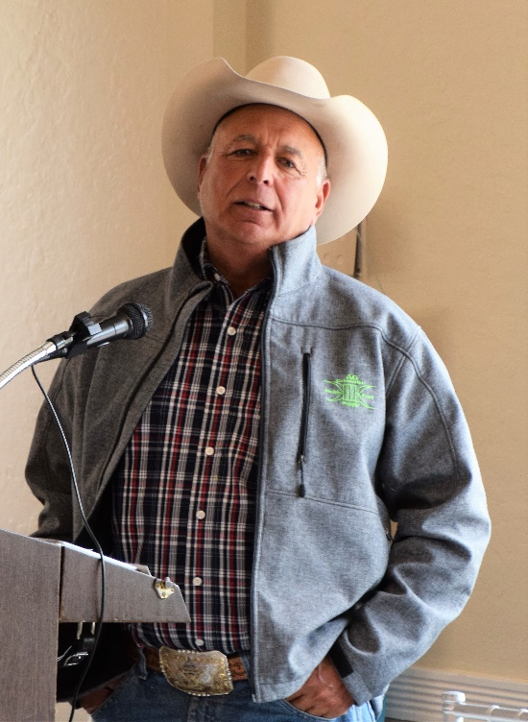
First hosted by Harry Rowell "The Rodeo King of the West" over 90 years ago, the Rowell Ranch Rodeo has provided the community with the opportunity to experience the historical sport of rodeo.
Today, the Rowell Ranch Rodeo is operated by a local non-profit organization continuing the traditional community events. The rodeo partners with many local non-profit organizations to help raise funds for a wide range of local charitable causes.

Russ Fields, Chairman of the Board of Director, and Janet Lemons, Board Member, provided an overview of the rodeo events. They shared video clips on the three main competitions (i.e., Bull Riding, Bareback Riding, and Saddle Broncing) and explained the scoring process.

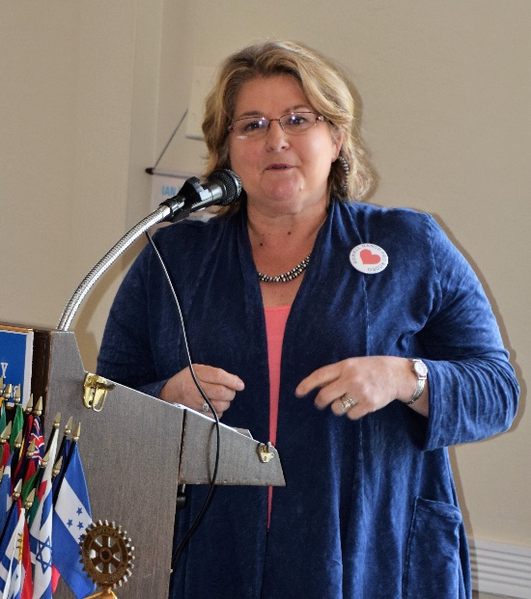
In his opening comments, Russ addressed the protest that the rodeo has faced in recent years as well as explaining how the rodeo protects the animals. Janet shared the programs that the rodeo offers for the youth of the community including special needs youth as well as the numerous events that take place during Rodeo Week. For more information about the Rowell Ranch Rodeo, its history, the organization, events, and community involvement click here.

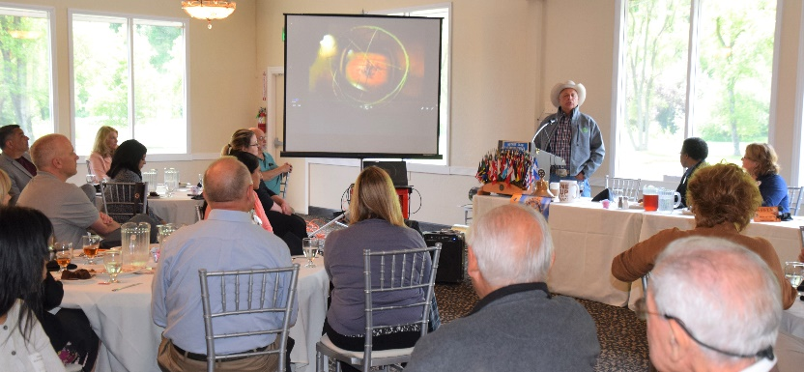

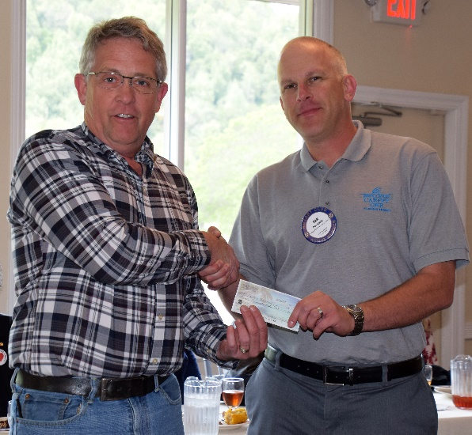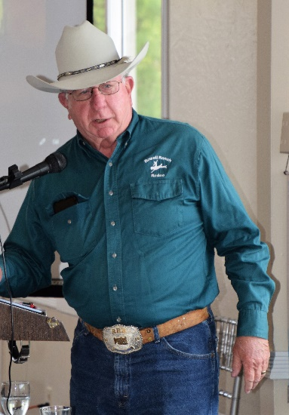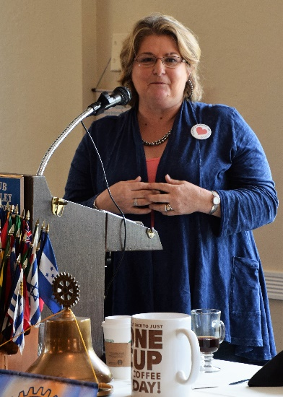
(Above L-R): John Aufdermauer presenting Castro Valley Endowment Secretary Dan Willits with a check for $1500 from his wife Bobbie’s cookie sales at the Chili Cook. Chevron Corporation matches the fundraising. Cliff Sherwood introducing the Rowell Ranch Pro Rodeo Program. Janet Lemons describing the Rodeo and the wide range of programs.
(Below L-R): President Jim Negri (L) and Hayward Rotary President AT Stephens (R) present Becca Savery, Janet Lemons and Russ Fields with Rotary Thank You gifts. Rodeo Queen Becca Savery assists President Jim Negri with the drawing.
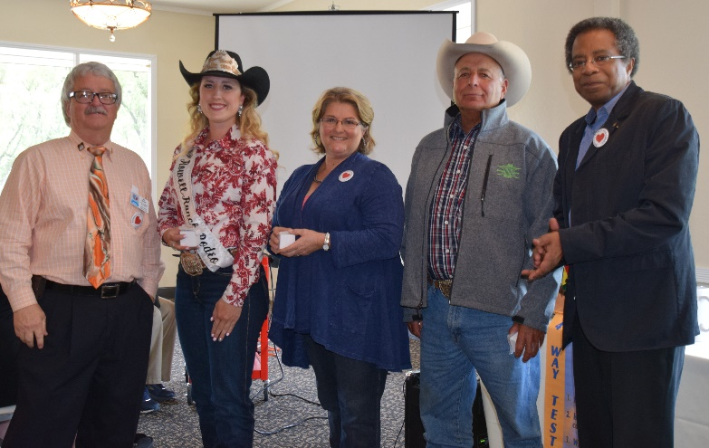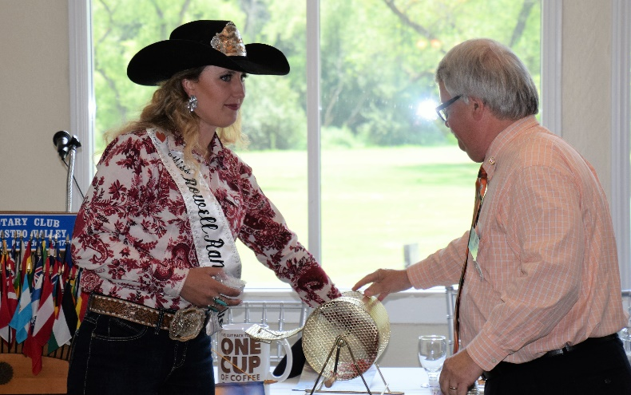

Chili Cook-off and Rodeo Parade
President Jim thanked everyone who helped organize and worked the Chili Cook-off on Friday evening and the Rodeo Parade on Saturday morning. Dan Willits and Cliff Sherwood provided a quick review of the Chili Cook-off since Chairperson Randy Vanderbilt was not at the meeting. Michaela Thompson and Bill Nott did the same for the Rodeo Parade. President Jim shared an email that he received after the Parade.

To: Negri, Jim [ciaojim_cvrotary@att.net]
From: Lisa May [seidelmay@gmail.com]
Hi~ I just wanted to say how grateful we are to the CV Rotary team at the parade this morning. My son, Gilbert, had a severe allergic reaction and we needed to get from the staging area to our car immediately and someone in one of the green carts brought us there right away. We were able to get home, take care of him, and were back in time to join Palomares for our special 150th year parade walk. And a thank you to Bruce Johnson, who I believe was the announcer, for asking about him as we rode past. It turned out to be a great day!! All the best, Lisa

Kern Lewis was the Rotarian with the cart. Thank you, Kern.

