Rotary Club of Castro Valley
Meeting Highlights of May 2, 10`17

Lunch Meeting Speaker: Alan West
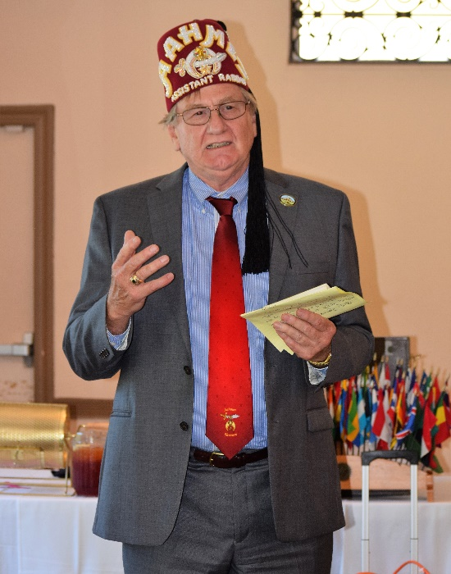
Castro Valley Rotarian Al West, Oriental Guide Of AAHMES Shriners of Livermore, was the day’s speaker. Al described the history of Shriners, their relationship to the Masons, and the purpose and function of Shriners. In general, all Shriners are Masons, but all Masons are not Shriners.
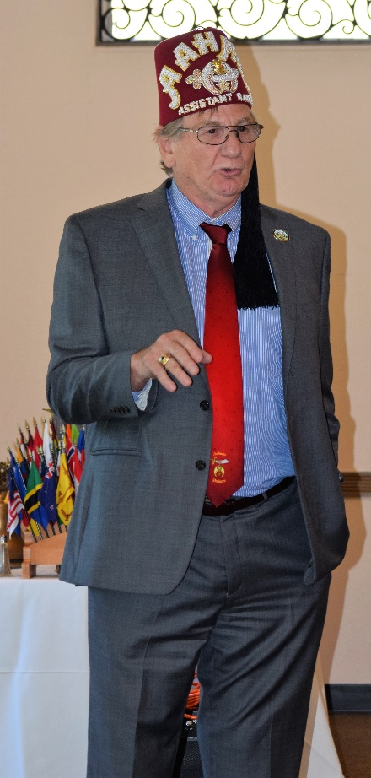
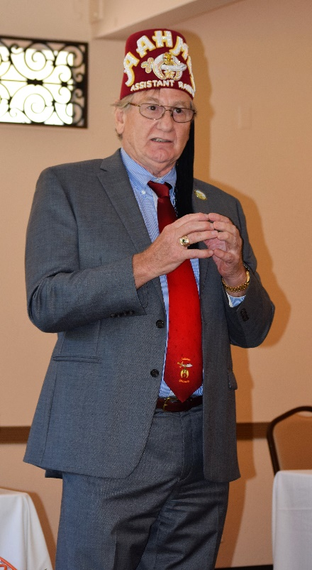
Masonry, also known as Freemasonry, is the world's first and largest fraternal organization. It is a brotherhood of likeminded men who genuinely care about each other. The fraternity of Freemasonry started hundreds of years ago, when stone masons and other craftsmen gathered after work in shelter houses or Lodges, and later organized into Masonic Guilds. Over time, the need of Masons declined and the Masonry evolved into an organization that started accepting members who were not craftsmen. Masonry is based on a belief that each man has the responsibility to help make the world as a better place. The Mission of Masonry is guided by the enduring and relevant principles of Brotherly Love, Relief and Truth. They have their own hierarchy and are organized as Craft Lodges. Groups of Lodges are organized under governing bodies known as Grand Lodges. Members of the Lodges are required to read up on their fraternity and earn a series of Masonic degrees. Once they have completed the third and final degree, members are titled Master Masons. They can continue their Masonic education by completing additional courses of study known as the Scottish Rite and York Rite. There are more than 50,000 members in the California Fraternity of Masons. Admission to these lodges is open to all men of good character and faith, regardless of their race, color, religious beliefs, political views, sexual orientation, phsical ability, citizenship, or national origin.

Shriners are all master Masons. In 1870, some members of the Manhattan Lodge felt that the rules of the Masonry were tad too focused on ritual. These members wanted a fraternity that stressed fun and fellowship. Billy Florence, an actor, conceptutalized the idea for a Near East-themed organization after attending a party thrown by an Arabian diplomat. Walter M. Fleming, M.D., added the structure to Florence’s proposed pomp and circumstance, drafting the fraternity’s name, initiation rites and rituals, and rules. Together they designed the new fraternity's emblem, devised a salutation, and determined that the red fez with a black tassel would be the group' head gear. It was decided that the local Shriner's chapters would be called Temples. The first such chapter, Mecca Shriners, met in New York City in 1872. Today there are approximately 400,000 Shriners belonging to 191 chapters in the U.S., Mexico, Canada, and the Republic of Panama. The Shriners adopted The Fez as the formal head gear in 1972. Shriners have their own emblem, greeting and salutation. Just like countries of North America are governed by representative bodies, so are the 191 chapters.

Women are not eligible to become members of the Shriners fraternity, but can join one of the several organizations for women which support the fraternity, its philanthropy, and Shriner's hospitals. These organizations are open to wives, widows, daughters, granddaughters, sisters, and nieces of the Shriners. They include Daughters of the Nile, Ladies Oriental Shrine of North America, Shrine Guilds of America, and Order of the Eastern Star.

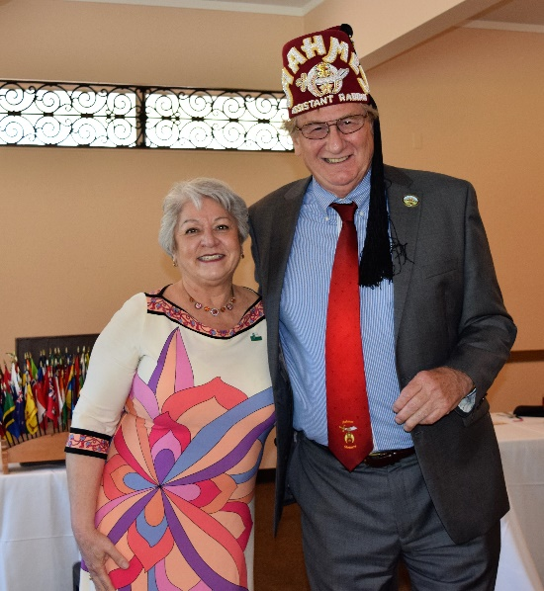
Shriners Hospitals for children was first established in Shreveport, LA in 1922 for providing free orthopedic, burn, spinal cord injury, and cleft lip and palate treatment. Today there are 22 Shriners Hospitals for children, 18 of which specialize in orthopedic care, treating injuries and problems of the bones, joints, and muscles as well as complicated conditions, such as brittle bone disease, spinal bifidia, and cerebral palsy. Additionally, four hospitals specialize in providing medical care to children with burns. Since 1960, Shriners Hospitals treat children with acute, fresh burns, reconstructive and restorative surgery on children with healed burns, treat children with severe scarring that limits mobility, or facial deformities caused by burns. Spinal and rehabilitation units are located within three Shriners hospitals; moreover, Shriners Hospitals for children established a cleft lip and palate program in 2005, which provides lip and palate repair, nasal reconstruction, facial work, and dental procedures, as well as audiological, speech and psychological services. Shriners Hospitals are also involved in medical research and have spent over $515 million in research during the last 40 years. Over 8000 physicians have received residency education and postgraduate fellowship training in Shriners Hospitals. Admissions to a Shriners Hospital is based on medical need. Children up to the age of 18 are eligible for admission, if they can benefit from the specialized services available at Shriners Hospitals.

Looking Ahead to 2017-2018
President Elect Jim Negri will be making 5 minute presentations through the end of the year described goals and plans for his year as President. He thanked the membership for approving the 2017-2017 Board of Directors and mentioned that he is finalizing the Program and Committee Chairs. District Designated Funds (DDF) will be used on local projects to repair, replace, and enhance Rotary signage throughout Castro Valley

Chili Cook-off and Rodeo Parade
May 12: Chili Cook-off at Rowell Ranch Rodeo at 5:00 – 9:00 p.m. Invite your friends
May 13: Rodeo Parade on Castro Valley Blvd. at 10:00 a.m. – 12:00 p.m.

Both events are All Hands On Deck events for Rotarians
If you have not volunteered, show up. There will be work for you.
