Rotary Club of Castro Valley
Meeting Highlights – May 22, 2018

Debby and Douglas Moore – The Vietnam Experience

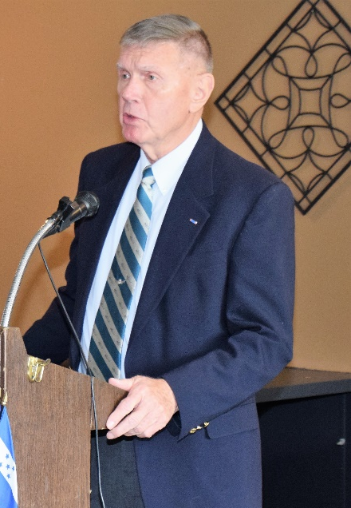
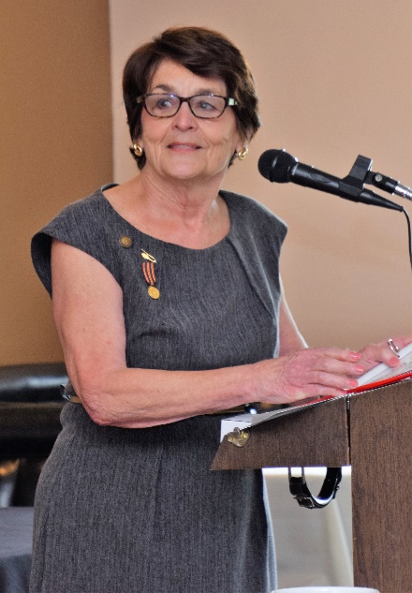
Rotarian Dawn Ortiz introduced her brother-in-law, Colonel Douglas E. Moore, who in turn provided a wonderful introduction of Dawn’s sister, his wife, Debby Alexander Moore. Colonel Moore completed 30 years of military service before retiring in 1989 as Executive Officer for The Army Surgeon General. His many duty assignments included tours in Germany, Japan, and Vietnam.

He served two tours in Vietnam flying medical evacuation helicopters, the first with the 57th Medical Detachment (DUSTOFF) at Tan Son Nhut in 1964-65 and then he commanded the 159th Medical Detachment (DUSTOFF) at Cu Chi supporting the 25th US Infantry Division in 1968-69. He also commanded the 307th Medical Battalion of the 82nd Airborne Division at Fort Bragg, and the 62th Medical Brigade at Fort Lewis where he served as Air Mission Commander for the search and rescue effort following the eruption of Mount Saint Helens in 1980.

His military decorations include the Distinguished Service Cross, Distinguished Service Medal, two awards of the Distinguished Flying Cross, Bronze Star, Air Medal with 32 Oak Leaf Clusters, and the Purple Heart. He is also a Master Army Aviator and Senior Parachutist.
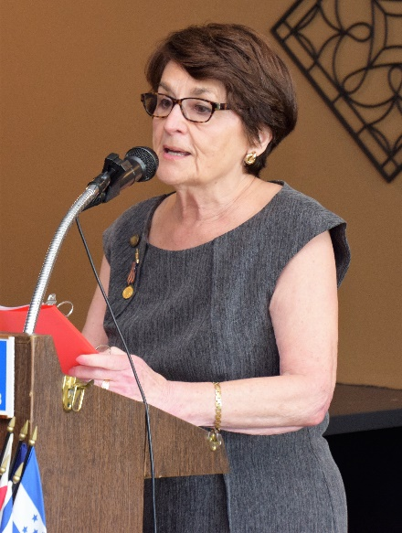
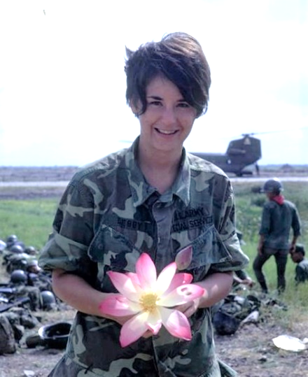
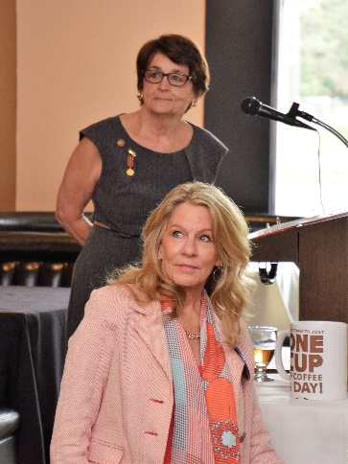
Colonel Moore provided an outstanding introduction to and background on Debby Alexander Moore, who served five years with Army Special Services which is now called Army Morale, Welfare, and Recreation. In 1968, at the age of 21, Debby was the youngest Special Services woman deployed to Vietnam. Serving deep in the Mekong Delta at Soc Trang. She was only one of two women and 400 men stationed on a tiny, isolated airfield where she ran recreation programs for soldiers during their breaks from combat operations.
After six months, Debby was transferred to a much larger facility at Cu Chi, the home of the 25th Infantry Division and its 26,000 soldiers. While at Soc Trang and at Cu Chi, Debby survived many enemy rocket, mortar, and ground attacks. Finishing that tour, she went home to California, but felt she hadn’t completed her mission in Vietnam, so she volunteered to return for another year and spent her second tour at Phu Tai and then Dong Tam. At the end of her second tour, Debby married an Army Lieutenant and was later assigned to Korea where she ran Army Special Services programs from 1975 – 1978. During this time, her program won the highly coveted All-Army Bi-Centennial award.
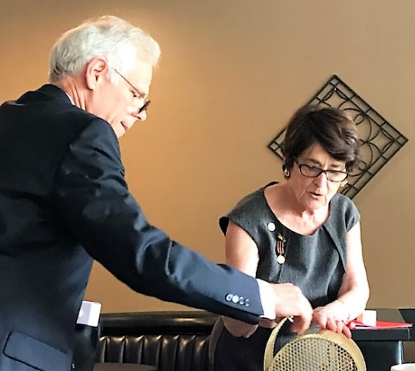
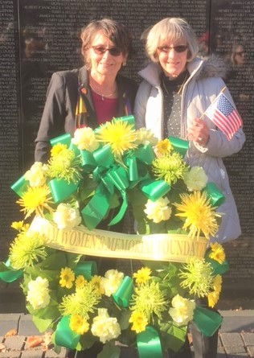
Debby showed a video of her deployment and experiences in Vietnam that captured the sights and sounds of her deployment that included many unusual experiences like riding a Tank Truck on her 22nd birthday, living in an apartment with bullet holes in walls and bathroom, participated in live bomber expeditions.

Debby described how she reconnected with Col. Moore 40 years after Vietnam at an event at the Vietnam Memorial in Washington, D.C. and how that led to their marriage.

She saw Vietnam life up-close. We thank Debby for her service and for sharing the experience with the Club.

 !"
#$%&'(')*)+
(,+-$)$.,$$/0
$

$12&#!334#&5$6786/$$$/
$
$
12&#!334$$9/
$
2&:686($0
$

;<$9%3;)$69
$
;3=,,$$
%$$>,$&
(
($%'&>$%?
($$&)$&),,
$$3);@&)%,$9!A=)$B((
%%&


 
!"#$%&'"&
(&
)&*&
+,,
*&&
)
&
--'.

!
'$,,,*&--
)&
)
/&-
0(

*&*

1&2
&"#3.4"#3%&
&&565
-

What’s New in Castro Valley? – New Door Ventures
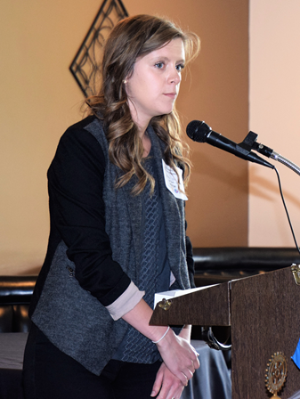
As part of the Club’s effort to promote what is happening in Castro Valley and the surrounding area, the Club hosted speakers from New Door Ventures. Kelly Smith Cole, daughter of Erma and Owen Smith, provided the introduce to New Door Ventures. Kelly described her family’s longtime commitment to the program and her involvement. (FYI – Kelly was a high school student of President Jim Negri.)

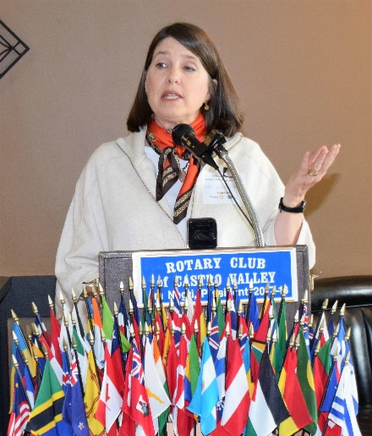
Kelly then introduced Kelsey Wu, Business Partnerships Manager, who described the history, goals, and program. New Door Ventures was founded in 1981 by Nazarene Church to provide compassionate service to people in need. While the organization is no longer a ministry the church, their foundation on Christian faith still informs their work.

New Door Ventures prepares disconnected youth for work and life. They believe that the youth are assets with God given potential and resilience who have the capacity to achieve and to contribute. New Door Ventures creates opportunities and provides dignity, self-esteem, and a path out of poverty. Individual growth and change occur best with a supportive community. As each member grows the community becomes stronger.

Since 1991, New Door has owned and operated their own businesses. Ashbury Images (screen-printing company) and Pedal Revolution (bicycle shop) are financially self-sustaining and serve a dual purpose: they provide quality goods and services to the community and create meaningful jobs for young people. These businesses offer youth the opportunity to gain experience in specific types of work and build both hard and soft skills.

In 2008, New Door Ventures started Ally Partners, contacts local businesses to support and sponsor interns with 12-15 hours per week of meaningful paid work to provide training and act as role models. The businesses provide employment for interns and New Door Ventures provides wages equivalent to San Francisco minimum wage and Worker’s Compensation as well as pre- employment training, weekly skill building workshops, progress review, and guidance. These programs prepare the youth for becoming useful members of society. Since 2016 the Ambassadors Council, a cohort of committed volunteers and New Door Ventures staff and others, plan and implement special projects and key activities to increase awareness and support of New Door Ventures so that it can reach significantly more youth in the future.

New Door Ventures has recently expanded into the East Bay, including Hayward, and is looking for local business with whom to partner. For more information about New Door Ventures, go to https://www.newdoor.org/what-we-do/

Rotary Scholarships
On May 24th, Endowment Secretary Dan Willits and President Jim Negri attended the Castro Valley High School Senior Awards Night to present four Rotary scholarships.
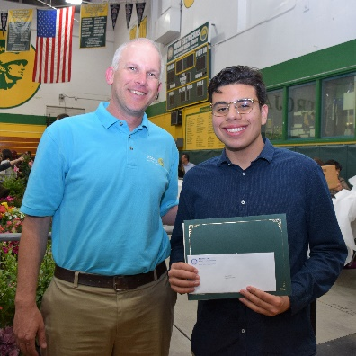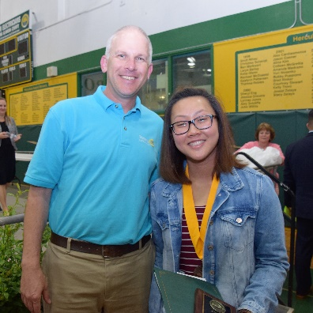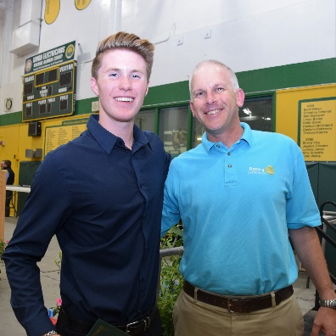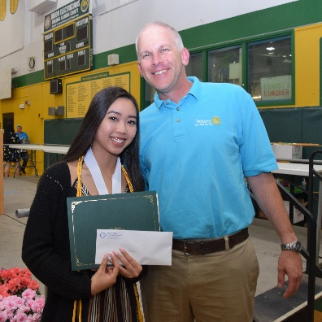
(Left to Right with Dan Willits) Castro Valley High School Seniors Juan Herrera, Jessica Wong, Samuel Prettyman, and Trang Ha.

Making A Difference Starts in Castro Valley

