Rotary Club of Castro Valley
Meeting Highlights – May 23, 2017

Lunch Speaker: Rachel Rosen, Founder of SPARK for Humanity
Rachael Rosen is a leadership coach and helps communities unleash their potential to work together and build trust. The process all starts with a game, which sparks meaningful connections and conversations, and allows the participants to openly share their experiences and beliefs. All S.P.A.R.K. experiences uphold and emphasize shared agreements, which allow for a unique experience:

Show up authentically and with love
Pause, listen with fearlessness and intentionality
Ask. Don’t assume. Show courageous curiosity rather than certainty
Respect multiple perspectives and see one another as equals
Kindly expect some messiness. Create space for vulnerability

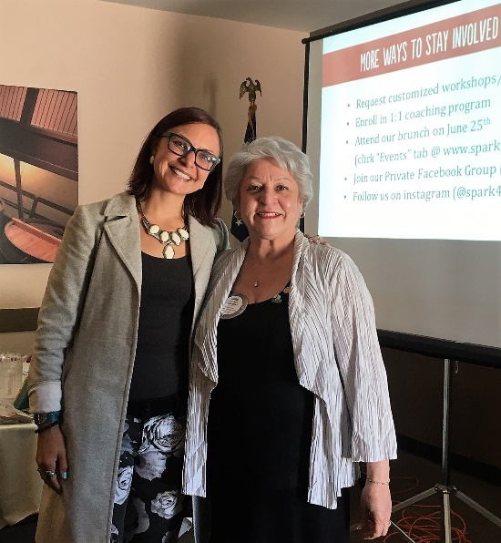
All participants uphold the “Vegas Rule,” whatever is said in the circle stays in the circle. For centuries, our ancestors sat in community by the fire to break bread, share stories, and solve problems. Fires have played a very significant role in the development of humanity across all religions and regions. The presence of fire ignites something unique in communities and that is what this game intends to do as well.

The S.P.A.R.K. experience is designed to normalize unfiltered, honest, and authentic reflections. The guiding principles of S.P.A.R.K. for Humanity are

-incorporate customer feedback
-to stay open to possibilities emerging with each version
-to celebrate the power players
-to bring joy and love to this work
-to build connections and collaborate with others

Further information is available at www.facebook.com/groups/1702656976653745/.

Chili Cook-off and Parade
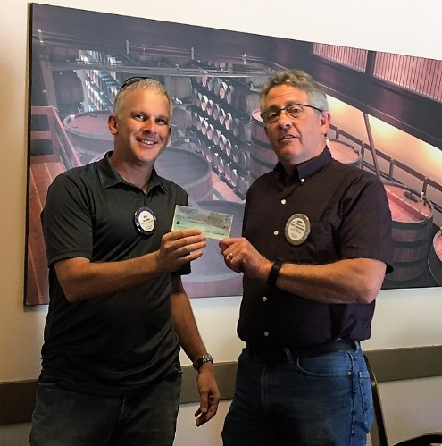
Bill Nott, Dan Willits, Randy Vanderbilt, Bruce Johnson, and Jerry Soohoo shared their personal experiences and impressions Chili Cook-off and Rodeo Parade. Overall, the two events were a smashing success.

Parvin Ahmadi talked about the 5 scholarships that the events fund. John Aufdermauer reported that $1400 was generated from cookies sales by his wife, Bobbie, with a match from Chevron. President Carol thanked all the volunteers who worked at the Chili Cook-off and Rodeo Parade – may who worked both events - and deserve THANK YOU from all Club members and the community.

Photos by Gary Bosley and Jim Negri from the Chili Cook-off
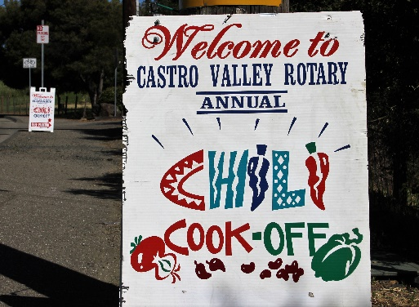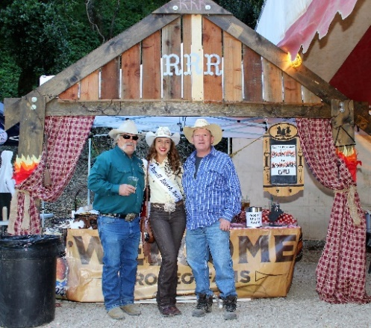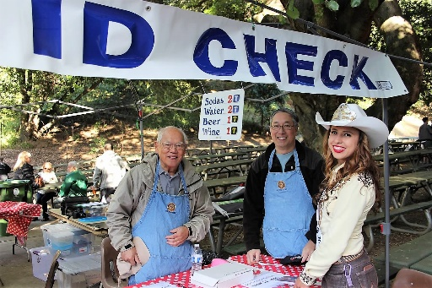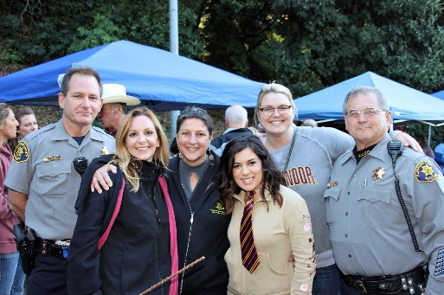
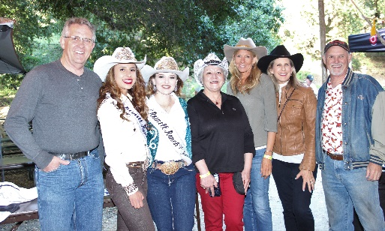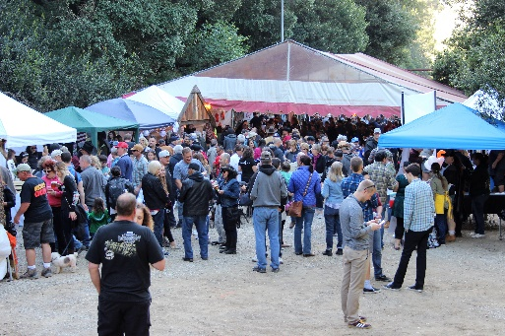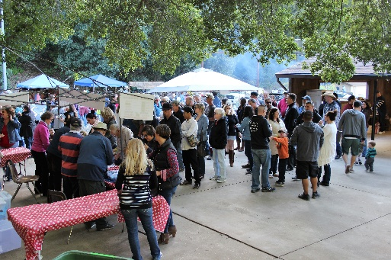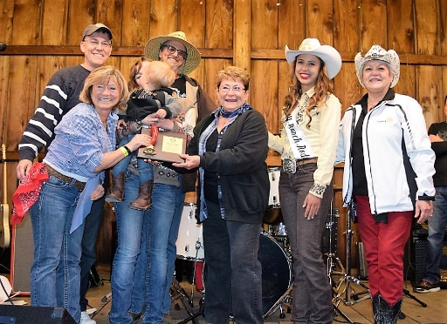

To see more photo from Gary Bosley, go to https://chilicookoff2017.shutterfly.com/23#5
Next Lunch Meeting: May 30, 2017
Speaker: AT Stephens, Executive Director - Hayward Area Historical Society
The Hayward Area Historical Society promotes an understanding of our shared history and the challenges and opportunities of the future by collecting, preserving and interpreting the diverse heritage of the East Bay community.
&
Randy Vanderbilt showing his Castro Valley History film
