Rotary Club of Castro Valley
Meeting Highlights - May 28, 2019

Chris Velbusa, General Manager of Alameda County Industries (ACI)
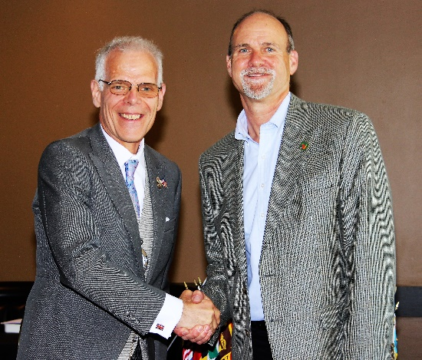
The Castro Valley Sanitary District (CVSan) recently selected Alameda County Industries (ACI) to provide residential, commercial and industrial collection services for recyclables, organics and garbage in the service area of Castro Valley for which CVSan is responsible. The change of providers was effective for May 2019.

Chris Velbusa, General Manager of Alameda County Industries (ACI), provided an overview of ACI and the services that it provides. ACI is the franchised hauling company for Alameda, San Leandro (excluding the area served by Oro Loma Sanitary District), and, in October 2019, San Ramon. ACI is a privately-owned company located in San Leandro and is wholly owned by San Francisco Scavenger Co., Peninsula Sanitary Service, and Pleasanton Garbage Co. At Present, ACI has a capacity of handling 1.2 billion pound of waste and has 215 employees. The Material Recovery Facility of ACI has a capacity of handling 225 tons per day and the Solid Waste has a capacity of handling 620 tons per day. At present, the transfer operation handles 100 ton per day.

The ACI contract with CVSan includes the following special features:
- It is initially a 10-year service contract.
- The rates charged by ACI are based on actual operating costs.
    - CVSan can perform a financial and operations audit every two years to ascertain that their operating costs are justified and revise the rates paid by the customers based on actual operating costs.
- ACI has a goal of diverting 90 percent of the collected waste as recyclable and/or organic waste and minimize waste for landfill.
    - ACI does not own any landfill or burial areas; therefore, it is in their interest to minimize waste for landfill.
- Source Reduction - ACI, in co-operation with CVSan, is planning to launch program for educating the waste generators to properly segregate all generated waste and minimize waste for land fill.
- ACI has converted all their waste collection vehicles to natural gas operated vehicles and has invested in a Compressed Natural Gas (CNG) plant, which results in reducing pollution.
- ACI wants to be partners with the community they are serving.
  - Recently they participated in the Rotary Club of Castro Valley Chili Cook-off winning 2nd Prize for their chili.
  - More information about ACI and it partnership with CVSan is available at https://www.alamedacountyindustries.com/cvsan/faqs/
Photo: Chris Velbusa (R) presents Roland Williams, CVSan General Manager and Castro Valley Rotarian, with a check along with a matching contribution from ACI for CVSan for Community Projects. (Photos by Gary Bosley)
Announcements:
- Parvin Ahmadi showed off the bags to be used in The Children's Literacy Project that the Rotary Club of Castro Valley is sponsoring ($5,000 in FY2018-19) along with the instructions for the parents/guardians to maximize the usefulness. of these bags. Congratulations and a huge thank you to Parvin and the Castro Valley Unified School District for initiating the outstanding project to serve child in the community.

