Rotary Club of Castro Valley
Meeting Highlights
May 29th, June 12th & June 26th

Greg Hitchan – Tri-Valley Ventures
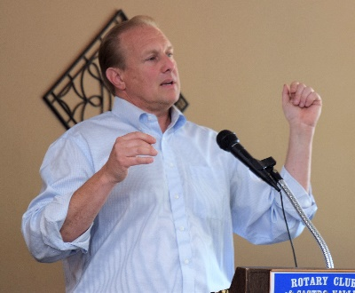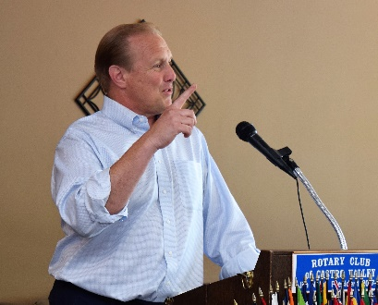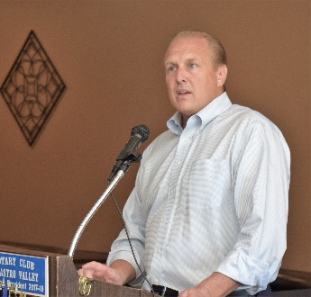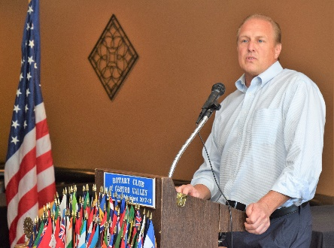
On June 26th, Greg Hitchan was the program speaker. Greg is the Founder and Managing Partner Tri-Valley Ventures. Greg has over 20+ years of experience in the investment business, having represented both public and private companies in mergers and acquisitions and as a Partner and Chief Operating Officer at Blum Capital Partners, a multi-billion-dollar San Francisco based private equity/hedge fund. Greg has invested in, advised and/or served on the Board of Directors of dozens of early stage private technology companies in the last several years through Tri-Valley Ventures and its predecessor investment entities. Greg shared stories of meeting the Dali Lama and former President Carter while working at Blum Capital Partners. Greg is a graduate on the U.S. Naval Academy, Defense Intelligence Agency and Stanford Law School.

Tri-Valley Ventures is the region’s first early stage venture fund identifying, investing in and partnering with founders and early stage business leaders in the East Bay. He described the type of businesses in which Tri-Valley Ventures and noted the initial investments are in the $250-500M range. Greg described the many advantages that the Tri-Valley possesses which makes it a great area in which to invest (e.g., location, transportation, higher education, types of businesses).

Greg is a resident of Pleasanton and married to KPIX news anchor Juliette Goodrich. More information about Greg is available here.

The Pleasanton Weekly had an excellent article on Tri-Valley Ventures and Greg. Read the article here.

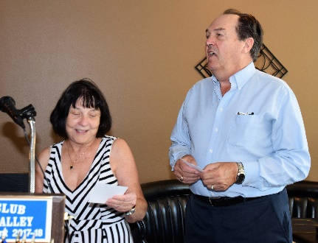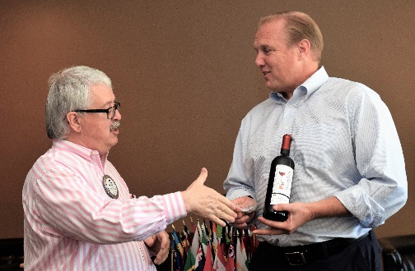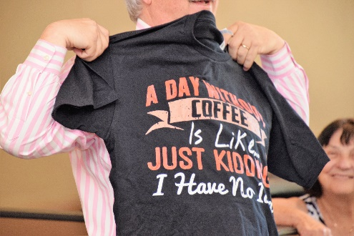
June 26th saw prospective member Ralph Yarnell help Ceta lead the Song of the Day. Ralph has already completed one task on his way to a Blue Badge. This was Jim Negri’s last meeting as President. Heidi Hausauer presented Jim with several gifts including this T-shirt. Jim thanked everyone for a great year.

* * * * *

Sherry Yarnell – Yarnell Jewelers
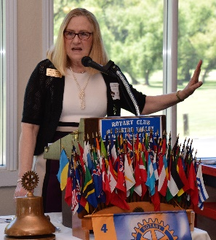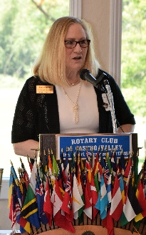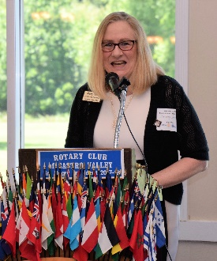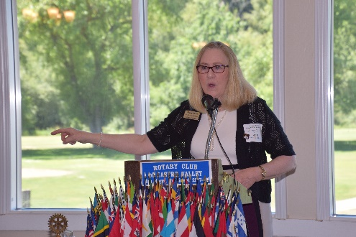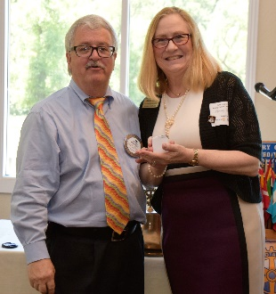
On June 12th, Sherri Yarnal was the program speaker. Sherry briefly touched on what is happening at the 580 Marketplace and the impact on her business. She spent most of her presentation focusing on current trends in the jewelry business, but more importantly, the specialized services that Yarnal Jewelers can provide its customers.

Sherry and her husband Ralph run Yarnal Jewelers. The staff is Gemological Institute of America (GIA) trained and certificated to provide outstanding service. Yarnal Jewelers offers unique collection of custom-designed jewelry, engagement and wedding rings, and new and estate jewelry. Additionally, Yarnal Jewelers is a full-service jeweler offering expert appraisal, repair, and restoration. Sherry stressed the personalized service that she and the staff provide. Sherry finished the presentation with a very informative Q&A with the members.

Sherry and Ralph Yarnal are prospective members.

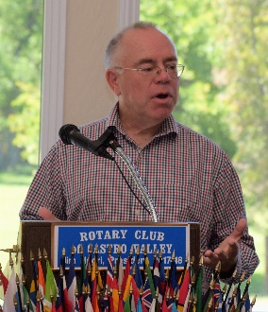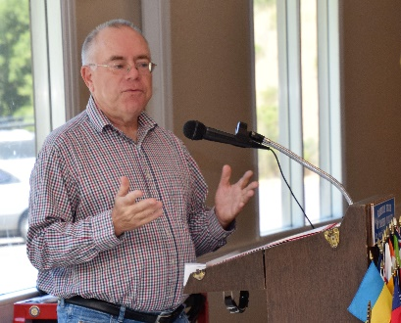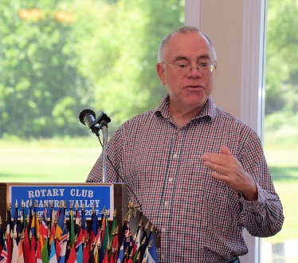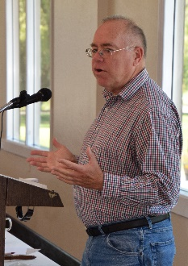
Craft Talk - Gary Howard
Gary Howard is a member of the Castro Valley Unified School District Board of Education. He was first appointed to the board in 2013 to fill a vacancy on the board and was re-elected to a four-year term in 2014. Gary received a Ph.D. in biological sciences from Carnegie Mellon University and completed fellowships at Harvard and Johns Hopkins. He worked 22 years as a science editor and writer for the Gladstone Institutes in San Francisco. He recently retired but will continue to edit and write books. He and his wife Shirley have lived in Castro Valley for over 24 years and their two daughters completed their early education at Proctor, Creekside, and Castro Valley High School.

President Jim thanked Gary for sharing and encouraged all members to share their personal and professional experience in a Craft Talk or Membership Moment.
* * * * *

Nima Jafarian - Chief Operating Officer at Stealth Mode AI Startup
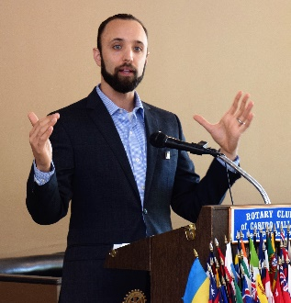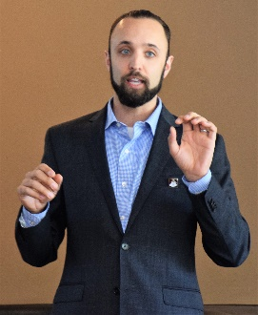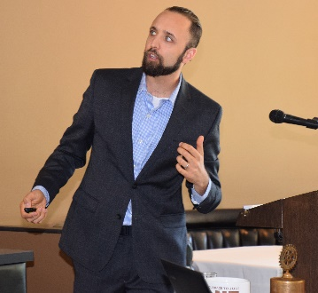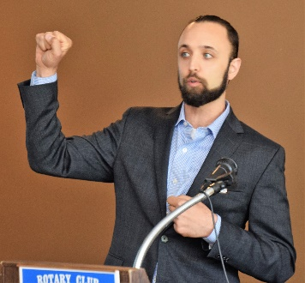
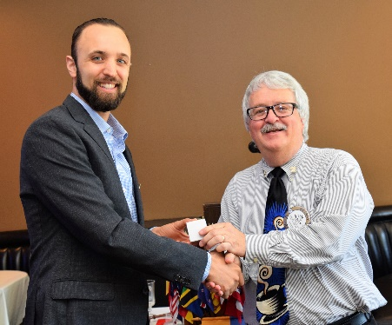
Nima Jafarian, who member Parvin Ahmadi described as “her favorite son in California,” was the presenter on May 29th. Nima recently started as the CEO at Stealth Mode AI Startup, which does not currently have a webpage describing the work it is doing because the company is truly in the startup mode. Nima described his work as working with a brilliant team to do provide users with a better, cheaper, and faster way to use technology to provide medical support to people using technology. He also explained the steps that a startup company goes through to bring a product to market. Nima has worked for several technology companies and describes his work as helping organizations increase revenue and profitability by empowering global teams and delighting customers with fantastic products and technical solutions. He has 10+ Years of experience in the technology sector as a product manager and R&D engineer with a BSEE&CS, MSEE, and MBA. We are looking forward to seeing the technologies that he described come on the market.

* * * * *

Meet the 2018-2019 Rotary International President Barry Rassin
Learn about Barry Rassin, the 2018-2019 President of Rotary International, and his vision and goals for Rotary International in the coming year with this link:
https://www.rotary.org/en/barry-rassin-strikes-balance-between-bahamian-bonhomie-and-decisive-leadership
He will be in the Bay Area for the Presidential Dinner in January. Watch for details.

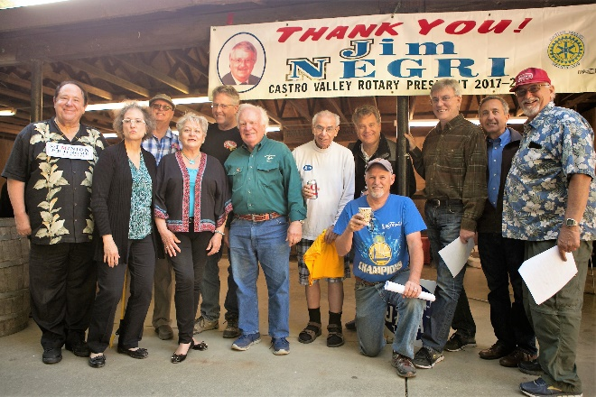
Demotion & John Goa Rotarian of the Year Award
President Jim was properly demoted on the evening of June 19th at Rowell Ranch. Thank you to Jerome Blaha and all the Past Presidents for capturing all of President Jim’s idiosyncrasies. A special thank you to Jerome for putting the skit together.

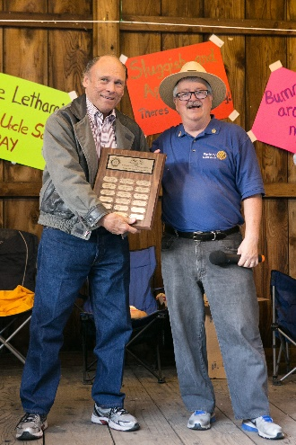
Everyone had a great evening as Jim was demoted and President Charles Mortimer and the 2018-2019 Board were installed. Members will receive a separate email with links to the photos.

Another highlight of the event as the presentation of the John Goa Rotarian of the Year Award as presented by the Club President. This year President Jim Negri name Gary Bosley as the Rotarian of the Year for all his behind the scenes work on arranging speakers for July, August, September, October and November as well as coordinating the Monthly Speaker’s Chair as well as instituting the “What’s New in Castro Valley?” presentations. Gary also served the Board of Directors in 2016-2018. Congratulations to Gary Bosley for Service Above Self.

