Rotary Club of Castro Valley
Meeting Highlight – May 30, 2017

AT Stephens, Executive Director of the Hayward Area Historical Society
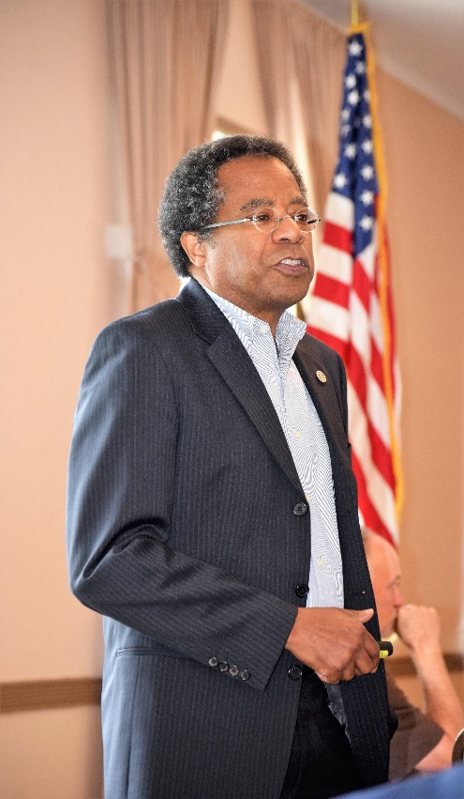
Executive Director AT Stephens, who is also President-Elect of the Rotary Club of Hayward, share the history of the Hayward Area Historical Society (HAHS) as well as what is new and exciting. He identified Marketing, Membership, and Money as the main areas of improvement in the coming years.

On February 28, 1957, 259 community members assembled at the Eden Congressional Church for the first formal program of the organization, a local history lecture by John Sandoval. The official Charter Roll of the Hayward Area Historical Society was signed by 385 individuals and 60 years later the membership is approximately 468 adults and families with more than 1600 Facebook, Twitter, and Instagram followers, and 2500 eNews readers connected with the organization.

The last of a breed of salt farmers, Alden Oliver's bequest in the early 1990'S enabled the Historical Society to hire its first director and professional staff take on the work of preserving and interpreting the historical and cultural hallmarks of our corner of the Bay. In the last few years, HAHS has purchase the former Joseph Magnin on Foothill Blvd. to expand HAHS’s physical presence. The Museum’s outposts (McConaughey House, Meek Mansion, and San Lorenzo Pioneer Cemetery) have logged about 63,000 visitors since June 2014. At the moment, the cost of outreach to the community, classroom visits, local and regional partnerships, curated exhibitions, and public programs draw more from HAHS’s reserves than donations. Future success depends on real and substantial grants and fundraising efforts.

At this time, HAHS has many programs for toddlers and young students, and works with CSUEB students, community members, and Community Multimedia Academy(CMMA). Club members are encouraged to visit HAHS and become members to support the great work taking place.

More information available at http://www.haywardareahistory.org/

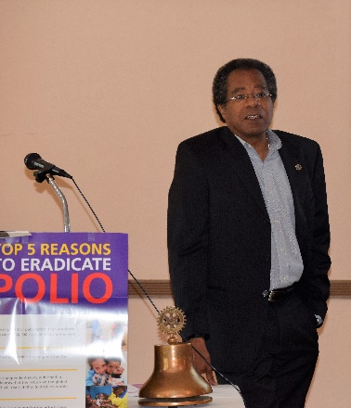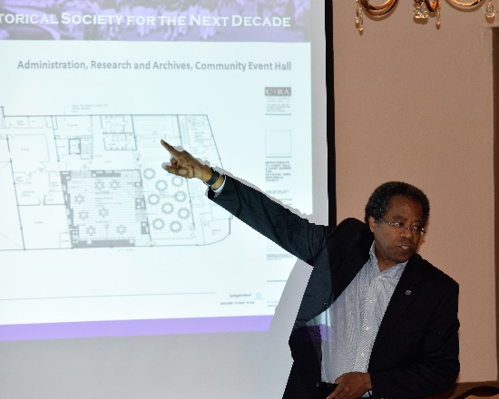
HAHS Executive Director AT Stephens describing future plans for HAHS.

Castro Valley History
Club member Randy Vanderbilt presented an abridged 15-minute version of his video on the History of Castro Valley. Honorary Rotarian Lucille Lorge, another local historian, was in attendance.
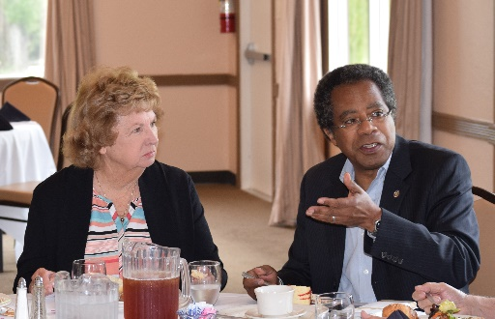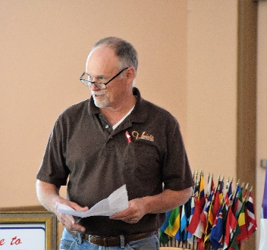
Lucille Lorge having lunch with AT Stephens and Randy Vanderbilt introducing his Castro Valley history film

End Polo Now
During the next four weeks, Rotary District 5170 is conducting a “flash campaign: to raise funds to End Polio Now. Through the efforts of Rotary and its partners, the world has seen 99% drop in the number of polio cases. The District 5170 Polio Chair is requesting that each member to contribute at least $26.50 to The Rotary Foundation (TRF) to support the End Polio Now campaign. All donated funds will be matched 2-to-1 by the Bill and Melinda Gates Foundation. President-Elect Jim Negri distributed information regarding that campaign and showed this one minute video: https://vimeo.com/77272023 (You may need to copy the URL to your browser.)

If you did not make you donation of $26.50 on Tuesday, bring a check to the next meeting. We are shooting for 100% of the members contributing. Thank you.

Eagle Scout Project
Earlier this month, Club members contributed over $500 to Luc Dochterman’s Eagle Scout project, a storage container at Castro Valley Elementary School. Actual work with take place on June 10, but members on needed to help on June 2-4 as well as June 10. Please contact Ceta directly to volunteer. Even an hour will help.

Looking Ahead
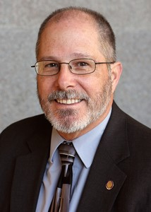
June 6 Lunch meeting with EBMUD Director Frank Mellon – “Is the drought really over and what is with those rates?

June 13 Lunch meeting with Castro Valley Women’s Club President Carolyn Darcy

June 20 Dark at lunch
Presidential Demotion at Rowell Ranch at 5:00 p.m.

June 27 Lunch meeting

June 28 Board of Directors meeting

July 4 Dark at lunch

