Rotary Club of Castro Valley
Meeting Highlights - May 8, 2018

Nancy O’Malley, Alameda County District Attorney
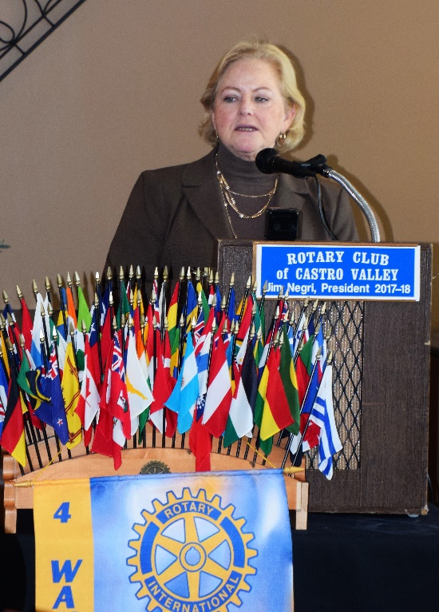
Alameda County District Attorney Nancy O’Malley provided an overview of the wide-range of programs and services in the District Attorney’s Office but focused on human trafficking and her work through the research institute H.E.A.T. (Human Exploitation and Trafficking). As District Attorney, she oversees a staff of approximately 400 employees. District Attorney O’Malley was appointed by the Alameda County Board of Supervisors in September 2009. Subsequently, she was elected unopposed to the position in November 2010 and 2014. Nancy is a member of the Rotary Club of Oakland. More information on DA Nancy O’Malley is available here.

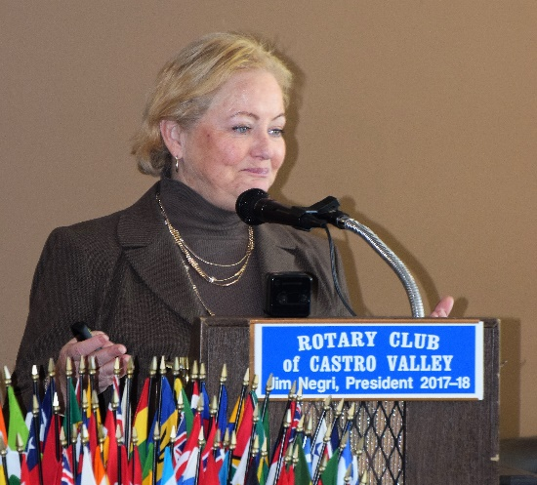
District Attorney O’Malley is one of the pioneers in addressing the issue of Human Trafficking including Sex and Exploitation in our communities. She believes that education is the most important tool available to combat these crimes. She stressed the need to use smart solutions in safeguarding our communities. Early childhood literacy, improving school attendance, serving and empowering by investing in children and family, improving Youth education, and employment opportunities can all help address the issues. Prevention and enforcement are both required in addressing the criminal conduct in these situations. The H.E.A.T. Institute has a five-point program for addressing Human Trafficking. The DA’s Office has recorded more than 600 convictions than involve more than 100 victims of human trafficking.

District Attorney O’Malley is responsible for establishing DAJA (District Attorney’s Justice Academy) for high school students in three areas of Alameda County. Professionals in various areas of the law address the students throughout the year-long program as well as participate with speakers as mentors. Of the students that have participated in DAJA over the year, 100% have gone on to higher education. The participating school have a very high positive impression of DAJA.

Safe Place Alternative (SPA) is another initiative of District Attorney’s Office for engaging youth and educating the community. SPA provides immediate temporary shelters for victims of human trafficking with the assistant of Catholic Charities. For a complete overview of the program and services provided by the District Attorney’s Office, go here. District Attorney Nancy O’Malley participated in the Rodeo Parade.
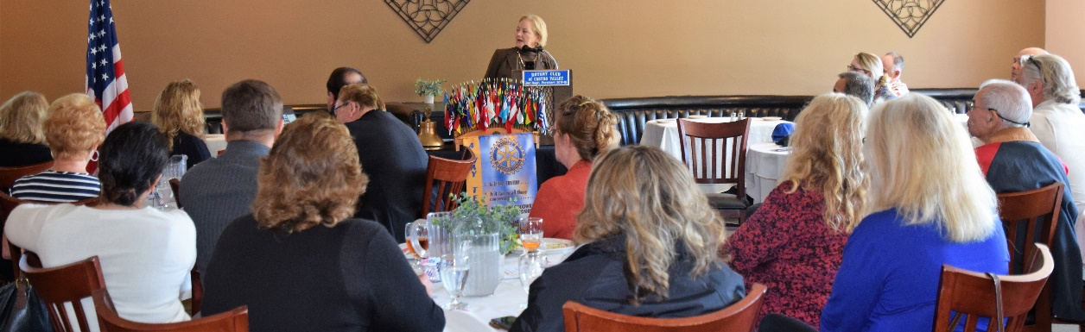
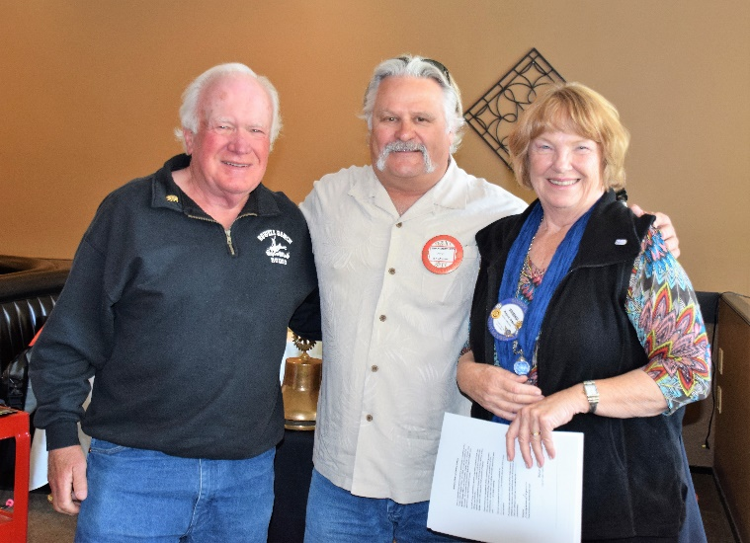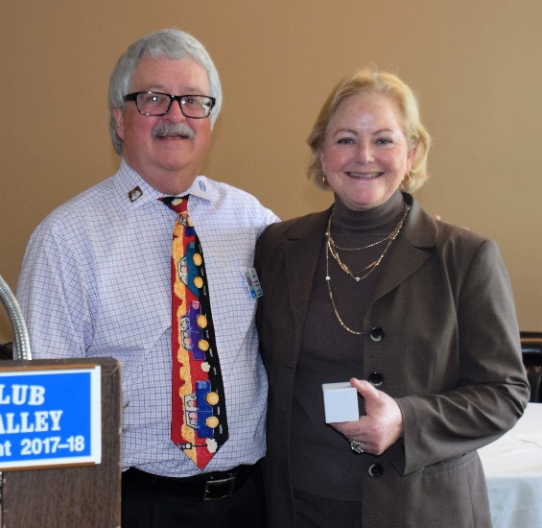
(L-R): The Club welcomed its newest member, Brian Morrison (center) with his sponsor, Dwight Perry (left), and Membership Chair, Virginia Degner. President Jim Negri presented District Attorney Nancy O’Malley with a Rotary thank you gift.

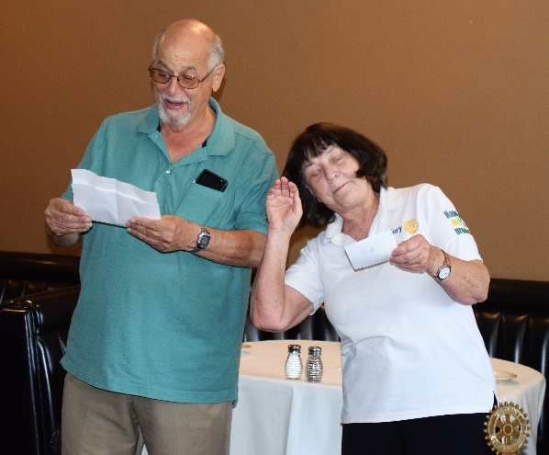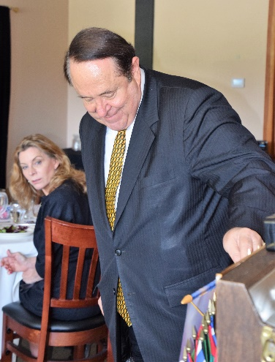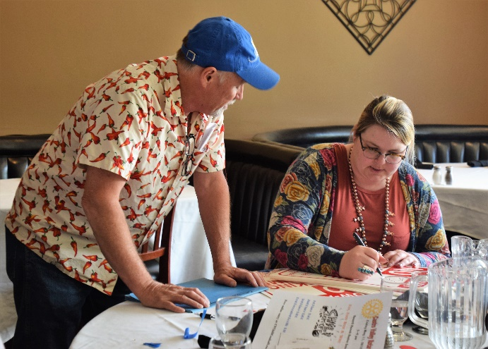
(L-R): Bill Nott and Ceta Dochterman lead the Song of the Day. Jerome Blaha leads the Four Way Test. Randy Vanderbilt and Ashley Strasburg prepare the No Parking signs for the Rodeo Parade.
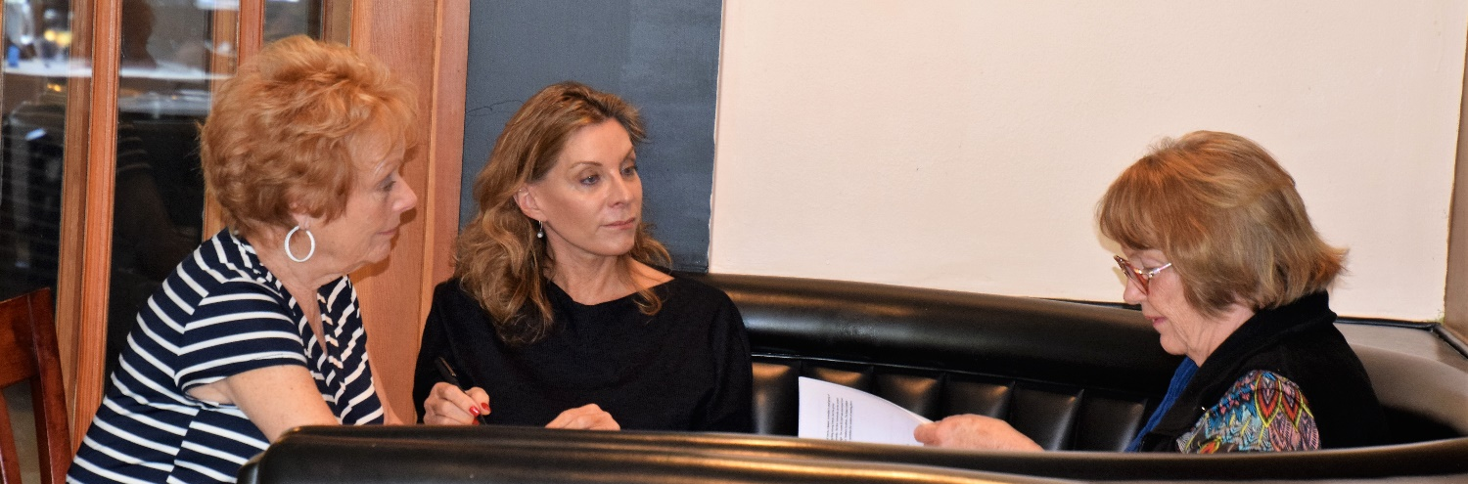
Membership Chair Virginia Degner (R) leads a new member orientation session for Carol Bigelow (L) and Sharon Leighty (C).

