Rotary Club of Castro Valley
Meeting Highlights
May 9, 2017

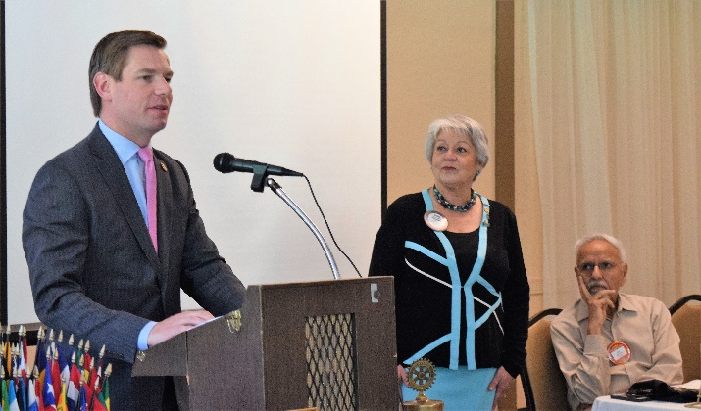
Lunch Speaker: Congressman Eric Swalwell, who represents California 's 15th Congressional District, was the featured speaker of the day. He was first elected to Congress in 2012 and is now serving his third term.
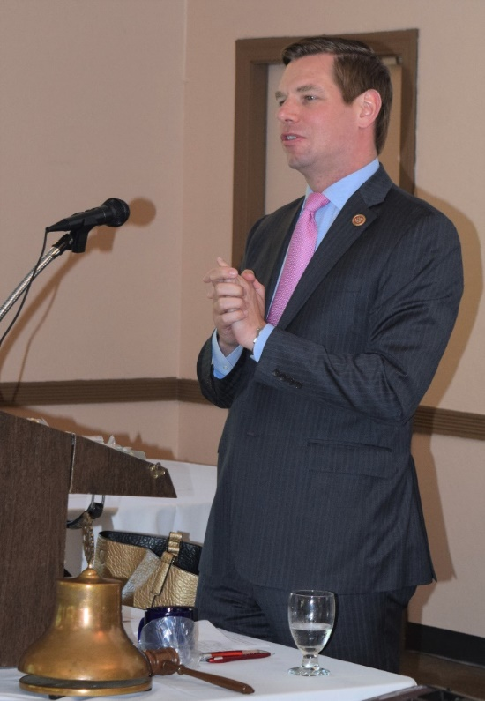
Growing up as the oldest of four boys and son to Eric Sr., a retired Police Officer, and Vicky, who works as an administrative assistant, Eric attended public schools in the East Bay. Receiving a Division 1 soccer scholarship was his ticket to becoming the first person in his family to go to college. During college, he worked as an unpaid intern in the office of Congresswoman Ellen Tauscher, and was on Capitol Hill on September 11, 2001. This inspired his first legislative achievement: using his Student Government Association position to create a public-private college scholarship program for students who lost parents in the attacks.
After earning his undergraduate degree and law degrees from the University of Maryland, Eric returned to the East Bay to serve as a prosecutor in Alameda County District Attorney's office for seven years. He also served as Chairman of the
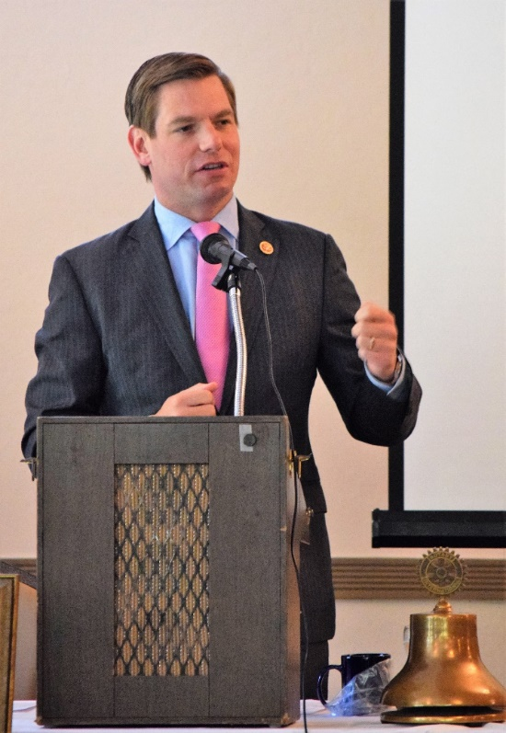
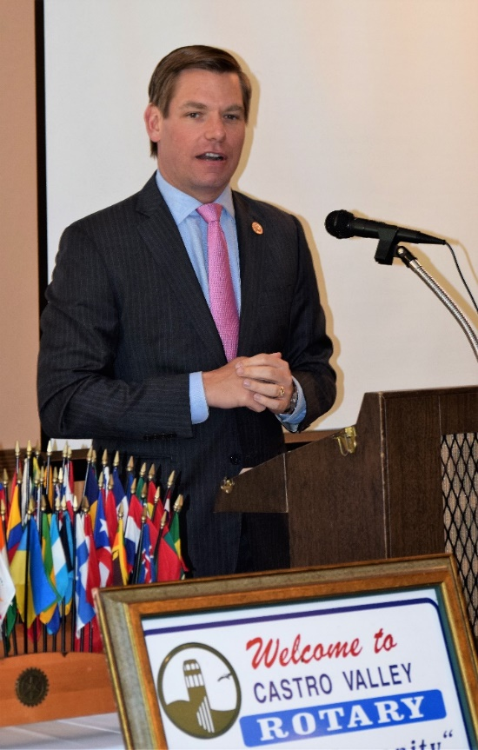
Dublin Heritage & Cultural Arts Commission, on the Dublin Planning Commission, and was elected to the Dublin City Council. In 2012, Eric was elected to represent California's 15th Congressional District. His first term legislative accomplishments include two of his bills signed into law - tied for the most bills signed from any freshman member of his class - including one that incentivized Charitable Giving after Hurricane Haiyan devastated Philippines. While serving on the Homeland Security Committee in his first term, he led a successful effort opposing a TSA proposal to allow certain knives planes and advocated for enchaining airport perimeter security with innovative technologies.
At present, Eric serves on the House Permanent Select Committee on Intelligence, and believes in protecting Americans is Congress's most solemn duty. He is the top Democrat on the Subcommittee on the Central Intelligence Agency (CIA), responsible for oversight, policy, activities, and budget of the CIA. Eric also serves on the House Judiciary Committee where he brings his perspective as a prosecutor on criminal justice issues while also addressing issues such as: voting rights, LGBT equality, comprehensive immigration reforms, and protecting a woman's right to make her own health care decisions.
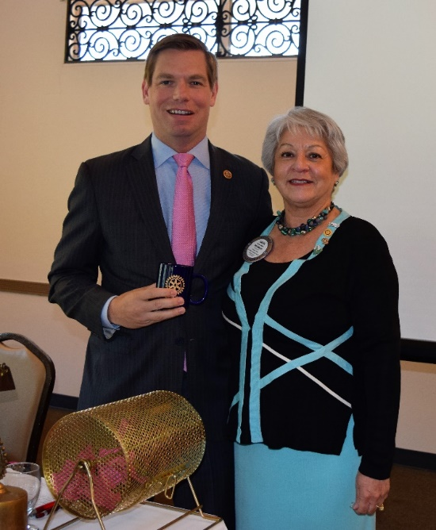
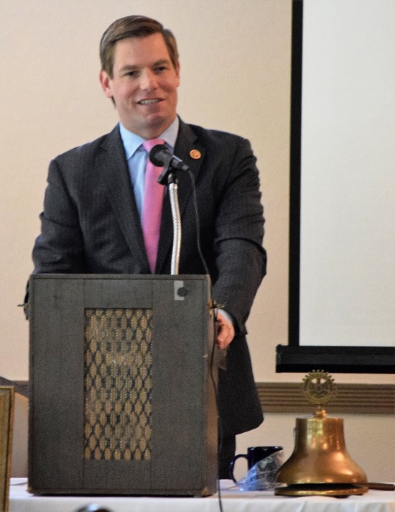
Eric also chairs the Future Forum, a group of 20 young Democratic members of Congress focused on issues and opportunities for millennial Americans including student loan debt and home ownership. He is co-chair of bipartisan caucuses United Solutions Caucus, Congressional Soccer Caucus, and Sharing Economy Caucus. In addition, Eric is a member of many other caucuses including, Ad hoc Committee for Irish Affairs, Animal Rights Caucus, Anti-Bullying Caucus, Congressional Asian Pacific America Caucus, Congressional Dyslexia Caucus, Cybersecurity Caucus, Democratic Whip's Taskforce on Poverty and Opportunity, Diabetes Caucus, Friends of Ireland, Future Caucus, High Tech caucus, India Caucus, International Religious Freedom Caucus, Internet Caucus, Science And Labs caucus, Sikh Caucus, Tom Lantos Human Rights Commission, Victim's Rights Caucus and Wine Caucus.
The Club appreciated the time that Congressman Swalwell spent sharing his background and issues facing the district and country.

Red Badge Inductions
Inducting new members to the Club is always a special occasion. President Carol inducted two new Club members, Diana Del Masso and Tim Sbranti, and challenged them to bring in a new member within 90- days.
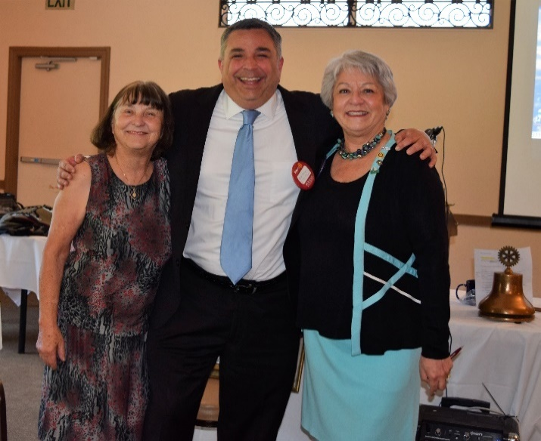
President Carol Wikle and sponsor Ceta Dochterman present new member Tim Sbranti with his Red Badge. Tim is the Deputy District Director for Congressman Eric Swalwell. He is the former mayor of Dublin.
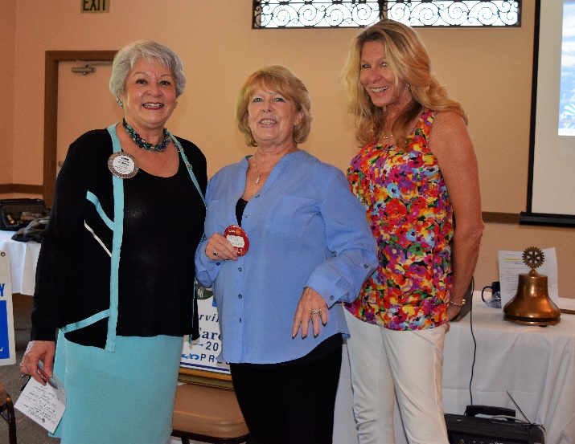
The Rotary Foundation (TRF)
President Carol Wikle and Sponsor Dawn Ortiz present new member Diana Del Masso with her Red Badge. Diana is the owner of Bay Produce, a local food distributer

Today, the Club had the opportunity to make three special presentations related to The Rotary Foundation.

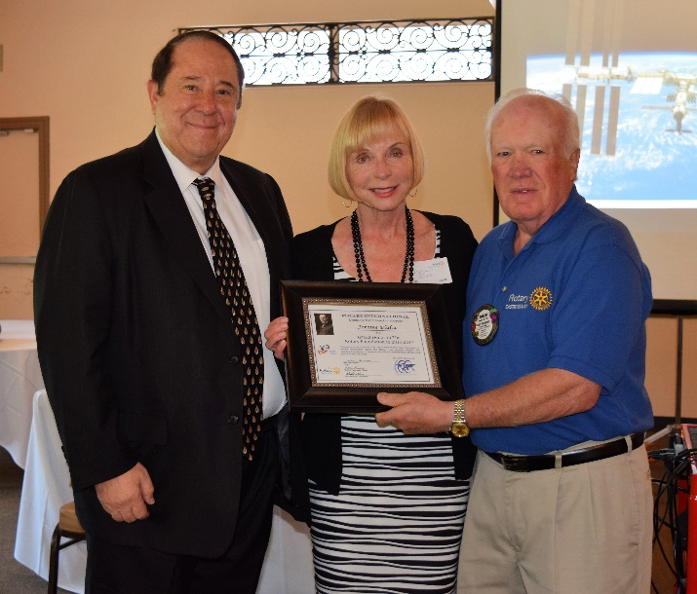
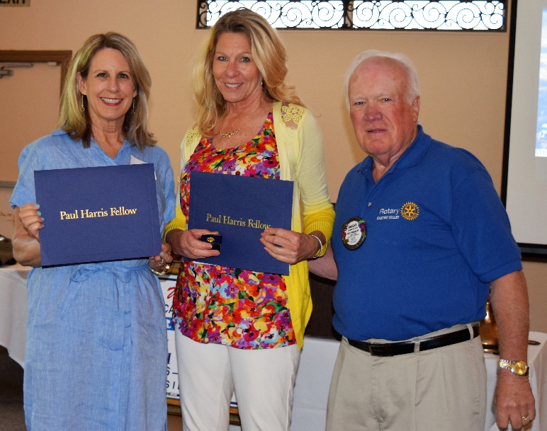
Dwight Perry presents Paul Harris Awards to Leslie Poniatowski (left) and Dawn Ortiz (right). Leslie was honored by her husband, Mark.
Dwight Perry presents Jerome Blaha with a District Recognition as a District 5170 Grand Donor to The Rotary Foundation (TRF) for 2016-2017. Jerome is joined by his wife, Melanie.

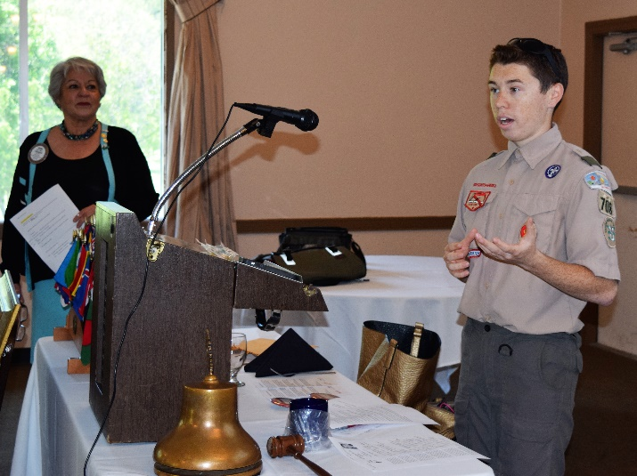
Boy Scouts of America
The Rotary Club of Castro Valley sponsors BSA Troop 708 in Castro Valley. Luc Dochterman, son of Rotarian Ceta Dochterman, is working on his Eagle Scout project, building a storage shed for Castro Valley Elementary School. Luc spoke to the Club about the project and requested fund for supplies. President Carol contributed her $300 per month Presidential fund and members contributed another $503 as part of "Passing the Hat." If you are interested in helping Luc on the project, he will be working on Saturday, June 3. Contact Luc or Ceta for details.
