Meeting Highlights for October 26, 2021

The Club heard outstanding presentations by Hayward City Councilmember Sara Lamnin and Castro Valley Forum Editor Michael Singer as well as many announcements about the great work in which the Club is currently engaged as well as work in the pipeline.

Below is a short synopsis of each presentation. Be sure to watch the video presentation and review the slides to more fully understand and appreciate each presentation.

Hayward Councilmember Sara Lamnin
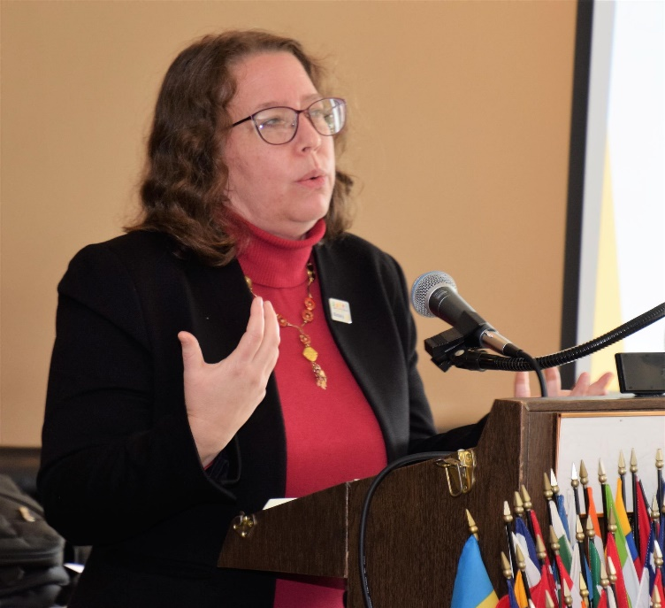►Described how she become involved in politics: (1) learning about the Constitution in junior high school; (2) working in the nursing home industry in South Hayward starting in 1996; and (3) working to support the Patients' Bill of Rights Act of 1989, which was never brought to the floor of the House for a vote.
►Discussed her work since 2014 when she was elected to the City Council, especially her involvement with the youth of Hayward.
►Reviewed her currents efforts with the Alameda County Coalition on Fair Redistricting. She noted that the greatest challenge is that the issue is "flying below the radar" despite its importance to the communities. (See graphic below.)
►Answered questions on (1) homelessness in Hayward, (2) the challenges of redistricting, and (3) what is happening with Skywest Golf Course.
►Described a new version of the 4-Way Test (See graphic below.)
►Be sure to check out Sara's "Whoo Whoo Story" in the video. You will be touched.

Click here to watch the video of the presentation and here for her slides.

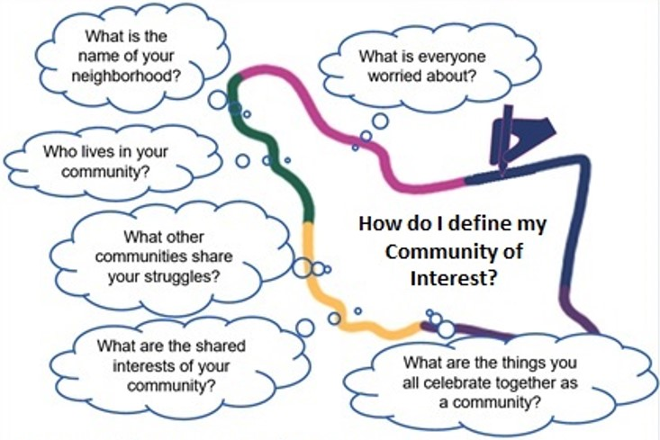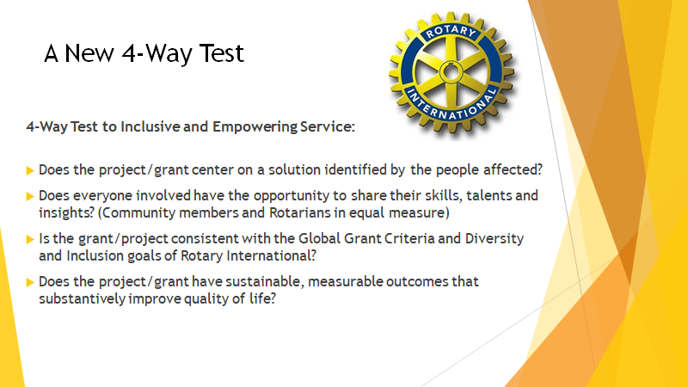
Michael Singer, Editor of the Castro Valley Forum
Michael was born in Haward, moved to San Lorenzon, and in 2005 moved to Castro Valley, citing the quality of the schools as an important reason. Early in his career, he was a report for Channel 30 in the Tri-Valley, but mentioned that he did not like reporting in the rain. Michael later worked as a reporter for CNET, The Economist, and Information Week before coming to the Forum in 2007.
Michael began with a history of the Castro Valley Forum, which was founded in 1987, and its current distribution number before recognizing the outstanding work of Forum founder Fred Zehnder. Michael strives to focus on the human side of the issues.
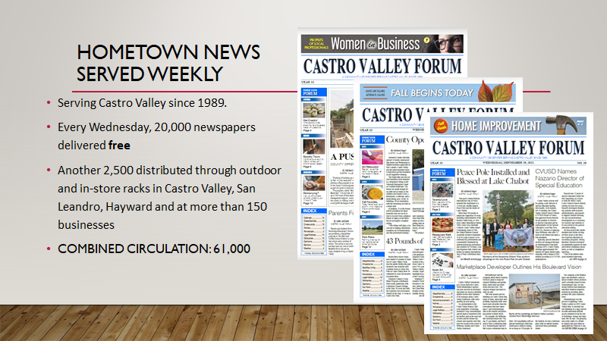
Focusing on the different sections in the paper as well as the Special Sections, Michael explained how the Forum seeks to provide independent community news and stories with integrity. Current issues of the Castro Valley Forum as now available online at MyCVForum.
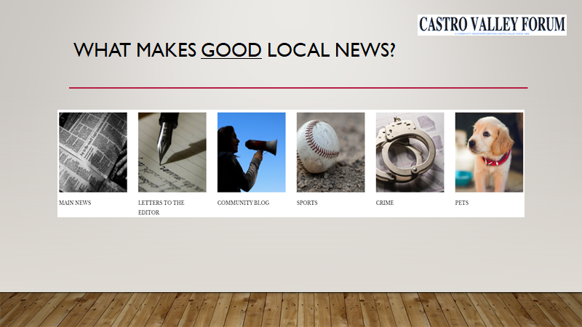
Before answering questions, Michael focused on what the community can do to support the Castro Valley Forum: keep advertising, keep providing the Forum with news and stories, and talk to people about the value the newspaper brings to the community.
President Dwight and others commended the Castro Valley Forum for the coverage and support that it has provided the Rotary Club of Castro Valley over the years.

The announcements for the day included
- Information regarding the Trunk or Treat on October 30
- That the rained-out Mixer at Dig Deep Farms will be rescheduled after the first of the year
- Via President Dwight, an update from Obse Lubo and Carol Wikle who attended the Breathing for Life (BFL) dedication in Nejo, Ethiopia.
- Donations and information regarding the Wheelchair Foundation fundraising and two trips next year.
- A report on the Polio Plus campaign - When the campaign started in 1988, there were 350,000 cases of polio annually in the world. As of last week, there are only 2 cases.
- Planning meetings for the Chili Cook-off and Rodeo Parade are scheduled for November 2.
- The Board of Directors will meet on November 9.
- Click here to watch all the announcements.
- Click here to see photos from the meeting
Check ClubRunner for upcoming meetings and events.

