Rotary Club of Castro Valley
Meeting Highlights – August 22, 2017
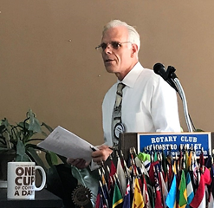
President-Elect Charles Mortimer presided over the meeting today in the absence of President Jim Negri who took a short vacation to view the eclipse in Oregon, but made sure his coffee cup was present. Thank you to Ajay for the Highlights and to Murline and Bruce for the photos.

How to Manage Your Intellectual Property (I.P.) Assets
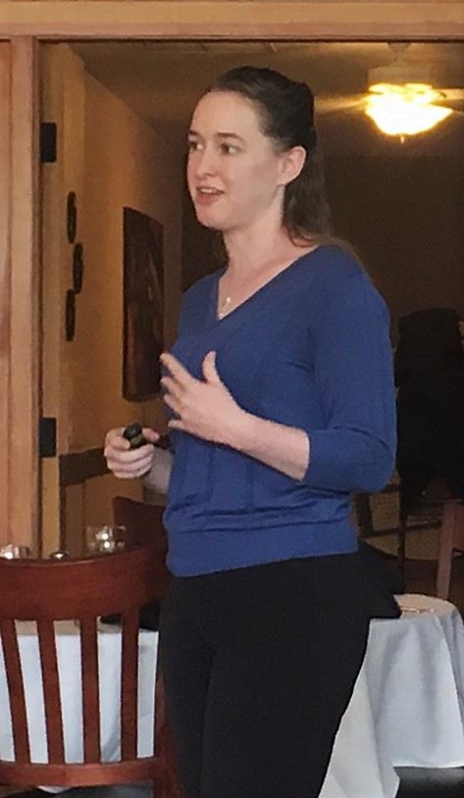
Speaker Chair Gary Bosley introduced Kelley A. Way, who is a member of California Bar and practices Copyright, Trademark, and Estate Planning Law at the Law Office of Kelley A. Way at Walnut Creek. Her presentation explained what I.P. assets are, what you need to know to manage them properly, and the differences between Copyright, Trademark, and Patent and how these tools can be used to protect your I.P. assets.

- A Copyright keeps your original work - Songs, Books, Articles, Art, Photographs and more - safe from being used without your consent. It protects your rights of reproduction, right of derivative works, right of distribution, right of public performance, display and transmission. Copyright laws allow the author rights for a limited period. Works published prior to 1978 had a life of 28 years from the date of original publication, which has been updated up to 95 years. Copyrights granted prior to 1923 have expired. The author can reclaim rights 35 years after their expiration in some cases.

- A Trademark is a Name or Symbol used in commerce, anything used to identify a product for sale, delivery, or production. The trademark lasts as long as it is used in commerce and is considered abandoned, if not used for 3 years. Trademark can be lost if it has become generic.

- A Patent is a Discovery, Invention, or a part of machine Design. Design Patents are granted for 14 years term. Utility Patents are granted for 15 years. Most of the Patents (about 90%) have life of about 15 years and must pay a maintenance fee to keep these alive.

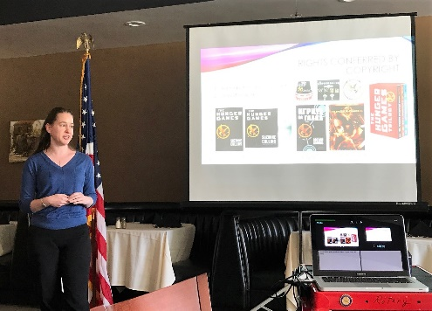
All Copyrights, Trademarks, and Patents are registered to prevent infringement. If an infringement is detected, the first step is a letter to Cease and desist. in case of Noncompliance a lawsuit can be filed for claiming financial damages. All Transfer of Ownership of Patents, Trademarks and Copyrights are considered as part of sale of the Business unless otherwise specified.

Ms. Wray has generously provided an outline of her presentation, which will be attached to the email of this Meeting Highlights.

Announcements
- Heidi Hausauer passed around Get-Well cards for KJ Page who has an appendix operation and for Mathilde Schmidt who broken her hip.
- CVUSD Superintendent Parvin Ahmadi invited members to visit Castro Valley High School classes as part of the Castro Valley Community Alliance outreach.

Upcoming Events
Speakers
August 29 Susan McCue – Alameda County Economic Development
September 5 Michael Mahoney – Eden Health District
September 12 Rick Silva – Business Networking and Referral Generation
September 19 Michael Moody – John Muir Health Partnerships and Affiliations
September 26 Panel on Home and Business Fire Prevention

- September 9-10 - Castro Valley Fall Festival – Rotary working a Beer & Wine Booth on 9/10
- September 27 - Board of Directors Meeting at 6:00 p.m. Chamber of Commerce Office

Random Shots
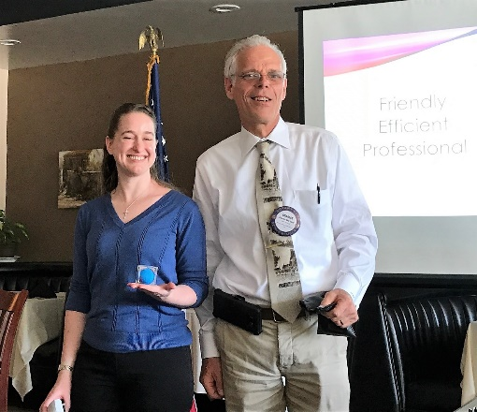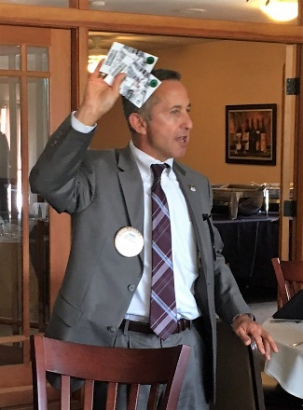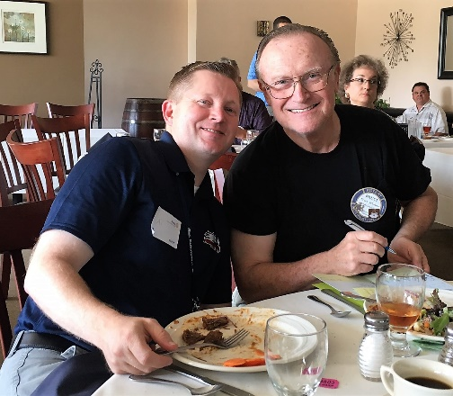

MAKING A DIFFERENCE
STARTS IN CASTRO VALLEY

