Rotary Club of Castro Valley
Meeting Highlights – August 8, 2015

Christoph Nauer: Success Breeds Success – Personal to Business
Murline Monat introduced Christoph Nauer, a business strategist and author, as the Speaker of the Day.

Christoph stated by stating that to have a successful business strategy one has must have a successful strategy for life. The first step on the road to success is to set goals for life in at least six categories: Health; Relationships; Finances; Time Management; Education; and Spirituality. The goals in each category should be SMART goals (Small, Measurable, Achievable, Realistic, Time bound). The next step is to define strategies and tactics (the What and How) and the Who (e.g., Do it yourself; Get help from others; Get it done for you; or Do not do it). The next step in the process is to develop a daily or weekly routine for achieving the goals followed by creating a schedule and following it. Christoph stressed removing artificial, self-imposed deadlines and taking control of your schedule.

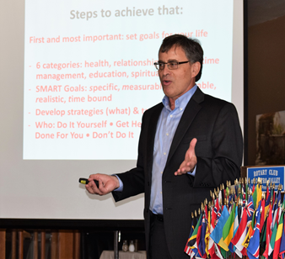
HOW TO PLAN YOUR DAY:

- Define prospects
- Plan your appointments
- Take care of your health
- Define time for Meals, for getting up, and for sleep
- Plan your phone calls and evaluate the need for making the calls
- Learn to delegate and define what you need to do for yourself (e.g., what to do for reducing your stress)
- Review all your time commitments, prioritize, and assign time for each task
- Schedule and follow your schedule. There is limited time available each day and time can have future value
- Learn to manage your time (time management is a learned skill)
- Practice and revise your schedule to get maximum benefit from the time assigned for each activity. Some activities produce better results than others.
- Allow time for reviewing what works and what does not.

TIME WASTERS:

- Management by crisis
- Telephone interruptions
- Inadequate planning
- Drop in visitors
- Ineffective delegation
- Personnel disorganization
- Lack of self-discipline
- Procrastination
- Meetings
- Paper Work
- Learning tasks
- Inadequate staff,
- Socializing
- Poor Communication
- Inadequate control and monitoring
- Progress reports,
- Incomplete Information

SUGGESTIONS FOR SUCCESS

- Identifying the time wasters and minimizing them in the daily routine
- Writing things down in a book
- Learning to say “No”
- Taking control of your schedule
- Identifying bad habits and changing
- Delegating
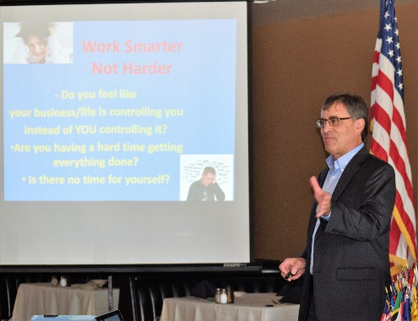
- Not taking over others work and responsibilities
- Above all, counting your blessings.

Christoph generously provided everyone with a copy of his book, 10 Secrets All Business Owners Must Know That Coaches and Marketing Experts Won’t Tell You! For more information go to http://christophnauercoaching.com The presentation was amazingly informative and motivating.

Announcements:
President Jim Negri announced that there is still time to contribute or pledge to The Rotary Foundation as a Double Sustainer ($200), but any contribution is appreciated and counts towards a member’s Paul Harris. Make a check to TRF and give it to Dwight Perry.

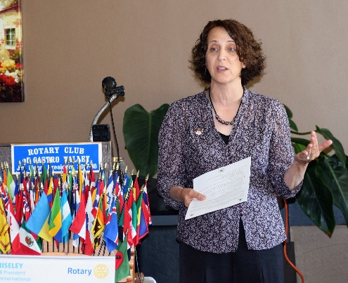
The Castro Valley Robotics Club needs mentors, materials, and money (the 3M’s). See Bill Nott to learn how you can support the Robotics Club.

Roland Williams invited members to one of the Castro Valley Sanitary District Information Meetings and provide input on current service proposals.

Superintendent Parvin Ahmadi distributed a handout on Castro Valley Community Alliance and asked members to actively participate in and contribute to the Alliance (see the handout at the end of the newsletter).

Don’t forget to bring a guest to be entered in a special drawing for President Jim. Currently, there are only two entries from the same member so your odds are good.

Future Events:
August 22 Lunch meeting with Attorney Kelley Way on Protecting Your Intellectual Property
Check the Club website for details and RSVP via the email invite for all lunch meetings
August 23 Board meeting at 6:00 p.m. at the Chamber of Commerce
August 29 Lunch meeting with Alameda County Economic Development Director Susan McCue
September 5 Lunch meeting with Michael Mahoney, CEO of Eden Health District
September 10 Rotary Club of Castro Valley will be staffing a Beer & Wine Booth at the Castro Valley Fall Festival (contact Jim Negri to volunteer)

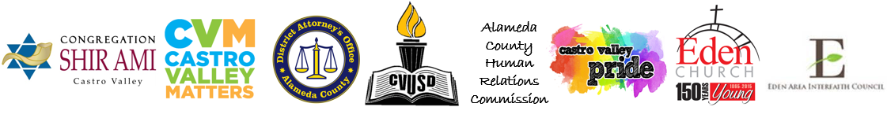
Castro Valley Community Alliance
The Community Alliance is a collaborative group of Castro Valley community and educational leaders, students, and families advocating for compassion, understanding and acceptance. We will leverage all available resources in our community to help ensure Castro Valley community members, including students attending schools in Castro Valley, are valued, welcomed, respected, supported and are provided the best opportunities to succeed academically, socially, and emotionally.

Castro Valley Unified School District (CVUSD) serves a diverse community with a rich history and dynamic members from across the globe. Students and families bring with them a variety of cultures, religions, experiences and languages. This diversity strengthens our community. CVUSD works diligently to ensure all students enjoy a safe, inclusive learning environment that encourages healthy academic, social and emotional development. CVUSD’s motto is “ALL means ALL.” ALL means ALL is the philosophy at the core of the Community Alliance and drives the work of the group.

- We partner with members of the broad, diverse Castro Valley community to engage in the shared effort of supporting every student’s success in school and in the community. The Community Alliance and CVUSD will engage in a comprehensive approach to build partnership in our community. CVUSD will host meetings of the Community Alliance to develop and plan activities to support our diverse community. The Community Alliance has planned the following steps to begin its work.

The Community Alliance will:
- Attend middle and elementary school walk-through registrations to connect with parents and inform them of the Community Alliance.
- Attend CVHS’s Back to School Night to connect with parents and inform them of the Community Alliance.
- Visit every school in district the first two months of school to let students know we are here to support them.
- Have a presence at community events, parent meetings and in the media to share our message of ALL means ALL.
- Celebrate diversity with multi-cultural community events.
- Plan community conversations in partnership with the County’s Human Relations Commission.
- Provide a series of parent and community workshops.
- Support the District Student Leadership Alliance. The District Student Leadership Alliance will produce a video and presentation to advocate for compassion, understanding and acceptance.

How can you be a part of this effort?
The Community Alliance is seeking partners to support the work outlined above. Opportunities for participation include:
- Become a Community Alliance member.
- Attend Community Alliance events.
- Attend Community Alliance trainings and workshops.
- Post and share information about the work of the Community Alliance.
- Follow the CVUSD Facebook page & Twitter feed.
- Help us develop a Community Alliance media presence.

For more information, contact Superintendent Parvin Ahmadi at superintendent@cv.k12.ca.us

