Rotary Club of Castro Valley
Meeting Highlights – July 25, 2017

Speaker of the Day: Jeff Kirschner, Founder of Litterati
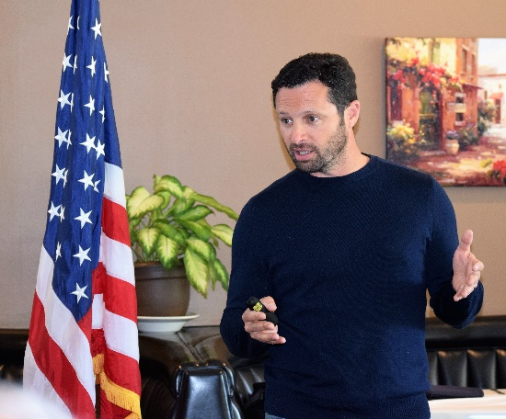
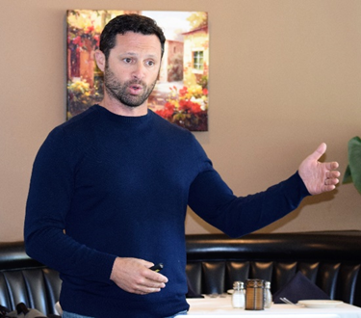
Jeff Kirschner founded Litterati after his daughter asked why there was an empty box of cat litter on their hike in the wood. Jeff described that litter is everywhere – soda cans, plastic bags, cigarette butts – littering the environment, choking wild life, and threatening our planet. Litterati is tackling this problem one piece of litter at a time and has developed an app to identify each piece of litter by taking its picture and identifying the location where it was found. Geotags provide identify the into problem areas while key words identify the most commonly found brands and products. This data can be used to work with companies and organizations to find more sustainable solutions. Jeff shared one example of an area in Oakland near a Taco Bell where most of the litter was unopened bags of Taco Bell sauce. He stress that this data could potentially be used by Taco Bell to either change the how it distributes the sauce, which would be a win-win situation for the environment and the company.

Litrratti app is being used worldwide in 114 countries and users have picked up and identified 723,325 pieces of litter worldwide (409,516 pieces of litter in the US). This work is accomplished by friends, neighbors, and interested citizens and is a great example of Local Problem Solvers Sharing Ideas with Leaders and Taking Action to Create Lasting Change. The work will much practice, patience, love, and a little bit of luck to make a major difference.
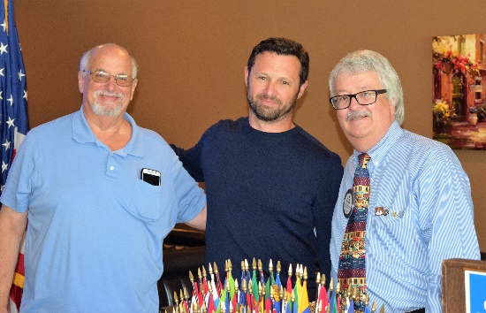

For more information regarding Litterati, go to https://www.litterati.org/ where you can also download the app and begin making a difference. You may be interested in checking the litter picked up in Castro Valley. This work is a great example of Making a Difference Starts in Castro Valley.

Announcements
- Dwight Perry asked for a moment of silence for Past DG Jim Mealey who recently passed away.
- Cliff Sherwood reminded members to sign up for the Club Picnic on August 15th. Invitations were emailed on July 20th. To date, 40% of members have yet to open the mail to learn about the Club Picnic. Details are posted on the Club’s website.
- President Jim Negri thanked those members who have contributed or pledged to be a Double Sustainer ($200 donation) during the District Governor’s visit on July 18th. He encouraged every to donate whatever amount he/she can. Any donation to TRF makes a difference. The group photo with DG Mahoney is now posted on the website masthead.

No Winners
- At the July 18th meeting, President Jim challenged members to bring a guest during the next month. When you bring a guest, please give Jim the card he distributed and you will be entered into a special drawing at the August 29th meeting.
Student Backpack Project
Rotary: Making A Difference
Making A Difference Starts in Castro Valley

After lunch, Rotarians assembled 96 fully supplied, student backpacks that will be distributed to needy students in Castro Valley and Redwood Christian schools prior to the start of the school year. A special thank you to Heidio Hausauer and Dan Willits for coordinating this project once again. Watch for an article in the Forum thanks to Bruce Johnson.
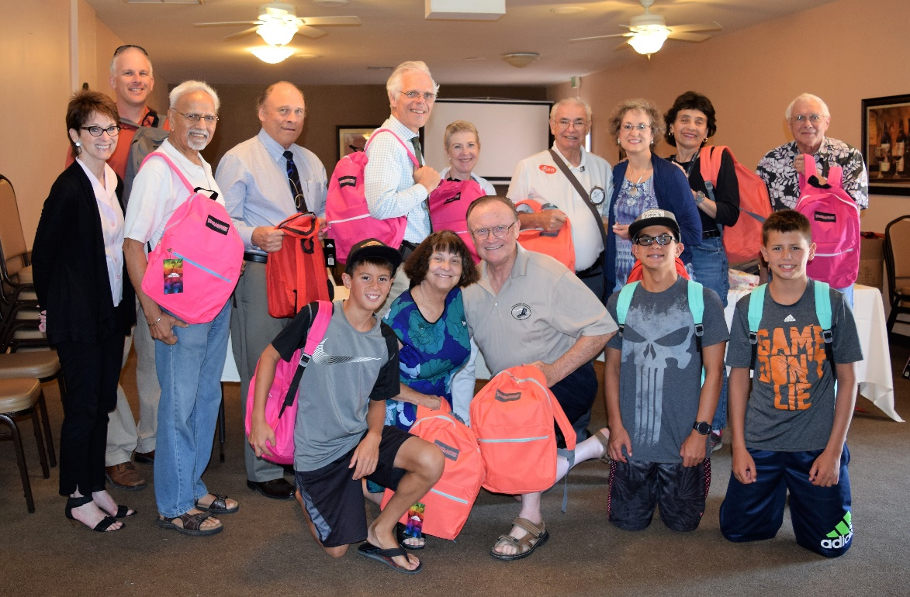

Upcoming Events – All events with details are posted on the Club website (www.castrovalleyrotary.org)
August 1 – Lunch meeting with Parvin Ahmadi on Looking Ahead to 2017-18 in CVUSD
August 8 – Lunch meeting with Christoph Nauer on Success Breeds Success
August 15 – Club Picnic at Lake Chabot Park – Dark at Lunch
August 17 – Chamber Mixer at Baywood Park
August 19 – District 5170 Leadership Training – Attracting and Maintaining Membership
August 22 – Lunch meeting with Kelley A. Way on How to Manage Your I.P.

Making A Difference Starts
in Castro Valley

