Rotary Club of Castro Valley
Meeting Highlight – March 14, 2017

Celebrating St. Patrick’s Day

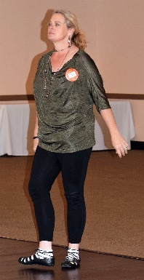
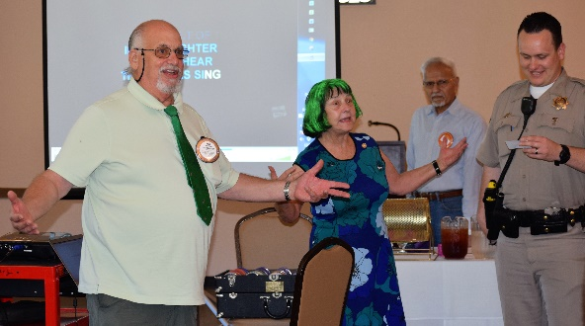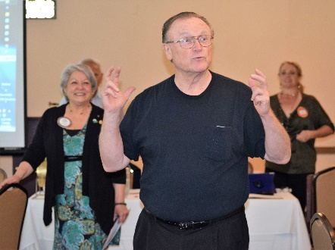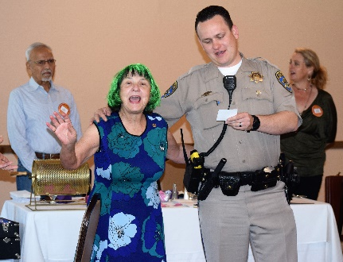
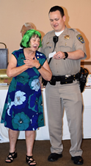
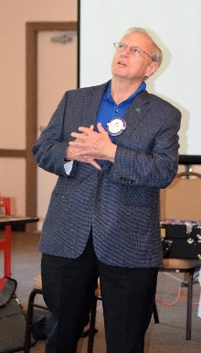
Even though it was International ∏ Day, the Club celebrated St. Patrick’s Day with song, history, dance, and jokes. Pictured above (L-R): Bill Nott, Ceta Dochterman & CHP Officer Dan Jacowitz singing “When Irish Eyes Are Smiling;” Bruce Johnson sharing that he recently learned that he’s 50% Irish; and, Ceta & Dan singing. Pictured to the right: (L-R): Michaela Thompson sharing an Irish history; Ceta & Dan singing; Michaela performing an Irish dance; and, John McPartland sharing an Irish joke.

Lunch Speaker: California Highway Patrol Officer Daniel Jacowitz,

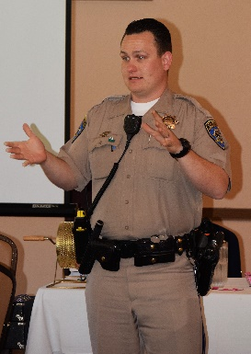
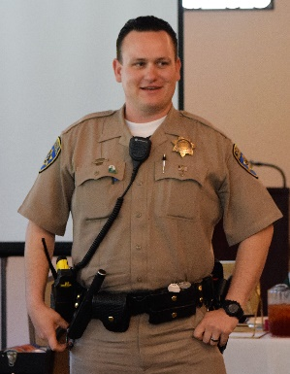
CHP Officer Dan Jacowitz has been an officer for 8 years and currently serves as the Public Information Officer for the Castro Valley Area CHP. He is a certified Drug Recognition Expert And has held titles of Field Training Officer, Officer-in-Charge and Mental Illness Response and Preparation Trainer. Officer Jacowitz grew up in the Bay Area and has lived here most of his life. He currently lives in the Bay Area with his wife and three children. Prior to working for the California Highway Patrol, he worked as an Assets Protection Specialist for Target Corporation, a Recreation Specialist for the City of San Leandro, a security officer for an international protection company, and a Park Ranger for the Hayward Area Recreation and Park District (HARD).

Officer Jacowitz described his experiences of dealing with the public as, “Interesting” and described some of the humorous and bizarre situations he has encountered when stopping people for offenses like use of cell phones while driving or driving over the speed limit. He emphasized that the speed limit is the maximum speed allowed and anybody driving even a mile or two above the specified speed limit can be given a ticket. The are no safe margins above the posted speed limit despite the urban legends.

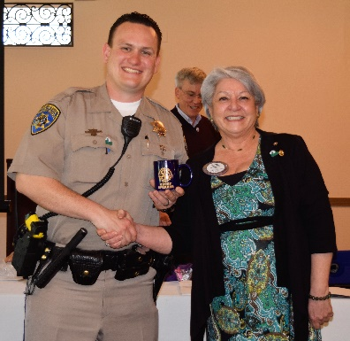

Officer Jacowitz has played a major role in the Club’s Annual Children’s Christmas Party by gathering gifts for the children, attending the party, and giving out various items such as balloons and stickers. Dan has exemplified Service Above Self.

Upcoming Speakers & Events
March 21 – Lunch Speaker: Glen Pomeroy, CEO of the CA Earthquake Authority
- Have you RSVP’d to ensure sufficient food & seating?
March 23 – Chili Cook-off Planning Meeting at 5:00 p.m.
- Everyone is invited to participate in the planning meeting.
- Everyone is expected to work the events on May 12.
March 28 – Lunch Speaker: Becky Paasche & Anotnia Mambelli, Woodroe Woods School
- Be sure to RSVP when you receive the invite.
Watch for the April speakers.
April 10 – Board of Directors Meeting
April 13 – District 5170 Assembly in Milpitas at 5:00 – 9:00
- All board members and committee chairs should attend. President-Elect Jim Negri will be sending information. Attendance at a District event is a requirement to earn a Blue Badge.

Have you checked the Club website recently?
www.castrovalleyrotary.org

