Rotary Club of Castro Valley
Meeting Highlights – November 14, 2017

Murline Monat – What’s New in Castro Valley?
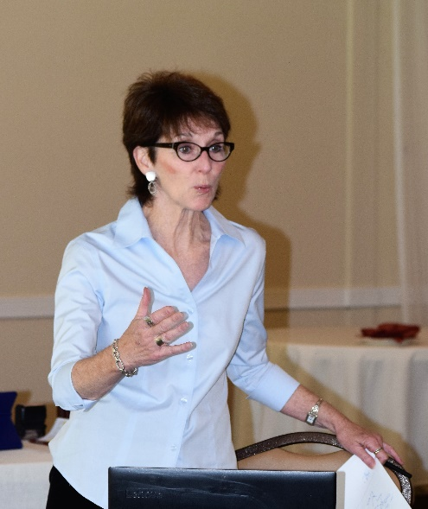
At today’s meeting, the Club instituted a new program, What’s New in Castro Valley? where local business people share new information regarding Castro Valley in a field. The Club’s own Murline Monat kicked off the program with a presentation about the economy and the real estate market. Four key points from her presentation were

- For the local market, housing market is healthy, inventory remains low, equity is up, affordability in the Bay Area is low, prices are up and expected to continue to increase. Should the current GOP tax plan go into effect, housing will be greatly impacted – see slides for specifics (we did not have time to review these).

- Economic outlook, international markets are healthy with strong growth. Emerging markets are 75% of GDP growth, India and China are in the lead. The world has mounds of debt, this is a concern to watch as well as geo political risks and changes in international leadership.

- US economy is strong, 9 out of 10 top companies in the world are in the US. However, US faces huge challenges, national debt is at an all-time high and will rise should the GOP tax plan go forward. Job growth in the manufacturing sector will continue to decline due to technology. 9 million jobs have been lost in manufacturing since 2010. New tax plan is a disincentive to move especially in coastal communities where property values are at their highest.

- Consumer confidence predicts the next housing cycle, change happens every 7-8 years. Bay Area is the epicenter of innovation.

- Murline has shared her presentation here in two PowerPoint presentations:
- https://tinyurl.com/yaca78ea
- https://tinyurl.com/yc3shnaa

Roland Williams leading the Song of the Day – It’s a Wonderful World by Louis Armstrong
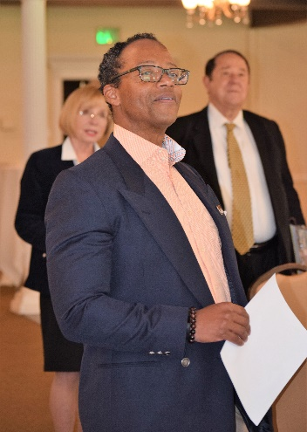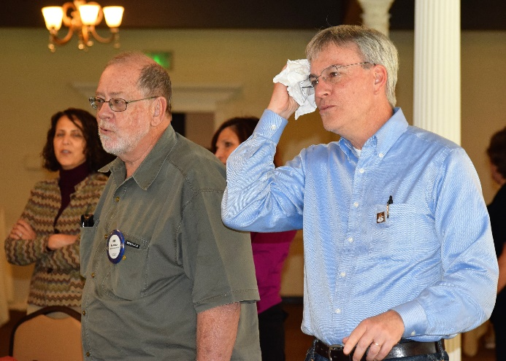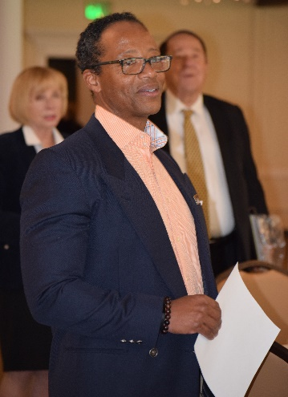

Focus Group on Membership and Lunch Attendance
President Jim Negri conducted a Focus Group on Membership and Lunch Attendance in which he asked each Rotarian to respond in writing to the following questions:

- Why did you join Rotary?
- Why do you remain a Rotarian?
- What have you personally done to recruit a new member?
- What does the Club need to do recruit new members?
- What are you going to do in the next two weeks to recruit a new member?

After writing their answers, the members engaged in a lively discussion regarding the direction of the Club in terms of membership. President Jim will be will writing to all members who were not present asking them to provide their input. Once a significant number of members have responded, President Jim will summarize the responses and form sub-committees to develop action plans to address the issues.

Announcements
- Jerome Blaha shared his plan for hosting the February Chamber Mixer on February 15 (tentatively at Redwood Canyon Golf Course). He will be asking each member to create an 8x11½ sheet about themselves and their business. Details to follow.
- Planning for the Poker Tournament, Chili Cook-off, and Rodeo Parade is moving along. Check the calendar for the next meetings.

Upcoming Speakers
- November 21 – Lynn Levin, President – Eastbay Soroptimist International
- November 28 – Dennis Waspei, Director – East Bay Regional Parks District
Check the website for more information. Be sure to register and bring a guest.

Rotarians and Friends Serving the H.A.R.D Thanksgiving Lunch at the Kenneth A. Aitken Senior Center

Service Above Self
Rotary Making a Difference
Making a Difference Starts in Castro Valley

