Rotary Club of Castro Valley
Meeting Highlights – November 28, 2017

Dennis Waespi, Director – East Bay Regional Park District
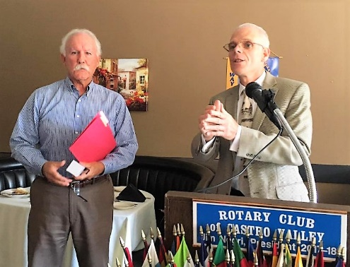
East Bay Regional Park District (EBRPD) was the featured lunch speaker. Dennis was born and raised in Castro Valley and he chooses to live in Castro Valley. He attended Castro Valley Elementary School, A.B. Morris Junior High, and graduated from Castro Valley High School.

Dennis was EBRPD employee for 36 years and has serve as one of the seven elected members of the Board of Directors for the past three years. He represents EBRPD Ward 3, which includes Castro Valley. Dennis encouraged everyone to check out the EBRPD website, http://www.ebparks.org/, and especially to watch the Quantifying the Quality of Life video.

Dennis covered a great number of topics including that it is estimated that it generates $200M income to the area it serves. Dennis shared the following interesting and information facts:
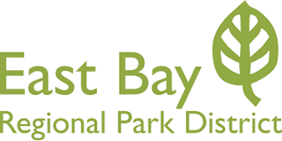
- EBRPD is the largest regional park district in the United States with 72 parks spread over its 124,000 acres.
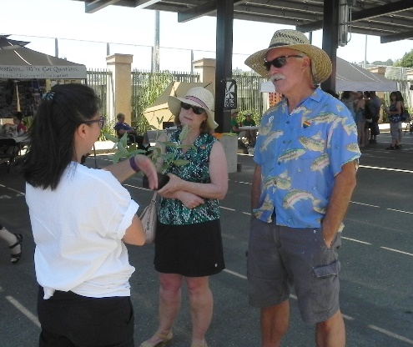
  - EBRPD hosts 25M visitors a year and a recent student by economic firm quantified the value of EBRP at $500M annually, including the values of recreation, health care, property values (living near a park increases home value by 10%). Read the study here.
- EBRPD received 26 grants in 2017 totaling $10M, the largest awarded from the federal government.
- EBRPD has 1,250 miles of trails, two golf courses and 823 full-time employees, with the number swelling to 1,000 employees during the summer, including 18 lifeguards who start at $15 per hour (a great job for high school student!).
- There are 60 sworn officers in EBRPD including its own police department, fire department, and stewardship department.
- There have no drowning in the past 8 years.

Visit www.ebparks.org for information about the Park District and on-going details about new and exciting projects like the Bridge Yard Property and the Dumbarton Quarry Park.
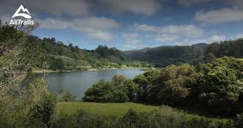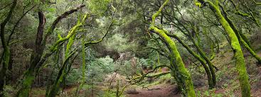
Check out the following videos for an overview of the East Bay Regional Park District;
- Did you know this about East Bay Parks?
- More than Just a Pretty Place
- Inspiration and Promise

Adopt-a-Family
The Club is moving quickly into the Christmas Spirit as they heard a short presentation from H.A.R.D. Volunteer Coordinator Zack Ebadi regarding the Alameda County Adopt-a-Family program and after the meeting wrapped packages for a family of five, including a jacket, shoes and a complete outfit for each family member. Project Chair Dr. Heidi Hausauer, who handled the shopping duties, looks forward each year to this project and “loves Black Friday sales.” Guest speaker, EBRPD Director Dennis Waespi, joined in the wrapping party.

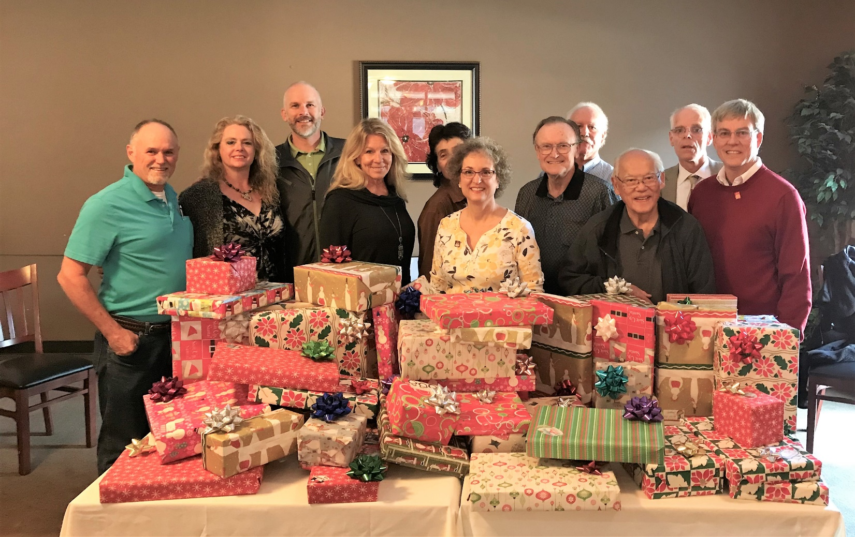
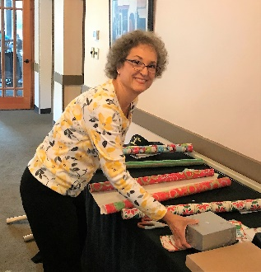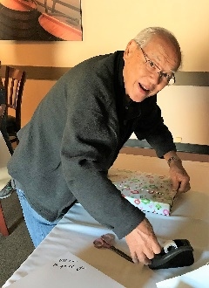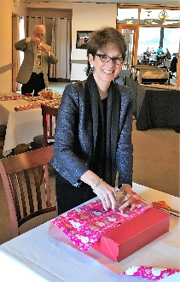.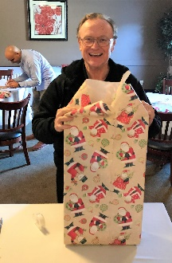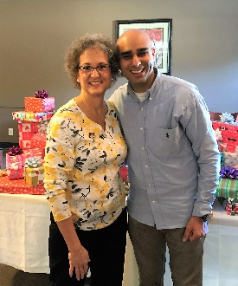

Upcoming Speakers & Events
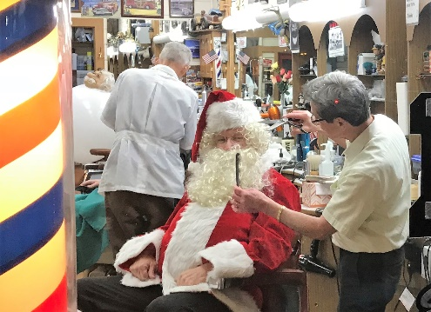
- December 5 - Nick Lavingia on “Challenges Executing International Mega Energy Projects” will discuss how to effectively manage issues associated with technology, community, culture, regulatory, politics, language, etc. This practical presentation will share what it takes to deliver that gallon of gas to your car.
- December 9 – Club Christmas Party at 6:00 p.m.
- December 12 – Children’s Christmas Party at 4:00 p.m. at Castro Valley Adult and Career Education Room 10. No lunch meeting this day. Santa is already getting ready to present the gifts.
- December 19 - Emily Griego, CEO San Leandro Chamber, on the changes taking place in San Leandro.

