Rotary Club of Castro Valley
Meeting Highlights for November 7, 2017

Jim Phillips, Ray Wallace & Jim Negri – Craft Talks
The program today consisted of three extended Craft Talks by Rotarians Jim Phillips, Ray Wallace, and President Jim Negri. Since the President forgot to assign someone to take notes, the descriptions of the talks will be brief.

Jim Phillips shared the influence of his father and godfather in terms of his law career. He focused on importance and implication of effective estate planning as well sharing his work with the Castro Valley Track Club. He noted that he was never able to practice law with his father, but very shortly, he will be opening a Castro Valley office with his daughter.
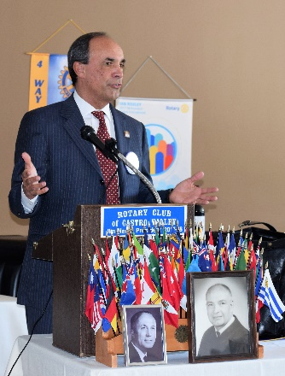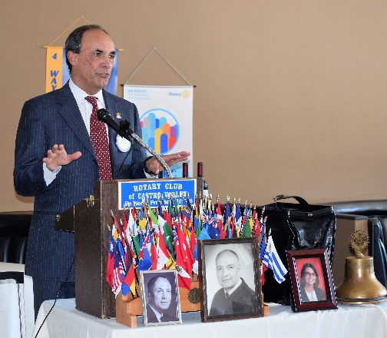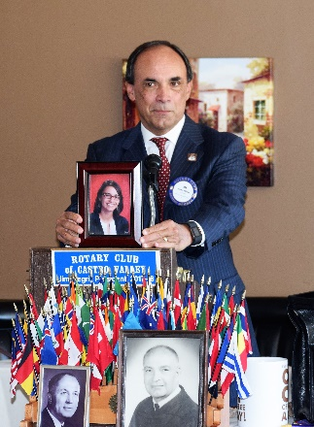

Ray Wallace described his pathway to California State University, East Bay (formerly Hayward) through a career of working with international students, living in Pakistan, writing travel books, and a variety of experiences that finally brought him to CSU and the Rotary Club of the East Bay.
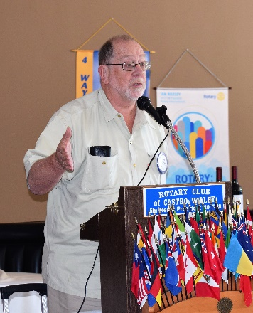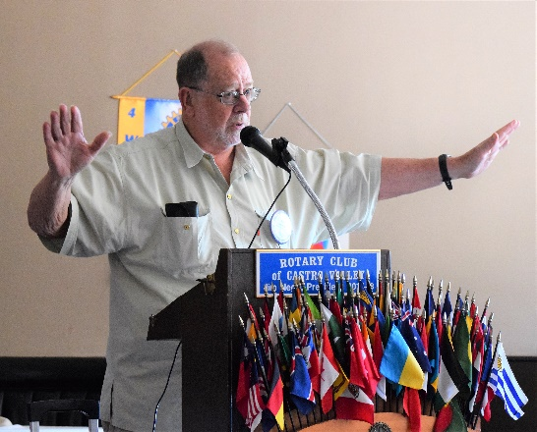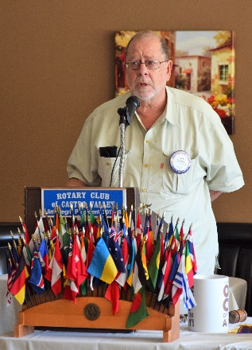

Jim Negri traced his career from playground director, umpire and referee, retail clerk, photographer, school custodian, teacher to superintendent. He noted that the concept of Servant Leadership has guided him throughout his career.
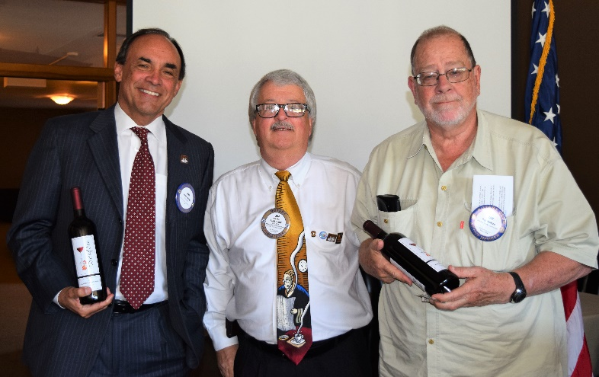
Jim Negri presented Jim Phillips and Ray Wallace with wine from
Twining Vines Winery in Castro Valley as a thank you gift.
Announcements
- Dwight Perry, The Rotary Foundation Chair, announced that November is The Rotary Foundation Month. The Club’s goal this year is $10,000 with every Rotarian contributing something. If you have not donated this year, please consider donating this month in any amount. Thank you in advance for your support. Every dollar makes a difference.
- President Jim Negri reminded members of the Special Focus Group on Membership and Lunch Attendance on November 14th immediately following lunch. All members are encouraged to participate.
- Volunteers are needed to judge the Light Parade on Castro Valley Blvd. on Saturday, November 11th. Please see Heidi Hausauer for details.
- Volunteers are needed to prepare and serve the H.A.R.D. Senior Thanksgiving Lunch on Wednesday, November 15th. Please see Michaela Thompson or Jim Negri for details.
- The Planning Committees for the Poker Tournament, Chili Cook-off, and Rodeo Parade will meet on Thursday, November 9th, at Direct Sales Floors. Please see Randy Vanderbilt, Dawn Ortiz, Mark Poniatowski, and Bill Nott for details. These committees meet the first Thursday of every month. The meetings are posted on the Club website under Upcoming Events.
- Medical Update: Bill Nott is fine after his encounter with the light fixture at lunch.

Photos from the Meeting
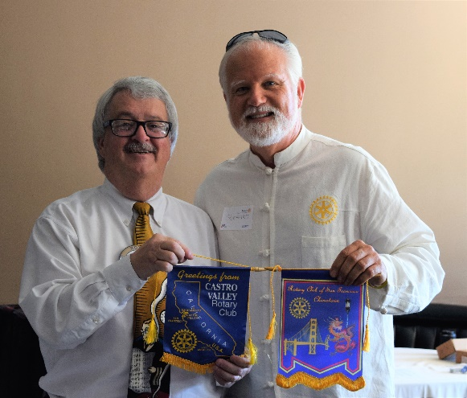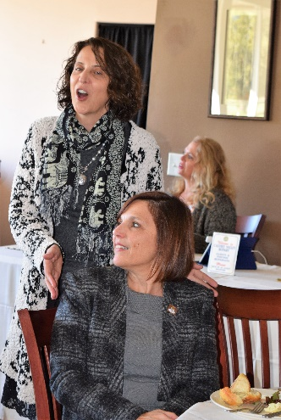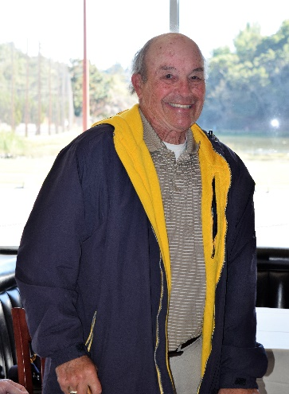
Left to Right: President Jim Negri exchanging Club banners with Richard Swartz, President of the Rotary Club of San Francisco - Chinatown. Richard is a retired nurse who helped tend to Bill Nott. He also made a donation to the Club to support and ad in the Children’s Theater Program of the East Bay program. Superintendent Parvin Ahmadi introducing Assistant Superintendent for Human Resources Dr. Sherri Beetz, who will be attending Rotary meetings in place of Dr. Candi Clark who has taken a new position in Los Angles. Bob Duey from the Rotary Club of San Leandro and the Boys’ and Girls’ Club of San Leandro.

Upcoming Speakers
- November 14 – John McPartland on Emergency Preparation
- November 21 – Lynn Levin on the activities of the Soroptimist International of the East Bay
- November 28 – Dennis Waspei on what’s happening at the East Bay Regional Park District
More details on each speaker are posted on the Club website under Upcoming Speakers.

