Rotary Club of Castro Valley
Meeting Highlights – October 17, 2017

Speaker of the Day: Dave Stark, Public Affairs Director for the Bay East Association of Realtors
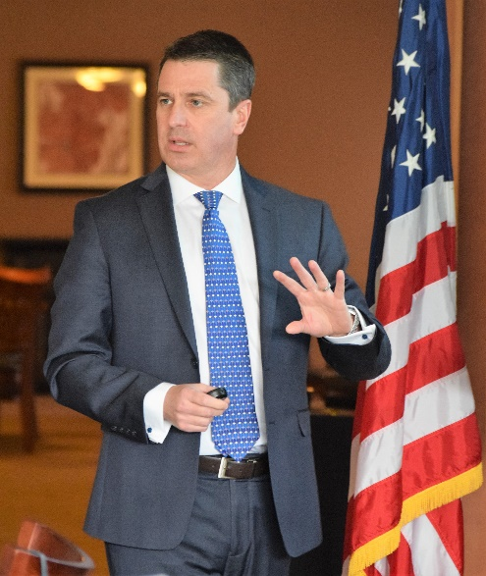
Dave Stark provided a very informative, and sobering view of the housing market in the Bay Area. The fact the homeownership in California continues to decline for a variety of reasons, including the following:
- Ownership turnover is lower in CA than in US – "It’s a great place to live – it’s the center of the current job market universe!”
- Homeowners are remaining in their homes an average of 10 years rather the prior average of 5-7 years.
- Boomers are remaining in their homes longer. There is nowhere to move (i.e., 77% of Californians age 55+ have not moved since 1999.
- Housing prices continue to rise (for example median price of a home in Castro Valley in 2001 was $400K, in 2016 $748K, and today the median price is $848K.
- East Bay affordability remains one of the lowest in the nation: California is 29%, Alameda County is 19%, and San Francisco is 12%.
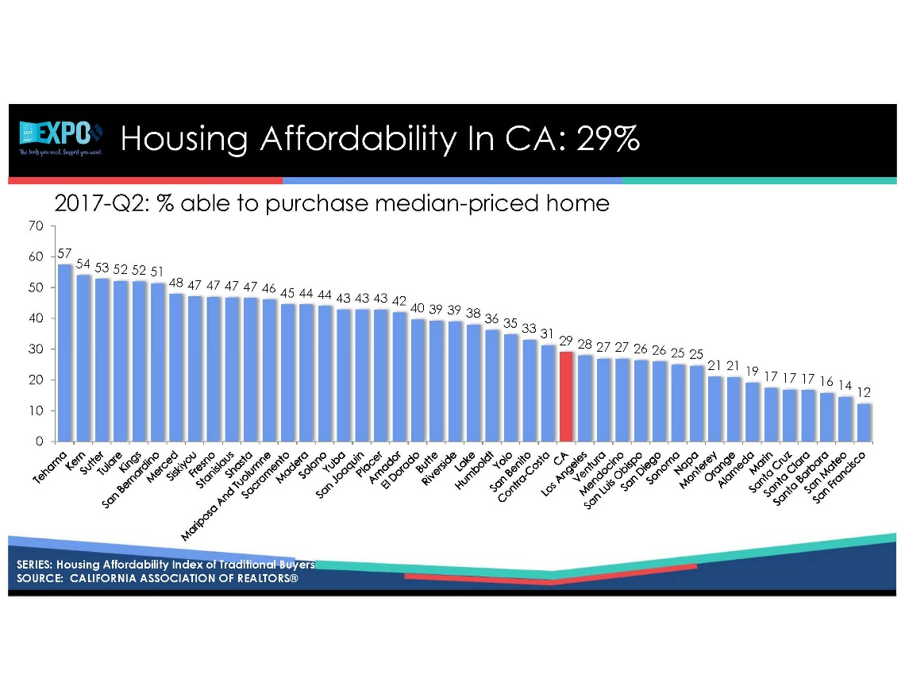
- In 2017, homeownership rate in California is 53.8% and is expected to decline further if California does not make changes to build more housing
After presenting the historical and current situations, Dave focused on what needs to be done, which included:
- Build more housing.
- California needs approximately 77,000 new units a year to keep up with the pace of jobs.
- From 2011 to 2016 in the East Bay, 150,000 jobs were created, but only to 50,000 homes were permitted. This trend is not sustainable.
- Overcome Community Resistance (i.e., not in my backyard syndrome).
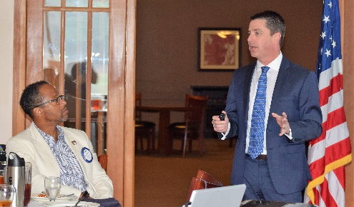
- Convert Commercial Development – convert retail malls to housing and shopping destinations.
- Review CEQA to reduce years of building delays.
Note: Dave’s complete PowerPoint presentation will be attached to the email sent to Club Members.

Announcements
- World Polio Day: October 24 is World Polio Day. PolioPlus Chair Dwight Perry will be auctioning a great book on the Rowell Ranch Rotary at lunch on the 24th. Come to lunch ready to make a significant bid to help eradicate polio.
- Volunteers Needed: Past President Carol Wikle announced that the Volunteer Signup sheet for the H.A.R.D. Senior Thanksgiving Lunch at the Kenneth Aitken Senior Center on November 15 was emailed to all members and is available on ClubRunner. The Club needs to provide 16 volunteers in two shifts (8:30-10:30 and 10:30-1:30). Volunteers need not be Rotarians. Family members are welcome. It is a great opportunity to highlight what Rotary does to others.
- Volunteers Needed: Past President Carol Wikle announced that the Nominating Committee for the 2018-2019 Officers and Directors will meet after the lunch on November 21. All Past Presidents as well as two at-large delegates comprise the Committee. If you are interested in serving as an at-large delegate, please contact Carol.
- Donations Needed: President Jim Negri announced that as in past years there will be a Rotary International float in the Rose Parade. Each Rotary Club has been asked to contribute $1.50 per member. President Jim announced that he would like to collect $3 per member. Donations will be taken starting October 24.
- Donations Needed: President Jim pointed out fliers to support fire victims in Rotary District. The flier will be posted on the Club website.
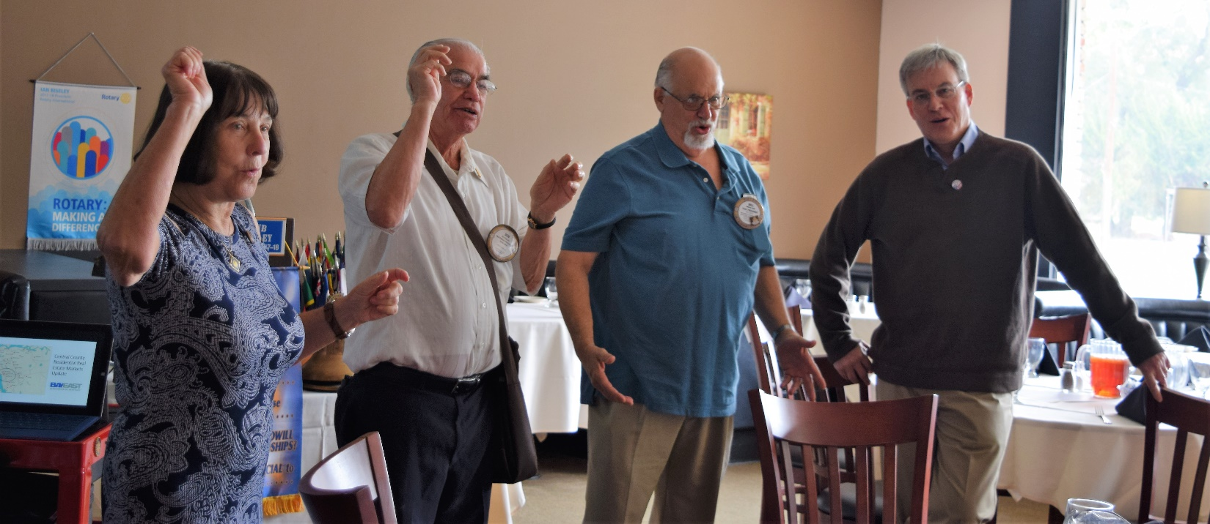
How could you not want to sing when Ceta, Ben, Bill, and Kern are leading the singing?
Upcoming Speakers
- October 24 - Rodrigo Orduña, AICP, Assistant Planning Director, Alameda County Planning Department, Community Development Agency - Implications of the new Residential Design Guidelines and How It Impacts Existing Homeowners and New Developers.
- October 31 – Mayor Barbara Halliday – What’s Happening in Hayward?

Upcoming Events
- October 25 – Board of Directors at the Castro Valley Eden Area Chamber of Commerce at 6:00-7:30 pm. All members are welcome.
- November 11 – Meet in the Street Light Parade on Castro Valley Blvd.
- November 15 – Rotary Club of Castro Valley serving the H.A.R.D. Thanksgiving Lunch at the Kenneth Aitken Senior Center. Volunteers needed.

