Rotary Club of Castro Valley
Meeting Highlights for October 31, 2017

Program: Hayward Mayor Barbara Halliday – What’s Happening in Hayward?
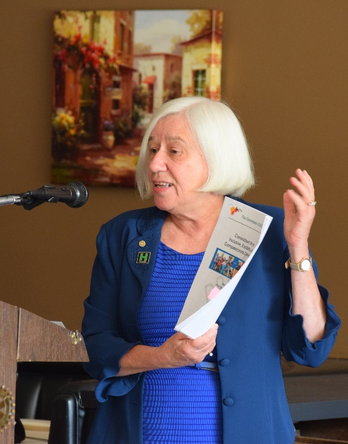
Barbara Halliday, the Mayor of Hayward, provided an inspirational presentation regarding the city’s progressive and innovative accomplishments as well as its future goals. The Mayor presented a short video showcasing housing and public works projects both past and present, and then spoke about projects that showcase Hayward’s innovative spirit. The video is available at https://www.youtube.com/watch?v=l-tdO6sgWss&feature=youtu.be. More comprehensive information about the City of Hayward is available at the following websites: https://www.hayward-ca.gov/discover and https://www.hayward-ca.gov/discover/news.

Mayor Halliday detailed a number major accomplishment in the City of Hayward, which included:
- Firehouse Clinic, opened in November 2015, is a trailblazing partnership between the City of Hayward, Alameda County Health Services Agency, and Tiburcio Vasquez Health Center, Inc. that is bringing new primary and preventative medical services to South Hayward.
- Eden Housing’s Alta Mira Senior and Family Apartments is considered a model of blended for-profit and affordable residential development. It is being followed by hundreds of millions of dollars of new residential projects now in the development pipeline in Hayward.
- The city’s Water Pollution Control Facility, shown in the video, was recognized by the U.S. Environmental Protection Agency as a Green Power Leadership Award winner by going from being a net energy user to a net energy producer through co-generation strategies and an investment in a 1 mega-watt solar array.
- Green Power Leadership: Hayward was honored with the US EPA’s Green Power Leadership Award for renewable energy generation at the Wastewater Treatment Facility.
Mayor Halliday also shared other advances in industry and investing in technology in Hayward, which included:
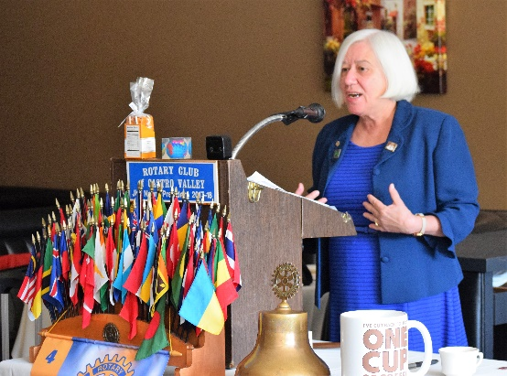
- Haywards Housing Projects: https://www.hayward-ca.gov/business/for-developers/development-activity
- Hayward's Business Concierge Program which is more than an enhanced service operation; it's a paradigm shift. With fully personalized assistance for every phase of one’s business development process, one will enjoy a tailored experience focused on one’s specific business requirements.
- Mervyn’s site: The City Council voted unanimously last week to reject an appeal by opponents of the planned transformation of the former Mervyns Stores headquarters, clearing the way for a vibrant new residential and retail development project, https://www.hayward-ca.gov/discover/news/may17/council-approves-old-mervyns-hq-project
- The Local Government Hispanic Network, a leading support organization for Hispanic local government professionals, announced on October 25th that the City of Hayward is the recipient of a 2017 Civic Engagement Award for its response to local concerns over changing federal immigration policies.
- Gillig Bus moved to Livermore, but Morgan Advance Materials is moving into the former Gillig site.
- The East Bay Economic Development Alliance (East Bay EDA) selected three cutting-edge Hayward companies as finalists for 2017 Innovation Awards. These awards celebrate and showcase outstanding organizations in the region that most contribute and embrace innovation in manufacturing, services, products and designs. The three companies are
  - MDC Vacuum Products (Advanced Manufacturing);
  - Alphabet Energy (Engineering and Design); and
  - Microvi Biotech Inc. (Life Sciences)
- Downtown Hayward Public Wi-Fi - Hayward’s publicly accessible Wi-Fi system has been upgraded! The new gigabit service provides free wireless internet access in Hayward’s historic downtown district now with multiple access points on nearby street lights. The City plans to expand the free Wi-Fi to the new Library and Heritage Plaza.
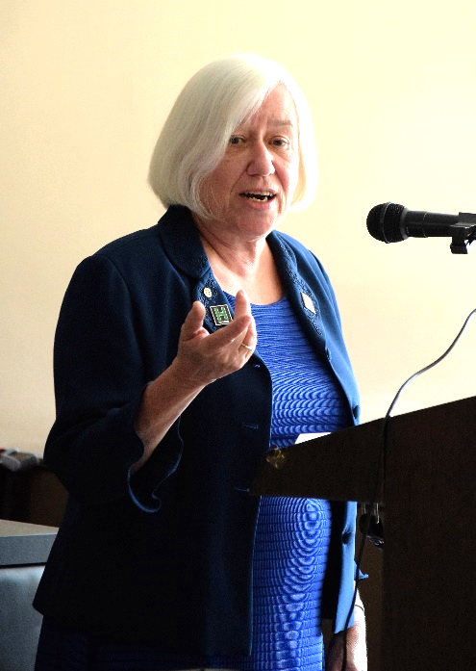
- Hayward's 21st Century Library and Heritage Plaza is the most environmentally sustainable project to ever begin construction in Hayward. The new library will be located on the corner of Mission Boulevard and C Street in Downtown, between the post office and City parking garage. The current library site will be transformed into Heritage Plaza, returning to its historic roots as a central community gathering place and arboretum. For more information, go to http://www.haywardlibrary.org/.
- On March 7, 2017, the Hayward City Council adopted a resolution to join the Compact of Mayors, a global coalition of mayors and city officials who pledge to reduce local greenhouse gas emissions, enhance resilience to climate change, and track their progress transparently. There are more than 640 cities around the world that have joined the Compact of Mayors, including 133 in the United States.
- On June 6, 2017, the City Council adopted a resolution declaring the City of Hayward a Sanctuary City.
- Fiscal Sustainability: Hayward’s Economic Development Strategic Plan is a purposeful, concentrated effort to achieve this vision with a focused use of City resources. The strategy seeks to spur catalytic projects that will cascade to the broader local economy while bolstering City revenues.
- Responding to traffic-safety concerns downtown traffic calming: Hayward traffic engineers plan to shorten traffic-signal cycles along Mission and Foothill Boulevards later this month as part of a traffic-calming pilot project. Signal cycles are being shortened by a third at each intersection in the loop north Fletcher Lane. The move is intended to reduce overall traffic speeds by eliminating the ability of drivers to travel through multiple intersections without stopping.
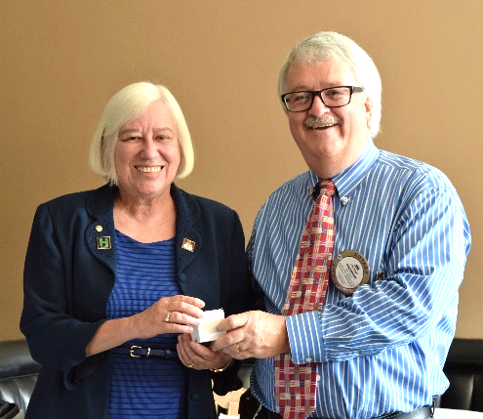
Mayor Halliday closed with the following statements,
- She wants a “resident friendly city.”
- She is willing to look at the rules if they do not make sense.
- She is optimistic about how things are going in Hayward.
- She is a member of the Rotary Club of Hayward and invites all members for the Rotary Club of Castro Valley to attend a meeting in Hayward on Monday’s at the Masonic Hall on B Street.

On behalf of the Club, President Jim Negri thanked Mayor Halliday for a highly informative presentation. Mayor Halliday was already wearing President Jim’s presidential pin.

Announcements
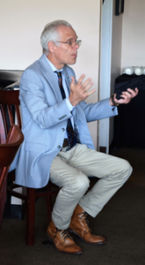
- President Jim Negri announced that there will be a Special Focus Group meeting on Membership and Lunch Attendance after the lunch meeting on November 14th. A reminder postcard and a detailed letter about the topics have been sent via snail mail to all member. It is important that members attend this Focus Group so that their voices are head on these critical issues.
- At the request of President Jim Negri, Dwight Perry once again had a sign-up sheet to order Rotary Club of Castro Valley polo shirts. Dwight will donate $10 per shirt to Polio Plus. November 7th is the last day to order.
- President-Elect Charles Mortimer announced the Club Holiday Party on December 9th at John Aufdermauer’s home. Details will follow, but mark your calendars now.
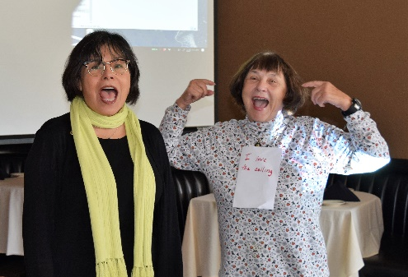
- The photo is Charles asking Mayor Halliday about imposing a fee on non-residents to drive through Hayward.
- The Children’s Christmas Party is scheduled for December 12th. The Club is dark at lunch that day. Chairperson Mark Poniatowski will be sending out details shortly.
- Maria Ochoa, a guest of Jim Negri and a Hayward Rotarian, joins Ceta to sign the song of the day.
- The Club still needs volunteers to help with the Thanksgiving Lunch at the Senior Center on Wednesday, November 15th. Sign up online or contact Jim Negri or Michaela Thompson. This event is a perfect Service Above Self event.

