Meeting Highlights – September 6, 2016

Rotoract
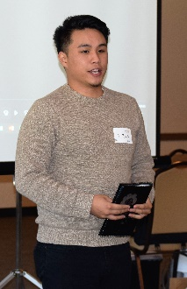
President Carol welcomed Vu Dinh, a student at Chabot College, who is working to revive Rotoract (Rotary for young adults for young adults 18-30) and commended him for his efforts. There are now 15 Rotoract members. Vu described goals and plans for the coming year, which will focus on coordinating events and activities for youth, including members of Interact Clubs. (Details at www.meetup.com/Rotaract-club-of-Central-alameda-County . The first major event will be at the San Leandro Marina in October. Vu is looking for Rotarians to help (e.g., for cooking, setup, etc.)

Service Above Self
There are a number of opportunities for Rotarians to serve in the coming months. President Carol and President-Elect Jim announced the following opportunities and passed around Sign- up Sheets:
- Beer and Wine Booth for the Chamber of Commerce at the Fall Festival( September 10th and 11th);
- Breathing for Life Gala Set-up (October 21st) and Take-down (October 23rd). The Club is receiving a 33% discount by providing Rotarians to assist with Set-up and Take-down;
- Breathing for Life Gala Business Sponsorships; and
- Thanksgiving Lunch at Aiken Senior Center (November 14th).
Please contact President Carol for volunteering at these events

President-Elect Jim also asked for volunteers to serve on the committee revising the club By-Laws. (Please contact Jim if interested in serving on this committee.)

Rotary Club of Castro Valley Foundation
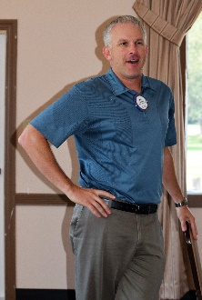
New Foundation Chair Dan Willis explained the purpose and workings of Club's
Foundation - to give scholarships to graduating Castro Valley High School students. Funds from the former Sunrise Club also support several scholarships each year. Watch for more details on Club Runner in the coming months. Please consider the Foundation for your end-of-the-year-donations

Speaker: Livermore Valley Wines
Our speaker was Brandi Addington, Coordinator of the Livermore Valley Winegrowers Association. She started her presentation with an outstanding video describing the history of and rational for the Livermore Valley as a great wine growing area. She focused on "taste of the land” as major reason for the success and national and international awards and acclaim for the Livermore Valley. The shifts in temperature and the fog are the major contributors to "the taste of the land.” There are now 68 wineries in the Livermore Wine Growing area which includes Livermore, Pleasanton, San Ramon, Danville and eastern part of Sunol. The wines in the Valley are a mixture of French, Italian and Portuguese varieties.

Overall, it was a very interesting and informative presentation. President Carol thanked her for the excellent presentation.

Upcoming Speakers
September 13 - Jennifer Hosterman, a candidate for the BART Board of Directors, District # 5.
September 20 – Paul McCreary, CEO of H.A.R.D.
September 27 - John McPartland, the incumbent BART Board of Directors, District # 5.

Check the Club website for more details regarding the speakers and upcoming events.

Consider inviting family, friends and colleagues to hear our speakers.

