Rotary Club of Castro Valley
Meeting Highlights – November 13, 2018

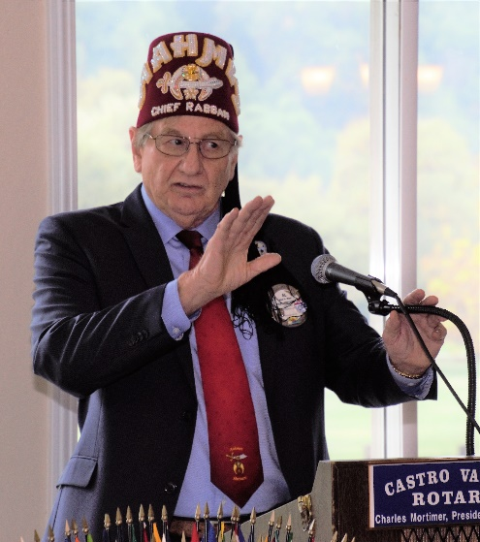
Alan West – Chief Rabban of the Aahmes Shriners & Castro Valley Rotarian
Al West, a Past President of the Rotary Club of Castro Valley and current member, updated the Club on the work of the AAMHES Shriners, especially the Shriner’s Children Hospital as well as the role Al is playing in the Shriners.

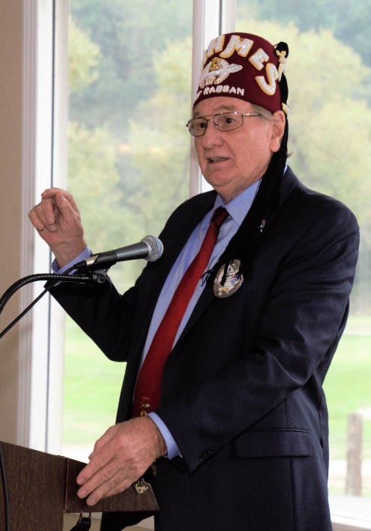
Currently, Al is the Chief Rabban of the AAHMES Shriners based in Livermore, which is keeping him very busy with responsibilities, challenges and opportunities. As Chief Rabban, Al is part of the Divan, which consists of all officers, both elected and appointed, from Potentate through the Chaplain. The officers of the Elected Divan constitute the Board of Directors of the Temple. The Board of Directors are responsible for the operation of all aspects of the organization. Next year Al will become the Potentate, which is like a Rotary District President.
Al explained the history of Shriners, which is described on their website as Shriners, or Shrine Masons, belong to the Ancient Arabic Order of the Nobles of the Mystic Shrine for North America (A.A.O.N.M.S.). The Shrine is an international Fraternity of approximately 500,000 members who belong to Shrine Centers throughout the United States, Canada, Mexico and Republic of Panama. Founded in New York City in 1872, the organization is composed solely of Master Masons.
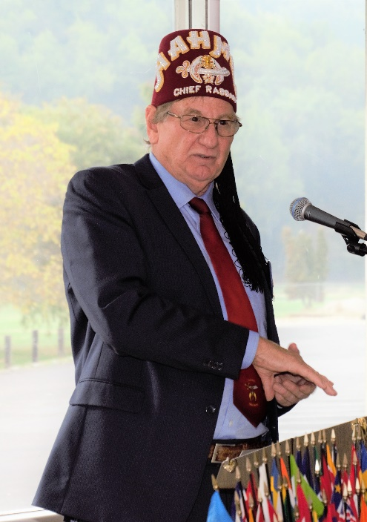
The Shrine is best known for its colorful parades, its distinctive red fez, and its official philanthropy, the Shriners Hospitals for Children, which is often called “the heart and soul of the Shrine.” Members of the Ancient Arabic Order Nobles of the Mystic Shrine for North America are members of the Masonic Order and adhere to the principles of Freemasonry — Brotherly Love, Relief and Truth. More information about AAHMES Shriners is available here.
Shriners Hospitals for Children is a network of 22 non-profit medical facilities across North America. Children with orthopedic conditions, burns, spinal cord injuries, and cleft lip and palate are eligible for care and receive all services in a family-centered environment, regardless of the patients' ability to pay.
Headquartered in Tampa, Florida, the hospitals are owned and operated by Shriners International, formerly known as the Ancient Arabic Order of the Nobles of the Mystic Shrine, a Freemasonry-related organization whose members are known as Shriners. Patients must be minors under the age of 18 and are not required to have any familial affiliation with the Shriners order nor Freemasonry. The current advertising campaign for the healthcare system features the tagline, "Love to the Rescue."
Recently, the Shriners hired a consulting firm to evaluate the operations of the hospital and make recommendations and modifications, if required. The consultants found that the operations at the hospitals are not operating in a cost-effective manner. Each hospital must have at least two live-in patients per night throughout the year. Most of the Shriner Children Hospitals are operating at 2.1 live-in patients per night on the average; therefore, the consultants recommended that these hospitals should be sold or leased. Presently, most of these hospitals are operating as outpatient facilities.
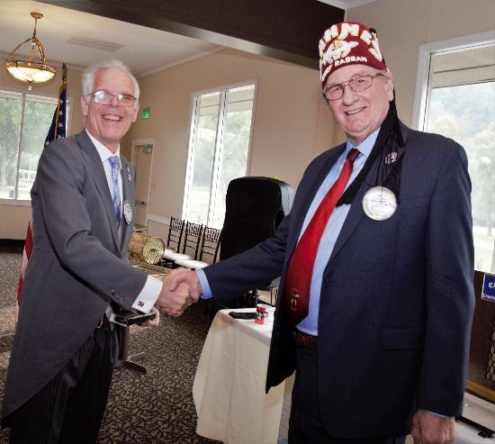
The consultants further recommended that the beds, if needed, should be leased from other operated hospitals on as needed basis. The long range is to lease or sell all the hospitals, except the one in Iowa. Any child requiring in hospital stays will either be transported to Iowa or find temporary homes in leased beds of local hospitals. This approach will change the priorities in the national budget in a major way. For example, it will require more money in the travel budget, but free up capital funds invested in hospital buildings and equipment. Hospitals in foreign countries are likely to be operated as before.

As always, it was great to get a visit and update from Al.

Scenes from the Meeting
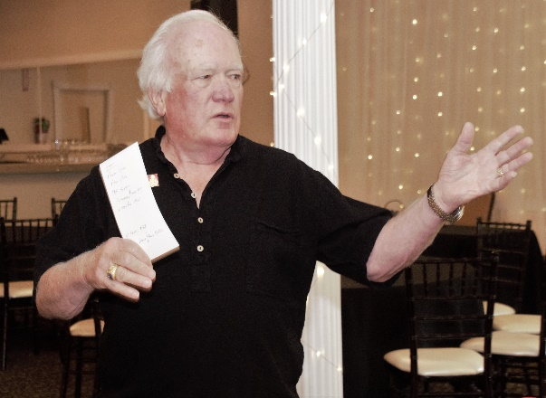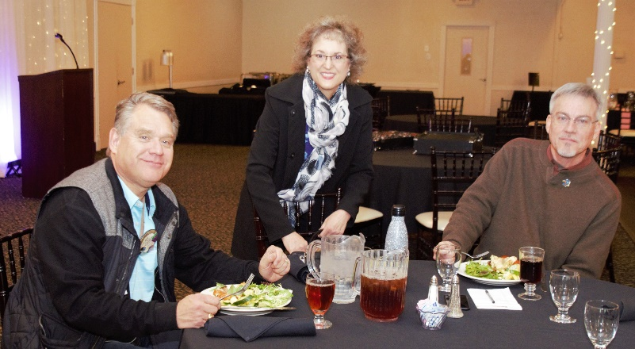
(Top left to Right): Dwight Perry once again leading the Four Way Test with his notes about Al West in case he forgets anything. Three Past Presidents, Jeff Moore, Dr. Heidi Hausauer and Kern Lewis enjoying lunch.
Bottom left to right): Mark Poniatowski reminding members that they have 4 tickets to sell for the Texas Hold ‘em Tournament on March 9th. Brian Morrison contributing on the 28th anniversary of opening his business. Carol Bigelow, besides serving a Greeter, reminds members about the Senior Thanksgiving lunch on November 14th. Gary Howard sharing his experience with his Cologuard test (he’s cancer free) and encouraging donations to support the study and elimination of colon cancer.
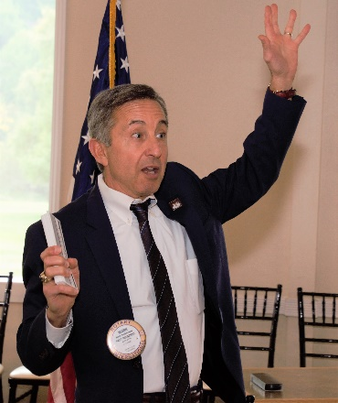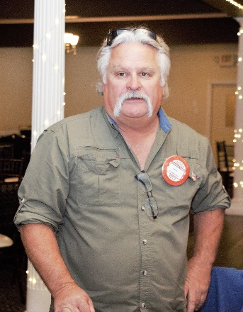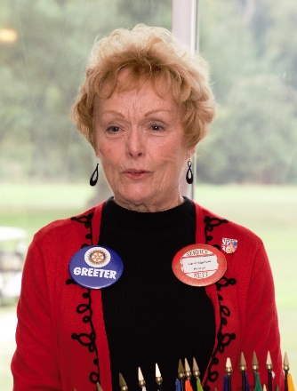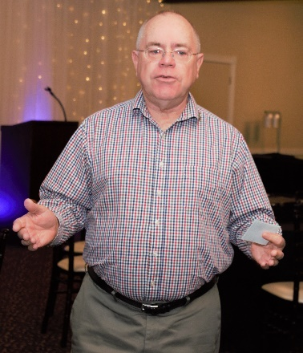
Announcements
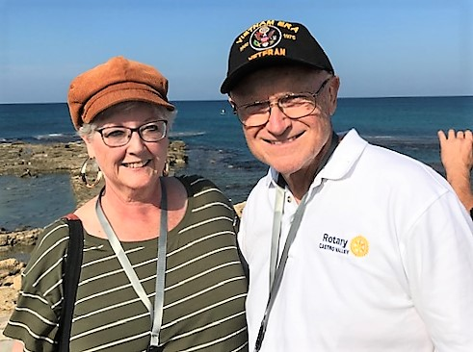
- November 16 - Castro Valley Meet in the Street/Light Parade canceled due to poor air quality
- November 16 - Proctor Elementary School garden beautification project canceled due to poor air quality
- November 20 – Lunch speaker will be Russ Hobbs on The Rotary Foundation – Bring you donation and, if you are a Paul Harris Fellow, wear your pin
- November 20 – Nominating Committee at 1:30 pm immediately after lunch
- November 22 – Happy Thanksgiving!
- November 27 – Lunch speaker will be Dave Rocha, Alameda County Fire Chief
Bruce Johnson with his wife, Linda, promoting the Rotary Club of Castro Valley in Israel.
- November 28 - Board of Directors Meeting at Don Jose’s (5:30- 7:00 pm) – All members are invited
- December 4 – Lunch speaker will be Zach Ebadi on Adopt a Family
- December 8 - Club Christmas Party at Heidi Hausauer’s home
- December 11 – DARK AT LUNCH
- December 11 – Children’s Christmas Party 2:00 – 7:00 pm at Castro Valley Adult School
- December 25 - DARK AT LUNCH
- January 1 - DARK AT LUNCH – HAPPY NEW YEAR!

