Rotary Club of Castro Valley
Meeting Highlights – November 15, 2016

Speaker – Alameda County Fire Chief David Rocha
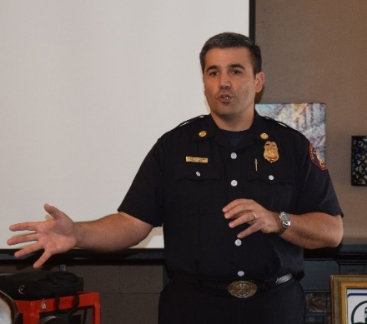
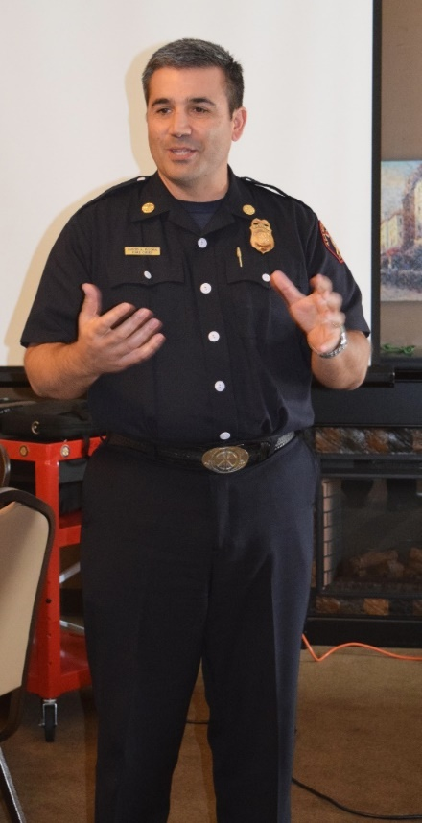
Dwight Perry introduced our lunch speaker, Alameda County Fire Chief David Rocha. The Alameda County Fire Department serves an area of approximately 508 square miles with a daytime population of 394,000 people. This includes most of the unincorporated, areas of Alameda County and the cities of San Leandro, Newark, Union City and Dublin. The department consists of 4 Battalions, 30 Fire Stations, 26 Engine Companies, 7 Ladder Truck Companies and 1 Heavy Rescue Vehicle. The Department has some Specialized Equipment, such as an Air/Light support unit, 3 Zodiac Boats, 2500 gallon Water Tender, Dozer and Hazardous Material Response Vehicle. Specialized Response Teams consist of Hazardous Materials Urban Search & Rescue and Water Rescue. The fiscal year 2016-2017 budget for the department is $133,878,346 with an authorization for 460 employees of which 340 are Firefighters and 33 Reserve Firefighters. The Department is comprised of four organizational branches that meet the operational, special operations and communication, administrative support services and fire prevention needs of the Department. The Fire Chief provides overall leadership and is responsible for the effective management, coordination and service delivery of all aspects of the Department.

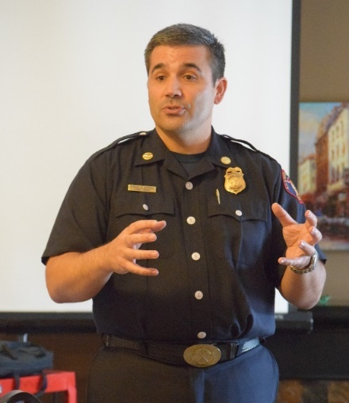
Operations Branch is responsible for emergency response and incident mitigation for fires medical emergencies, hazardous materials, urban search, rescue, and other emergencies

Communications and Special operations Branch is responsible for the operations of the Alameda County Regional Emergency Communications Center (ACRECC), the Medical Service Division, Hazardous Material and Water Rescue Programs and Emergency Preparedness.

Administrative Support Services Branch is responsible for a broad array of administrative, financial, and programmatic areas including Fleet Maintenance, Financial Services, and Human Resources functions.

Fire Prevention Branch is responsible for enforcement of all applicable State and Local fire codes and Standards and Fire Investigations.

Other interesting information presented by Fire Chief Rocha included:
- The Department serves three National Labs (Berkeley, Livermore and Sandia) and it takes two years for a firefighter to obtain security clearance.
- When the Department needs a drone (e.g., the recent fire on the Oakland-Emeryville border, the Department uses drones provided by the Alameda County Sheriff’s Office.
- The Department has a mud boat for work around the Oakland Airport.
- With the advent of GPS, firefighters no long need to memorize every street in the service area.
- Radio communication between departments has significantly improved since the Oakland Hills Fire, especially since the Oakland Fire Department has come onboard with the system.
- The Department overlaps territory with Cal Fire to provide services.
- All new firefighters are trained paramedics or EMTs.
- Of the 40,000 the calls last year, 72% of the calls were medically related. ACFD has a quicker response time than the County paramedics.

Overall, it was a very impressive and informative presentation by Chief Rocha, who answered a number of questions from the Club members.
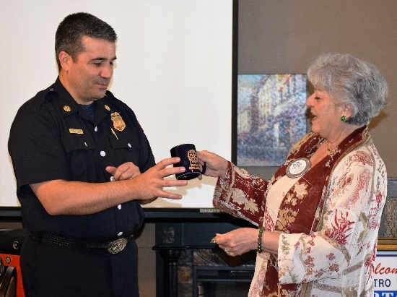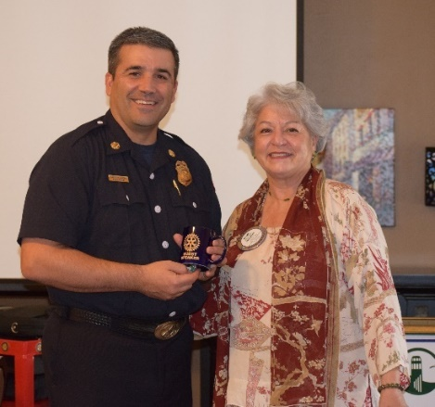
President Carol Wikle presents Chief David Rocha with a Rotary mug.

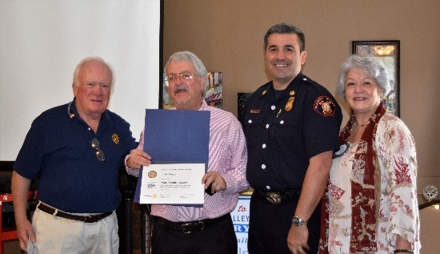
Paul Harris Recognition
Foundation Chair Dwight Perry presented Jim Negri with his Paul Harris pin for his contributions to the Rotary Foundation. Jim asked that his Paul Harris recognition be presented in the name of his father, Jim Negri. He asked Fire Chief Dave Rocha to join the presentation served 25 years in the Oakland Fire Department and his mother, Meri, served as the secretary for the Retired Oakland Police and Fire Association.

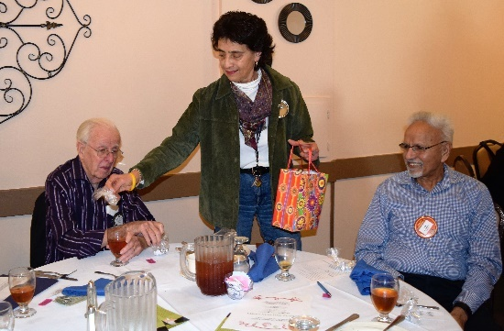
Happy Birthday, Margie!
Margie Ramos hands out candy to celebrate her birthday. She shared a story about her 3rd teacher who allowed students to bring candy on their birthday.

Dwight Perry led the Club in a rousing version of “Happy Birthday” something Margie usually does for the Club.

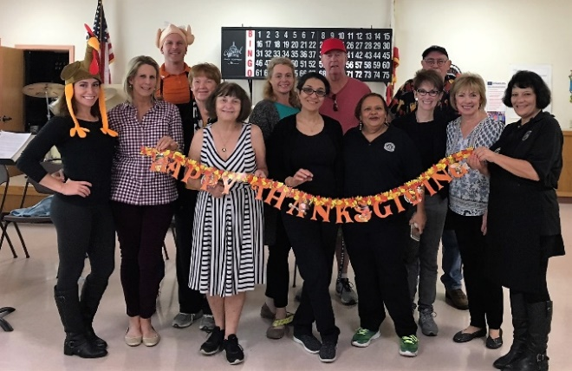
Thanksgiving Lunch at the Castro Valley Senior Center
Bill Nott and Dan Willits describe their experience preparing for the Thanksgiving Dinner at the Keith Atkin Senior Center on Monday, November 14th. Mathilda Schmidt, Ceta Dochterman, Murline Monat, Virginia Degner and Michaela Thompson also volunteered at the event along with spouses Leslie Poniatowski and Duane Degner. The Rotary Club of Castro Valley has been participating in this HARD event for a number of years. It is one of many examples of Service Above Self.

The nexst opportunity to volunteer is the Club’s Annual Children’s Christmas Party on December 13. See Mark Poniatowski for details.
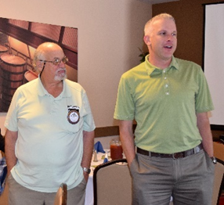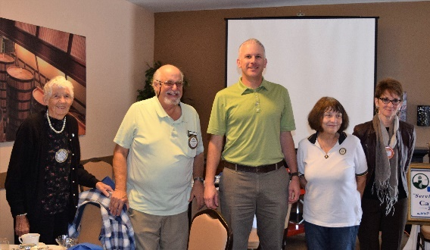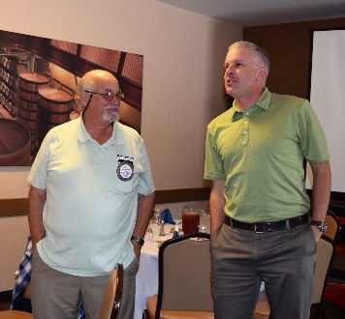
Service Above Self

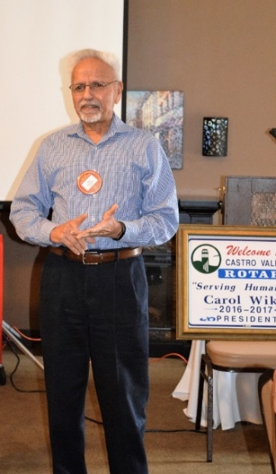
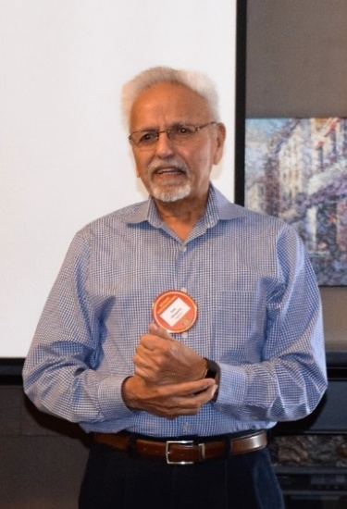
Craft Talk
Red Badger Ajay Ahluwalia described his life experience as a Nuclear/Mechanical Engineer and as an owner operator of a Chevron Gas Station. He migrated to USA in 1970 from India and became a Naturalized Citizen in 1976. He worked from Bechtel Engineering. Ajay lived in New Jersey for about 2 years, about 10 years in Texas and has been back in California since 1994. He is now retired and lives in Castro Valley.

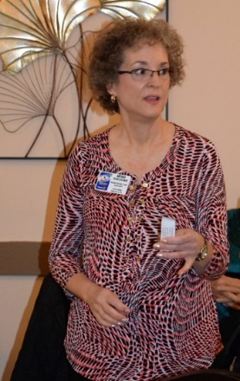
Castro Valley Meet in the Street/Light Parade
Heidi Hausauer thanked Club members Ajay Ahluwaila, Todd Anglin, Bill Nott, Margie Ramos and Dan Willits for volunteering as judges for Castro Valley Light Parade on Saturday, November 12th, with a special thanks to Todd for recruiting four other judges for the event. Volunteering for the Light Parade is just another example of how the Rotary Club of Castro Valley gives back to the community. Service Above Self

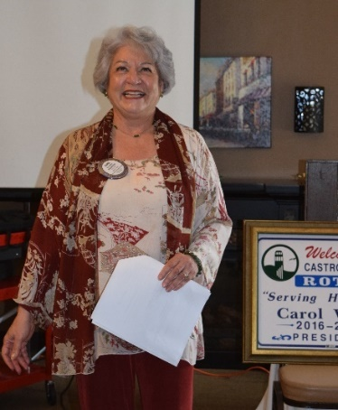

Announcements
President Carol announced the following decisions from the board meeting of November 14, 2016:
- Ajay Ahluwalia was approved as Club Secretary for the remainder of 2016-2017 replacing Jim Negri as the Interim Club Secretary.
- A grant of $500 to Redwood Christian Schools for emergency supplies. The Club will present the check at a future meeting.
- Agreement to support both Redwood Christian High School and Castro Valley High School students once again at Camp RYLA.

Mark Poniatowski requested volunteers for the Children’s Christmas Party on December 13th at Castro Valley Adult and Career Education Room 10. He also distributed a list to sign up as a volunteer. Contact Mark for more information on volunteering, but you will be able to sign-up at lunch on November 22 and 29.

Jim Negri reminded Club members about the Annual Holiday Party on December 10 at 6:00 p.m. at the home of Heidi Hausauer and requested a RSVP no later than November 30.

Upcoming Lunch Speakers
- November 22 - Laura Koshy who backpacked around the world for 18 months in her 20’s.
- November 29 – Annual Club Yoyo Competition with Bruce Johnson

More Photos from Lunch on November 15
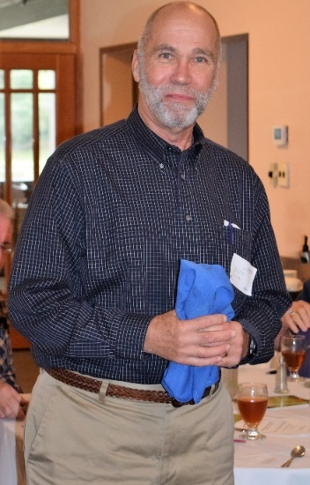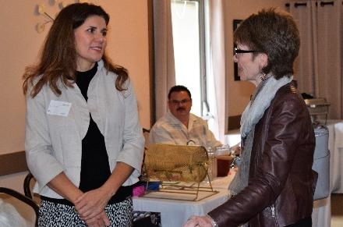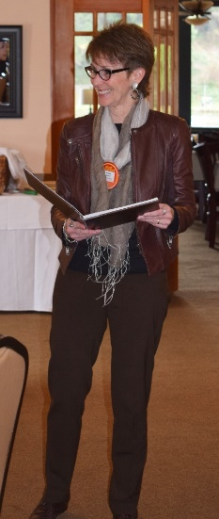
Red Badge Member Muriel Monat introduces Glen Juntti and Silvia Venegas. Glen was the guest of Ajay Ahluwalia and is Ajay’s daughter’s father-in-law as well as a member of the Rotary Club of Minnetonka, MN. Silvia, a guest of Todd Anglin, is Operation Manager for Fairway Independent Mortgage Corporation.
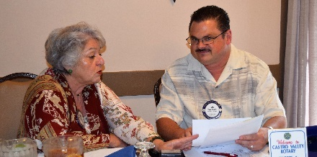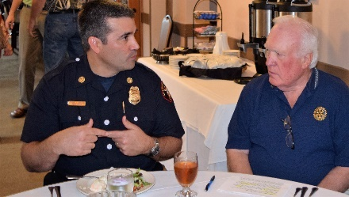President Carol and Treasurer Todd discussing the financials. Chief Rocha and Dwight sharing a thought before lunch. 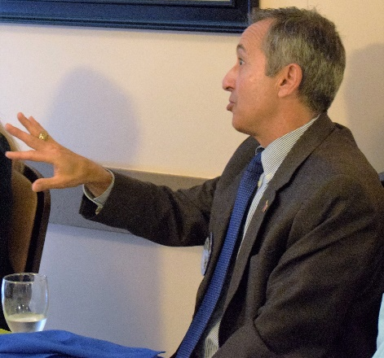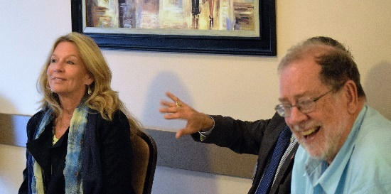
Mark asks a question of Chief Rocha and Ray reacts to the question.
