Rotary Club of Castro Valley
Meeting Highlights – November 20, 2018

Russ Hobbs – The Rotary Foundation (TRF)
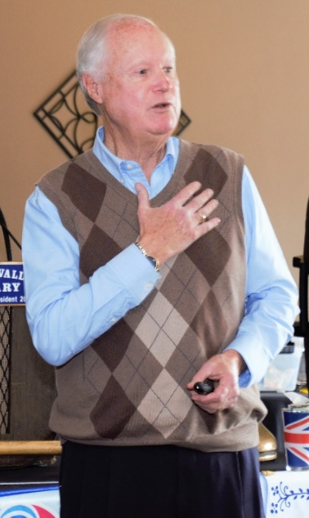
Russ Hobbs is a member of the Rotary Club of Santa Cruz and is a Past District Governor (PDG) and current The Rotary Foundation (TRF) Chair for District 5170.

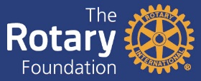
Russ began by explaining that any member of any Rotary Club anywhere in the world automatically become a member of Rotary International. There are currently over 35,000 Clubs and 1,200,000 members worldwide. The Rotary Foundation (TRF) collects contributions for all Rotary Clubs. (Moe information on The Rotary Foundation is available here. TRF holds the contributions for three years allowing the funds to grow and then half of each District’s contribution is returned the District. The District then allots funds to support the various Club projects. The various Club projects are evaluated by a District Committee, which in turn, distributes the money based on need, usefulness, and feasibility of success. This approach is how our Breathing for Life (BFL) Project was funded along with generous donations from individuals and Clubs.

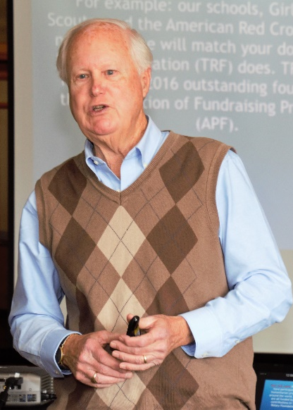
Russ then engaged PDG Dwight Perry, TRF Chair for the Rotary Club of Castro Valley, to pilot the members on a magic carpet ride to various TRF projects in which Russ has participated. These projects included
- Djibouti Project by the Rotary Club of Sunnyvale to provide cardiac care equipment for a hospital. This project like many TRF projects provided participants an opportunity to enjoy a safari in Kenya.
- Polio National Immunization Day in Ghana – Rotary has also participated in the Immunization Day in India where over 1.2M doses were given
- Grants for various projects in Guatemala including hospital equipment and shirts for kids
- Vocational Training Team Project in Laos
- The Feeding Dream School in Cambodia - Teaching English to Cambodian students and training them to work in the hospitality industry
- The Wheelchair Project in Mexico providing wheel chairs to individuals to provide mobility – Our Club has supported this project and Ceta and Luc Dochterman have participated in the delivery, building, and distribution of the wheelchairs.
  - Ken Behring, the founder of the Blackhawk Museum and the Wheelchair Foundation, has a section of the Blackhawk Museum set aside to recognition the work of the Wheelchair Foundation.
- New hospital equipment in China, which changed how the government provided services
Russ described how our Club’s Breathing for Life (BFL) Project in Nejo, Ethiopia, sprung out of Obse’s interest and an informal conversation with PDG Joe Hamilton, whose wife also works at Stanford Hospital. BFL at $375,000 will be one of the largest TRF projects ever. The project is scheduled for competition next year.
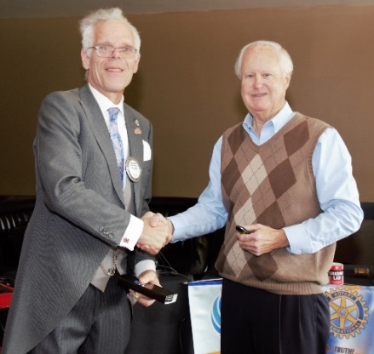
Russ stressed how TRF projects have helped millions around that world as creating lifelong memories and friendships for Rotarians who have participated. For more information, go to https://www.rotary.org/en/about-rotary/rotary-foundation.
Dwight Perry reminded everyone that November 27th is Giving Tuesday. For more information go to https://blog.rotary.org/2017/11/27/5-reasons-to-support-the-rotary-foundation-on-giving-tuesday-2/. If you haven’t made or paid you Paul Harris Pledge for 2018-2019, Tuesday is the day to do so.
Scenes from the Meeting
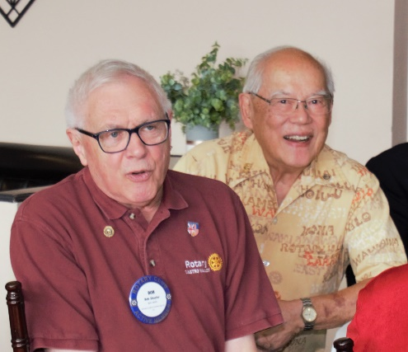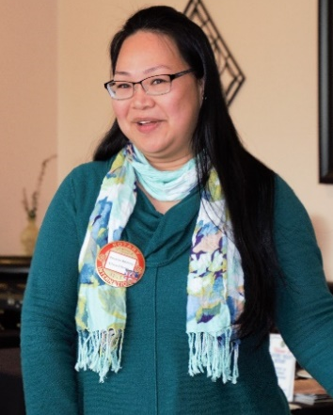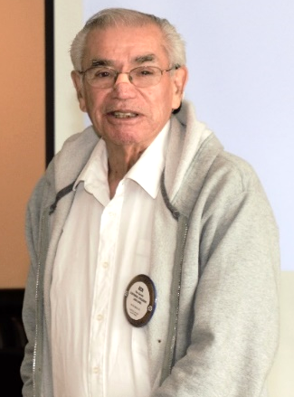
(Left to right): Bob Shayler returned from Hawaii and announced that he is not moving to Hawaii while Visiting Hawaiian Rotarian Tommy Gee looks on. Red Badgers Roselyn Antonio and Rita Sablan celebrate their birthday. The second attempt at Happy Birthday was better than the first, but that is not saying much. Ben Gurule thanked everyone for the birthday wishes and announced that he will be having surgery next week. Keep Ben in your thoughts.
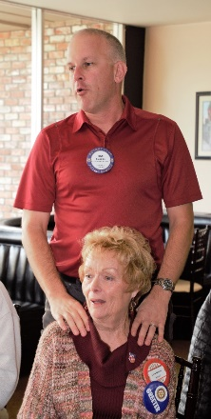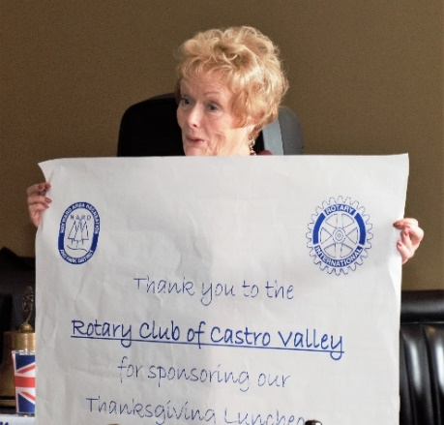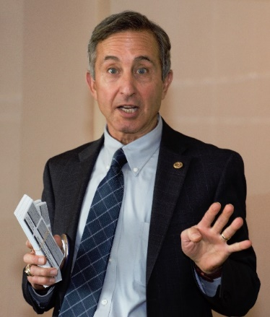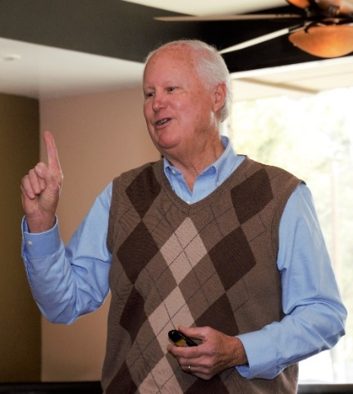
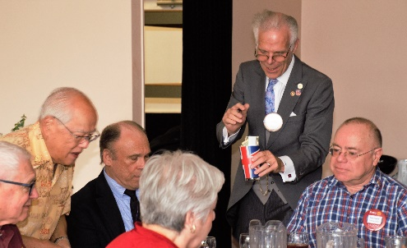
(Left to right): Dan Willits paying it forward for Carol Bigelow’s great work in organizing the Senior Thanksgiving Lunch that the Club Sponsored. Carol sharing the thank you poster from the event. Mark Poniatowski with his weekly reminder to sell four Texas Hold ‘em tickets. Russ Hobbs making a point about TRF. President Charles collecting for the Rotary Club of Paradise Foundation to assist the Camp Fire victims.

Upcoming Events

November 27 – Lunch with Alameda County Fire Chief Dave Rocha – Don’t forget to RSVP
November 27 – Report of the Nominating Committee at lunch
November 27 – Giving Tuesday at lunch – Make your Paul Harris pledge or payment
November 28 – Board of Directors Meeting at 5:30 pm at Don Jose’s – All members invited
December 4 – Lunch with Zach Ebadi, H.A.R.D Adopt A Family Program – Don’t forget to RSVP
December 4 – Vote on the 2019-2020 President-Elect at lunch
December 8 – Club Christmas Party at the home of Heidi Hausauer – RSVP ASAP
December 11 – Dark at Lunch
December 11 – Children’s Christmas Party at 3:00 pm at Castro Valley Adult School
December 12 – Texas Hold ‘em Meeting at 5:30 – Mark Poniatowski office
December 18 – Lunch meeting
December 25 - Dark at Lunch
January 1 - Dark at Lunch

Meeting Highlights
Notes by Ajay Ahluwalia
Photos by Jim Negri
Editor – Jim Negri

