Rotary Club of Castro Valley Meeting Highlights
November 29, 2016

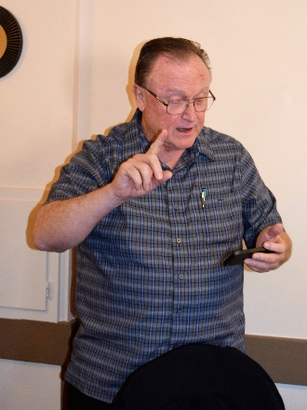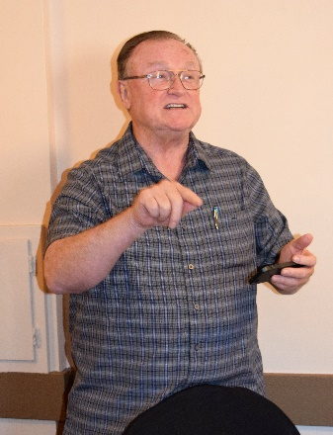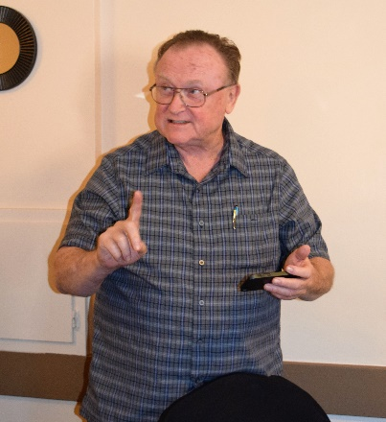
After the Pledge of Allegiance by Bill Nott, Bruce Johnson intently shares the Thought for the Day.

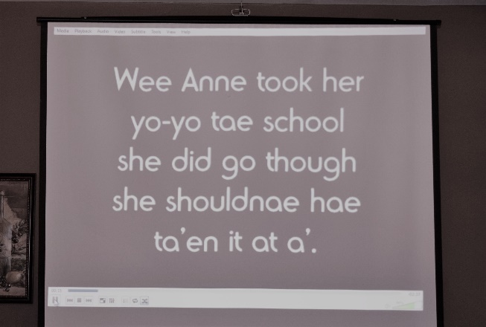
The Red Yo-Yo Song
In honor of the Club’s almost Annual Yo-Yo Contest, Ceta Dochterman selected an appropriate song, Red Yo-Yo, which is a Scottish primary school song. The chorus, which the members valiantly sang, is

Did ye find a red yo-yo, red yo-yo, red yo-yo
Did ye find a red yo-yo, wi a wee yellow string?

To hear the whole song, click here.

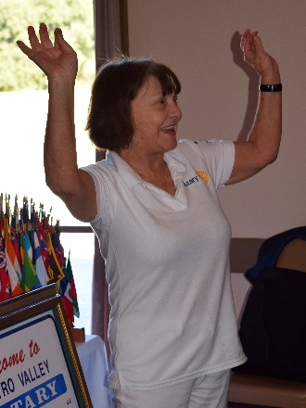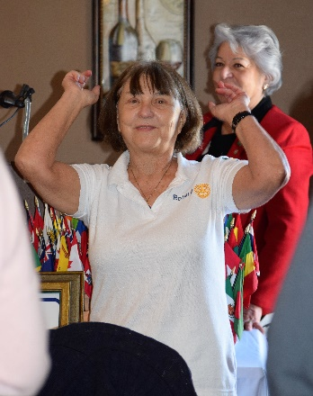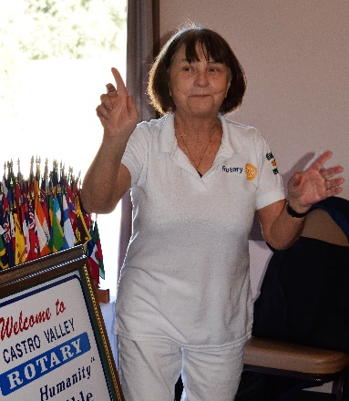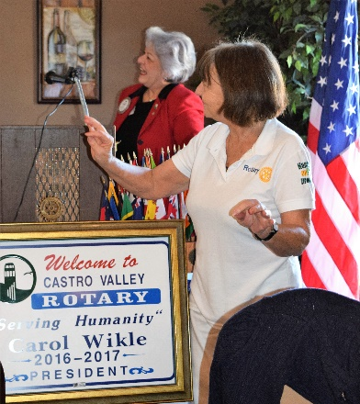
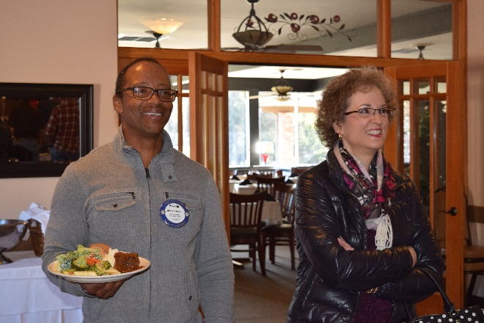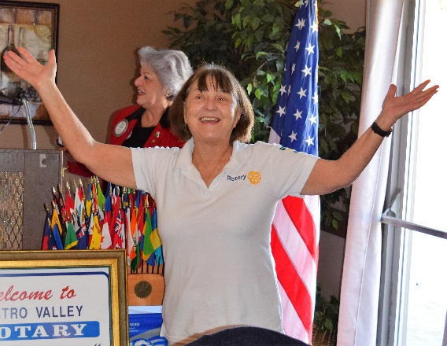
Roland and Heidi enjoy the singing as they arrive late for lunch.

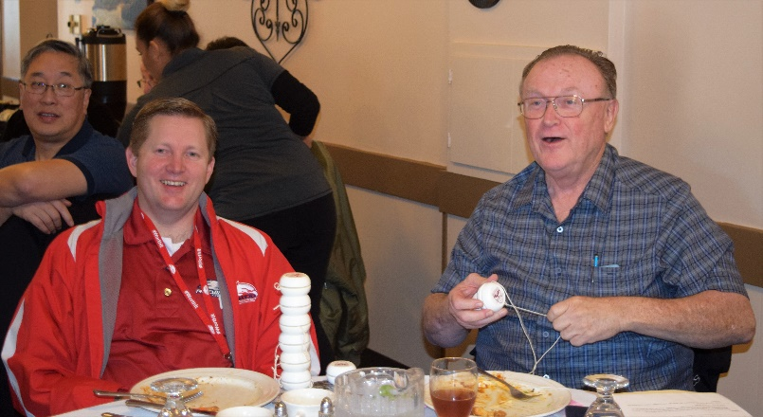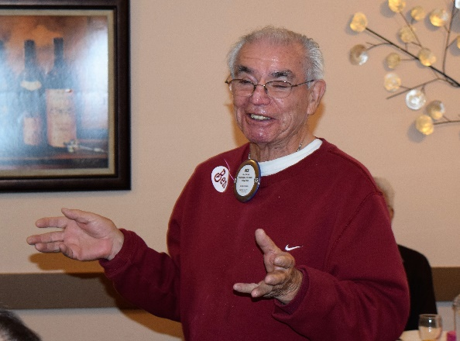
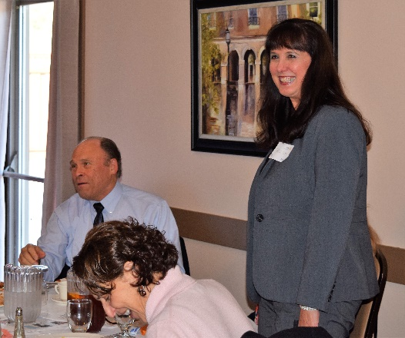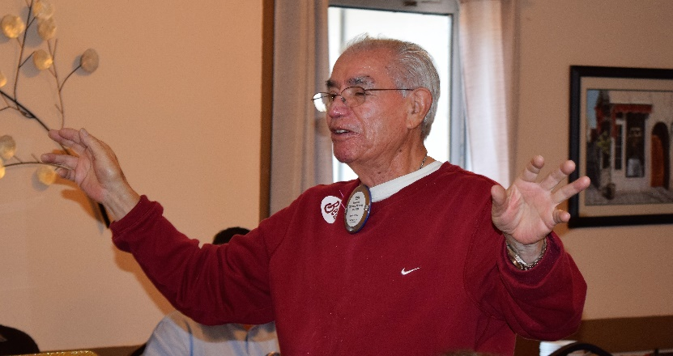
Ben Gurule leads the Sal Tedesco Memorial Hello Song for guests Al Hearne (guest of Bruce Johnson) and Gail Lew (guest of Gary Bosley).

New Red Badge Member
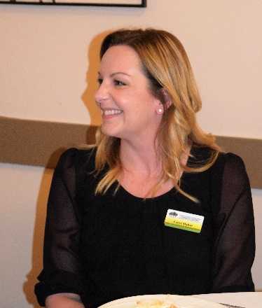
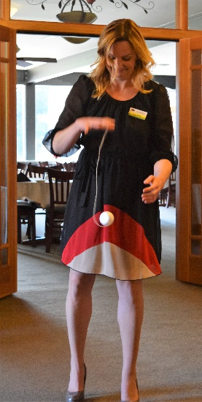
Caryl Maher was introduced as the newest member of the Rotary Club of Castro Valley. Caryl is the Business Development & Marketing Director for the Castro Valley Eden Area Chamber of Commerce (http://www.edenareachamber.com/). A Castro Valley resident for the past 15 years, Caryl has two child and has worked for the Chamber for two years. Please make the time to welcome Caryl to the Club and to get to know her as well as what the Chamber can do for you.

The December 2016 Chamber Mixer will be December 8th at Eden Medical Center at 5:30-7:30 p.m. This Holiday Mixer is held in conjunction with the Hayward and San Leandro Chambers.

Grant Presentation
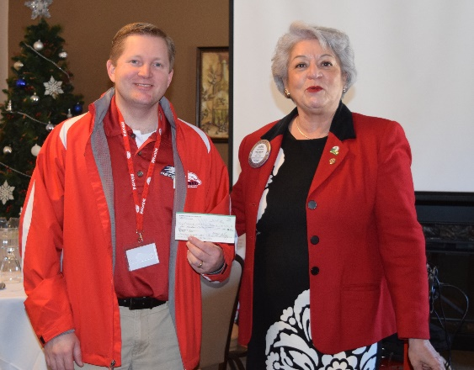

President Carol Wikle presents Redwood Christian Schools Superintendent Al Hearne with a $500 grant check to support emergency supplies at the Redwood Christian Schools. This grant was the first of the year awarded by the Club with more to come.

Annual Club Holiday Party
President-Elect Jim Negri announced that today, November 29, was the last day to RSVP for the Annual Club Holiday Party on December 10 at 6:00 p.m. Over 50 people have RSVP’s and both the District Governor Jeff Orth and Assistant District Governor Orrin Mahoney and their wives will be joining us. Jim reminded members of the White Elephant Gift Exchange (maximum value $20 and re-gifting is perfectly acceptable.)

Announcements
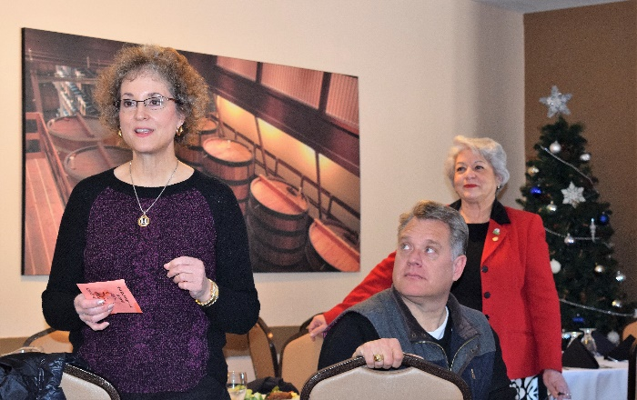
Heidi Hausauer reminded members that they have one week to make their $200 Double Sustainer contribution for the year, which earns a member a ticket in the District 5170 raffle to be held on December 7. Heidi will be present to collect your winnings if you are not present. There are many wonderful prizes and the Club has had big winners in the past.

Heidi also informed the Club the we have two needy families from H.A.R.D. She finished the shopping prior to Black Friday. We will be wrapping the presents on December 13 and giving them to Zack Ebadi, the H.A.R.D. Outreach Coordinator, who will be our speaker on the 13th.

President Carol described the Club’s Annual Children’s Christmas party on December 13 at Castro Valley Adult and Career Education (Room 10 – the Multi-Purpose Room). A number of members have already volunteered, but anyone is welcome to help out. See Mark Poniatowski for details.

ANNUAL CLUB YO-YO CONTEST
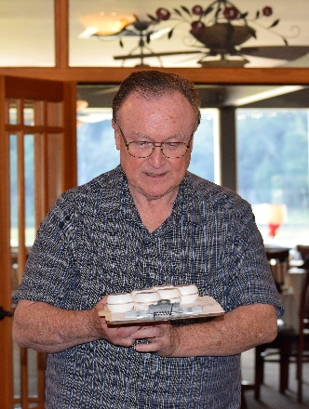
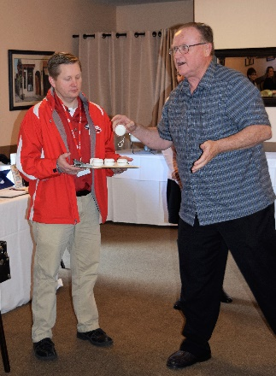
The program for the day was the Annual Club Yo-Yo Contest. Bruce Johnson introduced Al Hearne who would be keeping track of the scoring (10 points for completing the trick on the first try and 5 points for completing the trick on a second try.) Bruce selected four contestants and there were two volunteers; however, when Bruce selected Jim Negri, who was the staff photographer for the contest, Jim volunteered Todd Anglin to take his place. The other contestants were defending champion Dwight Perry, Parvin Ahmadi, Caryl Maher, Bill Nott and Jerry Sooho. Bruce presented each contestant with his/her own yo-yo and demonstrated each trick the contestant would attempt.
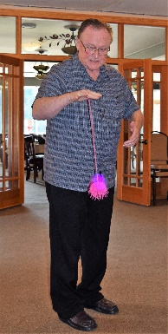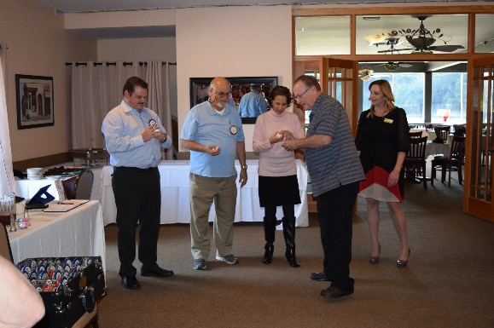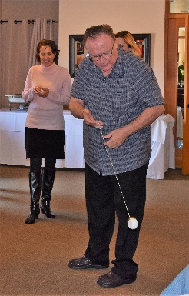
New Club Champion
After six challenging and entertaining rounds, Jerry Sooho was crowned the new Club Yo-Yo Champion with Parvin Ahmadi in second place and Todd Anglin in third place. Everyone who participated as well as the audience had a great time.
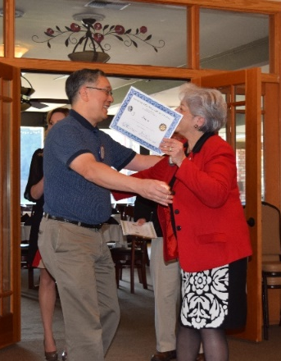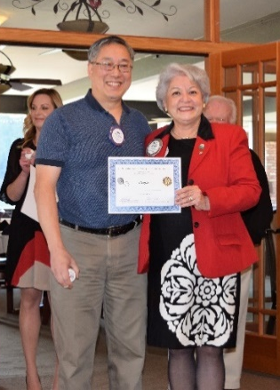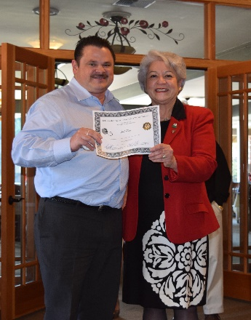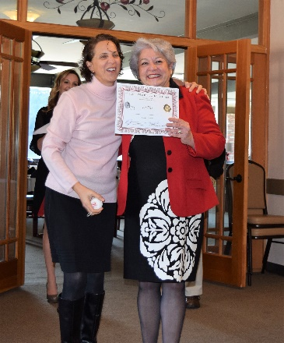
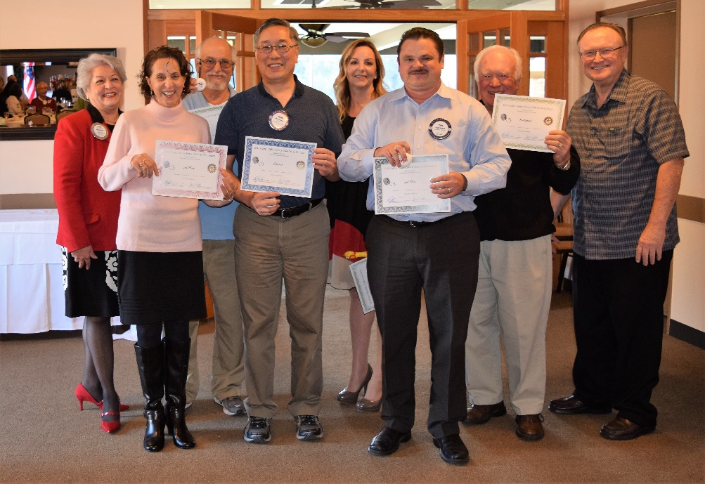
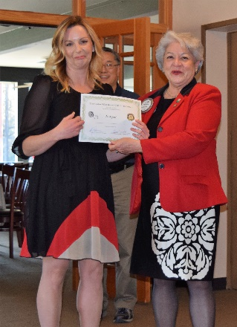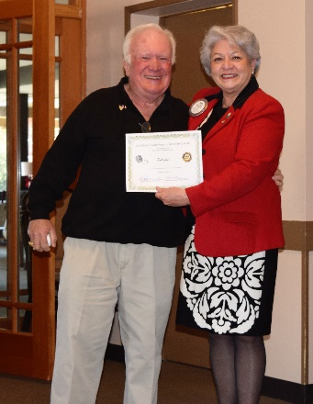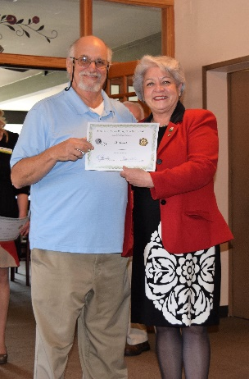
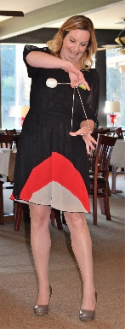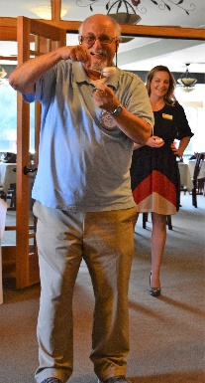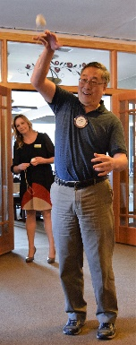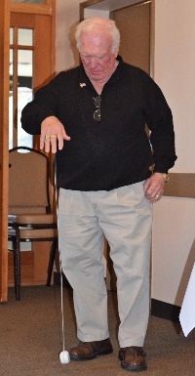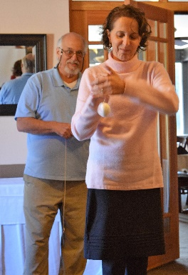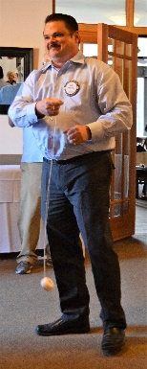
NOTE: Jim Negri has 300+ more photos from the contest that he will put in a slideshow or delete for a significant donation to the Breathing for Life Project.
Upcoming Events
- December 3: Lucille Lorge and Randy Vanderbilt present 200 Years of Castro Valley History at the Adobe Art Gallery – Reception 1:00-3:00 pm – Show runs through January 7, 2017
- December 6: Lunch meeting with Dr. Cynthia Mahoney on Climate Change
- December 7: District 5170 Leadership Meeting and Rotary Foundation drawing. See Dwight or Heidi for tickets
- December 10: Annual Club Holiday Party
- December 13: Lunch meeting with Zack Ebadi from H.A.R.D. Outreach & wrapping of Christmas presents for the two families that the Club has adopted
- December 13: Children’s Christmas Party at Castro Valley Adult & Career Education. Contact Mark Poniatowski to volunteer.
- December 20: Lunch meeting with Wendy Winsted from Sulphur Creek

