Rotary Club of Castro Valley
Meeting Highlights – November 6, 2018

Alameda County Sheriff Greg Ahern
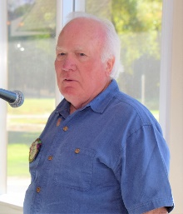
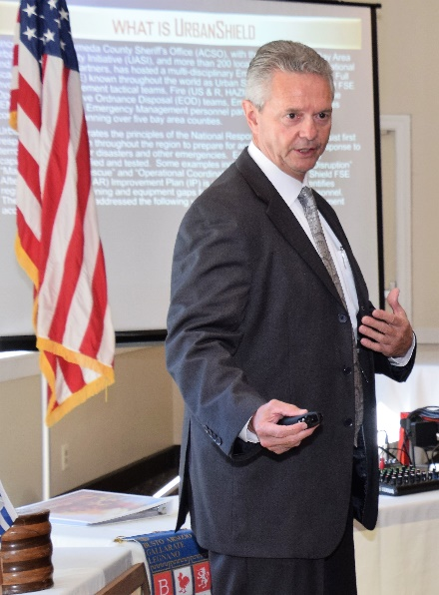
Alameda County Sheriff Greg Ahern was the lunch speaker today. Dwight Perry’s great introduction shared that after starting his career with the Alameda County Sheriff’s Office in 1980, Greg quickly moved through the ranks becoming Sheriff on January 8, 2007, the 22nd Sheriff in Alameda County since 1853.

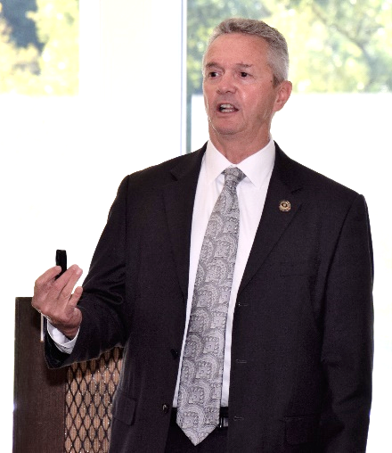
Sheriff Ahern is known locally, statewide, and nationally for his leadership and character. Sheriff Ahern oversees an annual budget of more than $400M for officers and $200M for jails. Sheriff Ahearn is also the Director of Emergency Services from Monterey to the Oregon border.

He and his wife Kathleen live in Livermore. Sheriff Ahern was honored by Redwood Christian Schools on October 23, 2018, with the Schools’ Lifetime Recognition Award, the same award presented to the Rotary Club of Castro Valley 2017 (see the October 31st issue of the Castro Valley Forum for a great article featuring him and his commitment to Alameda County residents). Sheriff Ahearn is the keynote speaker each year at the Castro Valley/Eden Area Chamber of Commerce Student Luncheon honoring one student from every school in our area. He is always an inspiration for the students, teachers, administrators, parents and community members.

Sheriff Ahern topic was the Urban Shield exercise, the largest training of first responders in the world. He shared a video that captured the forty-eight consecutive hours of intensive training funded ($1.7M) by the federal and state government as well as other sponsors.

The theme for Urban Shield this year was “Real Time Training for Real World Events” and involved more than 200 partners and 6,000 volunteers assisting in Alameda County, San Francisco County, San Mateo County and Contra Costa County.

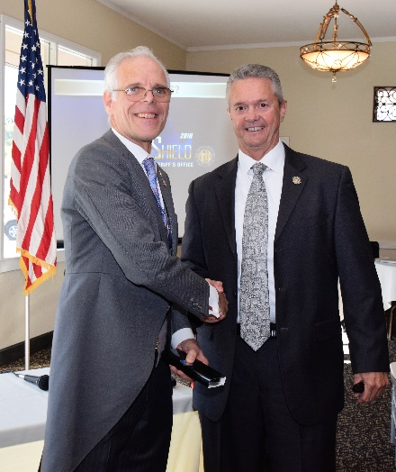
Sheriff Ahern’s presentation covered:
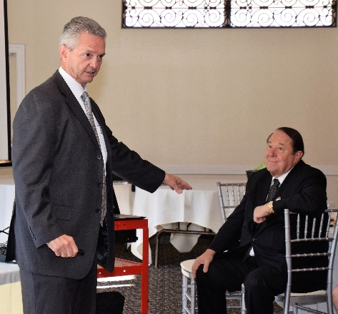
- Main goals
- International countries participating;
- Scenarios and Sites;
- Core Capabilities;
- Law Enforcement Scenarios;
- Emergency Ordinance Disposal;
- Fire Scenarios;
- Community Preparedness;
- Emergency Management; and
- Historical achievements of the program.

Sheriff Ahern encouraged anyone “who can stay up and active for the entire 48 hours” to volunteer next year! Ceta Dochterman has done it in the past and will be recruiting for sure! For Urban Shield information and details, please visit www.urbanshield.org/. The community is blessed to have Sheriff Greg Ahern serving everyone.

Scenes from the meeting
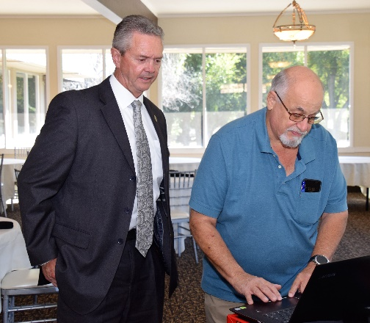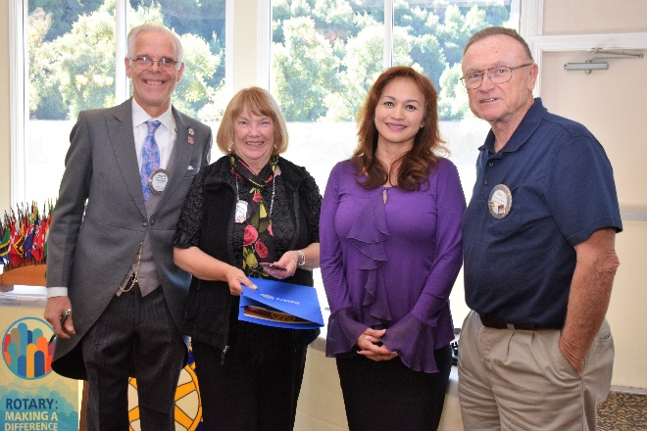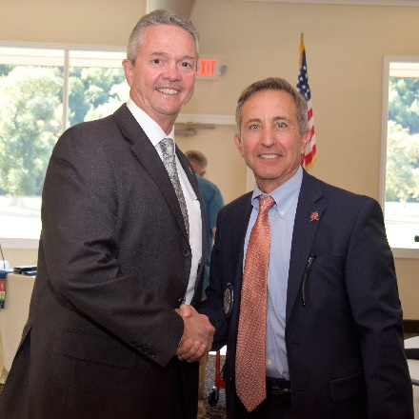
(Left to right): Sheriff Ahern making sure Bill Nott sets up the Urban Shield presentation correctly. President Charles Mortimer and Membership Chair Virginia Degner present Rita Sablan (Health Markets/Covered California) with her Red Badge and Membership Certificate as her sponsor, Bruce Johnson watches. Texas Hold ‘em Chair Mark Poniatowski making certain that Sheriff Ahearn knows about the March 9th event.
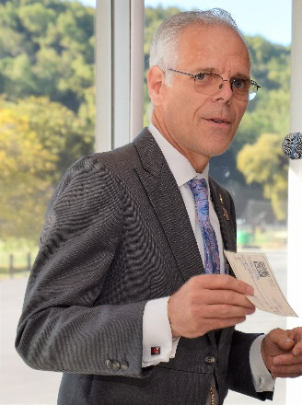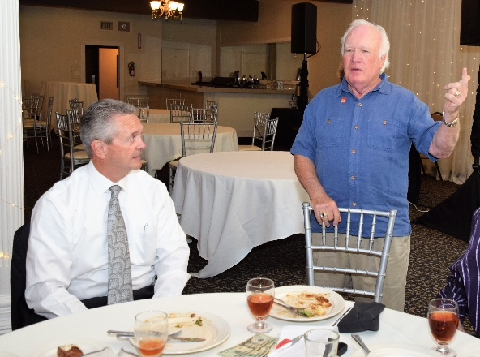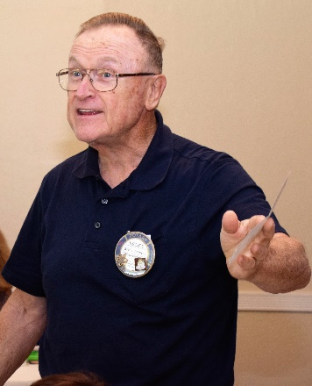
(Left to right): President Charles contributing to the Club in recognition of his birthday. Dwight Perry leading the Four Way Test as well as the Three Way, which was created by former RI President Cliff Dochterman. If you don’t know the Three Way Test, ask Dwight. Bruce Johnson recognizing his wife, Linda, and his 49th anniversary, which will be spent in either Israel or Turkey.
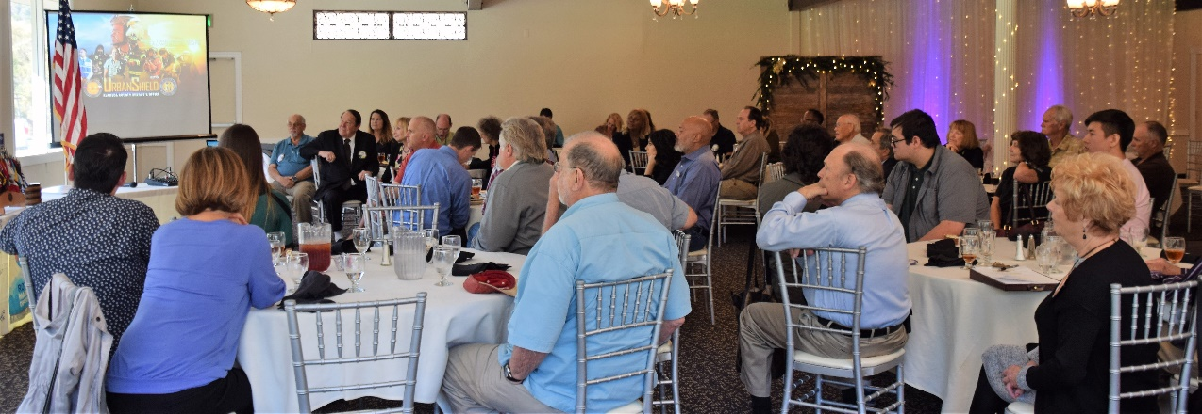
Sheriff Ahearn commands everyone’s attention even when he is not in the photo.
There were more than 40 people in attendance

Announcements
- Heidi Hausauer provided an updated on the Light Parade (originally schedule for November 10 and then postponed to November 17 before being canceled due to poor air quality).
- Mark Poniatowski reviewed the Texas Hold’ em Tournament and distributed tickets while encouraging everyone to “Promote, promote, promote!” Jim Negri looking for prized valued at $500 or more for final 10 players. Kern Lewis is looking for sponsors. See Mark, Jim or Kern for details. This event is the largest Club fundraiser of the year and is budgeted to net $25,000 so everyone needs to be involved.
- Carol Bigelow reminded everyone) to volunteer for the Senior Thanksgiving Feast for Seniors on November 14th at Kenneth C. Aitken Senior & Community Center. It is a great opportunity to give back to the community and promote Service Above Self.
- The Club Christmas Party will be held December 8th at Dr. Heidi’s. Cost is $40 per person with children under 18 free. See President-Elect Todd Anglin or Heid Hausauer for details.
- The Children’s Christmas Party will be held December 11 at Castro Valley Adult Education School (Room 10). Mark Poniatowski and Bruce Johnson are coordinating details and looking for volunteers. The Club is DARK at lunch that day.
- Mark your calendars for the Chili Cook-off (May 10) and Rodeo Parade (May 11). The theme for the parade is Be the Inspiration, which is the RI theme this year. Randy Vanderbilt and Todd Anglin respectively are coordinating the events. Planning meetings will start up again in January.
- President-Elect Todd Anglin shared that the Proctor Elementary School PTA was very thankful $1,250 Rotary grant to support the Garden Beautification Project. The grant helped fund about ten new flower beds which the PTA and parents have spent two weekends building. Once the garden is complete, there will be a grand opening and Rotarians will be invited to attend.

Please remember to RSVP for lunch every week.

Meeting notes by Bruce Johnson and Todd Anglin
Meeting photos by Jim Negri

Jim Negri, Editor

