Rotary Club of Castro Valley
Meeting Highlights for November 8, 2016

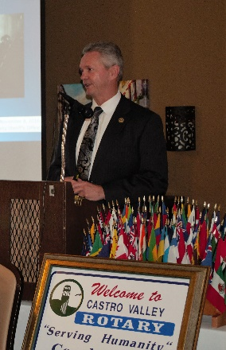
Alameda County Sheriff Greg Ahern
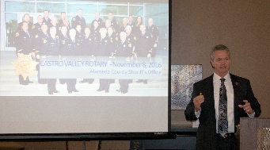
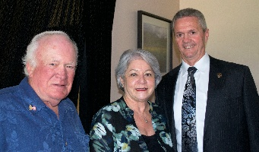
Dwight Perry introduced Alameda County Sheriff Greg, who has served as Sheriff since 2007. The Alameda County Sheriff’s Office (ACSO) has a $185M budget and over 1500 authorized positions (more information at https://www.alamedacountysheriff.org/about.php).

Sheriff Ahern was candid about the operation of the ACSO and shared a great deal of very useful information including the following: Every action of the officers is governed by a specific procedure. All actions of the officers (e.g., traffic stops, arrests, home calls, any type of contact with the public involving Tasers/guns) are reviewed by their supervisors. All the officers are equipped with state of the art Tasers (laser guided guns) and body cameras. The patrol cars are equipped with computers and use higher frequency communications, which provides them access to the motor vehicle data as well as police data for potential suspects.

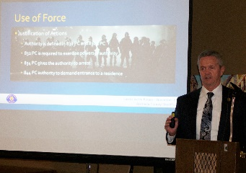
ACSO has started using Unmanned Aerial System for tracking potential criminals during chases and during Investigations of illegal activities, so that the officers can prepare adequately prior to confrontation with potential suspects and criminals. The body cameras of the officers are automatically activated on contact with the Tasers and/or weapons by the officer. Some of the delay between the accounts of the press and official statements by the Sheriff’s Office is a result of the review of the actions of officers, and the mandatory review of the Officer's body cameras and their statements.

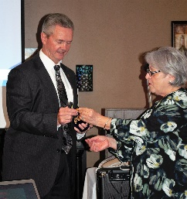
Sheriff Ahern spoke of true heroism and what it is like to volunteer one’s life to save a citizen and the rapid and difficult decision of when and where to shoot. A quote from a Rotarian, “He is an amazing man to appreciate and be thankful for his leadership and bravery.” Definitely Self Above Self.

Breathing for Life Project
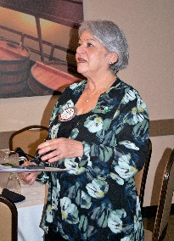
President Carol again emphasized the need for contributions for the project, if the Club is to meet its goal of providing an oxygen generator for the hospital in Nejo, Ethiopia. If you have not donated, please consider a donation in any amount and ask your family, friends and colleagues. This is a truly a worthwhile project to which many Rotary Clubs have already donated. You can donate online (see the Club webpage) or send a check with your full name and address on the check in order to receive a receipt from District 5170 501(c)3 94-3016176 for tax purposes.

Birthdays and Anniversaries
President Carol Wished Happy Birthday and Happy Wedding Anniversary to Jeff Moore, and Happy Anniversary to Bruce Johnson. Both Jeff and Bruce announced a contribution of $150.00 each to celebrate their happy occasions.
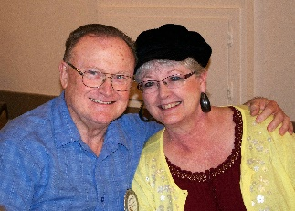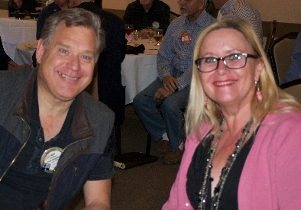

Upcoming Events (Always check the webpage for Upcoming Events)
November 9: Bill Nott announced the Rodeo Ranch Parade meeting at 5:30 p.m. at Direct Sales.
November 12: Heidi Hausauer requested judges for the Castro Valley Meet in the Street/Light Parade.
November 14: Volunteers serving the Thanksgiving Lunch at the Senior Center.
November 14: Board of Directors Meeting at 6:00 p.m. at the Chamber Office. Please review the grant requests prior to the meeting.
November 15: Lunch Speaker - Alameda County Fire Chief David Rocha
December 10: Club Holiday Party – Please RSVP by November 30.
December 13: Children’s Christmas Party at CV Adult & Career Education Room 10

More Photos from Lunch (Thanks to Murline Monat)

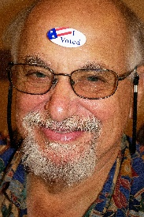
Did Bill vote?
