Rotary Club of Castro Valley
Meeting Highlights – October 16, 2018

Dave Nolting – Appraiser: Guidelines for Property Appraisals
Dave Nolting has worked in the real estate market for more than 45 years. Initially, Dave worked as a Real Estate Agent until the mid-1990's when he began working as a Property Appraiser. All property appraisers work for mortgage finance companies (e.g., banks, mortgage lenders) and are responsible to these companies. Their business, however, is regulated by Real Estate Boards. The Property Appraisers are certified by these boards and they operate in compliance with the requirements and principles of the Boards under uniform procedures and forms approved by the Boards.

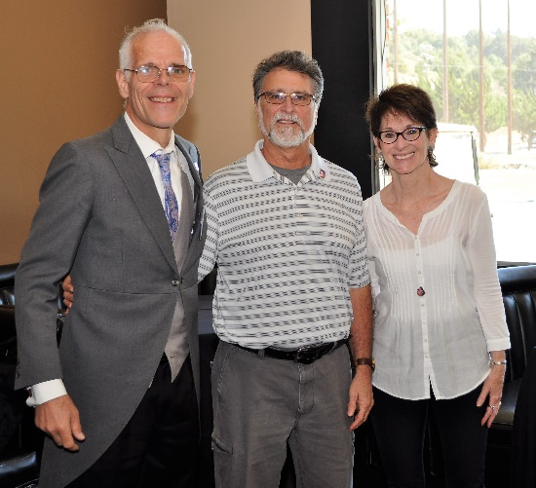
After being commissioned by the lending institution, the appraiser obtains the basic information of the property and then visits the actual site. The appraiser is required to collect all the basic information regarding the property (e.g., description of the property including number of levels; number of rooms on each level and their use; any underground rooms; other construction on the site including any temporary structures; any patios or decks;, landscaping;, view from the property; if the property part of a subdivision of similar properties or is it a unique design; property area; fenced or open; how it compares with surrounding properties; comparative analysis of the property values of similar properties in the area; maintenance condition of fixtures, painting and landscaping).

After recording the basic information regarding the property, the appraiser then takes interior and exterior photographs to justify his comparison with other similar properties in area. Based on these factors, he provides positive and negative estimates of the special features of this property as it compares with other properties in the area. Finally, the appraiser provides a rationale for the Final Appraisal of the property.

Announcements
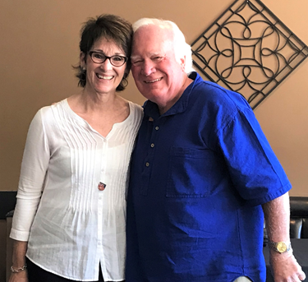
Murline Monet presented Foundation Chair Dwight Perry a check for $1,000 for the Polio Plus Foundation, which will be matched 2:1 by the Bill and Melinda Gates Foundation, making the total donation $3,000! Murline stated that “I was an honor to present the check and it’s rewarding to be a part of a far reaching effort to ensure the continued eradication of Polio.” Murline thanked the Paragon/Compass Community Fund Committee and her fellow agents for their generous contributions to build a significant fund and allow for this generous contribution. Murline noted that realtors with whom she works contribute a certain amount from each of their property sales to charitable organizations/causes and Murline was able to secure this contribution for the Polio Plus Foundation.
Texas Hold ‘em Sponsors
Randy Vanderbilt, Charles Mortimer, and Todd Anglin volunteered to be sponsors ($300) for the Texas Hold ‘em Tournament in March. See Mark Poniatowski for more information. Jim Negri will be soliciting prizes for the event so make your contribution to Jim as soon as possible.

Upcoming Club and Community Events
- October 24 – Board of Directors meeting at Don Jose’s Restaurant at 5:30 pm – all members welcome
- October 25 – Chili Cook-off (5:00 pm) and Rodeo Parade (5:45 pm) planning meetings at Direct Sales Floor
- November 10 – Castro Valley Light Parade on Castro Valley Blvd.
- November 14 - Thanksgiving Lunch at the Kenneth Aitkens Senior Center – volunteers needed – see Carol Bigelow for details
- November 14 – Texas Hold ‘em Planning Meeting at Mark Poniatowski’s office at 5:30 pm
- November 21 – Nominating Committee meeting after lunch
- December 8 – Club Christmas Party – see Todd Anglin for details
- December 11 – Club Children’s Christmas Party – see Mark Poniatowski for details

Meeting Highlights
Notes: Ajay Ahluwalia
Photos: Murline Monet
Editor: Jim Negri

