Rotary Club of Castro Valley
Meeting Highlights – October 2, 2018

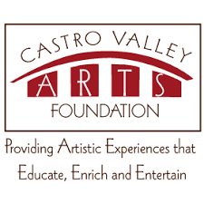
Due to a last-minute emergency with the scheduled speaker, Castro Valley Rotarians Murline Monat and Gary Howard stepped up to provide the program for the day.
Murline is currently serving as the Vice President of the Castro Valley Arts Foundation (CVAF). Rotarians Bernie Kempen and Bill Nott also served as members of the Board of Directors. The Rotary Club of Castro Valley has supported the CVAF in many ways since it was founded by Erma Smith and Terri Liebowitz in 1998 (read the history). Murline provided an update on current happenings with the CVAF and programs at the Castro Valley Center for the Arts (CVCFA).
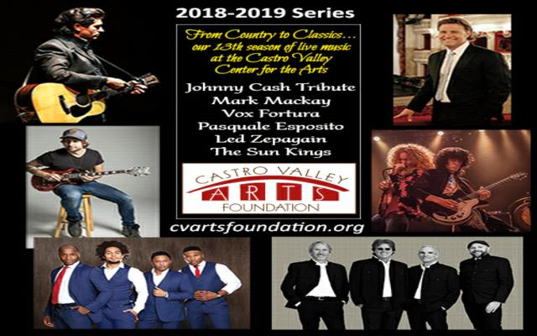
The Castro Valley Arts Foundation (CVAF) has a unique partnership with the Castro Valley Unified School District (CVUSD) and shares the financial burden of supporting the Castro Valley Center for the Arts. Every year, the Foundation donates $50,000 that is used exclusively for operational expenses. In addition to an annual fundraising campaign, the Castro Valley Arts Foundation produces a Series with performers from around the Bay Area and beyond. Concession proceeds from these shows fund scholarships to college-bound CVHS seniors who contribute their time and talents to the Center.
The high quality educational, enriching and entertaining events that Castro Valley Arts Foundation produces at the Center for the Arts make a difference in our community and keeps the Castro Valley Center for the Arts accessible to everyone. For more information about CVAF and upcoming programs, go to https://www.cvartsfoundation.org/. Also see the attached flier for additional information and ways to support the CVAF.
How Does Science Really Work?

Gary Howard who has spoken to the Club several times about his work in the scientific community, shared his insights and enlightened Club members about the real workings of science.
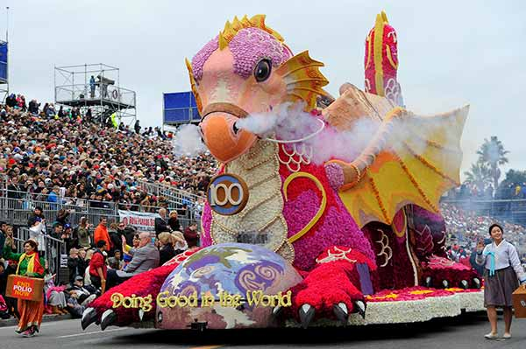
Announcements:
- Dwight Perry handled a Pass-the-Hat to support the Rotary International float in the Rose Parade. The float is completely funded by Rotarians. Every Rotary Club is asked to contribute $2 per member. It is not too late to donate.
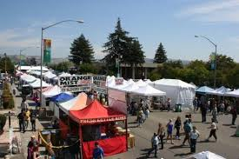
- The Board of Directors approved $375 for 10’x10’ popup tent for the Castro Valley Fall Festival. Be sure to mark you calendars and volunteer to staff the booth.
- The Castro Valley Eden Area Chamber of Commerce is sponsoring Bark and Boos on October 30th at 5:00-9:00 pm at the Adobe Center, 20395 San Miguel Avenue.
- Aaron Lewis announced that Rotary Club of San Leandro is holding its Annual Crab Feed on November 9. The cost is $50. See Aaron for details or check out the flier here.
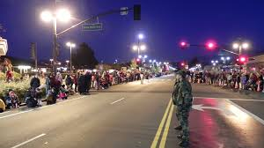
- Heidi Hausauer announced that she is still looking for judges for the Castro Valley Light Parade/Meet in the Street on November 10th. The event begins at 3:00 p.m. on Castro Valley Blvd with the Parade at 5:30 p.m. More details here.
- Heidi will also host the Club’s Annual Christmas party on December 8. See Todd Anglin for details. The President-Elect has the task of organizing this party.
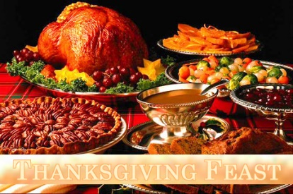
- Texas Hold ‘Em Tournament, the Club’s largest fundraiser, is scheduled for March 9, 2019, at Our Lady of Grace Church. Signup sheets are now available. President Charles agreed to donate a table and a TV as a prize. Jim Negri is soliciting prizes. Please see him to donate.
- Carol Bigelow is coordinating the Thanksgiving Lunch at the Senior Center on November 14. The Club needs volunteers for two shifts (8:30-11:00 to prepare food and 11:00-1:30 to serve and clean up. See Carol to volunteer.

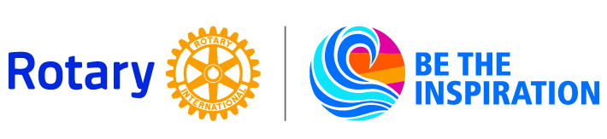

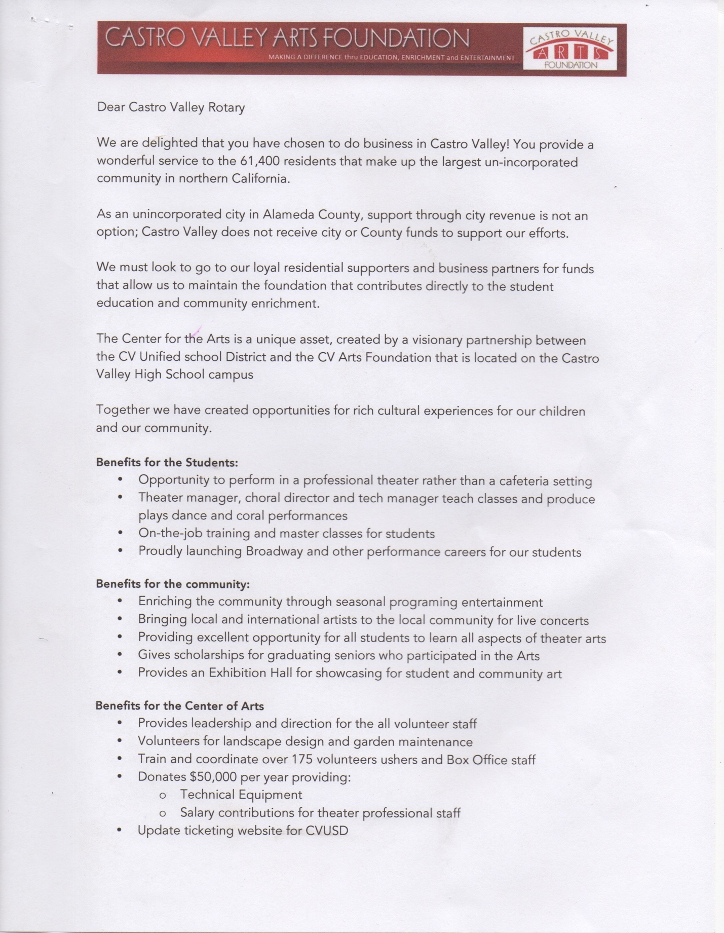

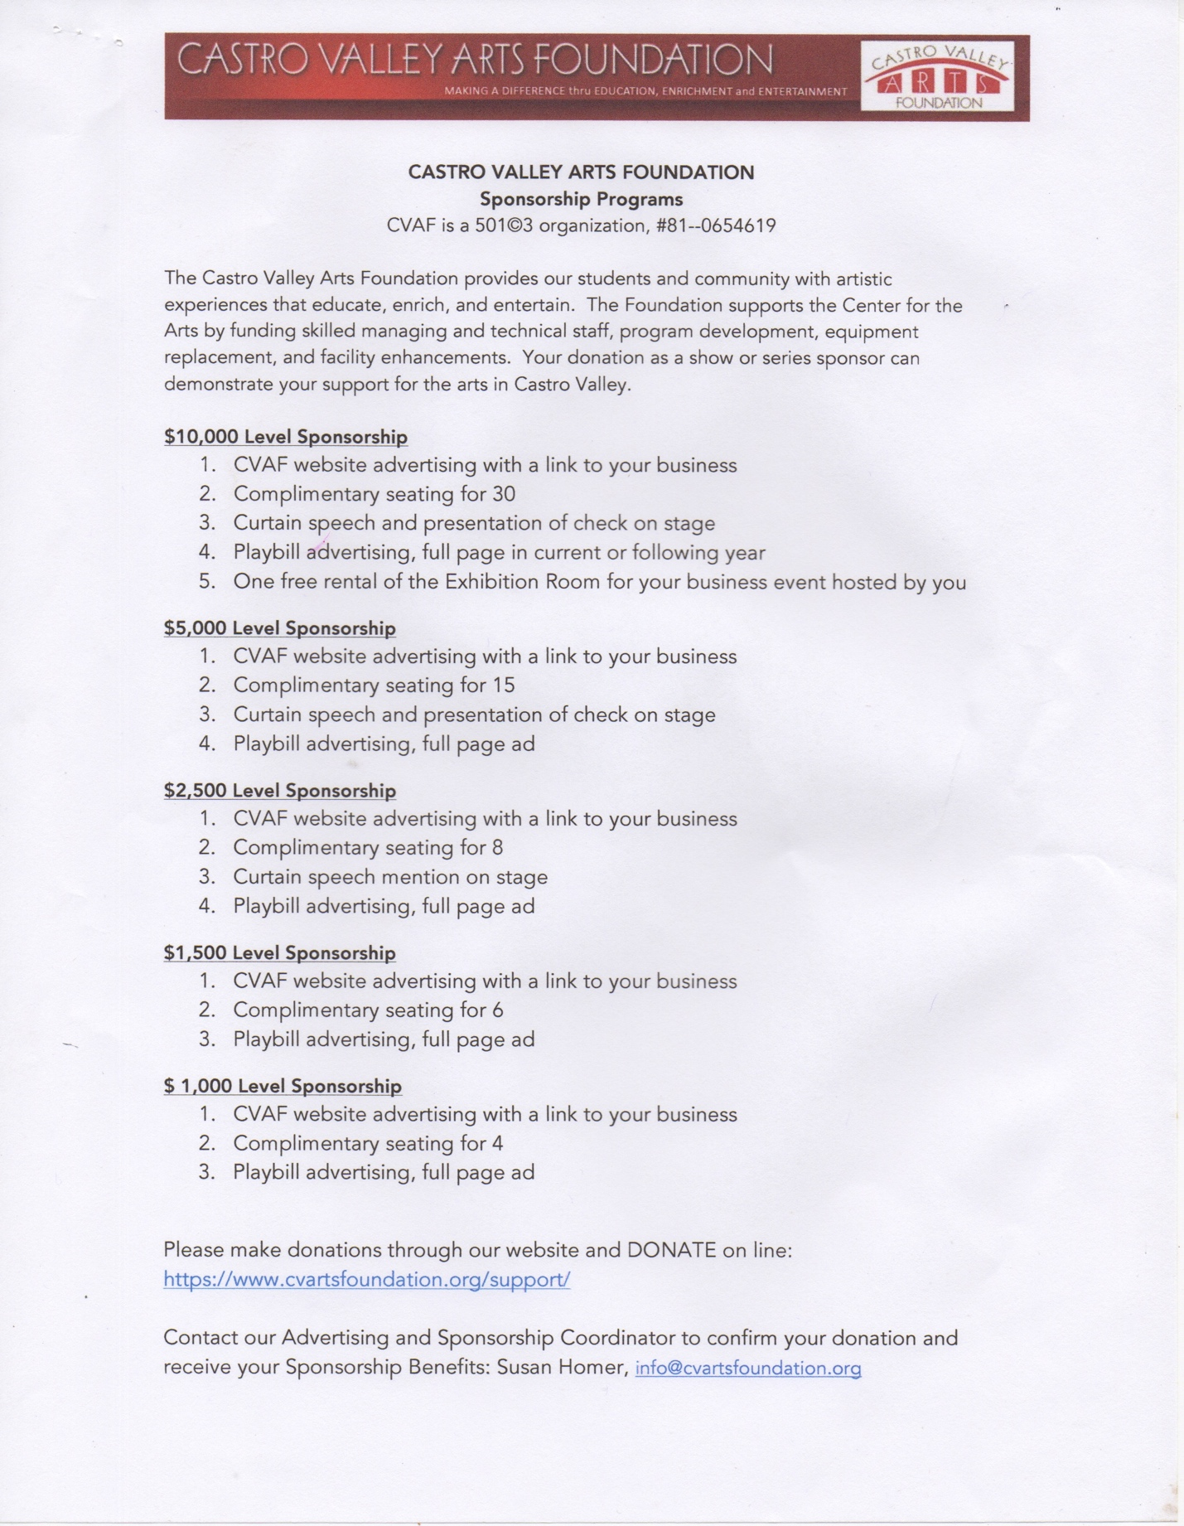

Sent from my iPad Pro 12.9

