Rotary Club of Castro Valley
Meeting Highlights – October 23, 2018

2018 Motorcycle Cannonball Race:
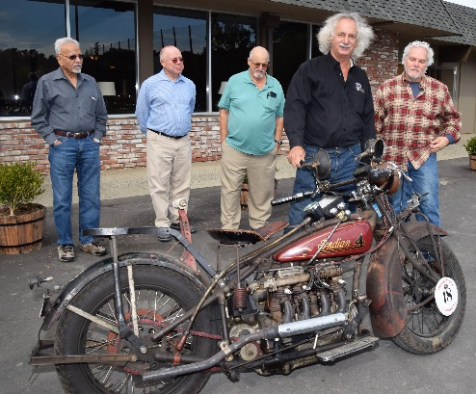
Doug Feinsod (member of the Rotary Club of Freedom) and Steve Gonzales described their participation in the 2018 Motorcycle Cannonball Race as well as past races. Doug (#18 on a 1909 Excelsior) has participated in the Race 5 times and Steve (#59 on a 1915 Harley Davidson 11F) 2 times. There were 123 riders in 2018. (Click here to see the riders and their motorcycles.)

A brief history of the Motorcycle Cannonball Race from its website:
Ten years ago, one man set out to become the first person to take a group of like-minded antique motorcycle riders across the United States on machines that were only often seen in museums and private collections. In 2010, Lonnie Isam Jr’s dream and bold sense of adventure took him and his friends from one ocean to the other, forever setting the standard of endurance for man and machine. Since 2010, history has been made and continues to be made; machines are coming out of the woodwork, they are being ridden, they are being enjoyed, and they are being put to the Motorcycle Cannonball test. (Click here to learn more about the history of the event.)
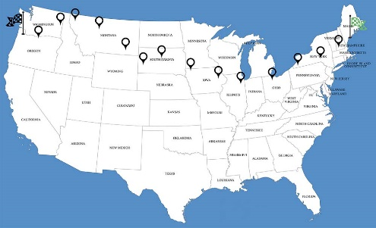
The Motorcycle Cannonball Race is a coast-to-coast race that participants complete 17 days. (Click here to see more details about the route.) All the participants are proud owners and collectors of antique motorcycles, many which are single speed bikes. Most of the participants are not traditional bikers and often ride only is this race. Even though it is known as a race, it is not a race in the traditional sense.

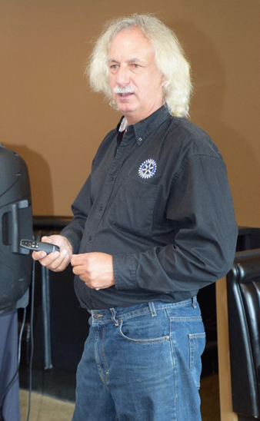
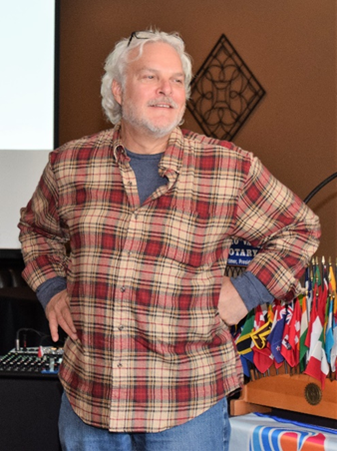
All the participants assemble at the starting station at the pre-announced location. None of the participant knows the route for the race. All participants are given the pre-printed route sheets about an hour before the starting time each day and this itinerary serves as their GPS. They generally travel about 200 to 250 miles in a day. Each stop is a planned celebration where the drivers and their group are entertained by the local organizers and they are provided a hotel for the night. Since these motorcycles are antique, each driver brings needed spare parts and helper/mechanic with them. At the midpoint, generally on the eighth day of the race, there is a major celebration and all participants get a day off for rest. At the final destination, there is another major celebration. Doug brought his 1909 Henderson motorcycle which he used in one of his Cannonball races (pictured above). All the rotary club members enjoyed looking at this motorcycle, asking him questions about its history, and taking many pictures. The presentation was a unique experience for all.

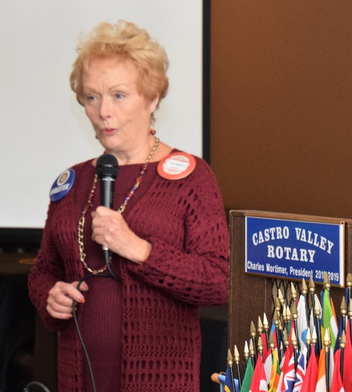
Member’s Moment
Rather than sharing her personal background, Carol Bigelow took the opportunity to share an important personal experience. Recently, she went for a routine physical examination and decided to have her mammogram examination. Couple of days later, Carol was called by the doctor an informed that they have noticed some abnormality in both her breasts and asked her to come for additional testing. To say the least, Carol went through an anxious period where she blamed herself for not getting her mammogram examination earlier and realized that many women keep postponing this important part of physical examination for as long as possible. Further testing revealed no anomaly, but Carol decided as part of Breast Cancer Awareness Month to alert other females regarding the importance of early testing and detection to avoid potential problems. She urged the male members of the Club to convince their mothers, sisters and significant others to have timely testing to avoid unnecessary anxiety and future regret. Thank you to Carol for sharing such a personal, but important story.

Scenes from the Meeting

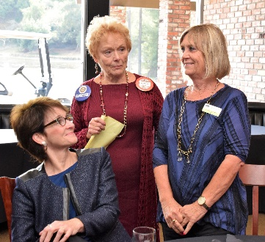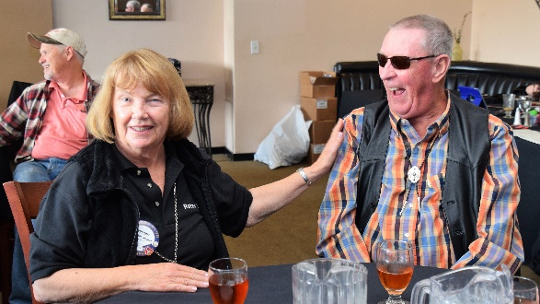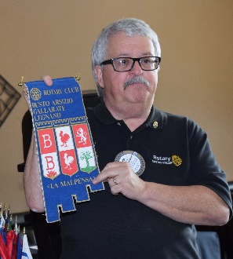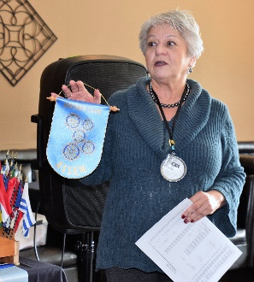
Left to Right: Greeter Carol Bigelow introduces Kathy Anderson representing the Castro Valley/Eden Area Chamber of Commerce as Murline Monet looks on. The Chamber will have a member attending meetings on a regular basis. Virginia Degner introduces husband Duane and his new shirt. Jim Negri presents a Club banner from the Rotary Club of Busto Arsizio, Gallarate, Legnano (La Malpensa) where he did a make-up on his trip to Italy. Carol Wikle presents a Club banner from the Rotary Club of Assen, Switzerland that Christine Clement Shurma visited recently.
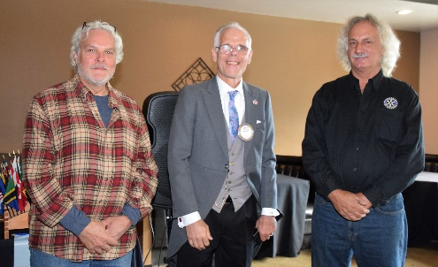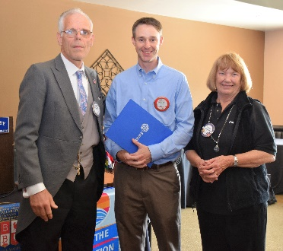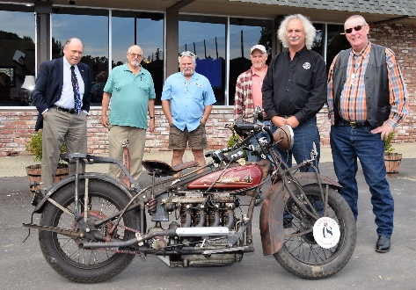
Left to Right: President Charles Mortimer thanks Steve and Doug for their outstanding presentation. President Charles Mortimer and Membership Chair Virginia Degner welcome Summit Health Center CEO Stephen Gray as the newest Red Badge members – be sure to introduce yourself to Steve and warmly welcome him to the Club. Members check our Doug Feinsod’s motorcycle.

Upcoming Speakers
- October 30: Julie Menack on Geriatric Care Management and Fiduciary Responsibilities
- November 6: Alameda County Sheriff Greg Ahern

