Meeting Highlights for October 25, 2016

Candidates for the Castro Valley Unified School District Governing Board

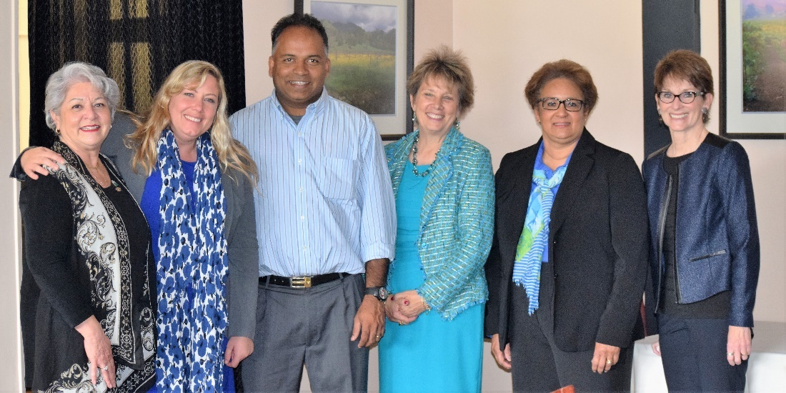
(Left to Right) Rotary Club President Carol Wikle, Lavender Whitaker, Tojo Thomas, Board President Jo Loss, Monica Lee, Monthly Speaker Chair Muriel Monat. Suresh Gupta was unable to attend.

At today's meeting, the Club hosted four of the five candidates for the Castro Valley Unified School District (CVUSD) Governing Board. The candidates outlined their qualifications to serve and vision for the future of the District. The presentation was part of the Club's ongoing efforts to engage the community and keep the members and guests informed on the issues critical to Castro Valley.
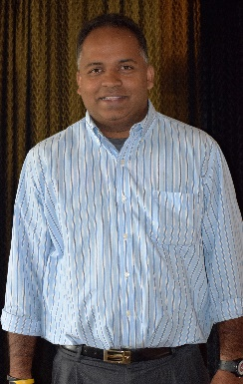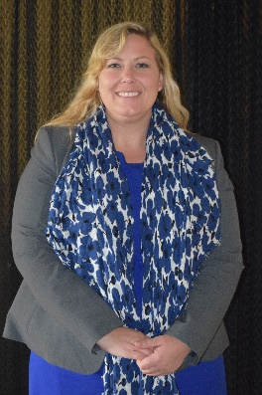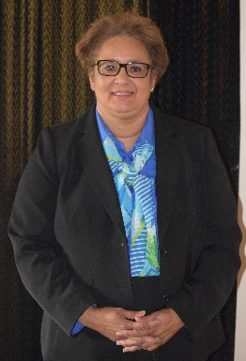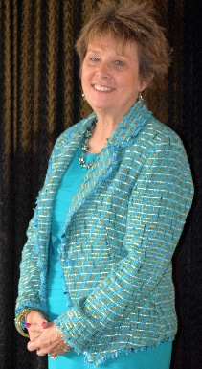
After the presentations, Club members asked questions about the candidate views on who is their number one constituency, the effect of potential teacher shortages and role of technology for students and staff. The presentations and answers by the candidates were enlightening and informative.
.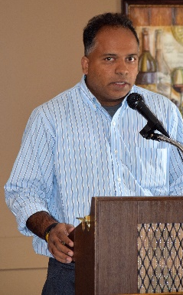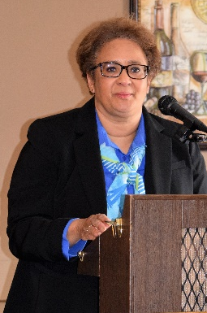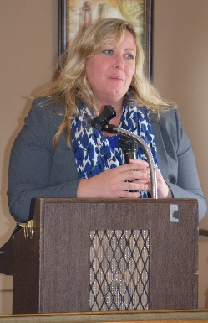
Be sure to vote on November 8th or mail your ballot.
Every vote counts!

District 5170 Avenues of Service
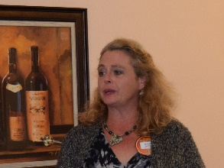
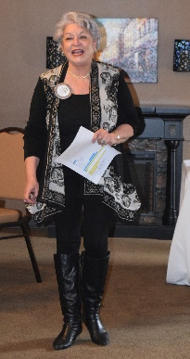
President Carol shared her impressions of the District 5170 Avenues of Service workshop on Saturday, October 22nd, in San Jose that Carol, Jim Negri, Obse Lubo, Ajay Ahluwalia and Michaela Thompson attended. For Ajay and Michaela, attendance was another step towards earning their Blue Badge. The workshop was very informative and provided many new ideas for the Club. Carol learned that the Club may be able to get a grant of approximate $10,000 toward unused DDF funds from other Clubs for our "Breathing for Life" project. Michaela Thompson and Ajay Ahluwalia were the Red Badge members who attended their first District Conference on Avenues of Service and stated that it provided an opportunity to understand the Role of the Rotary Club in managing and undertaking so many National and International Projects.

Breathing for Life Project
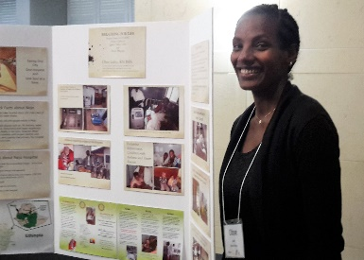
President Carol announced that a team including our own Obse Lubo left on Monday for Nejo, Ethiopia, to make the final arrangements for delivery of the oxygen generator. We are close to our goal, but still need donations in any amount from all members. Share the story with family, friends and colleagues. Go to the website to donate or bring a check to next week’s lunch meeting. Checks should include your full name and address plus District 5170 501 (c) 3 94-3016176 in the note section to receive the appropriate information for a tax deduction.
Obse at the Avenues of Service Workshop

RSVP for Lunch Meetings
President-Elect Jim Negri reviewed the new system in Club Runner to RSVP for lunch meetings and reported that he was encouraged that more members participated this week as compared to last week. He encouraged all members to use the system, so that there is enough seating and food for each meeting. Please RSVP even if you do not plan to attend. If you plan to attend, not eat lunch, RVSP “yes” and note in the comment section that you will not be having lunch. Please continue to invite guests to our meeting and you can register your guests when you RSVP.

Club Christmas Party
President-Elect Jim announced December 10th at 6:00 p.m. for the Club Christmas Party graciously hosted by Heidi Hausauer. Jim shared his white elephant gift from last year – an orange orangutan. Details will follow shorter, but mark your calendars.

Upcoming Events
October 29 - About 15 members are signed up to attend the Rotary Club of Fremont Warm Springs fundraiser on October 29 at Castlewood Country Club.

November 14 - Club members will be helping to prepare and serve the Thanksgiving Lunch for the seniors at the Kenneth Aiken Senior Center. Thanks to the generous support of our members all volunteer positions have been filled.

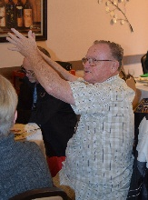
December 10 – Club Christmas Party (see above). Invitations with details to follow.

December 13 – Bruce Johnson reviewed plans for the Children’s Christmas Party to be held in Room 10 of Castro Valley Adult Education and Career Center at 4:00 pm for students of FESCO and Rubi's Place.

November Lunch Speakers – Dwight Perry, Chair
November 1- John Baiocchi, new artistic director for Chanticleers Community Theatre
November 8 - Greg Ahern, Alameda County Sheriff
November 15 – David Rocha, Alameda County Fire Chief

More Photos from October 25th

