Rotary Club of Castro Valley
Meeting Highlights – October 30, 2018

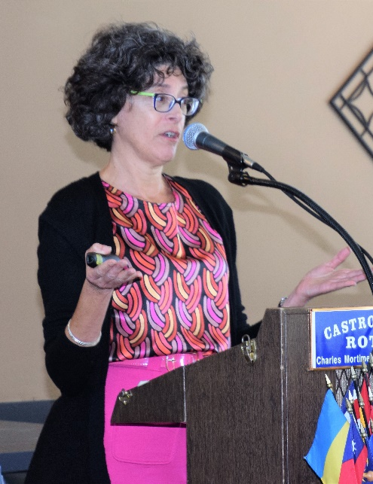
Julie Menack, Owner of Fiduciary Services and Life Care Management, was the speaker of the day. She discussed how the country is being hit by an Age Wave and the impact that it is having. Almost 10,000 people per day are turning 65 years and this trend is likely to continue over the next 20 years. Nearly 70% of the individuals over the age of 65 will become cognitively unable to complete at least two "activities of daily living" including dressing, bathing, or eating at some point in their lives and over 50% of people over age 85 will have some form of dementia. All these individuals are going to need some help in managing their affairs as they get older, less mobile, and less lucid. Some fortunate ones can depend on their children or other relatives who live nearby and can take on the additional responsibility of managing their affairs. Most others will have to look for help from other sources (e.g., government programs such as Medicare and MediCal; subsidized housing;, County Area Agency on Aging;, Meals on Wheels;, paratransit; nonprofits such as Senior Information and Assistance, Senior Centers, faith communities, diagnosis-based organizations such as Alzheimer’s Association and Parkinson’s Foundation; free services such as placement services; fee-based services such as Aging Life Care Professionals, Independent and Assisted Living Facilities, CA Licensed Private Professionals and Fiduciaries, Adult Day/ Health Programs and many others.
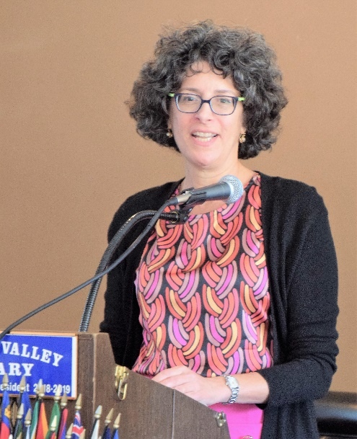
Some of the options provide valuable services and sources for information, others could useful for individuals with limit limited resources. A person with reasonable resources will benefit the most by pursuing the fee-based options. The Aging Life Care Professional typically include social workers, nurses, gerontologists or other heath/mental health professionals. They are knowledgeable with specialized training in the field and are familiar with community resources. They follow a strict code of ethics and standards of practice and usually charge about $100 to $250 per hour.
An Aging Care Professional provides help in the following areas:
- Professional Support: assesses needs, develops a plan, links to services, mediates family conflicts and provides crisis Intervention
- Monitors Client: ensures needs are met, identifies changes and makes adjustments, keeps family informed, provides peace of mind for the family, and ongoing evaluation and adjustment of plan
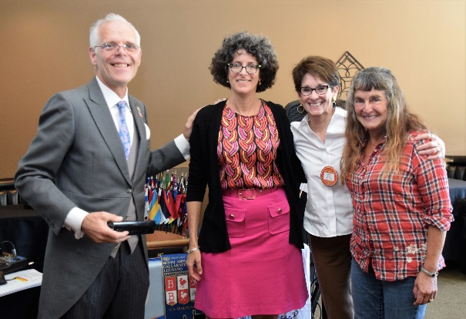
- Coordinates Care: finds the best options for the client's situation, provides a communication hub, provides advocacy, ensures quality and effective care, and helps if new problems arise

Julie explained that a professional fiduciary is an individual licensed by the state to serve as a Conservator (person or estate), Trustee, Agent under durable Power of Attorney, Agent under Advanced Health Care Directive, or Estate Executor. They are knowledgeable, have specialized training and have experience either finances, care or both.

A professional fiduciary follows a strict code of ethics and standards of practice, and usually charge between $100-175/hour. They help same way as Aging Life Care Managers, plus serve as a Financial Agent (e.g., pay bills, oversee/manage finances, act as Financial Power of Attorney, Conservator of Estate, Trustee). Individuals need a professional fiduciary if the concerns go beyond an individual’s or the individual’s family’s ability or if there is either no family or there are disagreements among the family regarding the client's needs. Help in locating and selecting Professional Health Care and Fiduciaries is available from the following sources:
President Charles thanks speaker Julie Menack, Speaker Chair Murline Monet, and Valerie Bach, a client of Julie's who shared her personal experiences.

- Aging Life Care Professionals: Aging Life Care Association (www.aginglifecare.org)
- CA Licensed Professional Fiduciaries: Professional Fiduciary Association of California (PFAC) https://pafc.pro.org

Proctor Elementary Beautication Garden Project
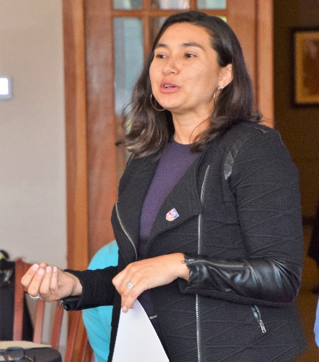
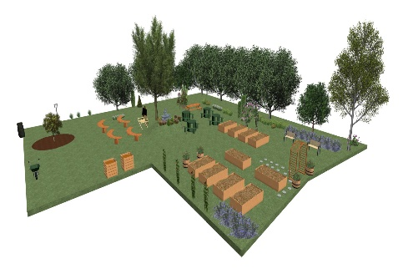
At the October Board of Directors meeting, the Board approved a grant of $1,250 to Proctor Elementary School for its Beautification Garden Project (e.g., cleanup the existing area and plant a new garden). Kat Troyer from the Protctor PTA thanked the Club for its generous grant and shared a presentation regarding the plans for the garden.

Phase I consisted of the cleanup of the area, which was completed by the Proctor students and teachers. of the school. Phase II will consist of planting and other upgrades to the garden. There will be plenty of opportunities for Rotarians to be involved. President Charles Mortimer present Kat the grant check after her presentation.

A View from the Meeting
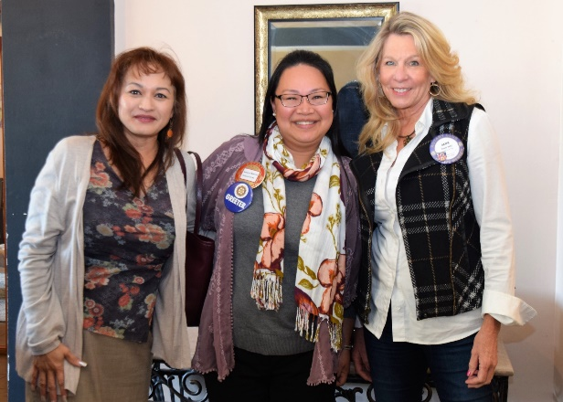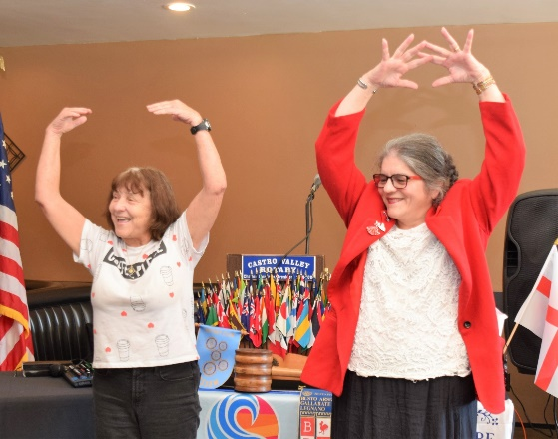
(Left to Right): Greeter Rosalyn Antonio (C) greets new member Rita Sabin and Dawn Ortiz. Ceta Dochterman and new Honorary Member KJ Page lead the Song of the Day, Itsy Bitsy Spider. Cliff Sherwood displays his Halloween spirit.
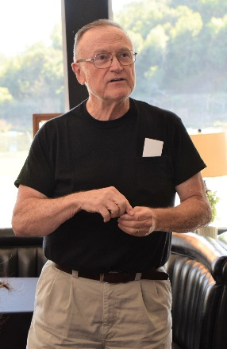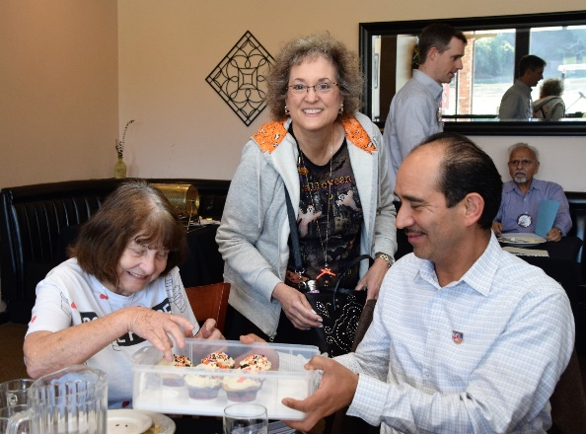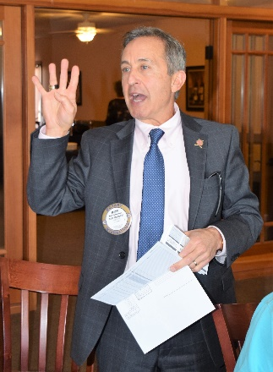
(Left to Right): Bruce Johnson shares a Thought for the Day. Heidi Hausauer shares Halloween cupcakes that she baked for the Club. Mark Poniatowski reminders everyone that they have four (4) tickets to sell for the Texas Hold ‘em Tournament on March 9, 2019.

